Using Environmental DNA (eDNA) to Improve the Accuracy and Efficiency of Managing the Invasive Pacific Red Lionfish in the Caribbean

Haley Erickson¹, Ben Grubbs¹, Rita Peachey², Joseph Shaw¹, Chip Glaholt¹

¹The School of Public and Environmental Affairs, Indiana University, Bloomington, Indiana 47405, USA
²Director of iSustain.tech, Bonaire, Netherlands Antilles, Dutch Caribbean

Abstract
The Pacific Red Lionfish (Pterois volitans) was introduced to the Atlantic Ocean in the 1980’s. Since their introduction the lionfish have rapidly spread throughout the Caribbean and the Gulf of Mexico, posing a serious threat to marine ecosystems throughout invaded regions. Lionfish have a high reproduction rate, as females can lay approximately 2 million eggs per year per individual. Lionfish are capable of consuming up to 20 fish in half an hour, and can reduce native fish populations by up to 80-90%. The high reproduction rate of lionfish, in combination with their aggressive appetite, lack of predation, and generalist behavior gives the lionfish competitive advantages in the areas they invade. The indiscriminate diet of the lionfish is problematic because many of their prey are herbivorous reef fish. Herbivorous reef fish help maintain coral reef health by consuming algae which, if left unchecked, would grow over the coral polyps, blocking the sunlight from getting to the symbiotic organism found in the coral, resulting in coral death and further biodiversity loss.

Current methods used to monitor the Caribbean lionfish invasion rely extensively on visualizing lionfish, the most common being visual surveys. These techniques are prone to inaccuracy (e.g., false sighting claims), are time and labor intensive, and can be financially costly. The dependence on these traditional management techniques greatly limits the effectiveness of managing this aggressive invasive species that is drastically altering coral ecosystems.

The goal of this study is to improve the efficiency and accuracy of managing lionfish by implementing the novel technique of using environmental DNA (eDNA) to confirm the presence of lionfish in a marine environment. eDNA has becoming an increasingly popular ecosystem management tool because it offers a unique, molecular alternative to the current methods used to monitor for organisms. Instead of visualizing the often elusive and nocturnal lionfish to determine its presence, water samples are taken from sites of interest and analyzed for lionfish DNA left behind in the water (e.g., scales, excrement, fish slime, etc) using standard molecular techniques (i.e., DNA extraction and PCR).

Our results show how the use of eDNA methods have the potential to reduce the time, money and labor required to conduct lionfish surveys. In addition, our lab studies showed that lionfish eDNA concentrations correlated with abundance even as density was held constant; however, viable eDNA persist in the environment for less than 48 hours. Processing an eDNA sample costs approximately $0.05, and numerous samples (1-50) samples can be run in <12 hours. Overall, our study shows that eDNA is an accurate and cost efficient methodology in detecting the presence of the invasive lionfish compared to traditional sampling.

Our study suggests that eDNA could be an effective management tool for monitoring the spread of the lionfish invasion in the Caribbean. This study will also exemplify the utility of eDNA for the monitoring of other marine invasive and endangered species.

Introduction

Environmental DNA (eDNA) sampling is a tool used for genetic surveillance of aquatic organisms. eDNA technology can be applied to detecting trace amounts of DNA collected from water samples. This technique can detect DNA from epithelial tissue, feces, gametes, mucous and the cells of dead organisms (Newton 2014) and only requires the collection of surface water samples from the site of interest; researchers do not need to see or catch the target species. Processing water samples is standard for molecular biologists: the water sample is first filtered to capture the eDNA, the DNA is then extracted and analyzed using PCR and run out on a gel (or sequenced) to determine its species composition.

Previously, this technique has been successfully used to track the presence of freshwater invasive species such as Asian carp (Hypophthalmichthys nobilis) and silver carp (Hypophalmichthys molitrix) along the Mississippi River Basin and in the Great Lakes (Jerde, et al. 2013; Jerde et al. 2011), as well as, used to catalog entire marine communities in an aquarium environment (Thomsen et al. 2012). Because the eDNA technique only requires a water sample, it reduces sampling time and eliminates the catching or handling of the target organism. This less harmful method is particularly important in studying rare and endangered species, such as monitoring endangered species in freshwater environments (Thomsen et al. 2011). Furthermore, eDNA is being used to monitor elusive organisms that avoid detection such as sharks. Currently, eDNA sampling techniques are being developed to monitor shark communities (Dr. Mariani and Judith Bakker of UK and Professor Glaholt IU, personal communication). Using eDNA to monitor aquatic organisms has been shown to be more time and cost efficient than current methods (Amberg, et al. 2015 ). However, the full potential of eDNA sampling is still being studied. Here we propose a novel utility of eDNA, by using it to determine the presence and movement of an invasive marine organism the lionfish in the Caribbean.

The Pacific Red Lionfish (Pterois volitans) originates from the Indo-Pacific region, but has invaded the Atlantic Ocean, Gulf of Mexico, and Caribbean Sea over the last few decades (Schofield 2010). The Pacific Red Lionfish are believed to have been introduced into the Florida coast due to their popularity in the aquaria pet-trade industry (Semmens et al. 2004; Whitfield et al. 2002). Lionfish are an invasive species due to the detrimental ecological effects on marine ecosystems (Schofield et al. 2017), and they are rapidly spreading through the Caribbean

In their native regions, lionfish densities reach approximately 26.3 individuals per hectare (Kulbicki et al. 2012). Lionfish densities in invaded waters are 3-15 times their natural densities, with 72.7 individuals per hectare in parts of the Atlantic Ocean (Whitfield et al. 2007) and more than 390 individuals per hectare in the Bahamas (Green and Coˆte 2009). Lionfish have rapidly and successfully invaded and established themselves since their introduction; it is estimated that they have invaded an area of approximately 7.3 million km² of the Western Atlantic Ocean, Caribbean Sea, and the Gulf of Mexico (Côté et al. 2013). It is anticipated that lionfish will successfully invade the entirety of the Caribbean, and spread south towards South America into Brazil’s coastal marine waters. (Schofield 2010). Their invasion success is attributed to low predation pressure, the ability to migrate large distances in response to density dependent and independent competition, indiscriminate diet, and their high reproduction rate (Barbour et al. 2011).

Lionfish reach sexual maturity early in their life cycles and reproduce within their first year of life (Morris 2009). In optimal conditions, lionfish can produce as many as 40,000 eggs every 4 days throughout the entire year (Morris 2009). This means a single female lionfish could produce approximately 2 million eggs each year. High reproduction rates make lionfish very efficient at rapid colonization, but dependent on survivorship. Lionfish maintain high levels of survivorship in their invaded territories much in the same way as other invasive species; by looking unique to and behaving differently than native fish in order to avoid would be predators. The natural predators of lionfish in the Indo-Pacific Ocean (e.g. groupers and sharks) are also found in the invaded areas of the Caribbean and Atlantic Ocean. However, these same predators have yet to acclimatize to the invasive lionfish. In terms of unique appearance, lionfish have bright red coloration and venomous dorsal spines that aid in warding off most potential predators (Halstead et al. 1955). However, recent reports suggest evidence that predation of lionfish is beginning to occur. For example, lionfish were found in dissected groupers in the Caribbean (Maljković et al. Cove 2008), and researchers have witnessed a spotted moray eel consuming a live lionfish in the field (Pimiento et al. 2013). One management strategy for reducing the impact of lionfish is trying to train predators to eat lionfish by feeding sharks and groupers dead lionfish, but the effectiveness of this strategy is still unknown (Albins and Hixon 2013). Furthermore, even if training predators to consume lionfish was effective, the natural top predators in reef ecosystems are extremely overfished, limiting the impact they could have on controlling lionfish populations (Mumby et al. 2011; Sadovy 1995).

Lionfish are broadly piscivorous, meaning their diet consists of many other fish. They have the ability to consume large amounts and varieties of fish, which has led to the reduction of native reef fish populations in invaded areas by around 80-97% (Albins and Hixon 2008; Benkwitt 2015). The depletion of reef fish in invaded areas is increasing as the lionfish diffuse throughout the Southeastern coast of the U.S., the Gulf of Mexico and the Caribbean Sea. However, the biggest effect their diet has on reef ecosystems is due to the large number of herbivorous reef fish that lionfish consume (Morris and Akins 2009). Herbivorous reef fish help maintain coral reef health by consuming algae which, if left unchecked, would grow over the coral polyps, blocking the sunlight from getting to the symbiotic organism found in the coral, resulting in coral death and further biodiversity loss (Albins and Hixon 2013; Lesser and Slattery 2011; Mumby et al. 2006). Lionfish are also voracious, generalized predators and are indiscriminate when consuming prey (Morris and Akins 2009). Researchers have observed a single lionfish consuming over 20 reef fish in as little as 30 minutes (Albins and Hixon 2008). In addition, lionfish can survive for long periods without eating, despite their typical high consumption of prey, allowing them to migrate great distances (Tamburello and Cote 2014).

Lionfish are also successful invaders due to their coloration and cryptic nature, causing potential predators and prey to mistake them. Sharks and groupers are natural predators of lionfish; however, these same predatory species have not been found to feed on lionfish in the Caribbean, but instead are being trained to feed on them by humans providing dead or tethered lionfish with limited success (Hackerott et al. 2013). Studies suggest that it is the cryptic nature of lionfish that prevents sharks and groupers from seeing them as potential prey items (e.g., Albins and Hixon 2013, Hackerott et al. 2013). Furthermore, the neutral coloration and elongated fin rays of lionfish are believed to cause native fish to mistake the lionfish as seaweed, crinoids, or even tubeworms; effectively camouflaging lionfish from potential prey (Albins and Hixon 2013). Lionfish have been documented employing a unique hunting strategy compared to native predators. They blow jets of water towards their prey, causing them to turn and orient themselves toward the lionfish which allows them to consume prey in the more effective headfirst direction (Albins and Lyons 2012). Fish in invaded areas are unfamiliar with and not adapted to lionfish’s coloration or hunting strategies, making them easy targets (Albins and Hixon 2013).

Current conservation and management efforts have been focused at the local level, with small scale attempts to reduce lionfish populations and prevent invasion in specific areas by using a variety of harvesting practices, including lionfish spear fishing tournaments (Albins and Hixon 2013). This technique would only be effective at reducing lionfish density in a small, routinely monitored area. However, eradication of the lionfish using these techniques is unlikely. Furthermore, current fishery management techniques have also been deemed either ineffective or too costly to implement in the fight to control the invasive lionfish (Albins and Hixon 2013). For example, common tracking techniques used to monitor other marine fish species are impeded by the lionfish’s cryptic nature, patchy distribution, migration patterns and rapid colonization capabilities (McCreedy et al. 2012). Similarly, traditional fish surveying techniques of getting into the water (e.g. scuba diving) and looking to determine if lionfish are present is a costly, time consuming and inaccurate approach. A 2013 study estimated that conventional visual survey methods underestimate lionfish abundances by approximately 200% (Green et al. 2013). The National Park Service has noted that a recommended amount of survey time is 5 minutes for every 50 square meters surveyed for simple habitats; requiring a large amount of time to properly conduct a visual survey of structurally complex reef ecosystems (McCreedy et al. 2012). The National Park Service has also evaluated several tools currently available to control lionfish, but they are all either costly, ineffective, damaging to ecosystems, or a combination of those qualities (McCreedy et al. 2012). More efficient and accurate methods are necessary to combat the devastating effects of this invasive species. In order to have effective site-specific management for this invasive species, determining what areas have not been invaded is critical. Therefore, being able to efficiently and accurately track lionfish to monitor invasion progress and reduce their threat to coral reef ecosystems is essential to improving current lionfish management.

We propose the novel use of eDNA, a technique commonly used in freshwater ecosystems to track the invasive lionfish in the Caribbean in hopes this tool can be an early indicator of newly invaded areas so that eradication methods can be implemented effectively. To achieve this goal, we developed field methods of tracking lionfish by first conducting controlled laboratory proof of principal experiments that were then applied in the field to determine accuracy, detection sensitivity and cost effectiveness of identifying invasive lionfish.

Our research adapts current eDNA methods to track and monitor lionfish populations in the Caribbean. As a proven effective tool used to monitor and track both invasive and endanged species in other aquatic ecosystems, eDNA offers a powerful technique to help mitigate the negative ecological impacts of lionfish invasion by creating an early indicator of this species arrival to new areas. Due to the extremely high reproduction rate of lionfish, early detection is critical in managing the spread and ecological damage of this invader. Furthermore, eDNA techniques provide environmental managers an affordable, efficient, and practical method to not only track and monitor invasive species, but also other rare, elusive or endangered aquatic species.

Methods

The following experiments were designed to detect the presence or absence of lionfish, determine if eDNA concentration correlates with lionfish abundance, measure the duration of time eDNA persists in the environment, and test its applicability in the field. The lionfish used in each of these experiments were collected from various sites off the coast of Bonaire (N 12º09.605’ W 068º16.919’) by certified divers associated with CIEE Bonaire and ranged in size from 3.4g to 24.1g with mean of 10.8g ± 5.4g.

Lionfish Detection & Abundance Laboratory Experiment

Objective: This experiment was designed to determine if eDNA can detect the presence or absence of lionfish, and if eDNA signal strength correlates with lionfish abundance.

Experimental Setup: The experiment was conducted at the CIEE Research Station in Bonaire, Caribbean Netherlands (N 12º09.619’ W 068º16.859’) using 12- 10 gallon glass aquariums. All aquariums in this experiment were cleaned using a 10% bleach solution and rinsed with freshwater to remove any DNA before being filled with unfiltered, homogenized ocean water collected off the beach outside of CIEE Research Station. Each aquarium was randomly assigned one of three lionfish abundance treatments (Low, Medium, and High) or a control. All treatments were replicated three times and consisted of the same density of lionfish, with only lionfish abundance varying among treatments. Control aquariums were filled with 4 L of homogenized seawater and contained 0 lionfish. Low abundance treatment contained 1 lionfish in 4 L of homogenized seawater. Medium abundance treatment contained 2 lionfish in 8 L of homogenized seawater. High Abundance treatment contained 4 lionfish in 16 L of homogenized seawater. All tanks were covered lids at all times, except when samples were taken, to prevent cross contamination or extraneous DNA from entering the water. The experiment was conducted outside the CIEE Field Research Station to simulate the natural temperature and light levels found in the Caribbean. Water quality (temperature, pH, light levels, dissolved oxygen, chlorine, hardness, ammonia) was monitored for the duration of each experiment.

Sampling: Prior to placing the lionfish in the treatment tanks, water samples (300 mL) were collected (T₀) from the control tank and each of the treatment tanks to determine the amount of background lionfish eDNA in the seawater. A second water sample (300 mL) was taken from all tanks 24 hours after the lionfish had been put in the tanks (T₂₄). Blanks were taken of the Milli-Q ultra clean rinse water used to clean all filtering equipment between samples to monitor potential environmental contamination. All water samples were filtered within 1 hour after collection.

eDNA Longevity Laboratory Study

Objective: This experiment was designed to determine how long eDNA persists in the environment.

Setup and Sampling: After the 24 hour water samples were taken for the abundance experiment, the lionfish were removed from the tanks. The water in each replicate of the Low abundance treatment tank was retained for 4 more days to test the duration eDNA persists in the water. Water samples of 300 mL were collected every 24 hours for 4 days using the same sampling procedure as described above. Again, blanks were taken during every sampling session.

Field Validation of eDNA Study

Objective: This experiment was designed to determine how far eDNA can be detected from a single caged lionfish in the field.

Setup: The field validation study was conducted at the Yellow Submarine dive site on Bonaire (N 12º09’34.8” W 068º16’55.4”). Researchers used a caged (dimensions: 30 cm long x 15 cm diameter with 1 cm² hole size) living lionfish (76.5 g) secured 0.5 m off the ocean floor in 2.75m depth of water in an area where no lionfish were present. The field location was determined to be free of lionfish by our researchers who surveyed a 100m radius from where the caged lionfish would be placed for 6 hours prior to the experiment (Figure 1).

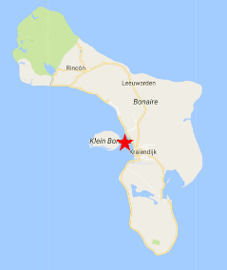
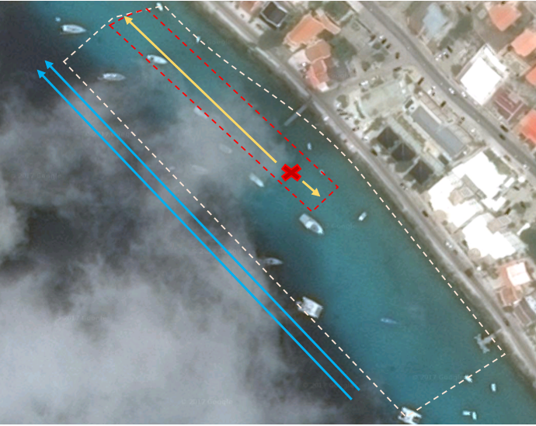
Surveyed Area
Sampled Area
Current Direction
Sample Direction
Figure 1: Map of field sampling area

Sampling: Sampling of the caged lionfish eDNA occurred 6 hours after placing the lionfish in the sampling area, to allow lionfish eDNA to be released into the water. A total of 10- 1 L water samples were taken by hand at surface level and ocean floor level. Samples were collected at surface level and ocean floor to determine if eDNA follows laminar flow or is distributed throughout the water column. Two control samples were taken 5 m up current from the caged lionfish to test for background lionfish eDNA; one at surface level, the other along the floor of the ocean. Eight samples were taken along a 100 m transect down current from the caged lionfish, to determine how far a lionfish could be detected using eDNA sampling. Three of the eight samples were taken at surface level at 5 m, 50 m, and 100 m away from the caged lionfish. Five of the eight samples were taken along the ocean floor at 5 m, 10 m, 25 m, 50 m, and 100 m away from the caged lionfish (see Figure 2).

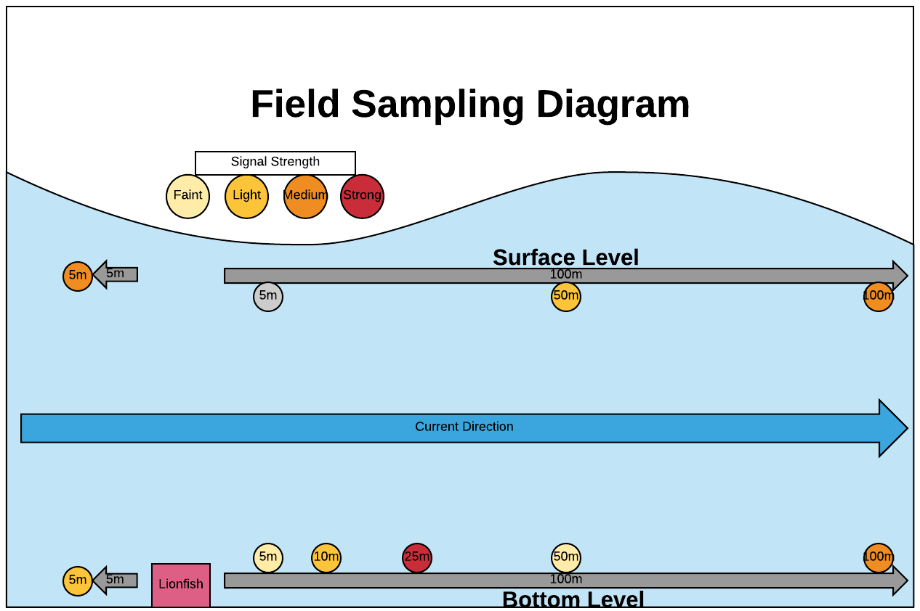
Figure 2: Field experiment sampling design.

After collection, the outside of all sample bottles were bleach wiped before being transported into the filtering area to avoid contamination. All samples were processed following the same procedure as the previous experiment and described in more detail below.

Filtering, Extraction & PCR

All samples were filtered within 24 hours after collection, following a standard filtering and extraction procedure. The filtering area and equipment were cleaned with bleach wipes to prevent contamination before processing each sample. Water samples were filtered using 300 mL Pall® filter funnels onto 1.2 µm PCTE filters (Millipore RTTP Isopore Membrane Filter). Filters were then folded inwards and placed into 2 mL tubes filled with 700 µL of CTAB warmed to 65 ºC (Doyle and Doyle 1987) and left to incubate at 65 ºC for 10 minutes. The 2 mL tubes were then placed into a 20 °C freezer until DNA extractions were performed.

The eDNA extraction followed a modified chloroform-isoamyl alcohol (hereafter “CI”) DNA extraction and isopropanol precipitation as described in (Renshaw, et al. 2014). Extracted samples were then processed for PCR using GoTaq polymerase and following standard PCR techniques. The following 12s primers designed specifically for lionfish were used: F- 5’ CCA TCT TAA CAT CTT CAG TG 3’ and R- 5’ CAT ATC AAT ATG ATC TCA GTAC 3’ (Freshwater, et al. 2009). As a positive control for our PCR we used DNA extracted from tissue samples taken from our experimental lionfish, as well as, non-lionfish DNA (i.e. Daphnia) as a negative control for our PCR. PCR products were visualized on a 1% agarose gel to determine lionfish eDNA presence and concentration in all samples.

Results

Lionfish Detection & Abundance

Low signals of lionfish eDNA were detected in the unfiltered sea water used in control tanks within the first 24 hours of this experiment, but tested negative after 24 hours (Figure 3). In two of the Low Treatment tanks (1 lionfish in 4L), water samples taken immediately after lionfish were placed in the tanks (T_{o}) tested positive for lionfish eDNA for low concentrations of lionfish eDNA, with the third tank testing negative. After 24 hours all three tanks tested positive for lionfish eDNA with medium signal strength. In Medium Treatment tanks (2 lionfish in 8L), samples taken at T_{o} tested negative for lionfish eDNA. After 24 hours, the Medium Treatment tanks tested positive in all three tanks for medium concentrations of lionfish eDNA. In High treatment tanks (4 lionfish in 16L), water samples taken at T_{o} tested positive in all three tanks for light concentrations of lionfish eDNA. After 24 hours, all three tanks tested positive for high concentrations of lionfish eDNA. In each treatment the strength of the signal of lionfish eDNA present increased from T_{o} to T₂₄. Furthermore, the signal strength at T₂₄ increased with lionfish abundance (e.g. low abundance means medium to low signal strength, and high abundance will have a stronger signal strength).

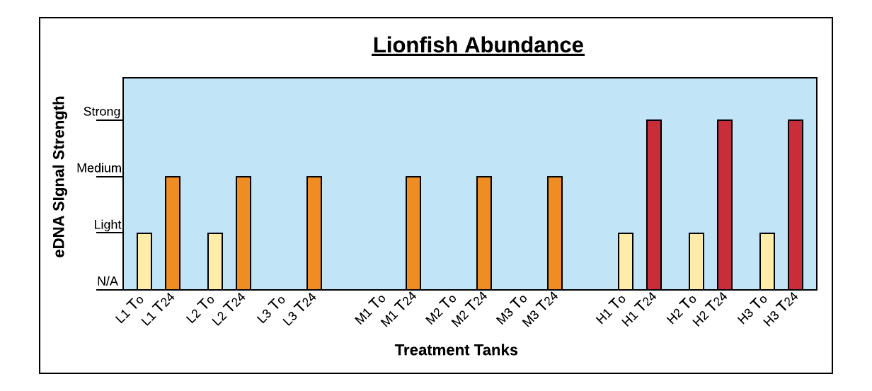
Figure 3: Lionfish eDNA signal was detected at low, med and high abundance treatments and surprisingly eDNA correlated with abundance even though density was held constant.

eDNA Longevity under Laboratory Simulated Environmental Conditions

On Day 1 of this experiment, after the lionfish were removed from the Low abundance replicate aquariums, two of the treatment tanks tested positive for lionfish eDNA with a very strong signal, while the third tank tested negative for any lionfish eDNA signal (Figure 4). Twenty-four hours after lionfish were removed all three samples still showed the presence of lionfish eDNA, with signals ranging in strength from light to strong. However, after 48 hours lionfish eDNA could no longer be detected in any of the treatment tanks. All tanks tested negative for lionfish eDNA for the remainder of the experiment.
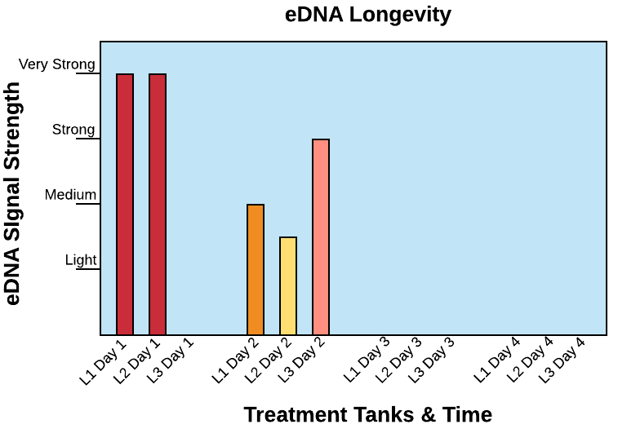
Figure 4: eDNA persisted under controlled lab simulated natural conditions for 2 days, but was undetectable by day 3. eDNA breaks down after 2 days under lab simulated natural conditions.

eDNA Detection Limits under Field Conditions

The two-control samples taken 5m up current from the caged lionfish to detect background lionfish eDNA both tested positive for lionfish eDNA with light and medium signal strengths (Table 1). This positive signal indicates the presence of significant background lionfish eDNA at our experimental sight. All samples taken down current, except for one at the surface level, tested positive for lionfish eDNA with varying signal strengths. Surface level samples and bottom level samples were consistent in their ability to detect lionfish eDNA.

Sample ID | Distance from Lionfish | eDNA Signal Detectable | Strength of eDNA Signal
Upstream- Bottom | 5m | Yes | Light
Upstream- Surface | 5m | Yes | Medium
Downstream- Surface | 5m | No | N/A
Downstream- Surface | 50m | Yes | Light
Downstream- Surface | 100m | Yes | Medium
Downstream- Bottom | 5m | ? | Faint
Downstream- Bottom | 10m | Yes | Light
Downstream- Bottom | 25m | Yes | Strong
Downstream- Bottom | 50m | ? | Faint
Downstream- Bottom | 100m | Yes | Medium
Table 1: Field study showed that eDNA can be detected at least 100m down current of a lionfish.

Discussion

Results from all three experiments indicate the strengths of the eDNA methodology, while highlighting areas in need of further research. The lionfish abundance study indicated that the strength of lionfish eDNA signal correlates with number of lionfish present under highly controlled conditions. In this experiment, we controlled for the distance between the sample and the target organism and the level of eDNA degradation by controlling the time at which the eDNA was present in the environment. In the field, both time and proximity to the target organisms are unknown and could each effect the eDNA signal strength, rather than abundance or density. Therefore, while our results support the use of eDNA concentration (i.e. signal strength) to infer abundance (Jerde et al. 2011; P.F. Thomsen et al. 2011), we strongly caution against the use of eDNA as a means to quantify target organisms until more field studies can validate our laboratory experiments. Alternatively, determining the exact number of individuals could be done using genomic tools such as sequencing and bioinformatics to identify unique genetic differences associated with individuals within water samples collected, to accurately assess the number of individuals and, therefore, estimate population size and density.

eDNA proved to be an effective methodology in determining presence of lionfish under controlled laboratory conditions and under field conditions. In fact, we were able to show conclusively that lionfish eDNA is detectable even through 3 days of visual fish surveys showed no indication of lionfish presence. However, due to the detection of background levels of lionfish eDNA, our field experiment was unable to determine the distance lionfish eDNA could be detected from its source. The sensitivity of the eDNA technique detectability does exhibit its high value for monitoring the presence/absence of rare, low density species in aquatic ecosystems.

The field component demonstrated that surface samples were consistent with bottom samples in their ability to detect lionfish eDNA. The ability to successfully take surface samples significantly reduces the time necessary to determine lionfish presence; it eliminates the time, effort, and costs associated with divers or snorkelers conducting visual surveys for several hours or days, and enables a boat and a person to collect monitoring samples to be run in the lab. This allows scientist and managers to collect more samples and subsequently increase the frequency of sampling and area sampled to improve monitoring of the lionfish or other invasive species.

Our eDNA longevity experiment clearly showed that eDNA lasts ~48 hours under the light duration and temperatures found on Bonaire. The length of time eDNA persists in the environment is an important variable in determining the maximum distance a positive eDNA signal could detect. Managers in the Caribbean can utilize this information to estimate the maximum distance lionfish might be away from the sampling sight, creating an area of interest based on current speed and direction. The conditions are common among areas found at this latitude and do not vary much seasonally due to its close proximity to the equator. A 48 hour longevity period not only gives confirmation that lionfish have been in that area in the last 2 days, but it also guarantees that lionfish have been absent in an area for the last 2 days if no eDNA is detected. Lastly, the sensitivity of eDNA detection of lionfish in the field makes this technique more accurate than survey data since lionfish like to hide during the day, making them hard to see. Missing even one adult female lionfish can make the difference in preventing a new area from being invaded. Thus, eDNA techniques can save environmental managers a substantial amount of time and money, and increase accuracy in monitoring the invasive lionfish.

Conventional methods evaluated by the National Park Service are all either costly, ineffective, damaging to ecosystems, or a combination of those qualities (McCreedy, Toline and McDonough 2012). The proposed eDNA methodology saves money by reducing sampling effort, and is itself an inexpensive process. Processing samples for this experiment cost approximately $0.05 per sample, or approximately $2.45 in total. Comparing this cost to conventional methods, which require several surveyors and countless hours to conduct the survey, it is clear how big of a game changer this methodology could be in advancing conservation biology.

eDNA has the potential to be a highly valuable environmental management tool for other aquatic species of interest; most notably in the monitoring of rare or endangered species. Researchers have already implemented eDNA to monitor endangered freshwater biodiversity (Thomsen et al. 2011), freshwater invasions (Jerde et al. 2011), and rare species (Thomsen et al. 2011). However, the marine scientist and managers have been slow to implement eDNA as a tool in their research and conservation efforts. A classic example of where eDNA could be highly effective is in the shark conservation efforts around the globe. Historic methods of collecting site specific community composition data on shark communities is difficult, inaccurate, time consuming, and expensive. Because of this, data on many species of sharks is insufficient. Currently, researchers are attempting to incorporate eDNA into shark community assessment projects. For example, our group is currently working with the National Park Managers on Bonaire to determine the species of sharks around the island as part of a Caribbean wide conservation project. Our group is incorporating eDNA tools into their research to minimize the cost and maximize the efficiency and quality of the shark conservation efforts on Bonaire (STINAPA of Bonaire and Professor Stephen Glaholt of IU, personal communication).

eDNA already has the potential to collect detailed community level data associated with all aquatic ecosystems. However, with additional research, eDNA could also be developed into a population level monitoring tool. To develop it as a population estimate tool, detailed molecular and bioinformatics work will need to be conducted. eDNA holds the potential to provide information on population size and community composition at a level of efficiency and accuracy previously unknown to ecologists, making eDNA a real game-changer in conservation biology.

Acknowledgements

This research depended on the resources and kindness of CIEE-Bonaire. Their research facility and housing allowed us to conduct our research on the remote island of Bonaire.

Thank you to Austin Collins for assisting in the processing of field samples collected on Bonaire.

Lastly, we would like to thank our funding sources, Hutton Honors College and SPEA, for their support, which allowed us to travel to Bonaire and obtain the resources necessary to conduct these experiments.

Works Cited

Albins, Mark A., and Mark A. Hixon. 2008. "Invasive Indo-Pacific lionfish Pterois volitans reduce recruitment of Atlantic coral-reef fishes." Mar Ecol Prog Ser 367: 233-238. doi:10.3354/meps07620.
Albins, Mark A., and Mark A Hixon. 2013. "Worst case scenario: potential long-term effects of invasive predatory lionfish (Pterois volitans) on Atlantic and Caribbean coral-reef communities." Environ. Biol. Fish 96: 1151-1157. doi:10.1007/s10641-011-9795-1.
Albins, Mark A., and Patrick J. Lyons. 2012. "Invasive red lionfish Pterois volitans blow directed jets of water at prey fish." Mar Ecol Prog Ser 448: 1-5. doi:10.3354/meps09580.
Amberg, Jon J., S. Grace McCalla, Emy Monroe, Richard Lance, Kelly Baerwaldt, and Mark P. Gaikowski. 2015 . "Improving efficiency and reliability of environmental DNA analysis for silver carp." Journal of Great Lakes Research 367-373.
Barbour, Andrew B., Michael S. Allen, Thomas K. Frazer, and Krista D. Sherman. 2011. "Evaluating the Potential Efficacy of Invasive Lionfish Removals." PLOS ONE .
Benkwitt, Cassandra E. 2015. "Non-linear effects of invasive lionfish density on native coral-reef fish communities." Biol Invasions 17: 1383-1395. doi:10.1007/s10530-014-0801-3.
Côté, Isabelle M., Stephanie J. Green, and Mark A. Hixon. 2013. "Predatory fish invaders: Insights from Indo-Pacific lionfish in the western Atlantic and Caribbean." Biological Conservation 164: 50-61.
Doyle, J., and J. Doyle. 1987. "A rapid DNA isolation procedure for small quantities of fresh leaf tissue." Phytochemical Bulletin (19): 11-15.
Freshwater, Hines, Parham, Wilbur, Sabaoun, Woodhead, Akins, Purdy, Whitfield, and Paris. 2009. "Mitochondrial control region sequence analyses indicate dispersal from the US East Coast as the source of the invasive Indo-Pacific lionfish Pterois Volitans in the Bahamas." Mar Biol. doi:10.1007/s00227-009-1163-8.
Green, S. J., N. Tamburello, S. E. Miller, J. L. Akins, and I. M. Côté. 2013. "Habitat complexity and fish size affect the detection of Indo-Pacific lionfish on invaded coral reefs." Coral Reefs 32: 413-421. doi:10.1007/s00338-012-0987-8.
Green, S.J., and I. M. Côté. 2009. "Record densities of Indo-Pacific lionfish on Bahamian coral reefs." Coral Reefs 28 (1): 107. doi:10.1007/s00338-008-0446-8.
Hackerott, S., A. Valdivia, S. J. Green, I. M. Côté, C. E. Cox, L. Akins, C. A. Layman, W. G. Precht, and J. F. Bruno. 2013. "Native predators do not influence invasion success of Pacific Lionfish on Caribbean Reefs." PLoS ONE 3 e68259
Halstead, Bruce W., Myrna J. Chitwood, and F. Rene Modglin. 1955. "The anatomy of the venom apparatus of the zebrafish, Pterois volitans (Linnaeus)." Anat. Rec. 317-333.
Jerde, Christopher L., Andrew R. Mahon, W. Lindsay Chadderton, and David M. Lodge. 2011. ""Sight-unseen" detection of rare aquatice species using environmental DNA." Conservation Letters 4 (2): 150-157. doi:10.1111/j.1755-263X.2010.00158.x.
Jerde, Christopher L., W. Lindsay Chadderton, Andrew R. Mahon, Mark A. Renshaw, Joel Corush, Michelle L. Budny, Sagar Mysorekar, and David M. Lodge. 2013. "Detection of Asian carp DNA as part of Great Lakes basin-wide surveillance program." Canadian Journal of Fisheries and Aquatic Sciences 70: 522-526. doi:10.1139/cjfas-2012-0478.
Kulbicki, Michel, James Beets, Pascale Chabanet, Katherine Cure, Emily Darling, Sergio R. Floeter, René Galzin, et al. 2012. "Distributions of Indo-Pacific lionfishes Pterois spp. in their native ranges: implications for the Atlantic invasion." Mar Ecol Prog Ser 446: 189-205. doi:10.3354/meps09442.
Lesser, Michael P., and Marc Slattery. 2011. "Phase shift to algal dominated communities at mesophotic depths associated with lionfish (Pterois volitans) invasion on a Bahamian coral reef." Biol. Invasions 13: 1855-1868. doi:10.1007/s10530-011-0005-z.
Maljković, A., T.E. Van Leeuwen, and S.N. Cove. 2008. "Predation on the invasive red lionfish, Pterois volitans (Pisces: Scorpaenidae), by native groupers in the Bahamas." Coral Reefs 27 (501). doi:10.1007/s00338-008-0372-9.
McCreedy, C., C. A. Toline, and V. McDonough. 2012. "Lionfish response plan: A systematic approach to managing impacts from the lionfish, an invasive species, in units of the National Park System." Natural Resource Report NPS/NRSS/WRD/NRR, National Park Service, Fort Collins, Colorado.
McCreedy, C., C. A. Toline, and V. McDonough. 2012. Lionfish response plan: A systematic approach to managing impacts from the lionfish, an invasive species, in units of the National Park System. Fort Collins, Colorado: National Park Service. https://www.nature.nps.gov/water/marineinvasives/assets/documents/Lionfish_Response_Plan_%20final_small.pdf.
Morris, JA Jr. 2009. "The biology and ecology of invasive Indo-Pacific lionfish." Dissertation.
Morris, James A., and John L. Akins. 2009. "Feeding ecology of invasive lionfish (Pterois volitans) in the Bahamian archipelago." Environ Biol Fish 86: 389-398. doi:10.1007/s10641-009-9538-8.
Mumby, P.J., A.R. Harborne, and D.R. Brumbaugh. 2011. "Grouper as a Natural Biocontrol of Invasive Lionfish." PLoS ONE 6 (6). doi:10.1371/journal.pone.0021510.
Mumby, Peter J., Craig P. Dahlgren, Alastair R. Harborne, Carrie V. Kappel, Fiorenza Micheli, Daniel R. Brumbaugh, Katherine E. Holmes, et al. 2006. "Fishing, Trophic Cascades, and the Process of Grazing on Coral Reefs." Science 311: 98-101. http://science.sciencemag.org/content/sci/311/5757/98.full.pdf.
Newton, Lisa. 2014. "Utilizing environmental DNA to identify aquatic invasive species."
Pimiento, Catalina, Eric Monaco, Andrew B. Barbour, and R. Brian Silliman. 2013. "Predation on Speared Red Lionfish, Pterois volitans, by Spotted Moray, Gymnothorax moringa." Florida Scientist 76 (3-4): 391-394. http://people.clas.ufl.edu/pimientoc/files/Pimiento-et-al.-2013.-Lionfish.-Florida-Scientist.pdf.
Renshaw, Mark A., Brett P. Olds, Christopher L. Jerde, Margaret M. McVeigh, and David M. Lodge. 2014. "The room temperature preservation of filtered environmental DNA samples and assimilation into a phenol-chloroform-isoamyl alcohol DNA extraction." Molecular Ecology Resources 15 (1): 168-176. doi:10.1111/1755-0998.12281.
Sadovy, Y. 1995. "The case of the disappearing grouper: Epinephelus striatus, the Nassau grouper, in the Caribbean and western Atlantic." Proc. Gulf Carib. Fish. Inst. 45. http://aquaticcommons.org/12765/1/gcfi_45-1.pdf.
Schofield, P.J., J.A. Morris, J.N. Langston, and P.L. Fuller. 2017. Pterois volitans/miles. https://nas.er.usgs.gov/queries/factsheet.aspx?speciesid=963.
Schofield, Pamela J. 2010. "Update on geographic spread of invasive lionfishes (Pterois volitans [Linnaeus, 1758] and P. miles [Bennet, 1828] in the Western North Atlantic Ocean, Caribbean Sea, and Gulf of Mexico." Aquatic Invasions 5: S117-S122. doi:doi: 10.3391/ai.2010.5.S1.024 .
Semmens, Buhle, Salomon, and Pattengill-Semmens. 2004. "A hotspot of non-native marine fishes: evidence for the aquarium trade as an invasion pathway." Mar Ecol Prog Ser 266: 239-244.
Tamburello, N., and I.M. Cote. 2014. "Movement ecology of Indo-Pacific lionfish on Caribbean coral reefs and its implications for invasion dynamics." Biological Invasions.
Thomsen, Philip Francis, Jos Kielgast, Lars L. Iversen, Carsten Wiuf, Morten Rasmussen, M. Thomas P. Gilbert, Ludovic Orlando, and Eske Willerslev. 2011. "Monitoring endangered freshwater biodiversity using environmental DNA." Molecular Biology 21 (11): 2565-2573. doi:10.1111/j.1365-294X.2011.05418.x.
Thomsen, Philip Francis, Jos Kielgast, Lars Lønsmann Iversen, Peter Rask Møller, Morten Rasmussen, and Eske Willerslev. 2012. "Detection of a Diverse Marine Fish Fauna Using Environmental DNA from Seawater Samples." PLoS ONE 7 (8): e41732. doi:10.1371/journal.pone.0041732.
Whitfield, Gardner, Vives, Gilligan, Courtenay, Ray, and Hare. 2002. "Biological invasion of the Indo-Pacific lionfish Pterois volitans along the Atlantic coast of North America." Mar Ecol Prog Ser 235: 289-297.
Whitfield, P.E., J.A. Hare, A.W. David, S.L. Harter, R.C. Muñoz, and C.M. Addison. 2007. "Abundance estimates of the Indo-Pacific lionfish Pterois volitans/miles complex in the Western North Atlantic." Biological Invasions 9 (1): 53-64. doi:10.1007/s10530-006-9005-9

