Ecosystem stability: How a Plant Community Blows Off Wind Pressure

Research into the effect of wind on plant community biodiversity, resilience and distribution in the semi-arid environment of Arikok Park, Aruba

Bachelor Thesis by Joao R. Wendrich Teixeira

6672655

Supervised by Angeles Garcia-Mayor

Copernicus Institute of Sustainable Development

Utrecht University

**Abstract**

This research paper aims to understand how Aruba’s plant ecosystem is shaped and affected by the constant wind pressure present on the island. This was achieved by evaluating and comparing multiple variables related to ecosystem stability, resilience and service provision with wind exposure (leeward and windward) and wind strength through data collection and analyses and a literature review. Results showed leeward sides present higher plant population, density and species richness, while windward slopes present higher biodiversity. Furthermore, the slopes with the highest wind strength were found to have the highest variations between exposure and the lowest values. These results point to the wind having an apparent hindering effect on plant population, richness and cover while showing that biodiversity is a more robust characteristic and could thus remain unchanged under environmental stress. Defining which slopes present higher stability and resilience cannot be concluded, but windward slopes, which present plant deformation and patchy distribution, could be better adapted to stronger winds that could occur with climate change, than leeward slopes, which have vegetation that is less affected by current conditions.

**Acknowledgements**

I would like to thank Jocelyn Ballantyne and Eric Mijts for giving me the opportunity to participate in the Aruba field program, for all the preparation that they gave me to do this, and for the support given to me during the rough moments. I want to thank Anita Aerts for introducing me to the reforestation project, allowing me to participate and for the help identifying the plant species I encountered during the data collection. I would also like to thank the park rangers for the guidance and information provided to identify the possible locations for my data collection and provide information on the area's history and conditions. I would like to thank my field assistant, Lino Castellano, for his support during the data collection and for sticking with me during long hours collecting data while making the whole process fun, considering how exhausting and "spiky" the entire process was. I would like to thank Maarten Eppinga for helping me fine-tune my methodology and giving me tips on data analyses and how to best capture the data. Finally, I would like to thank my friends for the support, especially Elise, for supporting me and ensuring I stayed sane during the long working sessions while writing this thesis, even through setbacks that seemed to make this process almost impossible. Finally, I would like to thank my supervisor, whose support, advice and knowledge ensured that I could finish this thesis with the required structure and quality.

**Table of Contents**

**Abstract2**

**Acknowledgements2**

**Table of Contents3**

**Introduction4**

**Literature Review4**

Effect of Wind**4**

Plant Adaptation to Wind**6**

Effects on Biodiversity and resilience**7**

Aruba as a Case Study**9**

Research Question and Hypothesis**11**

**Methodology12**

**Results14**

**Discussion19**

**Limitations and Future Research22**

**Conclusion24**

**References26**

**Appendixes33**

1 - Definition of traits and corresponding services**33**

2 - Bar Charts of Values for all Dependent variables per Quadrant**34**

3 - Additional Statistical Output**41**

4 - Photos of Aruba's Landscape**52**

5 - Population Data (Collected) for Each Quadrant**54**

**Introduction**

Today's world has been manipulated and altered by humans. There are very few parts of the world not yet touched by people. This effect we have is changing what developed for billions of years at unprecedented speeds (Environment, 2020). One major impact, deforestation, is causing unprecedented changes to ecosystems and the livelihood of those dependent on it (Csaba, 2019). From the loss of ecosystem services provided naturally by an ecosystem, to a decrease in the resilience, or the capability of a system to resist disturbances by returning to, and maintaining its initial conditions. These changes tend to follow the loss of species, and thus the loss of the ecosystem's biodiversity. It is then vital to understand these drivers of change so as to be able to prevent further destruction and destabilisation of forest systems. Many factors can affect plant survival, be it human-made or natural forces. However, this research focuses on wind, specifically wind in the small island state of Aruba, and its effect on vegetation biodiversity, service provision and resilience.

In many places, the wind is the most significant forest ecosystem disturbance that can cause large changes to its natural conditions. For example, it is estimated that between 50 and 71% of tree deaths in European forests are driven by strong winds (Gardiner, 2021; Hallinger et al., 2016). Thus wind-caused plant damage is a major cause of plant community, and structure changes (Seidl et al., 2014). Still, most research focuses on short, strong wind events, such as storms and hurricanes (Gardiner, 2021), with little research analysing the effects of constant wind pressures on tree communities. Plus, with increasing instability in climatic events, due primarily to climate change, winds are expected to worsen in strength and frequency, and thus the Aruban winds could become stronger (Gardiner, 2021; Seidl et al., 2014). This research aims to provide insight into how constant winds shape a plant ecosystem in Aruba's National Park. Understanding how this factor influences plant survival is also essential for restoration efforts, such as those present in Aruba, as conditions need to be created to ensure the survival of planted vegetation.

**Literature review**

**Effect of Wind**

The wind is a natural phenomenon that can cause physical damage to trees and other plants, such as leaf or branch breakage. In more extreme cases, wind can cause sudden stem breakage, known as windthrow, which corresponds to the uprooting of the whole tree (Gardiner, 2021; Gardiner et al., 2016; Lundquist et al., 2011; Schindler, 2012). Studies show that the threshold for canopy damage is around 8.5 m/s (Gardiner, 2021; Gardiner et al., 2016). Once this threshold is surpassed, trees undergo exponential damage with increased wind speed and strength, with damage increasing rapidly when above 25m/s (Gardiner, 2021). Four tree characteristics influence and define the threshold for tree wind damage. Wind loading, which corresponds to the amount of pressure the wind puts on the tree, depends mainly on tree height and diameter. Taller trees have a lower wind resistance, thus having a much lower threshold and, therefore, a higher risk of damage when compared to shorter trees (Gardiner, 2021; Hallinger et al., 2016). Tree diameter has an opposite trend, with larger diameters increasing the threshold and sustaining higher wind speeds, with reduced damage risk. Tree crown or canopy size is also an important factor that defines the tree's threshold to the wind. The higher the aerodynamic roughness of a canopy, accompanied by how dense it is, determines how air flows through it and around it and how much pressure it puts on the tree's structures. The more aerodynamic a tree is, the less resistance it creates against the wind and the less likelihood of sustaining damage. Finally, the last factor that influences wind damage is the spacing between trees. Generally, increasing the distance between trees will allow for higher wind speeds which can induce more injury compared to denser forests (Gardiner, 2021). Not only that, but more overgrown forests allow for close contact between trees when under the stress of wind, which helps dissipate some energy, reducing some of the created wind tension. Higher inter-tree spacing decreases this inter-tree support, reducing the overall stress threshold (Schelhass et al., 2007).

Another significant effect of wind is salt spray. Salt spray consists of the transport of ocean salt particles, carried by the wind, inland. Salt spray is one of the major influences on plant community composition in coastal areas, with its influence stretching to the immediate inland area. Wind catches this salt from bursting waves and carries it inland, where it settles on the soil (Du & Hesp, 2020). Increased wind speed increases salt spray distance and concentration, as stronger winds can carry heavier salts for longer distances, with it being an exponential increase (Du & Hesp, 2020; Tjalfe G. Poulsen et al., 2020). The effects of salt spray are more potent when accompanied by high evaporation rates, as salt soil concentrations become higher. Thus wind has the potential effect of increasing this salt concentration, as it also accelerates evaporation, which negatively affects plant development (Du & Hesp, 2020). Salt spray is known to reduce plant reproduction and growth. The constant accumulation of salt can also lead to leaf necrosis. This is especially true in the presence of leaf or branch damage (due to wind, for example), which allows for salt to enter the plant's tissue, leading to osmotic changes in its cells and increased plant injury. To deal with this, plants have some adaptations (Du & Hesp, 2020). Firstly, deciduous plants shed their leaves during windier periods (winter) to prevent salt damage. Second, plants can alter their growth pattern, being closer to the ground, which reduces contact with the wind. There is evidence that shrub height increases with distance to the coast. Third, leaf thickening can occur by increasing water presence and thus reducing salt concentration. Still, the vegetation shows signs of osmotic stress, especially in areas with low soil humidity. Generally, the pruning effect, or the asymmetrical growth of the plant, is seen with generally decreased biomass, which is also accompanied by reduced stomatal conductance and thus photosynthesis by around 80% (Du & Hesp, 2020).

Another prominent effect that wind has on ecosystem conditions is wind soil erosion. As wind flows at surface level, it lifts small sediments and deposits them somewhere leewards. This, in turn, results in the transportation of soil nutrients, which can be an essential factor in increasing leeward soil fertility. On the other hand, windward areas tend to become less fertile as nutrients such as nitrogen are blown away (Zheng et al., 2021). This shift in fertility slowly shapes plant composition, with less fertile areas becoming less dense and occupied by smaller, more resource-efficient species. At the same time, more fertile areas maintain a higher density and a wider range of species. Unfortunately, this soil transportation is also a factor contributing to plant damage, as these tiny particles can cause harm to soft plant tissue.

Wind also affects soil humidity by increasing evapotranspiration. This effect, more prominent in barren surfaces, results from the increased flow of air, which increases contact with the soil's surface, speeding up soil water transpiration (Davarzani et al., 2014; Du & Hesp, 2020; Négyesi et al., 2021; Tjalfe G. Poulsen et al., 2020). The primary condition for this is wind speed, temperature and soil exposure. Negyesi et al. (2021) found, through a wind tunnel experiment, that increasing wind speed significantly accelerated soil evaporation, with evaporation time decreasing exponentially with increased speed. The decrease in soil humidity increases the water stress that trees undergo, especially during dry periods, resulting in increased mortality. These effects of wind erosion have been found to block plant growth of tall trees and thus hinder species richness of towering trees. On the other hand, short tree richness was found to be resistant to wind erosion and therefore possessing a higher threshold (Zheng et al., 2021)

**Plant Adaptation to Wind**

Wind causes mechanical loading on trees, which is picked up by pressure receptors present in the structural cells (Gardiner, 2021). If constant or long-term, this pressure causes shifts in the growth pattern, speed, and form, leading to a deformed tree. These trees present a growth that resembles shrub growth, with its canopy close to the ground and leaves and branches growing on the leeward side of the tree. A growth form that is known as a "flagged plant shape". If this effect is extreme, then the trees develop a shape called Krummholz, which can be seen in the windiest areas of Aruba. When the wind is too strong, these trees also tend to lose their leaves or branches on the windward side, acting as another form of pressure release from the wind (Gardiner, 2021; Gardiner et al., 2016). Trees also alter the growth patterns of roots to increase tree stability against windthrow. This growth form is a way of acclimatisation that occurs in windy environments and reduces drag force and stress in the stem and roots (Gardiner, 2021; Gardiner et al., 2016). Trees thus have morphological adaptations to compensate for wind pressure and the pressure from their weight. By developing specific structures that resist these pressure loadings, it increases the threshold and thus prevents cellular collapse and stem failure, reducing the likelihood of plant death. Trees are also designed to vibrate in multiple frequencies and directions to dissipate and damp energy from wind loading (Gardiner, 2021). When these adaptations fail, and the pressure goes over the tree's elastic tolerance, the tree breaks or uproots. Tree death creates empty areas of exposed soil, affecting soil condition as it becomes more exposed to wind and other natural factors.

**Effects on Biodiversity and Resilience**

Wind can also affect biodiversity and resilience. The increased damage by wind can lead to plant death and thus increased pressure on plant species. Some species will perish in the area if this pressure is too strong, leaving a hollow place. This loss of species slowly changes the ecosystem community composition as biodiversity decreases while present species occupy the empty areas left behind by those that disappeared. There is a clear relation between biodiversity decrease and loss of ecosystem services (Duffy et al., 2017; White et al., 2015). It is proposed that different niches provide services that complement each other, with their functional traits being involved in this process of facilitation (Brockerhoff et al., 2017). These services, carried out by the species present in that ecosystem, are the lifeline for most lifeforms, including our societies. Reducing biodiversity then reflects in reduced biomass production, reduced resource cycling processes, reduced habitat provision and other services (Brockerhoff et al., 2017). These processes become more unstable and irregular as they become altered (Cardinale et al., 2012; Díaz et al., 2013). This change is also nonlinear, reflecting an accelerated decrease in the output of these services as biodiversity decreases. Biodiverse communities stabilise these services because of the higher number of functional traits present. Functional traits are species-specific characteristics that constitute the species phenotype and define their fitness to the environment and thus their response to its conditions affecting the ecosystem characteristics, in the form of essential services (Díaz et al., 2013).

In high functionally diverse communities, species coexistence is defined by species-to-species interactions (such as competition for resources). These interactions prevent the existence of species with similar functions and traits, as there is a partitioning process occurring (Bricca et al., 2021). This gives an ecosystem high adaptability to changes in the ecosystem's conditions. Furthermore, a diverse range of traits and functions increases the chances of some being suitable for the new conditions, thus preserving ecosystem services and productivity (Brockerhoff et al., 2017). On the other hand, in a low functionally diverse ecosystem, species coexistence is controlled by ecosystem conditions, mainly adverse conditions, that push for species convergence, a process called habitat filtering. In this case, species will be functionally closer, having similar traits and being well adapted to the ecosystem's current conditions (Bricca et al., 2021).

Ecosystems with lower functional diversity tend to have a higher resistance against extinctions. The loss of a species will most likely be replaced by another functionally similar species, thus maintaining productivity. On the other hand, these ecosystems will have less resistance to new changes in the ecosystem conditions, as the lower amount of traits reflect a reduced likelihood of them being adapted to the new conditions, possibly leading to the destabilisation and loss of productivity and services (Bricca et al., 2021). Ecosystem stability is defined by the ability of species in an ecosystem to maintain their productivity while enduring the current conditions and any future changes or disturbances to these conditions (Bricca et al., 2021; White et al., 2015). Ecosystem stability thus depends on functional stability as well as compositional stability. Functional stability refers to the presence of high functional diversity, while compositional diversity refers to high biodiversity and high species composition (White et al., 2015). These two forms of stability complement each other, as increasing compositional diversity does not reflect higher functional stability. Thus, it is crucial to ensure the maintenance of high biodiversity while providing functional diversity between them to ensure the proper stability of an ecosystem (Donohue et al., 2016; Thompson et al., 2009).

This insurance of biodiversity against ecosystem disturbances is referred to as the insurance Hypothesis. It states that a biodiverse ecosystem possesses a wider variety of traits and richness, which, under a disturbance, increases the likelihood of some being resistant to it while also increasing the probability of functionally similar species replacing (even if partially) extinct species that did not withstand said disturbance (Loreau et al., 2021; Yachi & Loreau, 1999). This hypothesis identifies two effects that result from high species richness. The first, the buffering effect, ensures decreased productivity variance when under a disturbance. This effect is based on the non-simultaneous response of species to disturbances, which allows for species to replace disturbed species. The second, the performing-enhancing effect, increases the productivity of an ecosystem over time. This effect depends on species interactions and how they benefit the community with their services (Loreau et al., 2021; Van de Peer et al., 2016; Yachi & Loreau, 1999). These are insurance effects as they prevent a decrease in productivity and can even increase when the system is undergoing fluctuations. Loreau et al. (2021) further expanded this theory by adding spatial insurance theory, which considers spatial distribution and spread of species in preserving ecosystem functioning resulting from high biodiversity when considering large spatial scales. This theory considers both temporal and spatial variability, with three main components: Local temporal variability, Spatial variability, and regional temporal variability. Together they define the mechanisms that influence stability within and between regions and how biodiversity plays a role in maintaining this inter-regional stability (Loreau et al., 2021).

It is also important to understand what can destabilise these ecosystems. A perturbation can be characterised as a pulse when it represents a short-term disturbance that inflicts a disruption in a short period. Alternatively, press disturbance is a long-term, continuous disruption that often results in permanent changes to the ecosystem conditions (Kéfi et al., 2019). This separation is based on four characteristics (magnitude, duration, frequency and spatial and temporal variability), which allow for understanding how they will affect an ecosystem and the response of the species present (Donohue et al., 2016). If these disturbances are strong enough to overcome an ecosystem's resistance, its conditions might go over what's known as a tipping point. A tipping point is a limit that represents the system's tolerance and that, if crossed, results in sudden changes in the conditions. These changes tend not to be easily reversible, thus needing increased human input to achieve its restoration (Chen et al., 2015; Donohue et al., 2016; Lenton, 2013). These tipping points are typically caused by positive feedback. Positive feedbacks are connections and interactions within a system that cause an amplification of an initial change. A perturbation influenced by such feedback will become stronger with time, possibly pushing the ecosystem into a new, degraded stable state beyond its tipping point. This stable state – a set of conditions to which the system tends to return to after a minor disturbance – is most likely accompanied by a reduction in productivity and species extinctions (Chen et al., 2015; D'Odorico et al., 2013; Donohue et al., 2016; Lenton, 2013).

There is evidence that high biodiversity and structural diversity increase forests' resilience to wind damage. Some species can reduce wind damage propagation, which would typically occur when weaker species are destroyed and leave gaps that escalate the damage. This resilience is thought to be due to the plants' high diversity in species and age, as it creates a structurally diverse forest with different tolerance levels to wind disturbances (Brockerhoff et al., 2017).

**Aruba as a Case Study**

In the case of Aruba, wind, which corresponds to a press disturbance, is putting pressure on its ecosystems. Aruba is a small island north of Venezuela, part of the Kingdom of the Netherlands. It has a long history of human presence, starting from the Amerindian expansion to the island, to the European occupation, both from Spain and The Netherlands. This history of occupation is accompanied by extensive periods of environmental destruction, change and manipulation of the native vegetation. Occurring mostly after European occupation, the island slowly shifted from a dry tropical forest environment to a semi-arid environment (van Nooren, 2008). This shift resulted from the complete removal of all trees and vegetation to give space for agricultural practices, resource extraction and cattle exploration. Still, the most significant part of this vegetation destruction on the island occurred in the mid 20th century when the expansion of road networks, tourist activities, mining activities and overgrazing by invasive species pushed for the removal of plant cover all over the island. Around 70 years ago, and considering that the island was mainly a forest ecosystem, the island had little to no tree cover (van Nooren, 2008; Veerbeek, 2016). Currently, the leading treat for vegetation is overgrazing. The long history of goat and donkey husbandry exploration lead to their invasion, which remains to this day, roaming freely throughout the island (Veerbeek, 2016). Overgrazing has shaped the vegetation community composition over the decades, with a prevailing survival of thorny plants (such as acacia) while other native trees declined in abundance. These overgrazers also play a role in changing the abiotic conditions of the area. Their activities increase barren soil, increase runoff and thus reduce water infiltration. In addition, it increases water and wind soil erosion, further reducing soil humidity and fertility (Veerbeek, 2016).

Aruba is an island with a regular wind presence. On average, Aruba has a maximum wind speed of 32 km/h, with the minimum average speed being 18.7 km/h in 2019 (Irausquin, 2019). Thus, the wind has the potential to have a significant effect on plant community development and distribution. Studies have found that wind-caused damage to trees begins at a wind speed of 8.5m/s (30.6 km/h), putting Aruba's wind variation above this threshold during the windiest periods. Indeed, there is a clear visual difference between windward and leeward plant distribution that shows how the wind affects trees and shrubs in the area. On all windward sides, one can see large areas of exposed soil, with vegetation patches visible between them. On the other hand, leeward sides present dense vegetation with few areas of open ground. Plant development also looks visually altered, with plant height being much higher on leeward sides. Windward trees and shrubs present a shape similar to the Krummholz shape mentioned before. With this in mind, it is then possible that wind is a major player in defining plant community characteristics. It possibly plays a significant role in ecosystem stability and resilience by shaping and defining which plants are present and which species affect ecosystem conditions with their corresponding services. This also presents a challenge to the reforestation efforts. With the wind's effect in consideration, it is a crucial factor to consider when choosing planting sites and how to ensure the saplings' survival.

Some efforts are being made to prevent and revert the vegetation destruction that occurred. In 2000, Aruba established its national Park, Arikok, to protect and prevent further destruction and soon restore the natural community structure and its biodiversity (*Aruba National Park Foundation*, n.d.). Another project that began two years ago is Ban Lanta Y Planta (*Trees For Aruba | Ban Lanta Y Planta!*, n.d.). This reforestation project aims at restoring native biodiversity while ensuring the success of planted areas in regards to the establishment of beneficial ecosystem services and restoring the tropical dry forest that was once present. They also aim to involve the community in this process by informing and bringing the issue into their minds and contributing to the fight against climate change. Currently planted in 3 locations on the island, their infant project is starting to expand as new sites are being selected for restoration (*Trees For Aruba | Ban Lanta Y Planta!*, n.d.).

Reforestation projects like Ban Lanta Y Planta, are crucial to restoring disturbed forest ecosystems. Reforestation comprises of planting and managing forest areas to create a new or partly new forest in areas where native forests were removed or partially destroyed. However, this is not the only method of ecosystem stabilising. Another technique, afforestation, comprises of planting new forests in areas where trees are not native too, thus creating an entirely new forest ecosystem (Cao et al., 2010; Liu et al., 2018; Rohatyn et al., 2021; Rotenberg & Yakir, 2010). These two methods are used not only for ecosystem restoration but also for resource extraction, mainly wood. In the latter case, a forest grows for a few years to then be cut down, and the process is redone all over again. Although it maintains overall vegetation cover over the years, it does not allow the forest to mature. Thus the interactions and services do not have time to establish themselves to their full potential (Van de Peer et al., 2016). Therefore, it is essential to allow for the maturation of a planted forest to obtain the services and accompanying stability and resilience that native forests have. It is important to note that this process can take up to 70 to 100 years for a forest to establish itself at a level of a native forest (Rotenberg & Yakir, 2010)

Nonetheless, even young forests bring essential benefits to an ecosystem. New services are created with the introduction of a variety of plant species. Services like biomass production, nutrient cycling, habitat creation, air purification, water cycling alterations, carbon sequestration and reduced erosion are some of the benefits associated with reforesting efforts (Cortina et al., 2011; Douglas et al., 2020; Evans, 2018; Jiao et al., 2018; Keller & Fox, 2019; Li et al., 2018; Liu et al., 2018; Rohatyn et al., 2021; Rotenberg & Yakir, 2010; Van de Peer et al., 2016). The increased presence of vegetation results in increased carbon sequestration. This, in turn, leads to higher biomass production. Soil organic matter then tends to increase as plant matter becomes part of the soil layer. This leads to short-term carbon deposition and allows for the cycling of nutrients, such as nitrogen. This is especially true for plants that can sequester nitrogen from the atmosphere through symbiotic relations with soil microorganisms (Jiao et al., 2018; Liu et al., 2018; Rohatyn et al., 2021). This nutrient cycling and nutrient take-up by plants also improve water quality by reducing nutrient runoff and overload in rivers and water (Keller & Fox, 2019). Finally, the increased canopy area provides some shading and cooling effect (Rohatyn et al., 2021) and provides a habitat for nesting birds and other wildlife (Douglas et al., 2020).

**Research Question and Hypothesis**

The following sections of this thesis will focus on understanding the effect wind has on plant communities in Aruba and how this information can be used for current and future reforestation efforts in Aruba. It is hypothesised that increasing wind exposure and wind strength harms plant community stability and resilience by reducing biodiversity, density and species richness. This then is accompanied by reduced presence of functional traits and reduced ecosystem services. This occurs due to wind's damaging effects to plant physiology and soil conditions, accompanied by increased plant mortality. Through means of the above literature review, accompanied by data analyses collected in Aruba, this paper will focus on understanding how trees respond to wind disturbances, how it affects the ecosystem's biodiversity and resilience and how this can be applied to reforestation efforts in Aruba, by addressing the following research question: *How do the constant winds shape, and affect, the natural biodiversity and resilience of a naturally grown area in Aruba's National Park, and how can this information be applied to a reforestation/conservation project initiative*?

**Methodology**

The weather in Aruba is stable and with minor temperature variations. However, this semi-arid environment has a long period of dry and warm months (February to September) and a shorter rainy season (Late October to January). Temperatures stay around 28° Celsius, and total rainfall is approximately 400mm (Oosterhuis, 2016). The sampled area, corresponding to a small section in the centre of the National Park, comprises multiple hills and "Roois", or dry river paths that become filled during the rainy seasons. The sampled area is within a lava formation, referred to as "Diabase" (Oosterhuis, 2016). Vegetation is dominated by thorny tree and shrub species, accompanied by cacti species of varied sizes (Oosterhuis, 2016). Less common, native species can be found between these dominant species, with their populations being a small portion of the populations they once had.

Figure 1 a, b - Map containing the locations of the sampled areas (b). Each icon represents locations of the sampled quadrants (10x10m). The distance to the ocean is the largest form the red area, while the green area has the lowest distance to the coast. The coast runs along the NW-SE line (a). Left (a), right (b).

The data for this research was collected along three hills. The hills were pre-selected using knowledge obtained from the local Park Rangers, each at different distances from the ocean, to consider the different wind strengths that exist at different distances to the ocean. Within each hill, both the southwest-facing leeward (LW) and northeast-facing windward (WW) slopes were sampled. This was done to create minimum variation between the leeward and windward slopes. Within each slope, 3 points were randomly selected at different slope heights (figure 1b). This selection was made with Google Earth Software. This height difference provides a complete overview of the slope, as visual differences can be seen between the slopes' top, middle, and bottom areas regarding vegetation density and greenness. These points were then turned into a ten-by-ten meter sampling quadrant using a tape measure and corner marker. Within the six slopes sampled, there were a total of 18 quadrants, measuring a total area of 1800 m2. The data collected within these quadrants correspond to population counts of all trees, shrubs and cacti species. Only these vegetation types were sampled as they comprise the majority of vegetation cover (Oosterhuis, 2016). Another reason is that tree and shrub species are the focus of the restoration efforts of local stakeholders. Furthermore, most grass species present are invasive and seasonal and thus were not considered in this study. These population counts were collected from the end of February until the beginning of March 2022.

The data was then processed in multiple steps. First, two biodiversity indexes, Shannon and Wiener Index and Simpson Index were calculated using the following formulas described in Spellerberg et al. l (2003):

Shannon-Wiener Index formula:

where *pi* represents the proportion of i-th species in a sample (Spellerberg & Fedor, 2003)

Simpson Index formula:

The Shannon Index (H) has no range limit but rarely has values beyond 4. The higher the value, the higher the biodiversity of the sampled area. On the other hand, the Simpson Index (D) ranges between 0 and 1, with 0 referring to the highest biodiversity and 1 referring to the lowest. To make things less confusing, the values obtained were subtracted from 1 to revert this. Thus the values seen in the results for the Simpson index (D') refer to 0 as the lowest biodiversity and 1 as the highest biodiversity.

Second, trait redundancy and functional diversity indexes were calculated. Trait redundancy provides an index value that shows how similar the species in an ecosystem are concerning selected traits. On the other hand, functional diversity indicates how many unique traits and services there are in an ecosystem. For this, each species was identified using local stakeholder knowledge and a source on the flora of Aruba (Proosdij, 2012). Based on their characteristics, each species was ranked on a list of pre-selected traits that represent major ecosystem services. These traits comprise: nitrogen fixation ability, leaf thickness, water-storing tissue, stem thickness, height, root deepness/seize and photosynthesis process (More details found in appendix 1). These traits were chosen as they relate to the capacity of the plant to resist the adverse effects that wind causes on plants and the soil. Trait redundancy and functional diversity were calculated using the following formulas, described by Bello and Leps (de Bello et al., 2007; Lepš et al., 2006):

Functional Diversity formula:

where dij corresponds to the dissimilarity between species j and i, and where pi or pj represents the proportion of a species in a sample (de Bello et al., 2007)

Trait Redundancy formula:

Trait redundancy (O) ranges from 0 (no redundancy) and 1 (fully redundant). The Functional Diversity index ranges equally between 0 (lowest diversity) and 1 (highest diversity).

Third, plant density and species distributions were estimated, with density being the fraction of total individual count per quadrant area (100m2). This was done to understand if the wind affects plant cover and distribution between WW and LW slopes and between different wind strengths. The most common species in each slope was also identified to understand better how wind can affect which species is dominant in the slopes. Finally, the number of tree and shrub species was also determined to see if wind affects the abundance of taller tree species compared to shrub species.

Finally, the processed data was statistically analysed. This was done using a factorial ANOVA. The data, separated by quadrant, was analysed against two independent variables: Wind Exposure (windward vs leeward) and Distance to Ocean (representing wind strength – 3; 2; 1). The dependent variables used are the following: Plant Density; Simpson Index; Shannon Index; Trait Redundancy Index; Functional Diversity; Number of Species; Population; Number of Trees, and Number of Shrubs.

**Results**

For Species Richness (DV) there is an overall significant difference (F (1, 12) = 6.125, p = 0.029), between windward slopes (M = 6.889, SD = 1.054) and leeward slopes (M = 8.444, SD = 1.740). More specifically, there is a significant difference between exposures at medium wind strength (p = 0.008), with no significant interaction effect between wind exposure and wind strength (see Appendix 3). Factor 1 shows the highest variability within the leeward slope. Medium wind strength shows the largest gap between leeward and windward, while the largest wind strength shows the lowest values for both exposures. Overall, leeward presents higher values Chart, box and whisker chart
compared to windward.

Figure 2 - Graph with species richness mean value range for the 3 wind strengths, separated by wind exposure. Asterisk represents a significant effect for wind exposure.



For Plant density (DV) there is an overall significant difference (F(1, 12) = 5.260, p = 0.003) between windward slopes (M = 0.677, SD = 0.319) and leeward slopes (M = 1.1758, SD = 0.720). More specifically, there is a significant difference between exposure at the highest wind strength (sig. = 0.001), with no significance for the interaction between wind strength and wind exposure (seen in Appendix 3). Figure 3 shows all three leeward values being higher than their corresponding windward values. The lowest wind strength presents the highest variability, with the highest wind strength having the lowest values for windward, as seen in figure 3.

Figure 3 - Graph with plant density mean value range for the 3 wind strengths, separated by wind exposure. Asterisk represents a significant effect for wind exposure.



For Shannon Index (DV) there is a significant difference (F(2, 12) = 7.204, p = 0.009) between highest strength ( M = 1.403, SD = 0.239), medium strength (M = 1.403, SD = 0.239) and lowest strength (M = 1.692, SD = 0.066) for wind. Post Hoc Bonferroni test for multiple comparisons found that there is only a significant difference between lowest and medium wind strength (p = 0.047 ; 95% CI=[-0.496, -0.0028]), and between medium and highest wind strength (p = 0.020 ; 95% CI=[0.424, 0.535] ), seen in figure 4. It was also found that, although there is no overall significance for wind exposure, for medium wind strength, a significant difference (p = 0.042) was found between leeward and windward (results in Appendix 3). No significant interaction effect was found for wind exposure and wind strength.

Figure 4 – Graph with Shannon index mean value range for the 3 wind strengths, separated by wind exposure. Letter label represents a significant effect between the wind strength factors, mainly between lowest and medium strength, and between medium and highest strength.



For Trait Redundancy (DV) and Functional Diversity (DV), no significant effects were found for wind exposure or wind strength. There was also no significant effect between the number of Trees (DV) and the number of shrubs (DV), and Wind exposure and wind strength. Figure 5 depicts the average number of tree species on windward and leeward slopes. It shows that the number of tree species decreases on windward slopes as wind strength increases. On the other hand, in leeward slopes, the number of trees appears to have a semi-circular trend, similarly seen in other graphs, where the highest values are present in the slope with medium wind strength while presenting the lowest value at highest wind strength.

Figure 5 - Boxplots with average number of trees species. Although not significant regarding neither wind exposure or strength, the graph shows larger values of number of trees for leeward compared to windward.

Tables 1a and 1b depict the species distribution in each quadrant, separated by windward and leeward quadrants, respectively. Table 1a shows that the species SP12 *(Melochia*)is not present in the leeward samples, being only present once in the windward 1 slope, corresponding to a shrub species. On the other hand, table 1b shows several species not present on windward slopes. SP8 (*Capparis*), SP10 (*Matelea*), SP13 (*Sesuvium*), SP14 (*Caesalpinia)*, and SP16 (*Bursera)* are all species that were only present in the leeward quadrants, with all of these corresponding to tree species. Species SP1(*Acacia*), SP3 (*Opuntia*) and SP6 (*Lantana*) are the only species found in all sampled quadrants, both on windward and leeward slopes. SP5 (*Salvia)* is only present in all quadrants of leeward slopes.

Table 1 a,b - Table of species distribution per quadrant for leeward slopes (a) and windward slopes (b). X refers to the species being present in the respective quadrant, while an orange square represents that the species is not present. Top (a), bottom (b).

Figure 6 depicts the percentage of vegetation cover for each species sampled on all six slopes regarding species population distributions on each slope. For the windward slopes, approximately 68% of the total windward population is comprised of only three species: SP11 (*Cnidoscolus urens*) and SP6 (*Lantana camara*), which both corresponds to shrub species, and SP3 (*Opuntia caracassana*), a cacti species. SP11 corresponds to approximately 43%, 33% and 22% of the vegetation cover for slopes windward 1, 3 and 5, respectively, while SP6 corresponds to approximately 10%, 31% and 8% of vegetation cover for slopes 1, 3 and 5 respectively. Then SP3 corresponds to 14.5%, 27% and 15% for windward 1, windward 3 and windward 5, respectively, being the second most present species in windward slopes. For the leeward slopes, approximately 71% of the total leeward population is equally comprised of 3 species: SP3 (*Opuntia caracassana*), SP5 (*Salvia officinalis*) and SP6 (*Lantana camara*), which represent cacti and 2 shrub species, respectively. SP3 corresponds to 23%, 32% and 45% for slopes 2, 4 and 6 respectively. SP6, the second most common plant, corresponds to 44%, 11% and 8% for slopes 2,4 and 6, respectively. Finally, SP5 corresponds to 23%, 20% and 8% for slopes 2, 4 and 6, respectively.

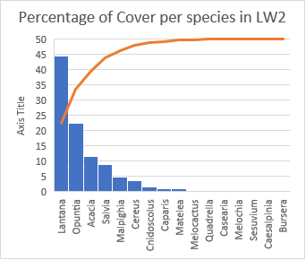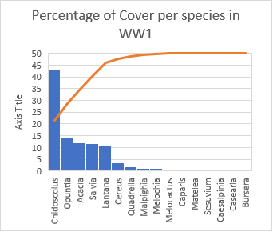****

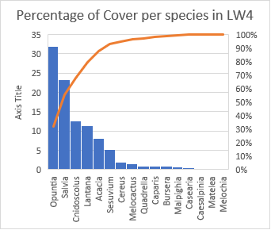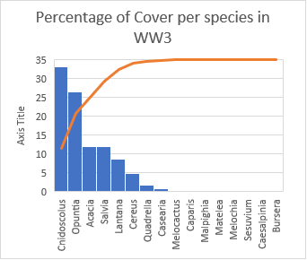

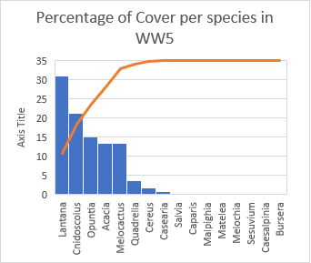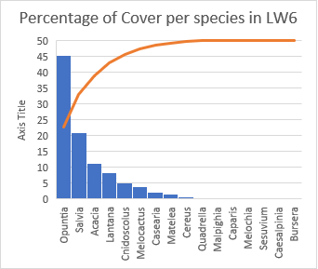

Figure 6 a, b, c, d, e, f - Graphs containing the distribution of each species per slope, in percentages of the total slope population. From left to right, top to bottom: windward 1 (a), leeward 2 (b), windward 3 (c), leeward 4 (d), windward 5 (e) and leeward 6 (f). The graphs are organized by widn strength, with a and b representing the slopes at lowest strength, c and d representing the slopes at medium strength and, e and f, representing the slopes at highest wind strength.

**Discussion**

These results provide insights into how wind shapes and influences plant communities in Aruba. There were no significant interaction effects between wind exposure and wind strength. Thus these two variables have independent effects on each dependent variable. Visually, there is a clear difference between leeward and windward slopes. Not only is the vegetation taller on leeward slopes, reaching way above 4 meters for most trees, but it is also densely packed. On the other hand, windward slopes are patchy, with large barren areas between vegetation clumps. Vegetation itself tends to be short, with most below 1.5 meters. Even cacti, which can reach 7 meters on leeward slopes, barely seemed to reach 2 meters on the windward slopes.

Figure a, b - Photos representative of windward slopes, where deformed vegetation can be seen (a), and also the patchiness cover and distribution of deformed and shortened plants (b). More images can be found in Appendix 4, including photos of leeward vegetation cover. Left (a), right (b).

Regarding species distribution, the results in table 1 show some differences in which species were found on leeward versus windward slopes. The five species only found in leeward areas seem to indicate that they prefer the conditions present on these slopes, which could be related to wind exposure. It does not necessarily mean that these species cannot survive under wind exposure, as it is likely that they can also be found on windward slopes (considering the small sampled area, this does not represent the whole park). Still, this distribution could be due to the higher plant density in leeward areas, as it could provide better shelter and thus better conditions for these sensitive species against environmental pressures. It is important to note that these five species correspond to tree species. This fits with the idea that tall species richness is negatively affected by wind exposure and thus lower than short richness (Zheng et al., 2021), which can be seen by the relatively equal number of shrub species between leeward and windward slopes. If this is the case, this distribution could be a secondary effect of wind. Still, the presented data does not allow for conclusive statements regarding these differences, and these assumptions are thus speculative.

Another noteworthy result regarding species distribution was the differences seen in the presence of trees and shrubs species. Figure 5 demonstrates a higher number of tree species in leeward compared to windward. It also shows a decreasing trend of tree species as wind strength increases. Although this trend is not statistically significant, it indicates that wind affects tree species more than shrub species. Shrub species, having a somewhat equal number between slopes, seem less affected by wind. This ties back to the earlier idea that tall species richness is more affected by wind than short species richness (Zheng et al., 2021). It is still noticeable that for shrub species, the highest wind strength also was accompanied by a much lower number of species in windward areas, which also points to shorter trees still being affected by wind, even if less than taller species.

Looking at species dominance within a slope, Figure 6 shows the dominant species found in each of the 6 slopes. These results indicate that different species dominate depending on wind exposure. Most of the population (68%) corresponded to 3 species on windward slopes, mainly SP3, SP11 and SP6. These species, which correspond to shrub species and a cacti species, seem better adapted than the rest as they are more abundant. This could also be due to the reduced competition from other species, as the land is more barren and vegetation is less dense. For the leeward slopes, the majority of the population (71%) corresponded to 3 species, mainly SP3, SP5 and SP6. These shrubs and cacti species seemed better adapted to leeward slopes as they are more abundant. SP3 and SP6 did equally well on leeward and windward and thus show that these two species are well adapted to the environment of the Park. Meanwhile, SP11 and SP5 seem better adapted to windward and leeward, respectively, which shows that some species are adapted to specific conditions within the park. In windward slopes, tree and shrub species have similar sizes (seen in appendix 4) and thus similar cover area. On the other hand, on leeward slopes, tree species present a much larger size, especially in height (visually seen in appendix 4), which could represent a higher productivity and service provision compared to much smaller shrub species.

With this in mind, it is important to note that, even though tree species were not abundant in numbers, they most likely produce most of the organic matter, and provide their services in larger quantities than the more numerous shrub species. For example, on leeward slopes, *Acacia* trees are taller than in windward slopes, and thus one of its services, nitrogen deposition, is likely done in higher quantities in leeward slopes.

It was expected that wind has a negative effect on biodiversity and overall species richness, and a negative impact on trait redundancy and diversity, with the wind causing higher plant mortality, accompanied by species extinction, and thus shaping the plant community in windward areas when compared to leeward areas. With this in mind, some results nicely fit these ideas, while some do not.

Plant density, and thus plant population (same trend as plant density), and species richness seem to follow this hypothesis. These variables present significant differences between wind exposures, with generally higher values for leeward slopes than windward slopes. This aligns with the idea that wind creates adverse conditions for the development and survival of plants, either directly, through direct damaging and deformation of growing trees, or indirectly through causing alterations to soil conditions, such as reduced nutrient availability and humidity or increased salt content in the topsoil. This damage then results in increased plant mortality, which reflects in lowered plant cover/density, lowered population and possibly reduced species richness in exposed slopes. This is visible in appendix 4, where an image of the coast in Aruba shows minimal vegetation cover.

The biodiversity indexes both present unexpected results. Biodiversity seems to be only affected by the strength of the wind, as more coastal areas present a lowered biodiversity compared to more inland areas. Meanwhile, indirect wind exposure (in leeward areas) does not affect biodiversity differently from direct wind exposure (seen in windward areas). Biodiversity was also generally higher in windward slopes compared to leeward slopes. This contradicts the hypothesis and the idea that increased wind mortality of plants would reduce the number of species and plant individuals present and thus decrease biodiversity. It is important to note that biodiversity values are affected by the number of species occupying a specific area and the population sizes of said species. Thus, there are fewer species in windward areas, with lower populations, occupying the same amount of space as in the leeward areas (space here is defined as the sampled area). This translates into higher biodiversity compared to leeward slopes, where there are almost double the plant population with a relatively slightly higher number of species.

There is no clear or significant difference between exposure or wind strength regarding functional diversity and trait redundancy. The existence of various unique traits does not seem dependent on the wind. This was not expected, as following the hypothesis, leeward areas would have a higher number of species (which is indeed the case) and thus would present a larger variety of functional traits. This could be due to the conditions in Aruba being highly selective, and therefore the species present containing similar characteristics and, thus, similar services are provided.

It can also be concluded that plant density and population size are more sensitive to wind than biodiversity or functional diversity. This also reflects on the stability of the ecosystem. Recalling that ecosystem stability is dependent on biodiversity and resilience (through service provision), the fact that biodiversity and functional diversity (and thus service provision) are less sensitive to wind pressures means that they are more likely to remain the same throughout time. Still, the sensitivity of plant density and population, although not directly affecting the stability of the ecosystem, if extreme, can lead to extinction which then affects the stability (thus a possible indirect effect). Such destabilisation could result from increased average wind speed, due mainly to climate change, which can further pressure these plant populations.

Interestingly, a trend arose from multiple data comparisons. Quadrants and the respective slopes with medium wind strength presented the highest values for most dependent variables, creating a curious "semi-circular" trend. This can be seen in the boxplots from figures 2, 3 (windward), 4, 5b and 16b, where it is visible that medium wind strength has the highest values, with the lowest and highest wind strengths having lower values. This trend goes against the hypothesis, as according to it, it would be expected to see a linear change in values along the 3 wind strengths. This trend could thus be from an extreme case for slopes in wind strenght 1 or for slopes in wind strength 2 that presents abnormally higher or lower values.

An important fact to consider concerning the productivity of the windward areas is that these plants and trees are severely altered. As mentioned, the constant wind pressures have shaped these trees into smaller shrub-shaped plants that rarely reach more than 1 meter tall (which even has led to the labelling of tree/shrub to most tree species present in Aruba). Therefore, when compared to leeward slopes, where these trees reach 3 to 4 meters, it can be expected that productivity will most likely be higher on leeward sides compared to windward sides. Thus, higher biodiversity or similar functional diversity does not necessarily reflect high productivity or high provision of ecosystem services, as these might be compromised by the physical deformations.

**Limitations and Future Research**

This research presents some limitations that need to be mentioned. Firstly, the small sample size reflects in the area not being as well represented as expected. This can alter the results obtained, where unexpected or strange results were obtained and do not align with the hypothesis. For example, one such result corresponds to the semi-circular trend already mentioned, which could be due to one of the slopes being an extreme case/outlier. Thus a larger sample would be required to confirm or correct this trend. Another set of results that could present different trends in a larger sample size are trait redundancy and functional diversity, which can show a more representative view.

The way traits were defined is also a limitation to the trait redundancy and functional diversity results. The lack of an accurate measure of each trait limits how representative these indexes are of the different slopes, as these were defined using average specie values.

Another issue that complicated the data collection was the difficulty accessing the randomly selected quadrants. Due to this issue, some quadrants had to be shifted to accommodate easier access, mainly on the windward slopes. Unfortunately, this altered the randomness factor that was present with the quadrant selections. Thus, to compensate for this, the corner markings of the shifted quadrants were randomly set, thus reducing the bias that may occur with the shifting of the quadrants.

Regarding future research, some more directions could be explored based on these results. First, it would be beneficial to look at a broader range of areas in the National Park to see if this trend is present in those other areas as well. This, with a larger sample size, could present more conclusive and representative data and help better understand how wind shapes plant communities. Second, this research focused only on tree, shrub and cacti species. Thus the inclusion of the seasonal grass could provide insight into if plant community composition is shifting from a forest-based landscape to grassland and if this shift could be attributed to wind. This is possible considering that windward areas, which possess more extensive areas of barren soil, contain a much higher presence of these seasonal grass species. Third, by taking measurements of each trait in windward and leeward areas for each species, a more representative and complete view of trait redundancy and functional diversity can be obtained, providing more evident results on the matter of resilience and service provision. Fourth, future research is also needed to understand how the distortion of the tree's shape affects its ability to provide its corresponding ecosystem services. This research could consist of sampling a wider area, accompanied by the measuring of chosen traits on each sampled area, instead of using average values. This could give a much better understanding of how the altered physical form of windward plants influences the provision of corresponding services while providing a wider, more representative results of the whole National Park.

Fifth, there is another direction in which future research could take. While taking samples in the field, some observations piqued my interest. In multiple locations, small tree saplings were seen growing in the leeward side of large cacti (*Cereus repandus*), especially in valley areas where the wind funnels through or on slopes with sideway wind (slopes facing NW and SE). It would then be interesting to analyse how cacti species could be creating a mutualistic or commensalistic relationship with growing native tree saplings. Such a relationship provides some wind sheltering to the small sapling. However, it remains to be understood how, if at all, does the cacti species benefit. It could even be possible that the cacti species are suffering from such relation, as the sapling could be competing for soil water and nutrients. Such research could give insights into how saplings survive in such windy conditions. This information could then be used to define strategies for reforestation efforts in windy areas.

Finally, it is important to refer to this research's contributions, both to the scientific community and to Aruba itself. These results provide a better understanding of how constant wind pressures affect and shape plant communities in semi-arid environments in Aruba. It also contributes to understanding how wind exposure and strength affect biodiversity and the resilience of an ecosystem. This information can potentially be helpful to stakeholders in Aruba, where multiple restoration and conservation efforts are active. Mimicking how nature develops and plants adapt to these conditions can provide a higher success rate for reforestation efforts, such as Balanta Y Planta. By defining practices that correctly support planted saplings and providing them with the needed conditions for survival, reforestation in windward areas could become possible to diversify and restore this altered ecosystem. The ultimate goal of supporting restoration projects also pushes for the Sustainable Development Goal 15, Life on Land. This Goal aims at *"Protect, restore and promote sustainable use of terrestrial ecosystems, sustainably manage forests, combat desertification, and half and reverse land degradation and halt biodiversity loss"* (*Goal 15 | Department of Economic and Social Affairs*, n.d.). This research fits into this goal by providing a better understanding of how biodiversity and resilience can be affected by a disturbance, wind in particular, and thus can assist restoration and management efforts that aim to maintain and increase stability. Furthermore, it also ties to theories regarding ecosystem stability and resilience, which, although already widely accepted, provide further support as some results align with these ideas and theories.

**Conclusion**

Based on the presented literature review and the results from the research project, it was shown that long-term, constant wind has a significant role in shaping plant communities differently than the effect of shorter-term, stronger winds. The various ways of wind damage can push vegetation to its limits, which leads to increased plant death when surpassed. This increased mortality slowly increases the presence of barren soil that becomes hard to fill as plant saplings struggle to settle these areas due to the constant wind pressure. The ones that manage to settle develop a deformed shape that, at first, seems to be a detriment to the ecosystem but could potentially present higher resistance to stronger winds that might become more common with climate change. This is especially true considering that windward plants are already shaped in this presumably more wind-flow efficient way. In contrast, leeward plants do not have such adaptation and could thus be more damaged with increased wind strength or change in wind direction. Indeed windward slopes plant communities seem more barren, with plant density being lower on all windward slopes and species richness also presenting lower values when compared to leeward slopes. Meanwhile, biodiversity does not seem as much affected by wind, with values being relatively similar between wind exposures, except for the slopes at the strongest wind strength. In these slopes, variation between wind exposures is more prominent and thus shows again that stronger winds have more significant effects on plant community. Thus, even with plant density and richness being more sensitive to wind, biodiversity presents higher resistance to it and thus is a variable that can withstand wind disturbances better. Regarding trait redundancy and functional diversity, which both represent the ecosystem’s ability to provide services under present ecosystem conditions and future conditions, these seem not to be affected by wind, as both windward and leeward presented similar values. Still, considering that plants undergo extreme deformation in windward slopes, it is likely that services provided by these individuals are compromised and thus not provided to the same extent as those found in leeward areas.

It is impossible to predict which slope, in fact, presents higher stability. Even though windward presents higher biodiversity, leeward slopes have a higher species richness and thus possibly provide more services and could be equally stable. This shows the difficulties in measuring ecosystem stability as both these slopes have adaptations and conditions that provide them with stability. Thus, only when under new disturbances is it possible to understand which side is more resistant. The species present in Aruba have developed in these windy conditions, creating adaptations that ease their survival. These adaptations could also prove helpful under stronger windy conditions, such as that of hurricanes, and thus these species possibly have a good chance of surviving what could come in the future.

Nonetheless, based on what can be concluded, wind appears to have a negative effect on plant community, as it negatively affects plant population and its community structure. Not only that, but it also alters soil conditions, increases the presence of barren soil, and induces plant deformation, which can all affect the provision of essential ecosystem services and the ability of new individuals to establish themselves and survive these conditions.

This small research project provides a steppingstone into further, more complete research, which could give a much better understanding of how constant, long term wind pressures affect plant communities and how these communities adapt and survive these conditions. In addition, this research has provided a better understanding of wind-shaped plant community. This is important to the fields of ecology and environmental studies in which most literature seemed focused on short term, strong wind disturbances, such as storms and tornadoes. These disturbances are indeed important and devastating but considering that Aruba is outside of the tornado belt, understanding the pressures of constant wind, is important for the understanding of how this ecosystem survived and evolved, even after human destruction, and how resilient it could be to stronger disturbances that might occur, especially under and increasing pressure from climate change.

**References**

*Aruba National Park Foundation*. (n.d.). Retrieved 19 March 2022, from http://www.arubanationalpark.org/main/

Bricca, A., Carranza, M. L., Varricchione, M., Cutini, M., & Stanisci, A. (2021). Exploring Plant Functional Diversity and Redundancy of Mediterranean High-Mountain Habitats in the Apennines. *Diversity*, *13*(10), 466. https://doi.org/10.3390/d13100466

Brockerhoff, E. G., Barbaro, L., Castagneyrol, B., Forrester, D. I., Gardiner, B., Ramon Gonzalez-Olabarria, J., Lyver, P. O., Meurisse, N., Oxbrough, A., Taki, H., Thompson, I. D., van der Plas, F., & Jactel, H. (2017). Forest biodiversity, ecosystem functioning and the provision of ecosystem services. *Biodiversity and Conservation*, *26*(13), 3005–3035. https://doi.org/10.1007/s10531-017-1453-2

Cao, S., Tian, T., Chen, L., Dong, X., Yu, X., & Wang, G. (2010). Damage Caused to the Environment by Reforestation Policies in Arid and Semi-Arid Areas of China. *AMBIO*, *39*(4), 279–283. https://doi.org/10.1007/s13280-010-0038-z

Cardinale, B. J., Duffy, J. E., Gonzalez, A., Hooper, D. U., Perrings, C., Venail, P., Narwani, A., Mace, G. M., Tilman, D., Wardle, D. A., Kinzig, A. P., Daily, G. C., Loreau, M., Grace, J. B., Larigauderie, A., Srivastava, D. S., & Naeem, S. (2012). Biodiversity loss and its impact on humanity. *Nature*, *486*(7401), 59–67. https://doi.org/10.1038/nature11148

Chen, Y., Kolokolnikov, T., Tzou, J., & Gai, C. (2015). Patterned vegetation, tipping points, and the rate of climate change. *European Journal of Applied Mathematics*, *26*(6), 945–958. https://doi.org/10.1017/S0956792515000261

Cortina, J., Amat, B., Castillo, V., Fuentes, D., Maestre, F. T., Padilla, F. M., & Rojo, L. (2011). The restoration of vegetation cover in the semi-arid Iberian southeast. *Journal of Arid Environments*, *75*(12), 1377–1384. https://doi.org/10.1016/j.jaridenv.2011.08.003

Csaba, J. (2019, September 13). *NYDF 2019 Progress Report: Protecting and Restoring Forests* [Text]. CLIMATE FOCUS. https://www.climatefocus.com/publications/nydf-2019-progress-report-protecting-and-restoring-forests

Davarzani, H., Smits, K., Tolene, R. M., & Illangasekare, T. (2014). Study of the effect of wind speed on evaporation from soil through integrated modeling of the atmospheric boundary layer and shallow subsurface. *Water Resources Research*, *50*(1), 661–680. https://doi.org/10.1002/2013WR013952

de Bello, F., Lepš, J., Lavorel, S., & Moretti, M. (2007). Importance of species abundance for assessment of trait composition: An example based on pollinator communities. *Community Ecology*, *8*(2), 163–170. https://doi.org/10.1556/ComEc.8.2007.2.3

Díaz, S., Purvis, A., Cornelissen, J. H. C., Mace, G. M., Donoghue, M. J., Ewers, R. M., Jordano, P., & Pearse, W. D. (2013). Functional traits, the phylogeny of function, and ecosystem service vulnerability. *Ecology and Evolution*, *3*(9), 2958–2975. https://doi.org/10.1002/ece3.601

D’Odorico, P., Bhattachan, A., Davis, K. F., Ravi, S., & Runyan, C. W. (2013). Global desertification: Drivers and feedbacks. *Advances in Water Resources*, *51*, 326–344. https://doi.org/10.1016/j.advwatres.2012.01.013

Donohue, I., Hillebrand, H., Montoya, J. M., Petchey, O. L., Pimm, S. L., Fowler, M. S., Healy, K., Jackson, A. L., Lurgi, M., McClean, D., O’Connor, N. E., O’Gorman, E. J., & Yang, Q. (2016). Navigating the complexity of ecological stability. *Ecology Letters*, *19*(9), 1172–1185. https://doi.org/10.1111/ele.12648

Douglas, D. J. T., Groom, J. D., & Scridel, D. (2020). Benefits and costs of native reforestation for breeding songbirds in temperate uplands. *Biological Conservation*, *244*, 108483. https://doi.org/10.1016/j.biocon.2020.108483

Du, J., & Hesp, P. A. (2020). Salt Spray Distribution and Its Impact on Vegetation Zonation on Coastal Dunes: A Review. *Estuaries and Coasts*, *43*(8), 1885–1907. https://doi.org/10.1007/s12237-020-00820-2

Duffy, J. E., Godwin, C. M., & Cardinale, B. J. (2017). Biodiversity effects in the wild are common and as strong as key drivers of productivity. *Nature*, *549*(7671), 261–264. https://doi.org/10.1038/nature23886

Environment, U. N. (2020, April 7). *UNEP Annual Report: Letter from the Executive Director - 2019 in review*. UNEP - UN Environment Programme. https://www.unenvironment.org/annualreport/2019/index.php

Evans, M. C. (2018). Effective incentives for reforestation: Lessons from Australia’s carbon farming policies. *Current Opinion in Environmental Sustainability*, *32*, 38–45. https://doi.org/10.1016/j.cosust.2018.04.002

Gardiner, B. (2021). Wind damage to forests and trees: A review with an emphasis on planted and managed forests. *Journal of Forest Research*, *26*(4), 248–266. https://doi.org/10.1080/13416979.2021.1940665

Gardiner, B., Berry, P., & Moulia, B. (2016). Review: Wind impacts on plant growth, mechanics and damage. *Plant Science*, *245*, 94–118. https://doi.org/10.1016/j.plantsci.2016.01.006

*Goal 15 | Department of Economic and Social Affairs*. (n.d.). Retrieved 7 May 2022, from https://sdgs.un.org/goals/goal15

Hallinger, M., Johansson, V., Schmalholz, M., Sjoberg, S., & Ranius, T. (2016). Factors driving tree mortality in retained forest fragments. *Forest Ecology and Management*, *368*, 163–172. https://doi.org/10.1016/j.foreco.2016.03.023

Irausquin, L. (2019). *Climatological summary 2019*.

Jiao, S., Chen, W., Wang, J., Du, N., Li, Q., & Wei, G. (2018). Soil microbiomes with distinct assemblies through vertical soil profiles drive the cycling of multiple nutrients in reforested ecosystems. *Microbiome*, *6*(1), 146. https://doi.org/10.1186/s40168-018-0526-0

Kéfi, S., Domínguez-García, V., Donohue, I., Fontaine, C., Thébault, E., & Dakos, V. (2019). Advancing our understanding of ecological stability. *Ecology Letters*, *22*(9), 1349–1356. https://doi.org/10.1111/ele.13340

Keller, A. A., & Fox, J. (2019). Giving credit to reforestation for water quality benefits. *PLOS ONE*, *14*(6), e0217756. https://doi.org/10.1371/journal.pone.0217756

Lenton, T. M. (2013). Environmental Tipping Points. *Annual Review of Environment and Resources*, *38*(1), 1–29. https://doi.org/10.1146/annurev-environ-102511-084654

Lepš, J., Bello, F., Lavorel, S., & Berman, S. (2006). Quantifying and interpreting functional diversity of natural communities: Practical considerations matter. *Preslia*, *78*, 481–501.

Li, X., Stainback, A., Barton, C., & Yang, J. (2018). VALUING THE ENVIRONMENTAL BENEFITS FROM REFORESTATION ON RECLAIMED SURFACE MINES IN APPALACHIA. *Journal American Society of Mining and Reclamation*, *7*(1), 29. https://doi.org/10.21000/JASMR18010001

Liu, X., Yang, T., Wang, Q., Huang, F., & Li, L. (2018). Dynamics of soil carbon and nitrogen stocks after afforestation in arid and semi-arid regions: A meta-analysis. *Science of The Total Environment*, *618*, 1658–1664. https://doi.org/10.1016/j.scitotenv.2017.10.009

Loreau, M., Barbier, M., Filotas, E., Gravel, D., Isbell, F., Miller, S. J., Montoya, J. M., Wang, S., Aussenac, R., Germain, R., Thompson, P. L., Gonzalez, A., & Dee, L. E. (2021). Biodiversity as insurance: From concept to measurement and application. *Biological Reviews*, *96*(5), 2333–2354. https://doi.org/10.1111/brv.12756

Lundquist, J. E., Camp, A. E., Tyrrell, M. L., Seybold, S. J., Cannon, P., & Lodge, D. J. (2011). Earth, wind, and fire: Abiotic factors and the impacts of global environmental change on forest health. In J. D. Castello & S. A. Teale (Eds.), *Forest Health: An Integrated Perspective* (pp. 195–244). Cambridge University Press. https://doi.org/10.1017/CBO9780511974977.008

Négyesi, G., Szabó, S., Buró, B., Mohammed, S., Lóki, J., Rajkai, K., & Holb, I. J. (2021). Influence of Soil Moisture and Crust Formation on Soil Evaporation Rate: A Wind Tunnel Experiment in Hungary. *Agronomy*, *11*(5), 935. https://doi.org/10.3390/agronomy11050935

Oosterhuis, H. (2016). *Landscape-ecological survey of Arikok National Park, Aruba Restoring vegetation of a dry tropical island* [Soil Physics and Land Management Group, Wageningen University]. https://www.dcbd.nl/sites/default/files/documents/Landscape-vegetation%20survey%20Arikok%20NP%20Oosterhuis%20Henk%20Jan.pdf

Proosdij, A. (2012). *Arnoldo’s Zakflora: Wat in het Wild Groeit en Bloeit op Aruba, Bonaire en Curaçao* (4th ed.). Walburg Pers.

Rohatyn, S., Rotenberg, E., Yakir, D., & Carmel, Y. (2021). Assessing climatic benefits from forestation potential in semi-arid lands. *Environmental Research Letters*, *16*(10), 104039. https://doi.org/10.1088/1748-9326/ac29e9

Rotenberg, E., & Yakir, D. (2010). Contribution of Semi-Arid Forests to the Climate System. *Science*, *327*(5964), 451–454. https://doi.org/10.1126/science.1179998

Schelhass, M., Kramer, K., Werf, D., & Wijdeven, S. (2007). *Introducing tree interactions in wind damage simulation—ScienceDirect*. https://www.sciencedirect.com/science/article/pii/S0304380007002578?via%3Dihub

Schindler, D. (2012). *Wind effects on trees | SpringerLink*. https://link-springer-com.proxy.library.uu.nl/article/10.1007/s10342-011-0582-5

Seidl, R., Rammer, W., & Blennow, K. (2014). Simulating wind disturbance impacts on forest landscapes: Tree-level heterogeneity matters. *Environmental Modelling & Software*, *51*, 1–11. https://doi.org/10.1016/j.envsoft.2013.09.018

Spellerberg, I., & Fedor, P. (2003). A tribute to Claude Shannon (1916–2001) and a plea for more rigorous use of species richness, species diversity and the ‘Shannon–Wiener’ Index. *Global Ecology & Biogeography*, *12*, 177–179. https://doi.org/10.1046/j.1466-822X.2003.00015.x

Thompson, I., Mackey, B., McNulty, S., & Mosseler, A. (2009). Forest Resilience, Biodiversity, and Climate Change. *Secretariat of the Convention on Biological Diversity, Montreal. Technical Series No. 43. 1-67.*, *43*, 1–67.

Tjalfe G. Poulsen, Weiling Cai, & Ankit Garg. (2020). Water evaporation from cracked soil under moist conditions as related to crack properties and near‐surface wind speed. *European Journal of Soil Science*, *71*(4), 627–640. https://doi.org/10.1111/ejss.12926

*Trees For Aruba | Ban Lanta Y Planta!* (n.d.). Retrieved 15 December 2021, from https://treesforaruba.com/

Van de Peer, T., Verheyen, K., Baeten, L., Ponette, Q., & Muys, B. (2016). Biodiversity as insurance for sapling survival in experimental tree plantations. *Journal of Applied Ecology*, *53*(6), 1777–1786. https://doi.org/10.1111/1365-2664.12721

van Nooren, K. (2008). *Human Impact on the Vegetation of Aruba*. 7.

Veerbeek, B. (2016). *The influence of goats on soil erosion and vegetation in Arikok National Park, Aruba | Dutch Caribbean Biodiversity Database*. https://www.dcbd.nl/document/influence-goats-soil-erosion-and-vegetation-arikok-national-park-aruba

White, R. R., Milholland, B., de Bruin, A., Curran, S., Laberge, R.-M., van Steeg, H., Campisi, J., Maslov, A. Y., & Vijg, J. (2015). Controlled induction of DNA double-strand breaks in the mouse liver induces features of tissue ageing. *Nature Communications*, *6*(1), 6790. https://doi.org/10.1038/ncomms7790

Yachi, S., & Loreau, M. (1999). Biodiversity and ecosystem productivity in a fluctuating environment: The insurance hypothesis. *Proceedings of the National Academy of Sciences*, *96*(4), 1463–1468. https://doi.org/10.1073/pnas.96.4.1463

Zheng, M., Song, J., Ru, J., Zhou, Z., Zhong, M., Jiang, L., Hui, D., & Wan, S. (2021). Effects of Grazing, Wind Erosion, and Dust Deposition on Plant Community Composition and Structure in a Temperate Steppe. *Ecosystems*, *24*(2), 403–420. Scopus. https://doi.org/10.1007/s10021-020-00526-3

**Appendix 1 – Definition of traits and corresponding ecosystem services**

**Traits and corresponding services:**

Nitrogen fixating ability – defined as a binomial variable ( 0 = no; 1 = yes). Represents the service of nutrient cycling and N fixation in soil

Leaf thickness – Defined as 0 = none; 0.5 = thin; 1 = thick. Related to salinity tolerance, as the higher the leaf thickness, the more water present and thus the lower the salt concentration. Represents the service water storing and carbon storing

Water storing tissue – Defined as 0 = no tissue, 1 = yes. Related to salnity tolerance, the presence of water reduces salt concentration within the plant's tissue. Represents water availability service.

Stem thickness– Defined as 0 = thin; 0.5 = medium; 1 = thick. Related to wind stress tolerance and tree stability, as the thicker the stem the stronger the support of the tree, thus enduring against winds that can cause stem breakage. Also corresponds to carbon storing and wood production service (at larger sizes)

Plant height – Defined as 0 = short (shorter than 0.5m); 0.5 = Medium (between 0.5m and 3 m); 1 = tall (higher than 3 m). Related to wind resistance, as taller trees undergo higher wind pressures and are thus more likely to suffer damage from it. Represents the service of carbon storage

Root deepness/size – Defined as 0 = shallow; 1 = deep. Related to wind stress tolerance, as the deeper the roots, the more stable the plant is, and thus less likely to undergo uprooting by wind. Also influences soil erosion, as roots present in topsoil reduce soil aprtice movement due to wind or water. Represents services of efficient nutrient use, stability, water retention and soil stability.

Photosynthesis type – Defined as 0 = C3; 0.5 = C4; 1 = CAM. Represents air filtration service and resource use efficiency

Table - Table containing the defined traits for each species, based on the description above, and based on average values found in databases or based on descrption of these species in bools about Aruba's flora

**Appendix 2 – Bar Charts of Values for all Dependent Variables per Quadrants**

Shannon-Wiener Biodiversity Index

Figure a, b - Graphs containig the values for Shannon Biodiversity Index for all sampled quadrants, and by slope. Top (a) and bottom (b).

Simpson Biodiversity Index

Figure a, b - Graphs containig the values for the Simpson Biodiversity Index, per quadrant (a) and per slope (b). Top (a) and bottom (b)

Population and plant community

Figure a, b - Graphs with the values for population count, per quadrant (a) and per slope (b).

Number of species and community composition

Species list:

Sp1: *Acacia tortuosa - tree*

Sp2: *Cereus repandus - cacti*

Sp3: *Opuntia caracassana - cacti*

Sp4: *Melocactus macracantho - cacti*

Sp5*: Salvia officinalis - shrub*

Sp6: *Lantana camara - shrub*

Sp7:*Quadrella odoratissima - tree*

Sp8: *Caparis liniaris - tree*

Sp9: *Malpighia emarginata - tree*

Sp10: *Matelea rubra - tree*

Sp11: *Cnidoscolus urens - shrub*

Sp12: *Melochia tomentosa - shrub*

Sp13: *Sesuvium portulacastrum - tree*

Sp14: *Caesalpinia coriária - tree*

Sp15: *Casearia tremula - tree*

Sp16: *Bursera karsteniana - tree*

Figure a, b - Graphs containing the number of species per quadrant (a) and per slope (b). Top (a) and bottom (b)

Plant density

Figure a, b - Graphs containing the plant density values per quadrant (a) and per slope (b). Top (a) and bottom (b)

Functional Diversity index

Figure a, b -Graphs containing the functional diversity values per quadrant (a) and per slope (b). Top (a) and bottom (b).

Trait redundancy index

Figure a, b - Graphs containing the values for trait redundancy per quadrant (a) and per slope (b). Top (a) and bottom (b)

**Appendix 3 – Additional Statistical Output**

**Test for Normality**

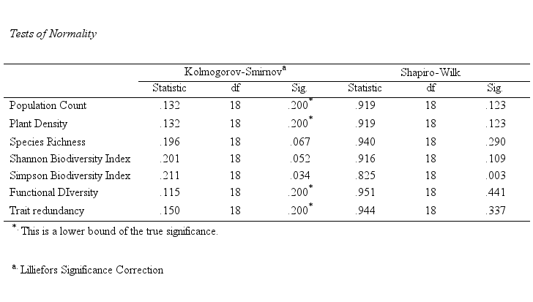

Figure 15 - Output of the normality test.

The normality test shows that only Simpson Biodiversity Index was found to be significant, and thus not presenting a normal distribution. After attempts at transforming this variable were not successful, this variable was not considered in the discussions and conclusions, especially since Shannon Index and Simpson Index are very similar Index that represent biodiversity measurements.

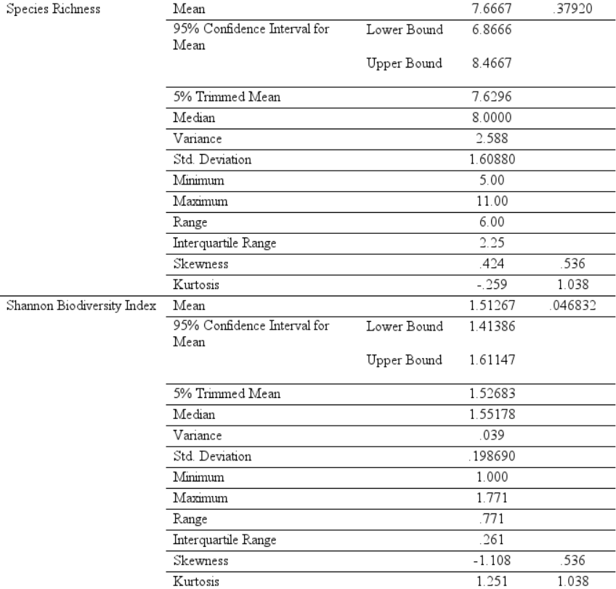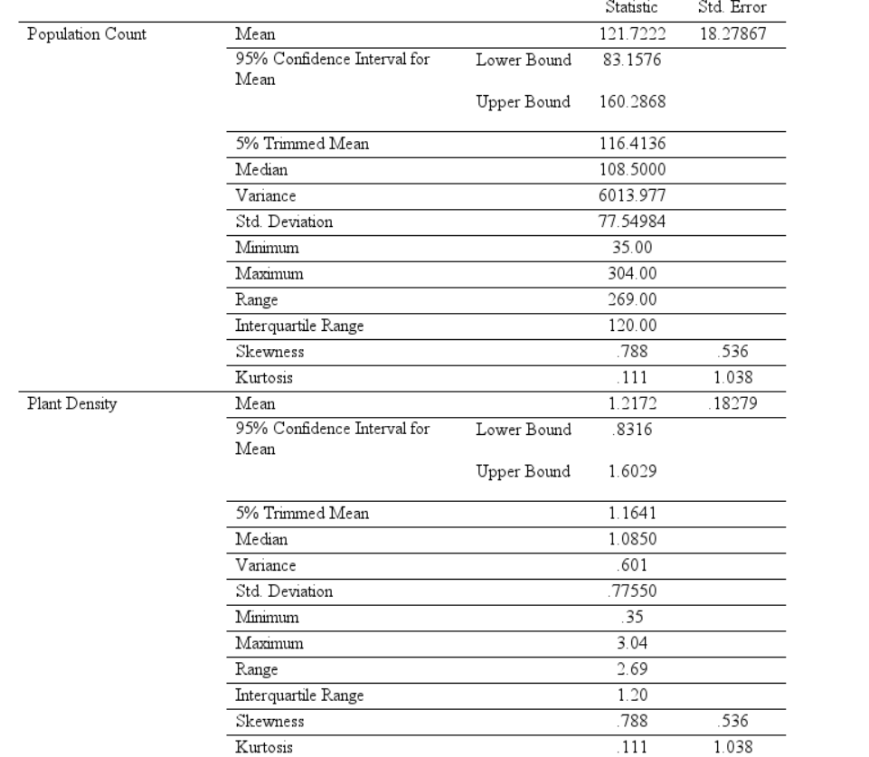**Descriptive Statistics**

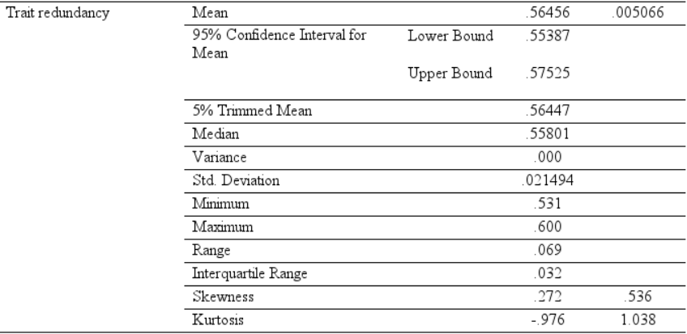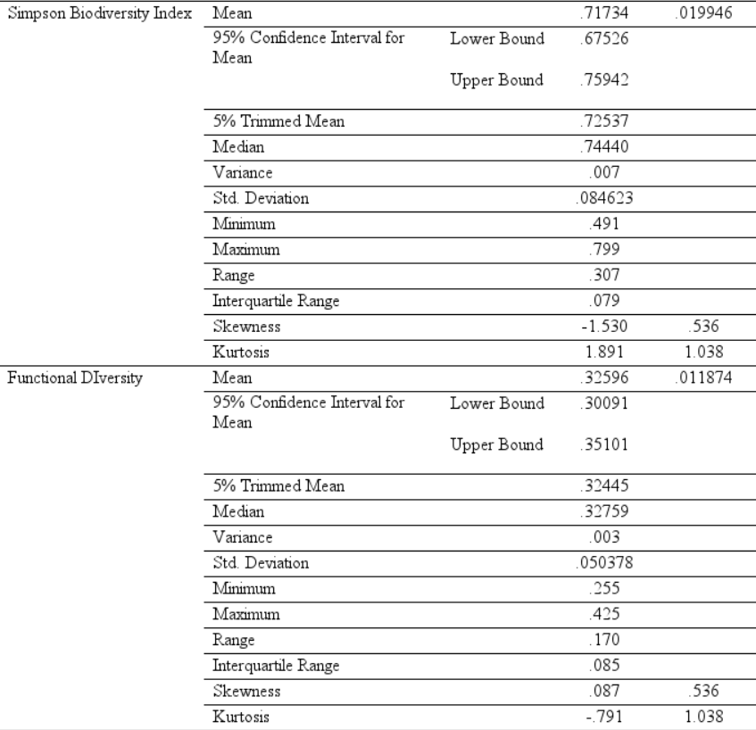

Figure 16 - Output of the descriptive statistics for each dependent variable.

**ANOVA output**

**Functional diversity showed no significant effect for wind exposure or wind strength**

Figure 17 - Factorial ANOVA output for functional diversity.

**Trait Redundancy showed no significant effect for wind exposure or wind strength.**

Figure 18 - Factorial ANOVA output for trait redundancy.

**Plant Density showed only a significant effect for wind exposure (p = 0.03)**

Figure 19 - Factorial ANOVA output for plant density

**Plant population showed only a significant effect for wind exposure (p = 0.03)**

Figure 20 - Factorial ANOVA output for plant population

**Number of Species showed only a significant effect for wind exposure (p = 0.029)**

Figure 21 - Factorial ANOVA output for number of species

**Shannon Index showed only a significant effect for wind strength (p = 0.009)**

Figure 22 - Factorial ANOVA output for Shannon index

**Simpson index showed no significant result for wind exposure or wind strength.**

Figure 23 - Factorial ANOVA output for Simpson index

**Additional ANOVA test output for Plant Density, Species Richness and Shannon Index**

These ANOVA tests were run to understand which of the slope pairs presented significant differences for wind exposure. Shannon Index, presented significant differences at medium wind strength, seen in figure

Figure 24 - ANOVA output for Shannon index identifying with pairs have a significant difference between wind exposures.

Plant Density presented significant difference for wind exposure at largest wind strength (p = 0.001), while showing no significant difference at the other two wind strengths.

Figure 25 - ANOVA output for plant density identifying with pairs have a significant difference between wind exposures.

Species richness presented a significant difference for wind exposure at medium wind strength (p = 0.008), while showing no significance for the other two wind strengths.

Figure 26 - ANOVA output for species richness identifying with pairs have a significant difference between wind exposures.

**Additional boxplots for variables not mentioned in the result section**

Simpson Index

Figure 27 a, b - Boxplot of plant population (a) and Simpson index (b) for their mean values. Left (a) and right (b).

Trait Redundancy Functional Diversity

Figure 28 a, b - Boxplot for Trait redundancy (a) and functional diversity (b). Left (a) and right (b).

**Appendix 4 – Photos of the sites in Aruba**

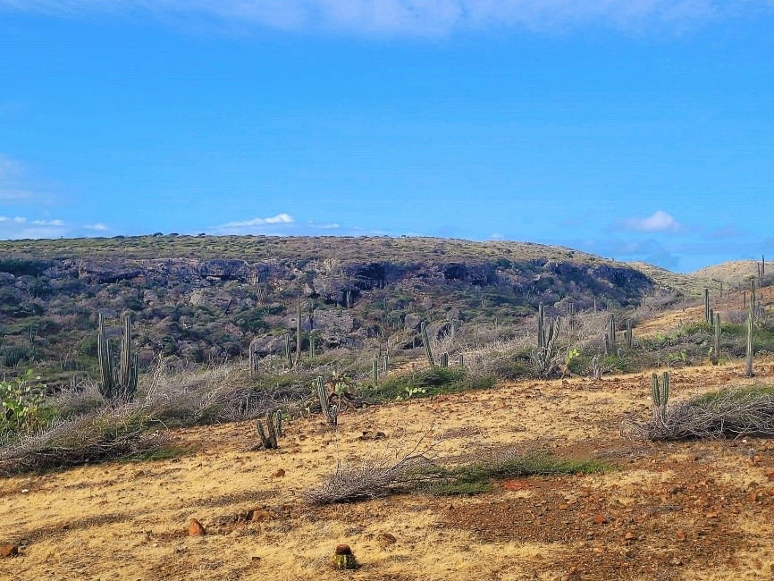Photos of various locations around the Park, which show the different extents of vegetation

Figure 29 a, b, c, d – Pictures of the landscape within Arikok Park. (a) Photo of the hill where windward 1 and leeward 2 were sampled. (b) photo of the area close to where windward 5 and leeward 6 were sampled. (c) photo of the area further inland than the image (a). (d) photo of an area close to the leeward coast of the island (located SW of the sampled area). Top left (a); Top right (b); bottom left (c); bottom right (d).

Figure 30 a, b, c, d – Photos depicting the tree distortion caused by wind (a), (b), as well as the most windward coastal areas of the island (c), (d). Top left (a); top Right (b); center (c); bottom (d). Image a and b retrieved from Veerbeek, 2016. Images c and d retrieved from: <http://wikimapia.org/1883355/Arikok-National-Park>

**Appendix 5 – Population Data (collected) for each quadrant**

Tables containing the collected data values for each quadrant.











