The infauna habitat of invasive seagrass *Halophila stipulacea* on the Dutch Caribbean island of St Eustatius.

 Bas Ottevanger & Cameron Stewart

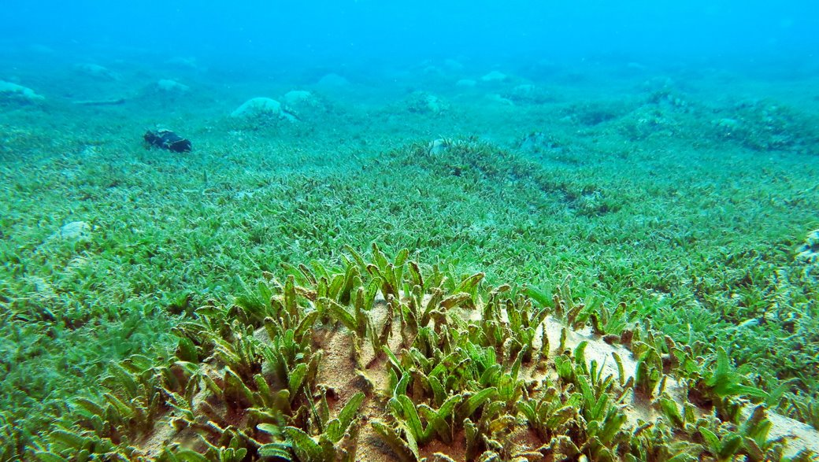

With assistance from:

[](http://www.google.com/url?sa=i&rct=j&q=&esrc=s&source=images&cd=&cad=rja&uact=8&ved=2ahUKEwigoZLN4dDlAhWPbFAKHbw-DdEQjRx6BAgBEAQ&url=/url?sa=i&rct=j&q=&esrc=s&source=images&cd=&ved=&url=https://agrofoodcluster.com/deelnemer/van-hall-larenstein/&psig=AOvVaw2QHQzzEJj7-UVjjxu2gED3&ust=1572963954305547&psig=AOvVaw2QHQzzEJj7-UVjjxu2gED3&ust=1572963954305547)



Status page

Title The infauna habitat of invasive seagrass *H. stipulacea* on the Dutch Caribbean island of St Eustatius.

Address Agora 1, 8934CJ, Leeuwarden

Auteur Bas Ottevanger & Cameron Stewart

Supervising Marlous Heemstra

teacher

Contact Marlous Heemstra & Anna Maitz

Number of pages 26

Version 2.0

Date 28-01-2020

Cover (Koplovitz, 2008)

**Summary**

Since the opening of the 160km long Suez canal on November 17, 1869, it was possible for large ships to navigate between the Mediterranean and the Red Sea. *Halophila stipulacea* has very short roots that can be pulled loose from the soil very easily and it is capable of reproduction by fragmentation. A fragment suspended in the water column can survive for approximately two weeks.When the habitat conditions for *H. stipulacea* are ideal it can resettle and regrow a large seagrass field within months. This way *H. stipulacea* managed to find his way to Flamingo bay, Grenada in 2002. Since then it rapidly spread across the whole Caribbean sea.

This non-native species pose a threat to the native seagrasses found in the Caribbean around the island, as it is fast-growing and tolerant to a greater range of conditions. This change in seagrass composition could lead to significant habitat change and affect the ecosystem around the island. The aim of this report is to identify the species found resident in the *H. stipulacea* beds at key dive sites around the island of St. Eustatius.

To determine the habitat usage 20 samples were collected between 18 and 20m depth at two popular dive sites. With a sample corer, the samples were lifted from the soil and placed in a double zipper bag. In total 390 individual animals were found in the samples. The biomass was measured giving the results that most of the plant structure is on or below the ground surface.

Based on this research, further monitoring of the seagrass beds is needed to find out what new habitat *H. Stipulacea* creates. To give a significant correct answer between the dry biomass and the number of species found / individuals, a statistical analysis is recommended.

**Table of contents**

Background 4

1. Head- and sub-questions 5

1.1 Main questions 5

1.2 Sub questions 5

2. Research methodology 6

2.1 Plan of work and time schedule on Statia 6

2.2 Equipment: 6

2.3 Sample collection 6

2.4 Processing 7

2.5 Advantages and shortcomings 7

3. Results 8

3.1 What species are found in the H. stipulacea beds at key dives sites on St Eustatius? 8

3.2 Biomass results: 9

3.3 Are these species locally native and how are they using the beds: habitat or grazing? 10

3.4 How does this compare with historic data on native seagrass beds? 10

Discussion 11

Conclusion 11

Recommendation 12

Acknowledgements 12

Source reference 13

Appendix 1: Template for data collection 6

Appendix 2: Data results 7

Appendix 3: Discovered species 8

# Background

*Halophila stipulacea* is a tropical, euryhaline marine angiosperm in the family *Hydrocharitaceae*, containing many aquatic plant species. A euryhaline marine angiosperm is a field of grass or flowering plants that live in saline marine environments, which are commonly called seagrass (Den Hartog, 1970). Just like terrestrial grasses, seagrasses also have chloroplasts. However, a significant difference between terrestrial grasses is the absence of stomata, small pores allowing for photosynthetic respiration. One thing that seagrasses have that terrestrial grasses lack, however, is air pockets called lacunae that are located in the veins of leaves which help to keep the leaves upright underwater (Alcocer, 2019).

Since the opening of the 160km long Suez canal on November 17, 1869 (Canal History , 2019), it was possible for large ships to navigate between the Mediterranean and the Red Sea. *H. stipulacea* has very short roots that can be pulled loose from the soil very easily and it is capable of reproduction by fragmentation. A fragment suspended in the water column can survive for approximately two weeks.When the habitat conditions for *H. stipulacea* are ideal it can resettle and regrow a large seagrass field within months. This way, fragments taken up in ballast water of ships can transport *Halophila* across the globe. The advancement in container and cruise ship technologies and industries over recent decades has brought with it bigger and faster vessels able to circumnavigate the globe in just a couple of weeks – spreading fragments as they go. The success of *H. stipulacea* as an invasive in the Caribbean Sea can be attributed to its rapid vegetative expansion (Marbá & Duarte, 1998), habitat flexibility (Coppejans, Beeckman, & Wit, 1992) (Pereg, Lipkin, & Sar, 1994), tolerance of a wide salinity range (Por, 1971) adaptation to high irradiance (Schwarz & Hellblom, 2002), and the ability to grow at depths from the intertidal zone to greater than 50 meter (Beer & Waisel, 1981). Because of this the chance that *H. stipulacea* fragments settle and establish new beds has increased and so the invasive spread across the world has begun. In the Caribbean, *H. stipulacea* was first reported in Flamingo Bay, Grenada in 2002 (Rulz & Ballentine, 2004). In 2007, it was reported in Dominica (Willette & Ambrose, 2009) and has since been widely reported throughout the Caribbean (Willette & Ambrose, 2009) (Debrot, et al., 2012) (Keninon, 2012). Most recently it was reported along the coast of Venezuela (Vera, Collado-Vides, Moreno, & Tussenbroek, 2014).

The ecological consequences of invasive species in marine environments can be severe (Carlton, Thompson, Schemel, & Nichols, 1990) (Boudouresque, Meinesz, Ribera Siguan, & Ballesteros, 1995) (Shiganova, 1998) (Casas, Scrosati, & Piriz, 2004). The loss of biological diversity and the impact on human activities are central concerns with the proliferation of an invasive species. To eradicate invasive *H. stipulacea* from the entire Caribbeanis simply not feasiblebecause a seagrass bed has so many individual plants. Removing them will cause that some individuals will end up in the water column and regrow somewhere else making the problem only worse. This process is also time-consuming and expensive. So the spread of invasive *H. stipulacea* is considered as an event that is happening but how are ecosystems reacting to the invasion? Does *H. stipulacea* create a new habitat with different species living in and around it? The aim of this research will be to get an answer if benthic life differs between native and invasive seagrass resulting in the following main question: Is there a difference in present benthic infauna and epifauna species between the native and invasive seagrass species?

# Head- and sub-questions

## Main questions

The invasive seagrass *Halophila stipulacea* is found spread throughout the Caribbean with beds found around St Eustatius. This non-native species poses a threat to the native seagrasses found around the island, as it is fast-growing and tolerant to a greater range of conditions. Already well established in the area, *H. stipulacea* is becoming a permanent resident of Caribbean waters. However, little research has been done into the habitat that the seagrass beds provide, and what species diversity is seen in the infauna found in the seagrass beds.   
  
The proposed aim of this investigation is to identify the species found resident in the *H. stipulacea* beds at key dive sites around the island. What insights do the species found represent – are locally native species using the seagrass for habitat or grazing? How does this compare to historical data on native seagrass beds?

**What is the state of benthic infauna species of the native and invasive seagrass species on St. Eustatius?**

## Sub questions

* What species are found in the *H. stipulacea* beds at key dives sites on St Eustatius?
* Are these species locally native, or invasive, and how are they using the beds - habitat or grazing?
* How does this compare with historic data on native *Thalassia* seagrass beds?

# Research methodology

To collect our data, dives to the seagrass beds were necessary. In the next three paragraphs, there is an explanation of the equipment that will be used, how the samples will be collected and processed. Data collection and processing was made possible by the Caribbean Netherlands Science Institute (CNSI)

## Plan of work and time schedule on Statia

In a time span of 20 days we visiting St. Eustatius and Saba. To get a clear overview of who is going to do what and when planning has been made (Table 4.1: Planning). The grey boxes refer to the subject that will be conducted on that day. The data collection had to be done as soon as possible so there was enough time to process the samples in the laboratory. The point of the planning is that the time that is reserved for our research will be achieved. The last few days of the excursion will be spent on the island of Saba, as a result, lab time is restricted to time on St Eustatius.

Table 4.1: Planning

## A picture containing indoor, wall, floor, sitting Description automatically generatedEquipment:

* Boat and safety equipment;
* Two skilled divers and equipment;
* Sample bags with a minimum of two zip rows;
* Refrigerator for sample storage;
* Storage bags/jars;
* Field data pages and water-resistant pens;
* Sampling corer;
* Sieves of 0.5-1 mm mesh.

## Sample collection

The literature recommends a hand-held corer for infauna sampling. This is a basic device, constructed from a simple tube with stopper. The corer used (*Figure 4.1*) was constructed from PVC with an internal diameter of 10cm and cores were taken to a depth of roughly 5 cm deep, resulting in a sample volume of ca. 392.7 cm3. To enable easy penetration of the substrate the opening of the corer was bevelled to a sharp edge. Operation of the corer is simple; the tube is lowered slowly to the seabed until contact is made, before slowly pushing into the seabed, with a twisting motion. Slow, deliberate movements reduce silting out and minimize seabed disturbance, but are also essential to avoid compacting the sample. Once fully inserted, a screw end was used to seal the top of the tube and form a seal. Once stoppered, the corer is slowly removed from the sediment and emptied into large 1-gallon, double zipper bags. The bags were then transported back to the boat in a mesh dive bag.

Figure 4.1 Sample corer

Following successful collection of samples were returned to the laboratory and the bags filled with freshwater, before storing and processing according to the literature recommendation (Andrea Raz-Guzman, 2001).

## Processing

Once samples were collected, they were processed in the laboratory. Each sample was sieved on a 0.75mm mesh to remove fine silt and sediment. Recommended mesh sizes for marine benthos are between 0.5 and 1.5 mm. (Holme, 1964). Once enough sediment had been removed via the sieve, the sample was entered into a lab tray with some clean freshwater, which helped with sorting as organic specimens often floated. All animals found were sorted into a petri dish and recorded. From the sorted samples, abundance data will be derived from counts of species using a simple count sheet and recorded as the number of individuals per sample (Appendix 6.1). Data on the seagrass biomass was also recorded, counts of shoots and roots along with weight measurements. From this data, it is possible to estimate the impacts of seagrass density.

## Advantages and shortcomings

The selected sampling method has the advantage of being simple, easily replicable and robust which has established core sampling as the recommended method for quantitative sampling of infauna. One key advantage to core sampling is that every sample has a consistent volume, allowing for measurement in the form of count per unit volume and allowing for easier statistical analysis.

The core sampling method used can result in the capture of epifauna alongside the infauna samples. While these species are of interest when looking at the benthic habitat of *H. stipulacea,* the sampling method selected does not account for motile epibenthic species that are not captured by the core. As such, this does not result in a fully accurate representation of the species diversity found in the epibenthos as many of them can move out of the way of the corer. Without a standard technique for dealing with epibenthic bycatch in the cores, Raz-Guzman recommends simply removing all protruding seagrass pieces from the corer and retain the remainder for further processing (Andrea Raz-Guzman, 2001).

# Results

The sediment core samples were taken from two different dive sites: Double Wreck (DW), and White Wall (WW), (*Figure 5.1*). A total of 20 sediment cores were obtained, 4 from White Wall and 16 from Double Wreck. The samples were collected from sites selected as they were both monospecific beds of *H*. *stipulacea*, and close to reefs which are popular with divers. Samples were taken from both closely reef-associated points, as well as further away from the reef, to ensure a diverse sampling of both the recently invaded sites closer to the reef and the more established beds further away. All samples were collected between 18 and 20m depth.

From the 20 sample cores from the two different dive sites, there were a total of 390 individual animals recorded. These come from a variety of phyla and classes. Most represented were the Echinoderms, Gastropods, and Crustaceans.

Figure 5.1 Map showing the dive sites of White Wall and Double Wreck. White Wall is situated on the edge of the marine reserve and Double Wreck in the bay in front of the harbour.

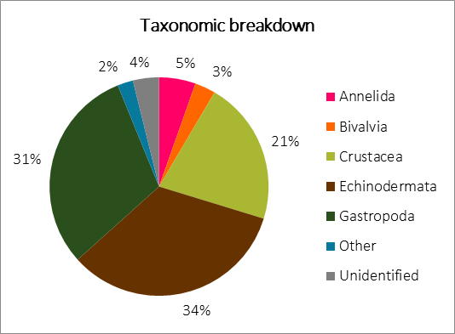

Figure 5.2 Percentage break down of different taxon of identified animals

## What species are found in the H. stipulacea beds at key dives sites on St Eustatius?

Species-level identification of the core samples posed a significant challenge. Due to this, specimens were identified as far as taxonomically possible. The specimens identified represented a variety of animals, with a broad range of habitat use for the *H*. *stipulacea* beds (*Figure 5.2*). Molluscs were highly represented, with both bivalves and gastropods being recorded. The most abundant molluscs were cerith snails, *Cerithium sp.*, which were also observed in high abundance *in-situ* during sample collection. Arthropods were well represented with crustaceans in the form of both round crabs and shrimp. Due to their small size, taxonomic identification of the arthropods posed a significant challenge.

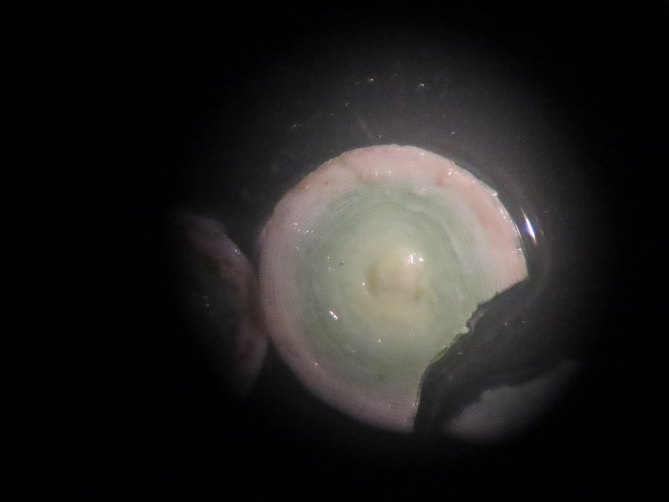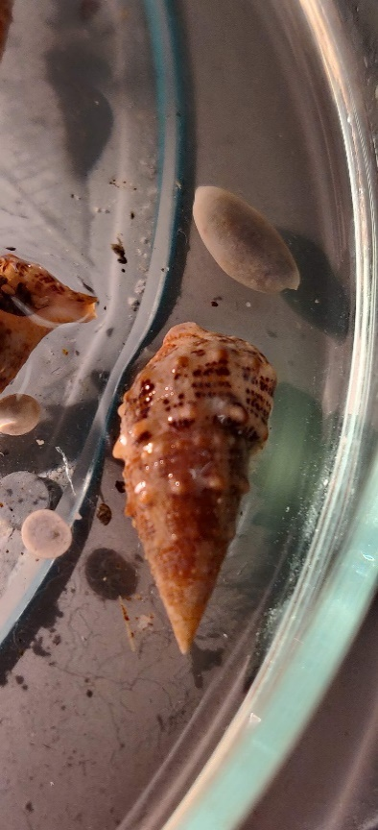

b)

a)

Highly abundant, with the greatest count of individuals were the circular bodies of what have been identified as juvenile sand dollars, representing the echinoderms.

Figure 5.3 Highly abundant were a) Cerithium sp and b) Sand dollar juveniles

## Biomass results:

Measurement of the dry biomass of the seagrass was divided into two categories. Dry biomass above was the mass of all living shoots containing chlorophyll and apical shoots of fresh growth, while biomass below included all roots and rhizome (*Figure 5.4*). The respective counts of these are shown in *Figure 5.5*.

Figure 5.4 Biomass in g of H. stipulacea, the larger the bubble the greater the mass (g) of the sample.

Biomass below was greater than that of the biomass above, indicative of much of the plant being on or below the seabed. The root and rhizome structure, while shallow, provides a complex benthic habitat with some shallow sediment stabilisation.

The data shows biomass above the sediment is less than below. This shows that the above-surface growth of *H. stipulacea* is less dense than that below. The vertical growth of the root structure can provide some habitat complexity; however, this is limited by the relatively short length of the leaves. When compared with biomass density of native beds the density of *H. stipulacea* is greater, which can limit access to the sediment of motile sediment feeders like the queen conch – an important fisheries species to the island (Maitz Boman, Bervoets, & De Graaf, 2019). It is noteworthy that samples 1-12 were reef-associated, while 13-20 were not. The reef-associated samples showed greater biomass weights, indicating more dense root systems. This is in line with research that found *H. stipulacea* capable of growing within the bare sand ‘halos’ formed around Caribbean reefs – sand that has been grazed bare of seagrass by herbivorous, reef-dwelling fish (Steiner & Willette, 2015), and indicates significant growth close to the reefs.

Figure 5.5 Classified counts of seagrass growth. The bars show the counts of shoots and rhizome scars, while the red line indicates the count of apical shoots. The apical count represents new growth of the seagrass, while high numbers of scars indicates age of the sample, as H. stipulacea has high leaf turnover rates and does not regrow leaves from the point where they were lost.

## Are these species locally native and how are they using the beds: habitat or grazing?

Due to the challenge of taxonomic identification to species level, it was not possible to determine whether the fauna found within the seagrass benthos were native or not. The habitat use for the seagrass beds can be determined by looking at the rough life history of the identified phyla.

As the most abundant, the sand dollar juveniles are noteworthy. Their diet consists largely of microscopic algae and particulate detritus found within the sediment. The abundance of juveniles contrasts with a singular fully formed individual indicates that the *H. stipulacea* could be a potential nursery site. The next most abundant group were the gastropod molluscs, predominantly consisting of cerith snails. The diet of these snails is similar to that of the sand dollars – they filter sediment for microalgae, fish waste and organic detritus. The snails were observed both on and within the sediment as well as on the leaves of the seagrass, however, the leaves showed no signs of grazing. Despite the abundance of the queen conch, *Lobatus gigas,* around the island there were no signs of larvae or juvenile conch. Most crustaceans found were small (<2cm carapace width) round crabs. The habitat use of the seagrass by these crabs is difficult to determine, as they could be adults of small species which would indicate they were using the seagrass as feeding grounds or juveniles of larger species, utilising the beds and benthos as shelter.

## How does this compare with historic data on native seagrass beds?

Literature research before the excursion indicated that the nearby islands within the Leeward islands archipelago were host to a number of native seagrass fields which were being invaded by *H. stipulacea*. It was expected that St Eustatius would be similar, due to its location. However, upon arrival on St Eustatius, it became evident that the native seagrasses of St Eustatius no longer grow in fields but rather as scarce isolated patches or singular individual plants, potentially due to climate change and anthropogenic pressures (Viana, Siriwardane-de Zoysa, Wilette, & Gillis, 2018). As a result, comparative analysis with species of seagrass native to the island was not possible.

# Discussion

The wide variety of organisms found within our samples indicates that there is a diverse population of benthic invertebrates found in the *H. stipulacea* beds at popular dive sites on St Eustatius. The organisms found in the benthos have a broad range of habitat uses. From the sediment filtering sand dollars and microalgae grazing cerith snails to the burrowing predatory mantis shrimp, there is a diversity of species making use of the complex and dense seagrass structure of the *H. stipulacea* beds. Despite the challenges in taxonomic identification, it is hoped that this study can serve as basis research into what is clearly an important benthic habitat. There is proposed further study being conducted by thesis students from Van Hall Larenstein, for which this study could provide an initial exploration of the benthic species. Furthermore, there is ongoing research being conducted by CNSI into the primary productivity of the *H. stipulacea* beds (Maitz, pers. Comm., 2019). The biomass data collected during this study indicate that while the above and below-benthos structure of the *H. stipulacea* beds is shallow, it is dense and complex and can provide habitat for a large variety of species. The differences in reef-associated biomass are in line with the 2015 study that describes the encroaching of *H. stipulacea* on the bare sand halos around Caribbean reefs (Steiner & Willette, 2015). However, this is not entirely negative; the reefs of St Eustatius are faced with a significant amount of sediment loading as a result of terrestrial erosion and wave action – the sediment stabilising effect of *H. stipulacea* in immediate proximity to the reefs could be a focus of further study.

# Conclusion

In this research is searched for an answer on the following question: What is the state of benthic infauna species of the native and invasive seagrass species on St. Eustatius. For this, a field research was carried out to discover the benthic infauna species.

A total of 390 animals were found in the 20 collected samples. The results show that most species fall under the class echinodermata (34%), gastropoda (31%) and crustacea (21%). Highly abundant, with the greatest count of individuals were the circular bodies of what have been identified as juvenile sand dollar. The small sizes of the different animals species (<2cm) can be an indicator that the habitat *H. stipulacea* creates is used as a nursery area and shelter ground. The dry biomass weight data shows that the mass above the sediment is less than below. This indicates that the above-surface growth of *H. stipulacea* is less dense than that below. The vertical growth of the seagrass structure can provide some habitat complexity. However, this is limited by the relatively short length of the leaves and roots.

From this field research can be concluded that a lot of animals are using the invasive seagrass beds as their potential feeding ground. To provide more information on what new habitat *H. stipualcea* creates, the beds should be monitored to get a more in-depth answer on how different key species are using the seagrass beds.

# Recommendation

The research showed that many species from different classes use the seagrass. Due to lack of knowledge, it’s not known if the different types of species foraging on the seagrass beds or that the individuals simply passed by when the sample was taken. A relationship between the dry biomass and the number of species found / individuals can’t be scientifically answered. To get a scientifically correct answer, statistics such as SPSS must be used. In this way, a significant right or incorrect answer may arise.

To find out what habitat *Halophila stipulacea* creates, it’s advisable to start monitoring seagrass beds. When processing the samples, it is necessary for the researcher to have more specific species knowledge.

# Acknowledgements

Special thanks would like to be given to Anna Maitz and the team at CNSI for their support with data collection and processing.

# Source reference

Alcocer, A. (2019, January 1). *Marine Angiosperms: Types, Location & Examples*. Retrieved from Study.com: https://study.com/academy/lesson/marine-angiosperms-types-location-examples.html

Andrea Raz-Guzman, R. E. (2001). Techniques for quantitative sampling of infauna and spall epifauna in seagrass. In F. T. Short, & R. G. Coles, *Global Seagrass Research Methods* (pp. 237-253). Elsevier.

Beer, S., & Waisel, Y. (1981). *Effects of light and pressure on photosynthesis in two seagrasses.* Aquat. Bot. 13, 331–337.

Boudouresque, C., Meinesz, M., Ribera Siguan, M., & Ballesteros, E. (1995). *Spread of the green alga Caulerpa taxifolia (Caulerpales, Chlorophyta) in the Mediterranean: possible consequences of a major ecological event.* Sci. Mar. 59, 21–29.

*Canal History* . (2019, January 1). Retrieved from Suez Canal Authority: https://www.suezcanal.gov.eg/English/About/SuezCanal/Pages/CanalHistory.aspx

Carlton, J., Thompson, J., Schemel, L., & Nichols, F. (1990). *Remarkable invasion of San Francisco Bay (California, USA) by the Asian clam Potamocorbula amurensis. I. Introduction and dispersal.* Mar. Ecol. Prog. Ser. 66, 81–94.

Casas, G., Scrosati, R., & Piriz, M. (2004). *The invasive kelp Undaria pinnatifida Phaeophyceae, Laminariales) reduces native seaweed diversity in Nuevo Gulf (Patagonia, Argentina).* Biol. Invas. 6, 411–416.

Coppejans, E., Beeckman, H., & Wit, M. (1992). *The seagrass and associated macroalgal vegetation of Gazi Bay (Kenya).* Hydrobiologia 247, 59–75.

Debrot, A., Hylkema, A., Vogelaar, W., Meesters, H., Engel, M., Leon, R., . . . Nagelkerken, I. (2012). *Baseline surveys of Lac Bay benthic and fish communities.* Bonaire: Netherlands: Institute for Marine Resource Ecosystem Studies.

Den Hartog, C. (1970). *The sea-grasses of the world.* London, UK.

Holme, N. A. (1964). Methods of sampling the benthos. *Advanced Marine Biology*, 235-243.

Keninon, F. (2012). *First actions in setting up an overseas seagrass monitoring network.* Universite de Bretagne Occidentale. 136 pp.

Koplovitz, G. (2008, August 1). *Halophila stipulacea*. Retrieved from Flora of Israel Online : https://flora.org.il/en/plants/HALSTI/

Maitz Boman, E., Bervoets, T., & De Graaf, M. (2019). Diet and growth of juvenile queen conch Lobatus gigas (Gastropoda: Strombidae) in native, mixed and invasive seagrass habitats.

Marbá, N., & Duarte, C. (1998). *Rhizome elongation and seagrass clonal growth.* Mar. Ecol. Prog. Ser. 174, 269–280.

Pereg, L., Lipkin, Y., & Sar, N. (1994). *Different niches of the Halophila stipulaceaseagrass bed harbor distinct populations of nitrogen fixing bacteria.* Mar. Biol. 119, 327–333.

Por, F. (1971). *One hundred years of Suez Canal - a century of Lessepsian migration: retrospect and viewpoints.* Syst. Zool. 20, 138–159.

Rulz, H., & Ballentine, D. (2004). *Occurrence of the seagrass Halophila stipulacea in the tropical west Atlantic.* Bulletin of Marine Science, 75(1), 131-135.

Schwarz, A., & Hellblom, F. (2002). *The photosynthetic light response of Halophila stipulacea growing along a depth gradient in the Gulf of Aqaba, the Red Sea.* Aquat. Bot. 74, 263–272.

Shiganova, T. (1998). *Invasion of the Black Sea by the ctenophore Mnemiopsis leidyi and recent changes in pelagic community structure.* Fish. Oceanogr. 7, 305–310.

Steiner, S., & Willette, D. (2015). Dimming sand halos in Dominica and the expansion of the invasive seagrass Halophila stipulacea. *Reef Encounter*.

Vera, B., Collado-Vides, L., Moreno, C., & Tussenbroek, B. v. (2014). *Halophila stipulacea (Hydrocharitaceae): A recent introduction to the continental waters of Venezuela.* Caribbean Journal of Science, 48(1), 66-70.

Viana, I. G., Siriwardane-de Zoysa, R., Wilette, D. A., & Gillis, L. G. (2018). Exploring how non-native seagrass species could provide essential ecosystems services: a perspective on the highly invasive seagrass Halophila stipulacea in the Caribbean Sea. *Biological Invasions*.

Willette, D., & Ambrose, R. (2009). *The distribution and expansion of the invasive seagrass Halophila stipulacea in Dominica, West Indies, with a preliminary report from St. Lucia.* Aquatic Botany, 91 (3): 137 - 142.

# Appendix 1: Template for data collection



# Appendix 2: Data results

|  |  |  |  |  |  |  |  |  |
| --- | --- | --- | --- | --- | --- | --- | --- | --- |
| Sample | Reef associated | # of Shoots | # of Apicle | # of Scars | Biomass wet (above) | Biomass dry (above) | Biomass wet (below) | Biomass dry (below) |
| DW1 | Yes | 21 | 6 | 64 | 17.48 | 0.91 | 9.75 | 1.78 |
| DW2 | Yes | 46 | 6 | 79 | 5.22 | 0.58 | 8.86 | 1.24 |
| DW3 | Yes | 50 | 7 | 81 | 7.39 | 0.77 | 10.08 | 1.57 |
| DW4 | Yes | 45 | 6 | 54 | 8.32 | 1.25 | 7.39 | 1.14 |
| DW5 | Yes | 72 | 6 | 160 | 9.82 | 0.85 | 15.49 | 2.08 |
| DW6 | Yes | 41 | 5 | 85 | 7.01 | 0.67 | 6.81 | 0.97 |
| DW7 | Yes | 40 | 6 | 40 | 6.52 | 0.58 | 10.02 | 1.06 |
| DW8 | Yes | ? | ? | ? | 9.71 | 0.83 | 10.72 | 1.65 |
| DW9 | Yes | 78 | 13 | 95 | ? | 0.91 | ? | 1.63 |
| DW10 | Yes | 39 | 15 | 124 | 6.09 | 0.56 | 8.83 | 1.1 |
| DW11 | Yes | 58 | 10 | 117 | 8.09 | 0.64 | 12.16 | 1.51 |
| DW12 | Yes | 75 | 16 | 101 | 13.85 | 1.01 | 11.04 | 1.14 |
| DW13 | No | 36 | 1 | 52 | 4.31 | 0.39 | 6.38 | 0.84 |
| DW14 | No | 43 | 10 | 83 | 7.69 | 0.6 | 7.99 | 0.72 |
| DW15 | No | 30 | 5 | 131 | 8.34 | 0.51 | 8.88 | 0.93 |
| DW16 | No | ? | ? | ? | 9.13 | 0.77 | 8.25 | 1.03 |
| WW1 | No | 55 | 13 | 150 | 8.78 | 0.65 | 10.29 | 1.11 |
| WW2 | No | 51 | 13 | 94 | 10.91 | 0.87 | 9.4 | 1.1 |
| WW3 | No | 60 | 7 | 151 | 9.93 | 0.67 | 12.19 | 1.12 |
| WW4 | No | 46 | 5 | 123 | 12.93 | 0.75 | 12.73 | 1.3 |

# Appendix 3: Discovered species

| Sample | Class | Common grouping | Count | Commentary | Total animals | Total species | Reef associated |
| --- | --- | --- | --- | --- | --- | --- | --- |
| DW1 | Bivalvia | Unknown | 3 | Smooth grey bivalve | 14 | 7 | Yes |
|  | Crustacea | Shrimp | 2 |  |  |  |  |
|  | Crustacea | Hermit crab | 3 | Living in cerith shells |  |  |  |
|  | Crustacea | Porcelain crab | 1 |  |  |  |  |
|  | Gastropoda | Marginellidae | 1 | Glowing marginella |  |  |  |
|  | Echinodermata | Sand dollar | 3 | Small white disc with green center |  |  |  |
|  | Unknown | Unknown | 1 |  |  |  |  |
| DW2 | Annelida | Segmented worm | 1 | Soft, white colouration | 10 | 5 | Yes |
|  | Crustacea | Round crab | 2 |  |  |  |  |
|  | Crustacea | Porcelain crab | 1 |  |  |  |  |
|  | Gastropoda | Ceriths | 5 |  |  |  |  |
|  | Gastropoda | Marginella | 1 |  |  |  |  |
| DW3 | Crustacea | Hermit crab | 2 | Living in cerith shells, one with eggs | 26 | 8 | No |
|  | Crustacea | Shrimp | 1 | One claw longer than body |  |  |  |
|  | Echinodermata | Brittlestar | 1 | Light white |  |  |  |
|  | Echinodermata | Sand dollar | 1 | Bright green |  |  |  |
|  | Echinodermata | Sand dollar | 11 | Small white disc with green center |  |  |  |
|  | Gastropoda | Ceriths | 7 |  |  |  |  |
|  | Gastropoda | Marginella | 2 | Light grey with brown specks |  |  |  |
|  | Unknown | Worm | 1 | Pale white with small cilia |  |  |  |
| DW4 | Crustacea | Porcelain crab | 2 |  | 21 | 6 | Yes |
|  | Echinodermata | Sand dollar | 3 | Small white disc with green center |  |  |  |
|  | Echinodermata | Sand dollar | 9 | Small white disc |  |  |  |
|  | Gastropoda | Ceriths | 5 |  |  |  |  |
|  | Unknown | Worm | 1 | White worm length 1 cm |  |  |  |
|  | Unknown | Worm | 1 | Yellow thick worm with visible legs across whole body | |  |  |
| DW5 | Crustacea | Manta Shrimp | 1 |  | 20 | 5 | Yes |
|  | Crustacea | Porcelain crab | 5 | One had a yellow parasite |  |  |  |
|  | Echinodermata | Sand dollar | 3 | Small white disc with green center |  |  |  |
|  | Echinodermata | Sand dollar | 7 | Small white disc |  |  |  |
|  | Gastropoda | Ceriths | 5 |  |  |  |  |
| DW6 | Annelida | Segmented worm | 3 |  | 16 | 5 | Yes |
|  | Crustacea | Porcelain crab | 1 |  |  |  |  |
|  | Echinodermata | Sand dollar | 7 | Small white disc with green center |  |  |  |
|  | Gastropoda | Ceriths | 4 |  |  |  |  |
|  | Gastropoda | Marginella | 1 |  |  |  |  |
| DW7 | Annelida | Segmented worm | 2 |  | 22 | 7 | No |
|  | Crustacea | Unknown | 1 |  |  |  |  |
|  | Echinodermata | Brittlestar | 1 |  |  |  |  |
|  | Echinodermata | Sand dollar | 2 |  |  |  |  |
|  | Gastropoda | Ceriths | 13 |  |  |  |  |
|  | Gastropoda | Unknown | 2 |  |  |  |  |
|  | Osteichthyes | Fish larval stage | 1 |  |  |  |  |
| DW8 | Annelida | Segmented worm | 2 |  | 8 | 5 | No |
|  | Crustacea | Porcelain crab | 1 |  |  |  |  |
|  | Crustacea | Small shrimp | 2 |  |  |  |  |
|  | Gastropoda | Ceriths | 2 |  |  |  |  |
|  | Unknown | Smooth worm | 1 |  |  |  |  |
| DW9 | Crustacea | Porcelain crab | 3 |  | 52 | 10 | No |
|  | Crustacea | Round crab with serrated carapace | 2 |  |  |  |  |
|  | Crustacea | Hermit crab | 2 |  |  |  |  |
|  | Crustacea | Shrimp | 1 | light pink with soft stripe banding |  |  |  |
|  | Echinodermata | Brittlestar | 2 |  |  |  |  |
|  | Echinodermata | Sand dollar | 20 |  |  |  |  |
|  | Gastropoda | Ceriths | 14 |  |  |  |  |
|  | Gastropoda | Smooth spiral shells | 3 |  |  |  |  |
|  | Polychaeta | Segmented worm | 4 |  |  |  |  |
|  | Unknown | Smooth worm | 1 |  |  |  |  |
| DW10 | Bivalvia |  | 1 | White bivalve with rows of ridges | 20 | 10 | ? |
|  | Crustacea | Porcelain crab | 2 |  |  |  |  |
|  | Crustacea | Round crab | 2 |  |  |  |  |
|  | Crustacea | Small isopod | 3 | Length of 2 mm |  |  |  |
|  | Crustacea | Hermit crab | 1 |  |  |  |  |
|  | Crustacea | Shrimp | 3 |  |  |  |  |
|  | Echinodermata | Sand dollar | 3 | Small white disc with green center |  |  |  |
|  | Gastropoda | Ceriths | 3 |  |  |  |  |
|  | Gastropoda | Marginella | 1 |  |  |  |  |
|  | Polychaeta | Polychate worm | 1 |  |  |  |  |
| DW11 | Bivalvia | White bivalve | 1 |  | 21 | 9 | Yes |
|  | Crustacea | Porcelain crab | 2 |  |  |  |  |
|  | Crustacea | Round crab | 1 |  |  |  |  |
|  | Crustacea | Shrimp | 2 |  |  |  |  |
|  | Echinodermata | Sea cucumber | 1 | Encrusted with sediment, slightly rubbery texture |  |  |  |
|  | Echinodermata | Sand dollar | 3 | Small white disc with green center |  |  |  |
|  | Gastropoda | Marginella | 2 |  |  |  |  |
|  | Gastropoda | Ceriths | 8 |  |  |  |  |
|  | Gastropoda |  | 1 | Smooth round spiral shell |  |  |  |
| DW12 | Annelida | Bristly worm | 1 | Segmented body with cilia | 25 | 8 | Yes |
|  | Crustacea | Shrimp | 2 |  |  |  |  |
|  | Crustacea | Small isopod | 3 |  |  |  |  |
|  | Crustacea | Porcelain crab | 2 |  |  |  |  |
|  | Crustacea | Smooth round crab | 2 |  |  |  |  |
|  | Crustacea | Hairy round crab | 1 |  |  |  |  |
|  | Echinodermata | Sand dollar | 8 | Small white disc with green center |  |  |  |
|  | Gastropoda | Ceriths | 7 |  |  |  |  |
| DW13 | Crustacea | Shrimp | 1 |  | 6 | 3 | Yes |
|  | Echinodermata | Sand dollar | 3 | Small white disc |  |  |  |
|  | Gastropoda | Ceriths | 2 |  |  |  |  |
| DW14 | Annelida | Polychate worm | 1 |  | 22 | 8 | No |
|  | Annelida | Lugworm | 1 | About 30cm long, with 'seapearl' attatched to tube |  |  |  |
|  | Bivalvia | Pinna camea | 1 | Translucent fan shaped valves, spiky |  |  |  |
|  | Crustacea | Hermit crab | 2 |  |  |  |  |
|  | Crustacea | Shrimp | 2 |  |  |  |  |
|  | Crustacea | Hairy round crab | 2 |  |  |  |  |
|  | Gastropoda | Ceriths | 12 |  |  |  |  |
|  | Unknown | Parasitic worm | 1 | Long white worm living inside cerith shell |  |  |  |
| DW15 | Bivalvia | Smooth brown elongated bivalve | 1 |  | 9 | 6 | ? |
|  | Bivalvia | Smooth round bivalve | 1 |  |  |  |  |
|  | Crustacea | White isopod | 1 |  |  |  |  |
|  | Crustacea | Shrimp | 1 |  |  |  |  |
|  | Echinodermata | Sand dollar | 2 |  |  |  |  |
|  | Gastropoda | Ceriths | 3 |  |  |  |  |
| DW16 | Annelida | Bristled segmented worm | 2 |  | 13 | 6 | No |
|  | Annelida | Smooth segmented worm | 2 | Smooth body with cilia |  |  |  |
|  | Crustacea | Porcelain crab | 1 |  |  |  |  |
|  | Echinodermata | Brittlestar | 2 |  |  |  |  |
|  | Gastropoda | Ceriths | 4 |  |  |  |  |
|  | Gastropoda | Marginella | 2 |  |  |  |  |
| WW1 | Annelida | Segmented worm | 4 | With cilia | 19 | 9 | No |
|  | Bivalvia |  | 1 | Small round white bivalve |  |  |  |
|  | Crustacea | Hermit crab | 2 |  |  |  |  |
|  | Crustacea | Hairy porcelain crab | 1 |  |  |  |  |
|  | Crustacea | Smooth round crab | 1 |  |  |  |  |
|  | Crustacea | Shrimp | 1 | Small white shrimp |  |  |  |
|  | Echinodermata | Sand dollar | 4 | Small white disc with green center |  |  |  |
|  | Echinodermata | Brittlestar | 1 |  |  |  |  |
|  | Gastropoda | Marginella | 1 |  |  |  |  |
| WW2 | Annelida | White segmented worm | 1 |  | 10 | 7 | No |
|  | Annelida | Tubeworm | 1 | 2 cm long, light brown, opening on one end |  |  |  |
|  | Crustacea | Hairy round crab | 1 |  |  |  |  |
|  | Crustacea | Smooth round crab | 2 |  |  |  |  |
|  | Echinodermata | Brittlestars | 1 |  |  |  |  |
|  | Echinodermata | Sand dollar | 3 | Small white disc with green center |  |  |  |
|  | Gastropoda | Ceriths | 1 |  |  |  |  |
| WW3 | Bivalvia | Smooth round bivalve | 1 | White shell | 28 | 10 | ? |
|  | Crustacea | Smooth round crab | 2 |  |  |  |  |
|  | Echinodermata | Brittlestar | 4 |  |  |  |  |
|  | Echinodermata | Sand dollar | 2 | Small white disc with green center |  |  |  |
|  | Echinodermata | Sand dollar | 6 | Small white disc |  |  |  |
|  | Gastropoda | Ceriths | 4 |  |  |  |  |
|  | Gastropoda | Marginella | 1 |  |  |  |  |
|  | Gastropoda | Smooth round shell | 1 |  |  |  |  |
|  | Unknown | Parasitic worm | 2 | Long white worm living inside cerith and marginella shell | |  |  |
|  | Unknown | Parasitic worm | 5 |  |  |  |  |
| WW4 | Bivalvia | Round white bivalve | 2 |  | 29 | 6 | No |
|  | Crustacea | Hairy porcelain crab | 4 |  |  |  |  |
|  | Echinodermata | Sand dollar | 18 |  |  |  |  |
|  | Gastropoda | Ceriths | 1 |  |  |  |  |
|  | Nematoda | Thin white worm | 3 |  |  |  |  |
|  | Unknown | Pink worm | 1 |  |  |  |  |

