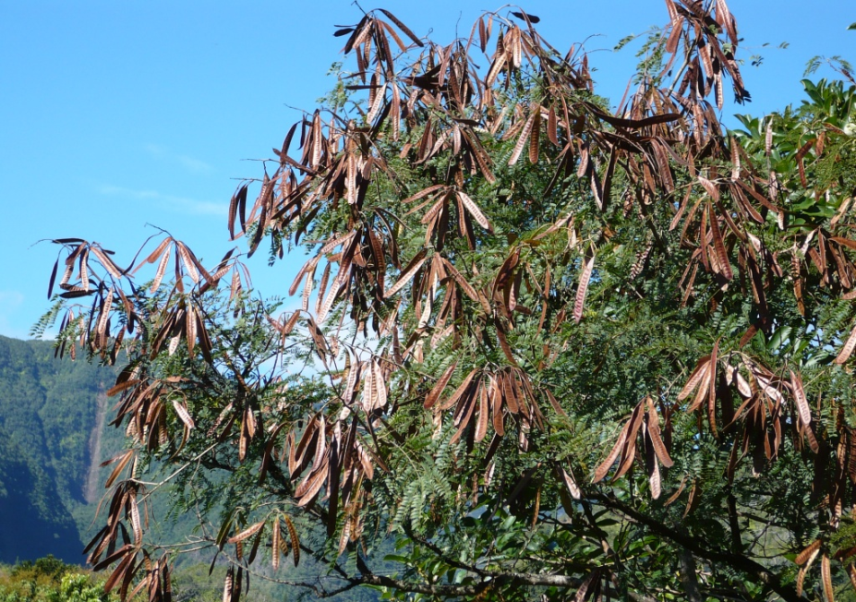
Distribution and density of Leucena leucocephala on Sint Eustatius

Author: Jesse Hermens

Distribution and density of Leucaena leucocephala on Sint Eustatius
A study on an invasive tree species in the Dutch Caribbean

Author: J.I.M.M. Hermens
Student Number: 950529329100 (WUR)
E-mail address: jesse1.hermens@wur.nl

Van Hall-Larentein University of Applied Sciences
Course: BSc Forest and Nature Management
Specialisation: Tropical Forestry

Facilitating organisation: Sint Eustatius National Parks (STENAPA)

Supervisor University Jaap de Vletter
Supervisor STENAPA: Hannah Madden

Wageningen, 04-06-2017

Abstract:

Sint-Eustatius is part of the Dutch Caribbean and has three national parks which attract many tourists to the island. The national parks form an important source of income for the population and its economy. Unfortunately, Leucaena leucocephala has established itself on Sint-Eustatius as an invasive tree species and is a threat to the natural flora within the National Parks. The purpose of this research is to determine the distribution and density of L.leucocephala and to identify areas that are at risk of further invasion of the species. A random sampling design which covered 25% of each national park was used to collect data. The soil cover, canopy cover and number of mature trees were measured to indicate possible risk areas. Mature trees able to produce seeds and the number of saplings indicates the success of reproduction, thus the threat of further invasion. The density of L.leucocephala is especially high in areas that are characterised by disturbances or erosion and in areas with a lot of bare soil and an open canopy. An explanation could be the presence of goats in these areas. It is uncertain if the goats cause erosion or that they promote the species in another way. The obtained knowledge is meant for Sint-Eustatius National Parks to get the population of L.leucocephala under control. The risk areas should receive a different kind of management and intense monitoring by Sint-Eustatius National Parks. The main limitation of this research is the fact that a few areas are not examined because they were inaccessible due to dangerous slopes and loose rocks.
Keywords: Leucaena leucocephala, STENAPA, invasive species, Dutch Caribbean, density, distribution, erosion, goats.

Preface:

My acknowledgements to the people who helped me with the research and made it possible to execute this research. First of all, I want to thank Hannah Madden for having me as an intern at the Sint Eustatius National Parks. I could always rely on her whenever I needed help or advice. She also provided me with the necessary equipment to execute my field work. I want to thank Jaap de Vletter, for his assistance and guidance. He was my mentor of the Van Hall-Larenstein University and a great help. Furthermore, I am thankful for the efforts of Tom Brink, Janne Brouwers and Willem van Wijk for assisting me in the field and helping me with the collection.

Table of contents:

Abstract: iii
Preface: iv
1. Introduction: 1
2. Methods: 2
2.1 research area: 2
2.2 Data collection methods: 4
3. Results: 6
3.1 National parks: 6
3.2 Areas outside the national parks: 7
3.3 Correlation based results: 8
4. Discussion: 9
4.1 Major findings: 9
4.2 Explanation of findings: 9
4.3 Limitations: 10
4.4 Alternative explanation: 11
5. Conclusion: 11
6. Recommendations: 12
7. Bibliography: 13
Annexes: 15
Annex 1: Factsheet Leucaena leucocephala 15
Annex 2: Random plot design 17
Annex 3: Field sheets 20
Annex 4: Densities of L.leucocephala across Sint-Eustatius 21

Introduction:

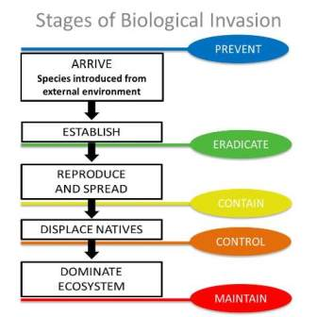
Non-native organisms introduced to an area are called invasive species. Invasive species can either introduce themselves or be introduced by human interference (National Wildlife Federation, 1996). Seeds located in between the feathers of travelling birds and insects nesting in shipped fruits are examples of invasive species. Invasive plant species can reduce or even out-compete the natural vegetation (ISAC, 2006) (figure 1), affecting the environment, economy or even human health (NISIC, 2012) (Dept.Environment, 2012). Invasive species can out-compete native species by better utilisation of resources, resistance against diseases or absence of natural predators (Frits-Baastad, 2011).
Figure 1: the visualized process of invasive species out-competing the local ecosystem (State of California, 2016).

The Leucaena leucocephala is a tree species with many competitive characteristics such as; quick re-sprouting after being cut or burned, the ability to pollinate itself, and year around flowering and fruiting (Shelton & Brewbaker). Another competitive aspect of the L.leucocephala is that it forms dense monospecific thickets, which suppress and replace other species (Leeuw, 2014). The species colonises especially well on disturbed, eroded and rural areas (Hughes, 1998) (Faisal & Barakbah, 2008). For further information on characteristics of the L.leucocephala see Annexe one.

L.leucocephala has established itself on Sint-Eustatius, one of the islands of the Dutch Caribbean. The tree species is not native to this area, making it an extremely invasive species because the species has no natural competitors or predators. Unfortunately, the island contains many disturbed, eroded and rural sights which provide opportunities for L.leucocephala to establish itself and promote its growth. L.leucocephala is present in some regions of the national parks, threatening the natural flora and ecosystems. The national parks of Sint-Eustatius contain over 500 native plants and are a hot spot for biodiversity. The National Parks attract many tourists to the island and forms a primary source of income for the population and the economy, this threat to the national parks leads to the objective of this study.

Sint Eustatius National Parks (STENAPA) wants to eradicate the L.leucocephala from the national parks because the species forms a threat to natural vegetation and ecosystem. However, the organisation lacks information about the specific distribution and densities of the tree species. The primary objective of the research was the determine this unknown piece of information and to identify areas that are at risk of being invaded by L.leucocephala; this leads to the research question:

Where and in what density is Leucaena leucocephala present on St. Eustatius?

Methods:

2.1 research area:

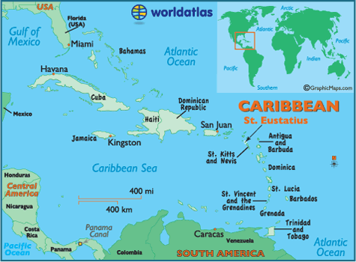
The project took place on Sint-Eustatius, situated in the northern Lesser Antilles, figure 2. Sint-Eustatius forms the Dutch Caribbean together with Saba and Bonaire. The island enjoys a tropical climate, which means an average of 18 degrees Celcius during the year including both a dry and wet season (Stattia-tourism, 2015).
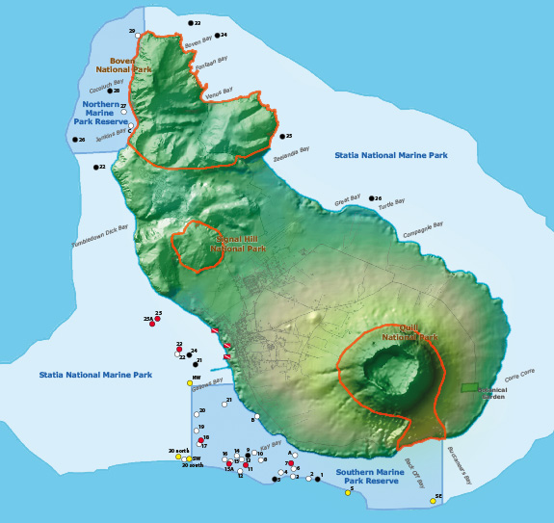
The island contains several biodiversity hotspots located in the National Parks (Statia National Parks, 2012). These biodiversity hotspots attract many tourists to the island and are a major source of income for the community and the island’s economy (Statia National Parks, 2012). There are three national parks situated on the island; the Miriam C. Schmidt Botanical Garden, the Quill National Park & Boven National Park (Statia National Parks, 2012). See figure 3 for clarification on the exact location of the National parks and other areas with their respective local names.
Figure 2: The location of Sint-Eustatius on the world map.
Figure 3: Layout of the Island Sint-Eustatius indicating the location of the National Parks including the local names of certain areas (Statia Tourism, 2012).
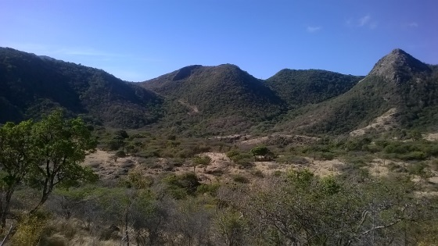
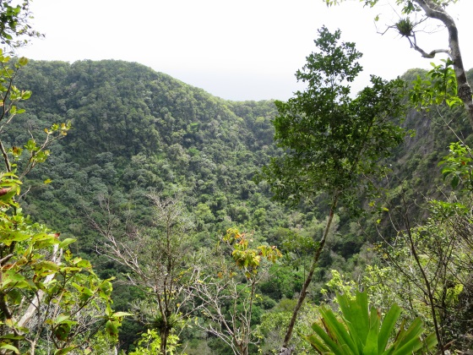
The Quill is an old Stratovolcano covered in lush vegetation, both inside the crater at and outside. The vegetation consists of species such as Kapok trees, Palms and Elephant ear leaves, figure 4. The lush vegetation can grow here because of orographic lift which causes rain clouds to accumulate on the crater top (Statia National Parks, 2012*1). The orographic lift results in a high amount of precipitation, compared to the rest of the island, creating a unique environment (Haby, 2011). We examined the entire Quill National Park on a height of 250 metres and above because this its natural boundary. The Quill consists of several locally named areas, all of these are examined: Compagnie Land, The Quill, Around the Mountain trail, Quill trail and Mazinga.
Figure 4: Vegetation in the inside of the Quill volcano (own picture).
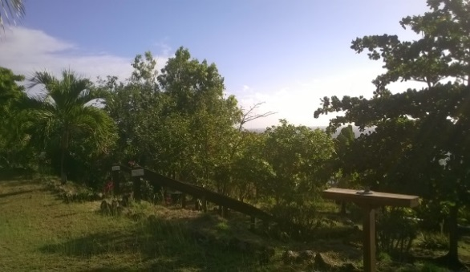
The Boven National Park is the National Park located on the far Northern side of the island. A rough rocky environment and dry thorny vegetation characterises the area, see figure 5. The area is the furthest place away from the Quill, gaining little no rainfall as a result of the orographic lift. The Northern part of the island is very remote and is rarely visited by people. Erosion in continuously present in the area (Statia National Parks, 2012). The research area involved everything above the southern foot of the mountains. This border stretches from the northern part of Zeelandia Bay along the top of Game Bow to the end of Signal Hill Road. The locally named areas included in the research area Boven are Boven, Bergje, Jenkins Bay, Gillboa Hill, Venus and Venus Bay. Signall Hill is located outside of the Park on the terrain of NuStar Terminal NV but is still part of the Boven National Park but. Signall Hill is accessible by asking permission to enter in advance. The area is of conservation interest and still forms a port of the Boven National Parks, that is why I included Signall Hill in the research area.
Figure 5: Vegetation at the Boven National Park (own picture)
The Miriam C. Schmidt Botanical Garden is located east from the Quill. The garden is a man-made landscape and contains most of the native species naturally occurring on the island and is shown in figure 6. The garden contains a high educational and touristic value.
Figure 6: The Miriam C. Schmidt Botanical Garden (own Picture)
The primary focus of the research was on the National Parks. However, it is according to STENAPA important to have a general overview of the species distribution across the entire island. A general overview could indicate possible seed sources from where the species spreads, forming a treat to the National Parks. A general overview could also support evidence that the species effects inhabited parts of the island as well, resulting in support from the island’s population for removal. Every area outside the national parks was examined except the centre town and Orange Bay because the citizens remove the trees themselves within these areas. It is interesting to mention that there are herds of free-roaming goats present over the entire island.

2.2 Data collection methods:

I used a random sampling design to collect the data. Random sampling is a method in which part of a population or area is sampled, and the results are supposed to be representative of the whole population or area (Mora, 2011).
I created the sampling design through the following steps: First, I drew a grid map of the research areas. ArcGIS, a geographical computer program, was used to create the grid maps. Each square in the grid was 100 by 100 meters. Every square was designated a number ranging from 1 to 506. A sample of 25%, along with good sample sources, data collection methods, screening criteria and quality controls ensure that the results are representative of the area (Mora, 2010). Thus 25% of the research area was sampled to create representative results.
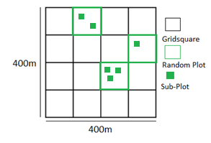
Secondly, I randomly generated 25% of the squares as plots. 114 numbers were randomly generated (506/4), and linked to the numbers assigned to the squares in the grid, see annexe 2. I generated the random numbers with Microsoft Excel. I generated a new number if a number occurred twice until no similar numbers remained.
Thirdly, I made sub-plots with the dimensions of five by five metres within the random plots, see figure 7. I made a sub-plot around an L.leucocephala tree wherever they occurred within a random plot. The number of sub-plots ranges from no sub-plot up to 20, depending on the number of L.leucocephala individuals. The trunk of a tree was used to define a whether a tree was growing inside or outside the sub-plot. I created a new subplot when I determined that a tree was growing outside the initial sub-plot.
Figure 7: Random plot design, with possible sub-plots in the random-plots in case of the presence of Leucaena leucocephala.

I collected information within the sub-plots because of the following two reasons: 1.) To determine why the L.leucophala thrives well in certain areas 2.) To determine the characteristics of potential risk areas. I collected information on the following nine plot parametres: soil cover, canopy cover, density, GPS coordinates, the local name of the area, number of seedlings, saplings, mature and over mature trees. Additional data was collected on all mature and over-mature trees on height, crown vitality and diameter at breast height (DBH). All of these parameters indicate either if the areas is an erosion sight or that the number and vitality of trees form a treat.

Table 1: the quantity classes related to Leacaena leucocephala
Class | Number of individuals
1 | <5
2 | 6-20
3 | 21-50
4 | 51-100
5 | >100
The most important data that I collected in the sub-plots was the number of L.leucephala trees. I made a classification was to enable faster data collection, with accuracy. The classification applies to all growth stages; seedling, sapling, mature and over-mature. A Diameter at Breast Height (DBH) between five and ten centimetres defines a tree as mature. A DBH larger than ten centimetres defines an over-mature tree. A single individual is described as the main trunk with all sprouts and its offshoots. This explanation is necessary because L.eucocephala possess the ability to coppice, which is resprouting into new shoots from its trunk after cutting or damage. Table1 shows the class with the responding number of tree individuals used to classify the number of trees per sub-plot.
Table 2: Crown vitality classes of the Leucaena leucocephala/
Additional data was collected from the mature trees within the sub-plots because these are the individuals that disturbed seeds and directly influence the population and number of individuals on the island. I collected the following data per mature individual; DBH, height and crown vitality. I used a diameter measuring tape to measure the DBH, and I estimated the height by visual observations with a precision of 0.5 metres. The crown vitally was noted by using the classification used in Table 2
Crown Vitality Class | Description
0 | Dead
1 | Almost dead, leaves ranging between none and a few
2 | Weak, some leaves and pods, some vital branches
3 | Normal, decent amount of leaves, pods and many vital branches
4 | Vital, a lot of leaves and pods, many branches
5 | Very vital, full crown with a lot of vital branches, many leaves and pods.

All the data collected in the random plots and sub-plots was written down on fields sheets, shown in annexe 3. Coordinates were taken at both the centre of each random plot and sub-plot, enabling verification of the data and monitoring activities in the future.
The areas outside the national parks that were only visually observed, to give a general indication of the species across the island. The classification I used is described in Table 3. No plots were created nor was any specific data collected, so a general classification for the number of L.leucocephala was created for the areas outside the national parks.

Table 3: Description and abbreviation of the number of Leucaena leucocephala in the areas outside the national parks.
Description for number of Leucaena leucocephala outside the national parks | Abbreviation | Frequency per 100m
No Leucaena leucocephala present at all | NP | 0
Few trees and mostly separate individuals | FS | <15
Few mostly clustered trees | FC | <30
Many separate trees | MS | 15>
Many clustered trees | MC | 30>
Area containing both many separate and clustered trees | MSC | 15> 30>
Area consisting of almost only Leucaena leucocephala | AA | -

Results:

3.1 National parks:
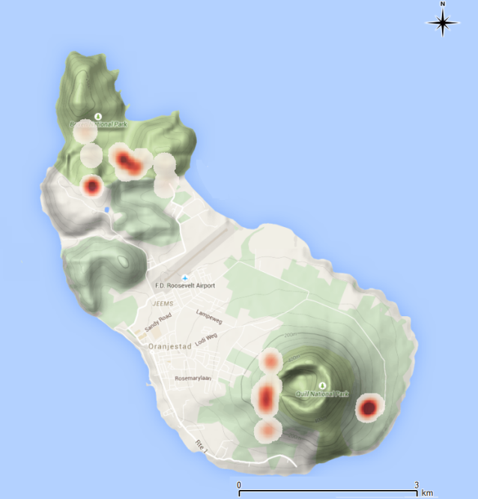
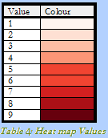
Figure 8 shows the areas within the national parks that contain Leucaena leucocephala. The points on the heat map are based on the coordinate points taken in the middle of the plots and show the distribution and densities of L.leucocephala. Darker spots, so a higher value indicate a higher density; lighter spots, so a lower value indicate a lower density. The figure indicates that the highest densities are west of the Quill crater, the Miriam C.Schmidt Garden and the centre of Boven National Park. The following local names can be linked to these areas: Quill Trail, Southern part of Bergje trail, large parts of Venus, Gillboa Hill entrance and the Miriam C. Schmidt Botanical Garden.
Figure 8: Heath Map of St.Eustatius presenting the Density of Leucaena leucocephala (Own map, use of ARCgis)

3.2 Areas outside the national parks:

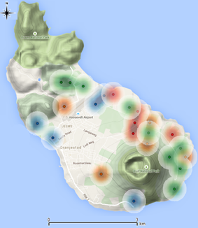
Figure 9 represent the areas outside national parks regarding the presence of Leucaena leucocephala. This result is meant to give a general overview of the distribution of Leucaena leucocephala across the island. The colours in figure 7 are linked to the classification of Table 3.
- Red: MSC
- Orange: MS or MC
- Green: FS or FC
- Blue: NP
Several areas could not be visually observed because they were not accessible or located on NuStart property, these areas were: Mary’s Glory and Tumble Down Dick.
The following results can be derived from figure 8. Note: the central town and the national parks are not included in the figure.
Figure 9: Map of St.Eustatius showing the classification regarding visual observation of Leucaena leucocephala densities (Own Map, use of ARCgis

- Result 1: The trees species is present across almost the entire island.
- Result 2: The highest densities (MS, MC or MSC) appear north east of the Quill including the areas; Guyeau, Halfway Path, Lower Place, Peru, Rhoda’s and Rocky Town.
- Result 3: The densities decrease towards the south-west in the direction of the town and White Wall.
- Result 4: Medium densities of Leucaena leucocephala are located east of the Quill.
- Result 5: The area between Zeelandia beach, the town and Boven National Parks contain relatively low densities of Leucaena leucocephala.
- Result 6: No Leucaena leucocephala was found around Orange Bay and Dockers Island (South of Quill).
A detailed classification of all the local areas is given in Annex 4.

3.3 Correlation based results:

The following results are derived to determine common characteristics that can possibly explain why certain areas contain high densities of Leucaena leucocephala.
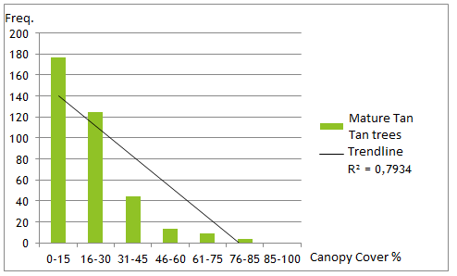
Figure 10 shows the number of Leucaena leucocephala individuals measured per canopy cover class. The figure shows a steady decrease in the number of trees when the canopy cover is denser. The difference because especially big between the classes 30-45% to 46-60. The correlation is strong (0.79), but not significant.
Figure 10: Number of Mature Leucaena leucocephala trees compared to the canopy cover
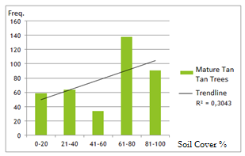
Figure 11: Number of mature Leucaena leucocephala trees compared to the soil cover.

Figure 11 shows the number of Leucaena leucocephala individuals per soil cover class. The soil classes each cover 20%. However, no strong correlation or result could be derived from the figure.

Discussion:

This chapter consists of the following four sections; Major findings, explanation of findings, limitations and alternative explanations.

4.1 Major findings:

The central research question was; Where and in what density is Leucaena leucocephala present in St. Eustatius? This section displays the most relevant and interesting results.
National parks:
- The Leucaena leucocephala is present all three National Parks in higher or lower densities.
- Lower densities within the national parks were found in: Around the Mountain North & South, Jenkins Bay Trail and Gillboa first ridge.
- The highest densities within the National parks were found in Quill trail, the southern part of Bergje trail, Miriam C. Schmidt Botanical Garden, Venus and the entrance of Gillboa Hill.
Areas outside of the National Parks:
- The Leucaena leucocephala is present in lower or higher densities across the entire island. However, the species was not present on Dockers Island and Orange Bay.
- The highest densities were found northeast of the Quill National parks.

4.2 Explanation of findings:

The obtained information matches with the results from other studies. General information sheets about the Leucaena leucocephala mention (annexe 1) that the species prefers erosion sights, bare soil and an open canopy areas. Several studies on erosion or the Leucaena leucocephala confirm as well that the species occurred more often on erosion sights, bare soil and/or an open canopy (Hughes, 1998) (Faisal & Barakbah, 2008). The following results obtained during this research confirm this conclusion from the other studies as well.
The areas below are areas which contain the highest densities of Leucaena leucocephala and are all characterised by lower or higher degree by the characteristics mentioned above. Interesting to mention is that the Quill Trail is the only area (from the areas below) which is not located in the Boven National Park.
- Bergje Trail: There is a large gully present next to the Bergje Trail and follows the trail for the most part. Almost all the L. leucocephala trees were found inside the gully, which is characterised by erosion and a low soil and canopy cover.
- Gillboa Hill (entrance): The entrance of Gillboa Hill is the roughest area of the entire island characterised by a barren landscape full of hills suffering from erosion where only the toughest species can survive. Each hill suffers from erosion, has a low to no soil and canopy cover at all.
- Jenkins Bay Trail: This trail is one big gully which in probably the largest gully present on the island. Continuous erosion characterises the gully due to heavy rainfall, open canopy and a low soil cover.
- Quill Trail: The trail is located around the Quill crater and is a lap around the volcano. This implies that the trail is located on a hillside and is rather steep. Erosion gullies and loose rocks are present in multiple locations around the volcano; these are also the exact places where the species occurs. Furthermore, the species did not occur in areas of the Quill Trail which were covered in lush vegetation and/or with a high canopy cover.
- Venus: This area is very open, thus has a low canopy cover. Furthermore, there are two large gullies present throughout Venus. Most of the invasive individuals are present within these gullies. However, some individuals have established themselves outside the gullies under a dense canopy.
We can derive from these results and previous literature studies that the L.leucocephala indeed prefers and occurs in areas characterised by erosion, open canopy and a low soil cover. Figure 9 confirms this theory as well because it confirms that the species occurs more often in areas with a low canopy cover. Although the correlation in strong (0.79), it is not significant.
Figure 11 shows the correlation between the number of L.leucocephala and the soil cover. However, no clear trend could be detected. This result contradicts the trend mention by multiple studies. However, many plots were located in areas with a low soil cover but high canopy cover. These plots contain one factor that promotes the growth of L.leucocephala and one factor that hinders the growth L.leucocephala. The combination of these two factors may be the reason why the obtained results do not follow the trend.

4.3 Limitations:

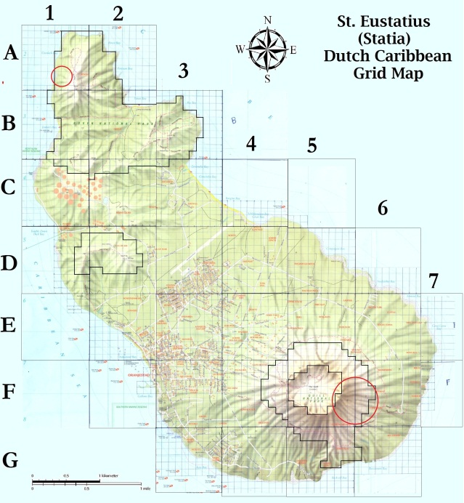
There were several limitations in this study that may have caused bias in the results. The first major limitation is the inaccessibility of the south-eastern part of the Quill and the area west of Boven. The red circles mark these areas, see figure 11. The southeastern part of the Quill was inaccessible due to the presence of loose rocks, causing danger of falling, twisting ankles and causing a rock avalanche. The western part of Boven contained a health risk because there were several beehives present.
Figure 11: Inaccessible areas within the National Parks of Sint Eustatius, which have not been examined (Own map, used Paint)
The second limitation was the loss of several coordinate points. The coordinate points taken in plots A1 to A9 were corrupted and no longer useable. Plots A1 to A9 were located northeast of Gillboa Hill.

4.4 Alternative explanation:

An interesting observation occurred during the research which may be an alternative explanation for the distribution and densities of L.leucocephala across the island. Sint-Eustatius contains herds of free-roaming goats, which means that no one owns the goats in question. Goats are known to cause a lot of erosion by foraging and climbing behaviour (Van Bussel & Verbeek, 2016). The observed densities and distribution of goats seem to comply with most of the data on distribution and density of L.leucocephala on the island. The goats are present across the entire island, just as L.leucocephala is present across the entire island. No goats are present or observed around Dockers Island and Orange Bay, the only areas which were free of L.leucocephala. But what about the National Parks:
We sighted a herd of free-roaming goats only twice inside the Quill National Park. The goats are denied access to the national park with a lot of effort. So it is safe to assume that goats are usually not found within this national park.
The highest densities of goats and most free-roaming herds are located and observed in the Boven National Park, as well as the highest densities of Leucaena leucocephala. The area is very remote, so no effort is made to contain the goats in this National Park.
There is clearly a link is present between the presence of goats and L.leucocephala. However, the exact link is not known. The most obvious explanation would be that the goats cause erosion of which the L.leucocephala profits. Another explanation could be that the goats do not include the tree species in their diets while eating the species competing with the Leucaena leucocephala.

Conclusion:

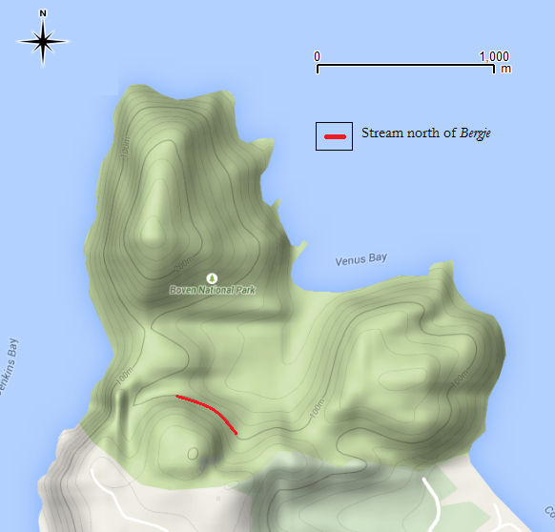
The conclusion indicates areas that are at risk for further invasion of the L.leucocephala. Several areas are at risk because they contain favourable characteristics for the growth of L.leucocephala, or are located next to areas with a high density of L.leucocephala. The following areas are such locations:
The gully between Bergje and Jenkins Bay Trails (1*) see figure 12. There is another big gully in the Jenkins Bay area located close to the with L.leucocephala infested gully. This gully is also characterised by an open canopy, low soil cover and erosion. Only a small area separates these two gullies, invasion could happen easily happen through heavy rainfall promoting seed distribution.

Figure 12: Indicated location of the gully between Bergje and Jenkins Bay Trail.
(1* not to be confused with the Jenkins Bay Trail which is a different gully.)
Venus: This area contains the highest density of L.leucocephala on the island within the national parks. Mature trees, saplings and seedlings were all located in high densities, which forms a treat to the area because there are several eroded gullies in the area which are at risk for invasion.
Gillboa Hill entrance: The highest number of juvenile individuals of L.leucocephala and many mature individuals as well are present at the entrance of Gillboa Hill. Most of these individuals are located on top of the surrounding hills in dense groups. The hills themselves have a open canopy and low soil cover. Heavy rainfall and gravity could easily transport the seed down the hill resulting in a complete domination by Leucaena leucocephala.

Recommendations:

The first recommendation is a monitoring program to indicate whether or not the L.leucocephala. The current distribution and density of L.leucocephala has now been identified. However, the organisation does not yet know if the species is still spreading and invading other areas. An extensive monitoring project should be implemented in both areas containing L.leucocephala and risk are in danger of invasion.
The second recommendation is to study into the effect that the free-roaming goats have on the vegetation and erosion. As mentioned before, the goats are present in every area of the island but are not controlled or even remotely monitored. A study towards their effect could contribute largely to the erosion control and monitor the population of L.leucocephala.

Bibliography:

De Leeuw, S. (2014). Leucaena leucocephala suppression on Sint Eustatius. Sint Eustatius.
Dept.Environment. (2012). Australian Government department of environment. Retrieved 4 24, 2015, from Invasive species: http://www.environment.gov.au/biodiversity/invasive-species
Faisal, S., & Barakbah, H. (2008). Engineering properties of Leucaena leucocephala for prevention of slope failure. Elsevier.
Federation, N. W. (2012). Invasive species. Retrieved from National wildlife federation: http://www.nwf.org/wildlife/threats-to-wildlife/invasive-species.aspx
Frits-Baastad, E. (2011, June 10). Yukon. Retrieved 4 21, 2015, from Invasive species: http://www.env.gov.yk.ca/animals-habitat/invasivespecies.php
Haby, J. (2011). the weather prediction. Retrieved 5 4, 2015, from Orographic lifting: http://www.theweatherprediction.com/habyhints2/447/
Hughes, C. (1998). A genetic resources handbook. Oxofrd: Oxford University press.
ISAC. (2006, April 27). The national invasive species council. Retrieved from Invasive Species Definition Clarification and Guidance White Paper: http://www.invasivespeciesinfo.gov/docs/council/isacdef.pdf
Leeuw, S. d. (2014). Leucaena leucocephala suppression in Sint Eustatius. Sint Eustatius.
Mora. (2011). Simple random sampling. Retrieved 5 12, 2015, from Investopedia: http://www.investopedia.com/terms/s/simple-random-sample.asp
Mora, M. (2010, May 13). Does A Large Sample Size Guarantee A Representative Sample? Retrieved from Relevant Insights: http://www.relevantinsights.com/representative-sample
National Wildlife Federation. (1996). National Wildlife Federation. Retrieved 4 12, 2015, from Invasive species: https://www.nwf.org/Wildlife/Threats-to-Wildlife/Invasive-Species.aspx
NISIC. (2012, November 28). Retrieved from National invasive species information centre: http://www.invasivespeciesinfo.gov/whatis.shtml
Shelton, H., & Brewbaker, J. (n.d.). FAO. Retrieved 5 13, 2015, from Leucaena leucocephala: http://www.fao.org/ag/agp/agpc/doc/publicat/gutt-shel/x5556e06.htm
Shelton, H., & Brewbaker, J. (n.d.). Leucaena leucocephala - the Most Widely Used Forage Tree Legume. Retrieved 6 28, 2015, from FAO: http://www.fao.org/ag/agp/AGPC/doc/Publicat/Gutt-shel/x5556e06.htm
Statia National Parks. (2012). Retrieved 6 5, 2015, from Parks: http://www.statiapark.org/parks/index.html
Statia National Parks. (2012*1). Retrieved 6 5, 2015, from Quill / Boven: http://www.statiapark.org/parks/index.html
Statia Tourism. (2012). Retrieved 5 6, 2015, from Dive Map: http://www.statia-tourism.com/diving/dive-map-2/
Stattia-tourism. (2015). Statia-Tourism. Retrieved 6 5, 2017, from Climate: http://www.statia-tourism.com/nature/explore-our-island/climate/
STENAPA. (2003). Statia National Parks. Retrieved 4 17, 2015, from Sint Eustatius National Parks: http://www.statiapark.org/
STENAPA. (2005). Saint Eustatius National Parks. Retrieved from roaming livestock project: http://www.statiapark.org/projects/livestock.html
STENAPA. (n.d.). Sint Eustatius National Parks. Retrieved 6 28, 2015, from http://www.statiapark.org/
Van Bussel, T., & Verbeek, B. (2016). Dutch Caribbean Biodiveristy Database. Retrieved 6 5, 2017, from The influence of goats on soil erosion and vegetation: http://www.dcbd.nl/document/influence-goats-soil-erosion-and-vegetation-arikok-national-park-aruba

Annexes:

Annex 1: Factsheet Leucaena leucocephala

This factsheet provides information about the properties and characteristics of L. leucocephala.

8.1.1 Taxonomy:
- Order: Fabales
- Family: Fabaceae
- Genus: Leucaena
- Species: Leucaena leucocephala
- Common names:Tantan, Guaje, Washim

8.1.2. Morphology
Leucaena leucocephala is a long-lived tree or bush species. The bush can vary in height from seven to twenty meters. Leaves are bipinnate with six to eight pairs of pinnae bearing 11-23 pairs of leaflets 8-16 mm. The flowers are a cream colour and produce a cluster of brown pods which vary in size from 13 to 18 mm and each pod contains 15 to 30 seeds. The commonest form of L. leucocephala is the shrubby free-seeding one Ongeldige bron opgegeven..

8.1.3 Distribution
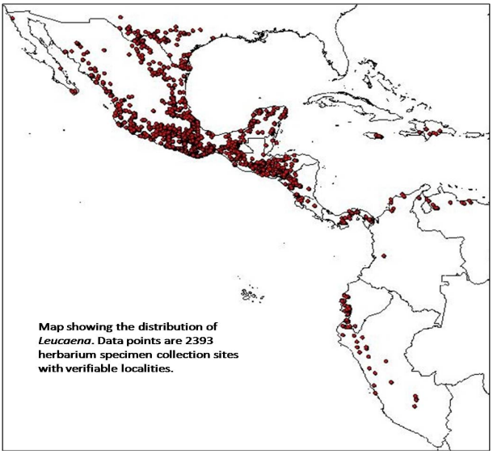
Leucaena leucocephala is native to southern Mexico and northern Central America (Belize and Guatemala), but is now naturalized throughout the tropics Ongeldige bron opgegeven..

Figure 1: Distribution map of the Leucaena leucocephala

8.1.4 Habitat requirements
Soil requirements: L. leucocephala appears in several types of soils which include; limestone soils, costal sends, self-mulching vertisols. L. leucocephala also appears in more exotic places or soils but only when the aluminum ratio is very low.
Moisture: The plant requires between 1500 and 3000 mm of rainfall every year and cannot stand long or multiple periods of flooding.
Light: Needs a high amount of light to develop well. Ongeldige bron opgegeven..

8.1.5 Uses
L. leucocephala has many uses including: food, medicine, fodder for cattle, fuel wood and a hedgerow system. It is currently used in many agroforestry systems as a species to intercrop with and to provide shade Ongeldige bron opgegeven..

Annex 2: Random plot design

Table 1 shows the randomly generated numbers which cover 25% of the research area. A new number was generated in Excel, if a number was double-generated. Secondly a map (figure 1) of the research area is shown, a grid was drawn over this map with squares of 100 by 100 meters. Each of the squares was assigned a number, which was later linked to a randomly generated number. The combined outcome of the grid map and random Excel numbers is shown in the random sampling map (figure 2).
Table 1: Randomly generated numbers

Boven National Park |  |  | Quill National Park
4 | 109 | 226 | 346 | 470
5 | 111 | 227 | 350 | 472
6 | 113 | 228 | 351 | 475
7 | 115 | 232 | 359 | 477
11 | 119 | 235 | 363 | 478
13 | 122 | 239 | 365 | 480
28 | 125 | 246 | 368 | 481
29 | 130 | 247 | 374 | 492
39 | 131 | 251 | 381 | 493
41 | 133 | 257 | 386 | 502
47 | 146 | 261 | 387 | 503
49 | 147 | 265 | 388 | 505
52 | 155 | 270 | 393
54 | 165 | 272 | 398
57 | 166 | 278 | 405
59 | 174 | 279 | 409
66 | 187 | 280 | 413
68 | 192 | 287 | 419
69 | 195 | 292 | 420
70 | 197 | 303 | 421
71 | 200 | 320 | 429
73 | 205 | 321 | 431
74 | 209 | 307 | 440
75 | 210 | 323 | 447
78 | 211 |  | 449
91 | 212 |  | 450
95 | 215 |  | 451
98 | 222 |  | 459
101 | 223 |  | 460
107 | 224 |  | 465

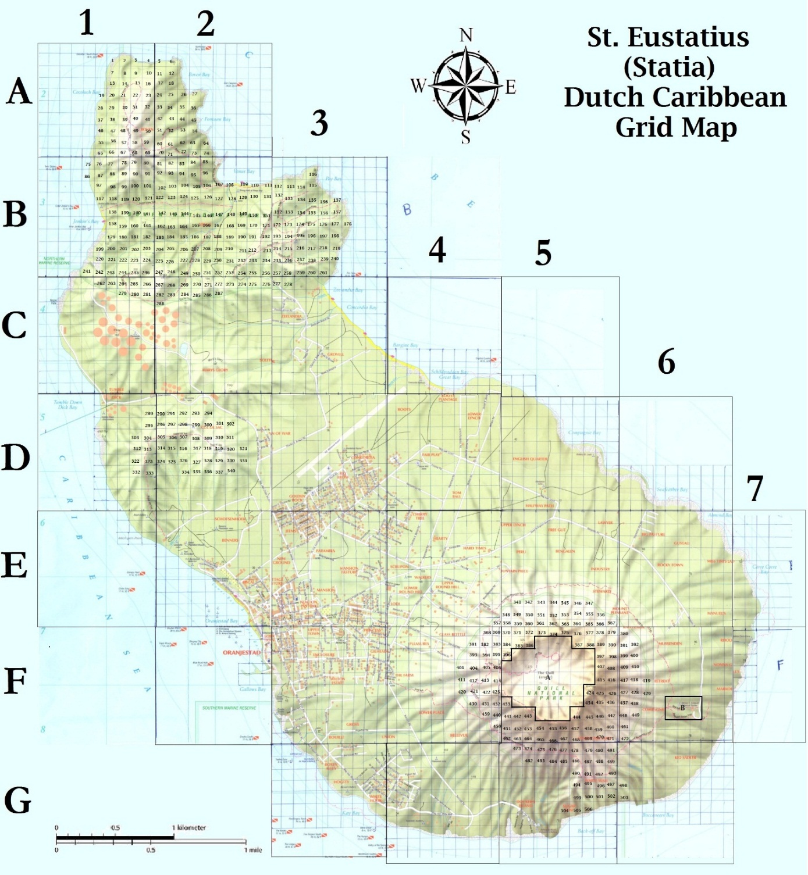
Figure 1: Map showing the location of assigned numbers of the grid squares
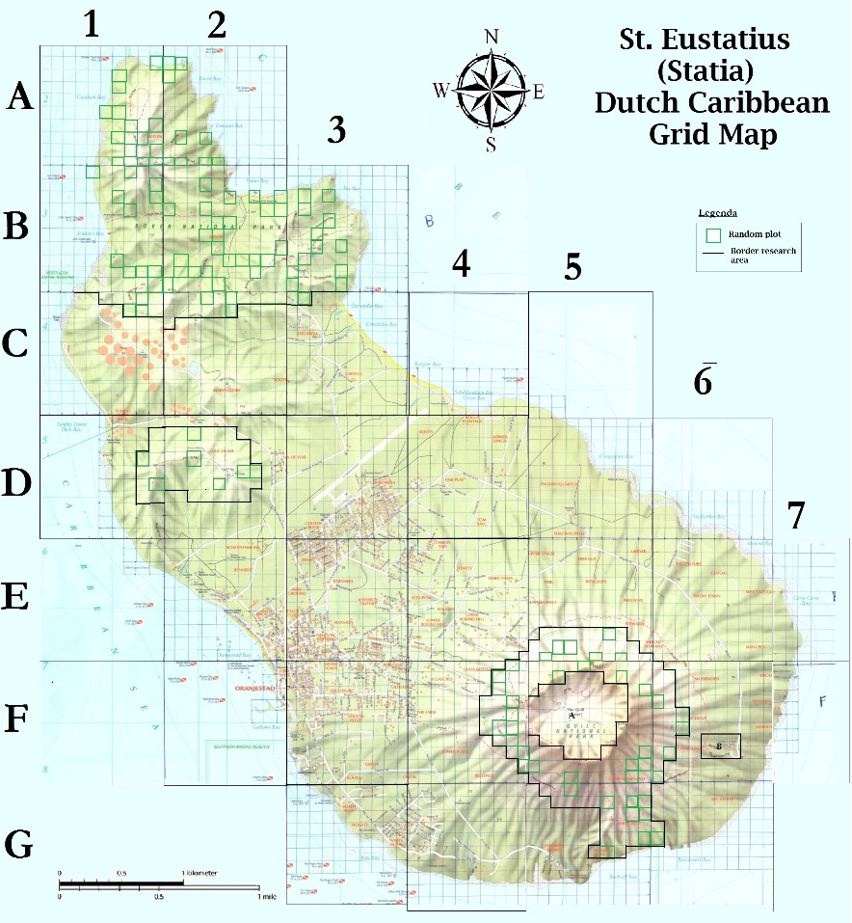
Figure 2: Grid map showing the random generated plots in the research areas

Annex 3: Field sheets

Example of the data collection sheet which was used.
Table 1: Example of field form for within the national parks for the random plots
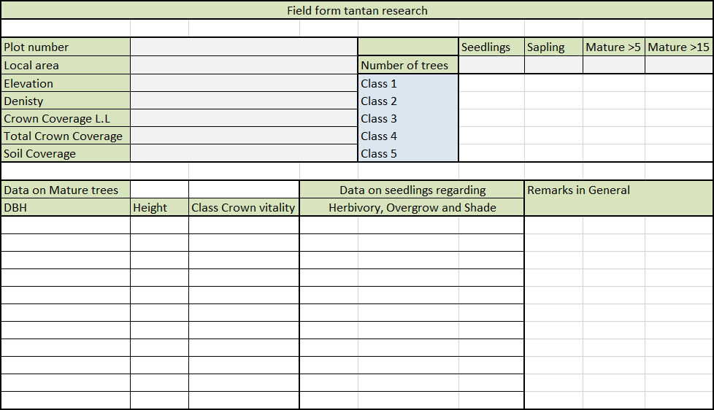

Annex 4: Densities of L.leucocephala across Sint-Eustatius

Area | Density category
Bengalen | FCFS
Benners | NP
Big Pasture | MC
Dockers Island | NP
English Quarter | FS
Free Gut | MSFC
Grovel | FS
Guyeau | MCFS
Halfway Path | MCFS
Industry | FCFS
Kid Sadler | FCFS
Knippenga | FS
Lawyer | FCMS
Lower Place | MSFC
Man of war | FSFC
Manuel’s | FS
Markoe | FS
Mary’s Glory | X
Miss Tini’s Land | FS
Mussenden | FS
Nonna Grell’s | FS
Peru | MCFS
Reatreat Compagnie | -
Rhoda’s | MSFC
Rocky Town | MCFS
Roots | NP
Roots Plantage | NP
Schotsenhoek | NP
Solitude | FSFC
Tumble Down Dick | X
Upper Lynch | MCFS
Zeelandia | FS

