Beach Profile Survey On Six Beaches on Sint Eustatius (Sept-Dec 2015)

# http://geologycafe.com/images/ano_nuevo3.jpg

**Author: Niels Verboon**

**Date: May 2016**



Inhoudsopgave

1

1. Introduction 3

2. Materials & Method 5

3. Results 7

4. Conclusion 9

5. Discussion 10

6. Acknowledgement 11

7. References 12

Appendix I field datasheet 13

# 1. Introduction

Shorelines over the whole world represents the area where land meets the sea. The shape of the shoreline can be caused by following factors: breaking waves, high and low tide, longshore & nearshore currents, biological processes, sedimentation of rivers, the changes in sea level, sinking and rising of the land, and activity of humans (**Pinet, 2013)**. The place where land meets the sea is usually called beach “an active zone of sediment transportation that lies between the erosional area that lies above the water level and the depositional zone area below the water level’’ (**Pinet, 2013)**.

Beaches can be subdivided into different zones; the most active zone is the nearshore zone. The nearshore zone can be subdivided into three zones. The breaker zone is the first zone of the nearshore zone that lies most seawards. In the breaker zone the waves begin to break, because of longshore bars. After the breaker zones comes the surf zone where the waves lose their energy. Lastly is the swash zone, this area is continuously covered and uncovered with each wave surge. The entire nearshore zone shifts back and forward, because of high tide and low tide. The offshore is the open water that lies seaward. The backshore or foreshore is the zone that borders on the nearshore and normally stays dry (**Pinet, 2013).** The beach profile of beaches changes during the seasons. This happens because of the changes of the weather that has an influence on the wave climate. For example, settled weather moves sediment onshore and creates a summer profile and rough weather transports sediment offshore and creates a winter profile (**Pinet, 2013).**

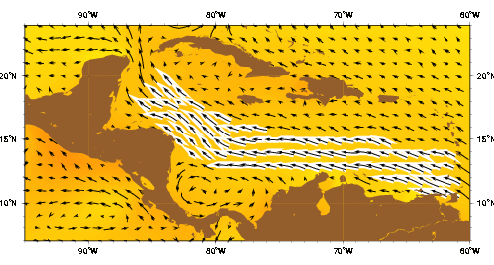

Figure 1.4: Caribbean currents (Oceancurrents, 2003)

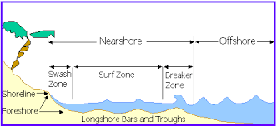

Figure 2.2: Different zones (Conrad Butcher Institute, 1997-2014)

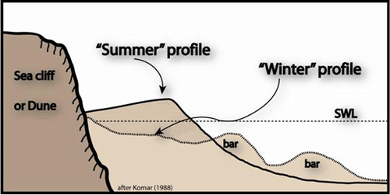

Figuur 1.1: Swell & Storm Profile (Komar, 1998)

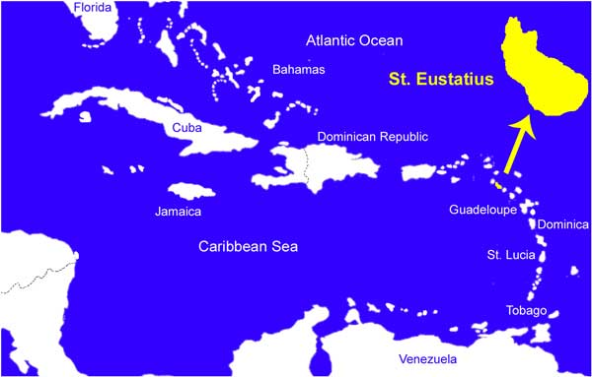

Figure 1.3: Location Sint Eustatius (VeVesWorld, w.d)

This report is about the beach profile survey on St. Eustatius. St. Eustatius is located in the Eastern part of the LAC (Latin America and Caribbean) region and is one of the Windward islands. The water inflow for the Caribbean Sea is of the most part from the equatorial Atlantic Ocean via the North Equatorial, North Brazil, and Guiana Current (**Gyory et al., 2013**). The Windward islands region is dominated by a mixed mainly diurnal tide (**Kjerfve, 1981**). On the west side of the Windward islands there is a wave climate with an average of approximately 1 meter and on the Atlantic side a wave height between 1,6 meters and 2 meters and these wave. The maximum of the wave heights is during the winter months (DJF) (**Reguero et al., 2012**). In the largest part of the Caribbean Sea the mean tidal range is less than 20 cm, this applies to the Windward islands as well (**Reguero et al.,2012**).

Besides the influence through wave climate it is important to take into account the probable increasing occurrence of hurricanes in the LAC region, because of global warming (**Cambers, 2003).** Previous research to beach erosion revealed the impact of hurricanes and shows the increasing number of hurricanes in the Atlantic Basin (**Cambers, 2003**). The hurricanes occur between June and November and taking a lot of sand away which are resulted in a negative sand balance (**Cambers, 2003**).

Furthermore, it is important to take into account the sea level rise. Over a long period of time, it will probably decrease the length of the beaches (**Stephan et al., 2000).** If this research will perform over a longer period it will be visible to see the changes over a long period of time.

Besides the sea ocean currents, occurrence of hurricanes and sea level rise that are influencing the beaches of Sint Eustatius there are also harbour constructions that are affecting the beach profile and sand balance. These harbour constructions are only located on the west side of the island, this concerns the oil pier of NUstar and the transport harbour.

Sint Eustatius has a varied coast. On the west side of the island are two big sandy beaches. There are beaches with boulders, pebbles and rocks. On the east side are beaches with rocks, boulders, pebbles and sand and combination of these occur as well. The rocks and sand are of volcanic origin.

The objective of this study is to start up a beach profile survey for a long term period that will be execute by students that are supervised by researchers. The data is useful for several things. At the first place there is a turtle population that are nesting every year on the beaches. Furthermore, the data can be compared with data from other beach profiles in the LAC region.

# 2. Materials & Method

Six beaches on Sint Eustatius have been investigated between September – December 2015. Every beach is measured once in two weeks over a period of fourteen weeks so for each transects are seven measuring dates. The method that is used is the Rahn- Method. This method is invented by Professor Jennifer Rahn (**Jennifer Rah, March 2015**). The beaches that have been investigated on St. Eustatius are; Zeelandia Beach, Turtle Beach, Lynch, Oranje Bay, Crook’s Castle and Smoke Alley Beach. Zeelandia Beach, Turtle Beach and Lynch are beaches that are located on the Atlantic side of St. Eustatius. Oranje Bay, Crook’s Castle and Smoke Alley are located on the other side of the island, the Caribbean side.

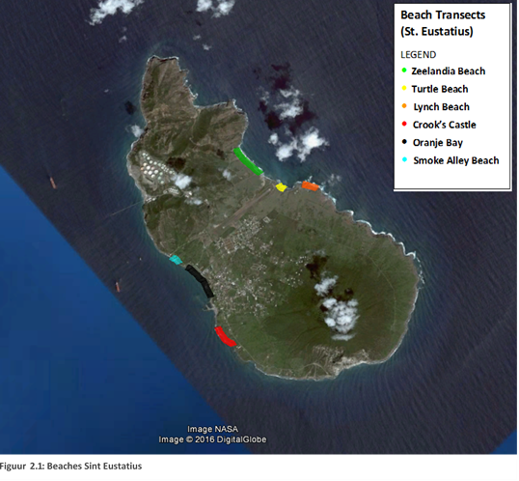

* **Kleuren en codering heel de tijd hetzelfde**
* **Graphs met wanneer de stranden zijn opgemeten**

On every beach transects are determined, a transect is the length of the beach from water to the end of the beach where the vegetation or cliff starts. The starting point of a location is located where the vegetation stops or where the cliff starts. Every starting point of a transect is sprayed and the locations are recorded by using a GPS and database. These GPS coordinates are saved in a database. The distance between the transects is approximately 10 percent of the entire beach, but sometimes there are deviations, because some places are difficult to measure or there were no suitable substrates for spraying spray on the starting point. To measure one transect you need an A-Frame with a digital level and an t-shaped bubble level attached to the A-frame with tape or tie-rips and a tap measure of 50 meters long. The tape measure can be laid perpendicular across the transect. With the A-frame including the T-shaped bubble level and the digital level, it is possible to measure the profile of one transect (meter by meter). The T-shaped bubble level indicates the slope (negative or positive) and the digital level indicates the size of the angle. Each measurement has to be written on the datasheet with the positive or negative angle and the size of the angle. Besides the positive or negative angle, it is also useful to write the ground type of each measurement on your datasheet. Use paper that is resist against water so the data not will get lost. The data of each transect will be stored in the database. By analysing of the data is looked at changes between the period with regard to; beach profile, ground type and total meters of every beach. By analysing the data is used a formula (SIN (X*PI ()/180))/SIN ((PI ()/2)-X*PI ()/180). With this formula it is possible to convert every angle too meters. If every angle of a transect is converted to meters, the outcome will give the total meters that one transects rises or drops. In this research the total meters of all the transects at one day at one beach are summed. It is possible to see changes during time with the meters that are summed of one measure date. Furthermore, attention is paid to the ground type, because if the total metehrs decrease, while the ground type sand occurs relatively more, you cannot speak about a negative sand budget. The ground type is also useful information of the morphology of the beaches of Sint Eustatius.



Figure 2.3: Digital level

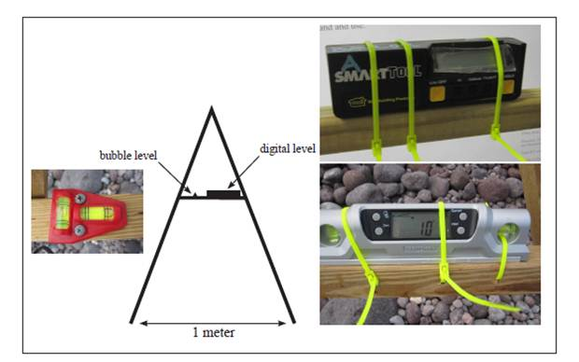

Figure 2.2: A-Frame

* Pictures of the beaches (bijlage)
* Different underground types

# 3. Results

In the first six graphs the different beaches of Sint Eustatius are shown. In every graph are shown the ground types that changes during a period from end September till half December 2015. Almost all transects of the beaches are measured 7 times, with a time period of approximate 2 weeks between the measurements. Each beach has 10 transect, except for Smoke Alley Beach. Due to the ground types number are very low at figure 3.6. Most transects were between 15 a 30 meters long, except for some transects on Zeelandia Beach, because of this the total number of the summed ground types is much higher on Zeelandia beach instead of other beaches (figure 3.5). On every graph is mentioned what type of beach it is and on which side of the island the beach is located. In the graphs of Crook’s Castle is one date missing, because of material problems that cause a lack in the beach profile data. Beaches Crook’s Castle, Oranje Bay and Lynch Beach consist of a lot of boulders or pebbles with sometimes a combination of sand and coral or others (figure 3.1, 3.2 & 3.3). Smoke Alley is a sandy beach with boulders in the swash zone (figure 3.6). Zeelandia Beach and Turtle Beach consist of a lot of sand that reduced over time (figure 3.4 & 3.5). Zeelandia Beach and Turtle Beach have both a very negative meters’ net (-75 & -27) over the period end September – half December (figure 3.7). The beaches on the west side of the island (figure 3.1, 3.2 & 3.3) consist more sand at the last measurement (half & end December) than the first measurement (end September and the beginning of October).

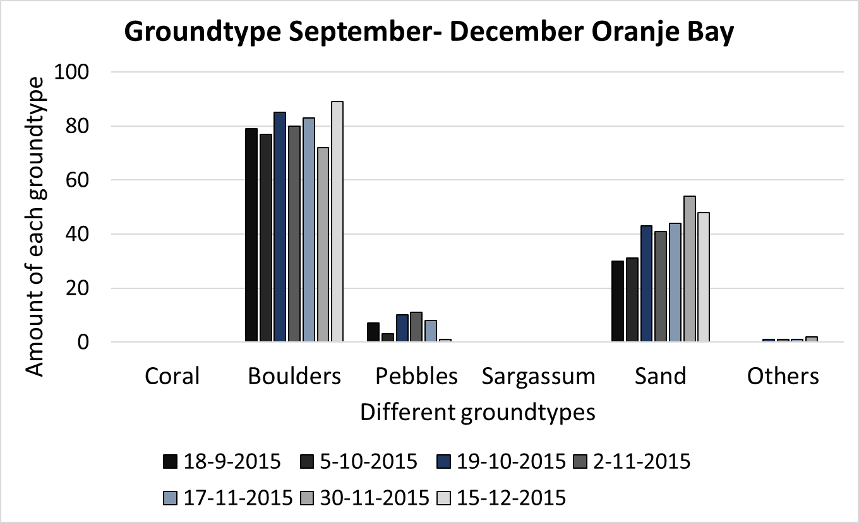

Figure 3.2: Oranje Bay (most part a rocky beach/ west coast)

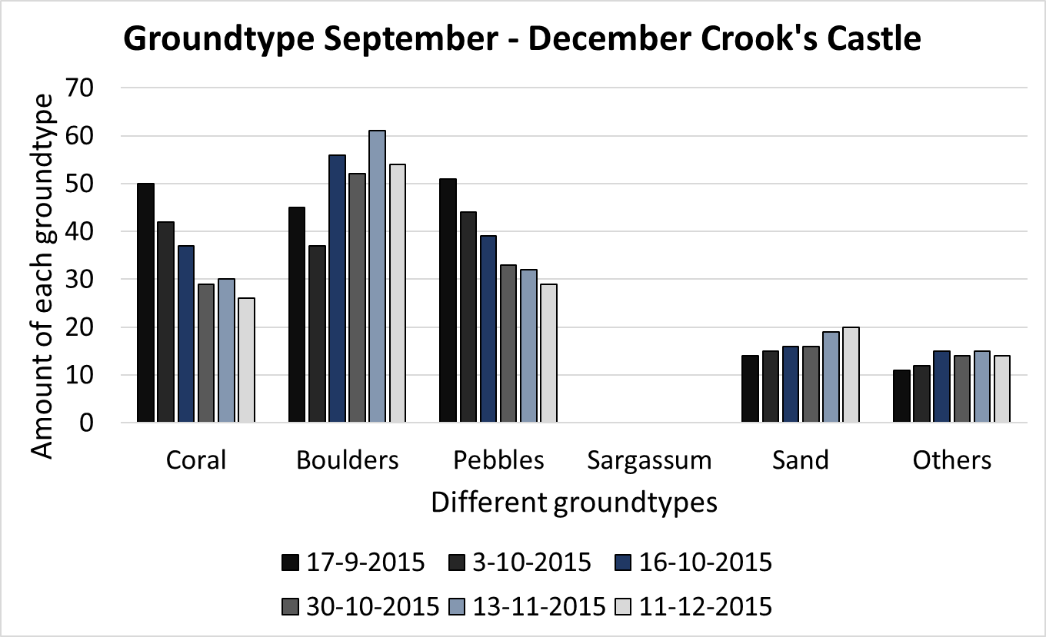

Figure 3.1: Crook Castle (most part a rocky beach/west coast)

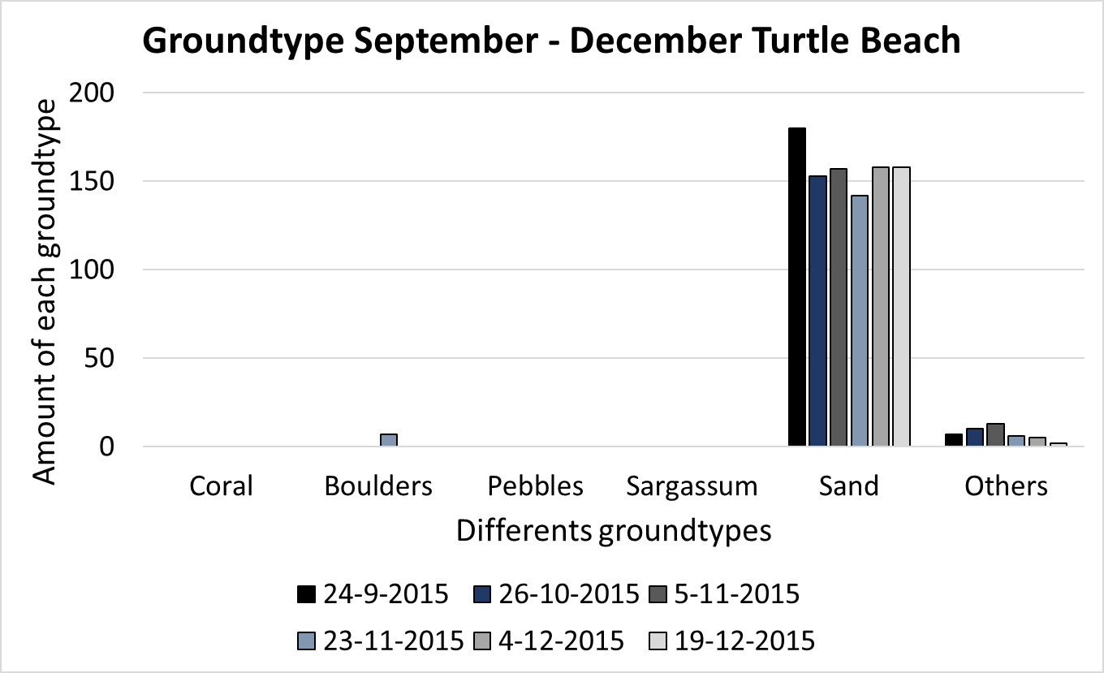

Figure 3.4: Turtle Beach (sandy beach/east coast)

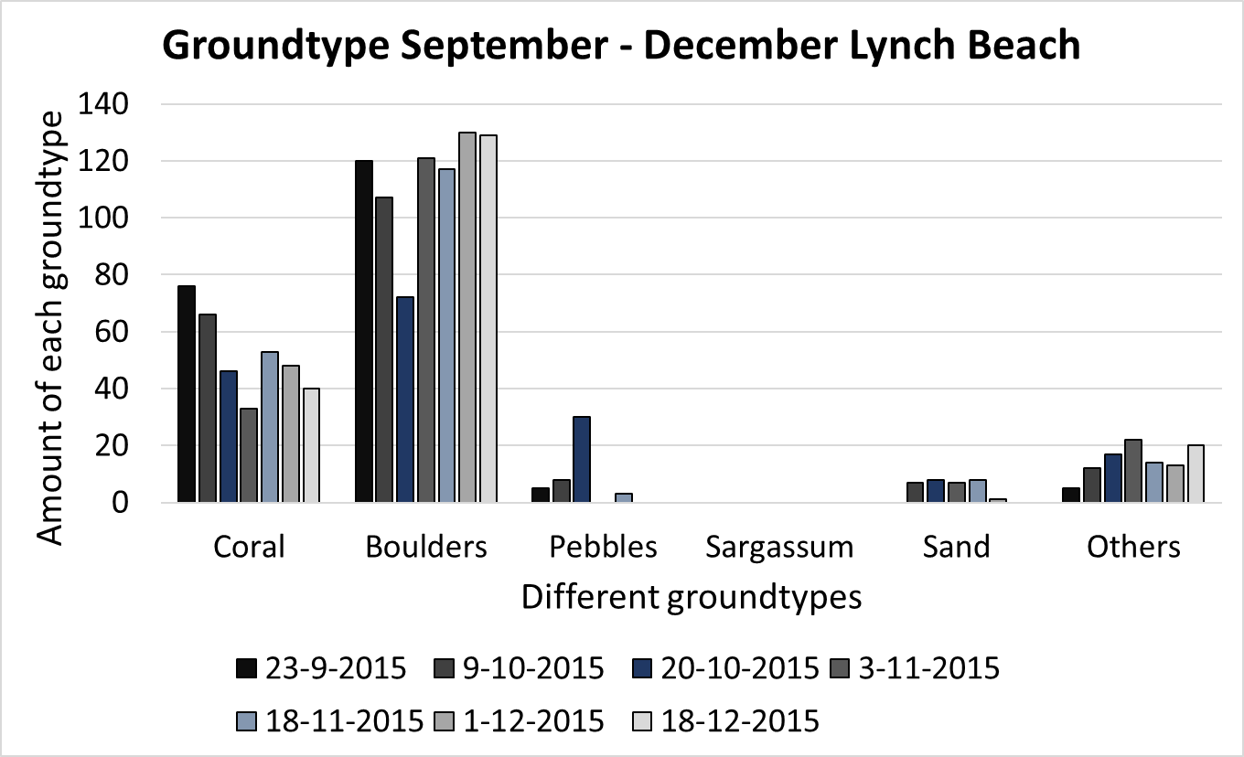

Figure 3.3: Lynch Beach (rocky beach/ east coast)

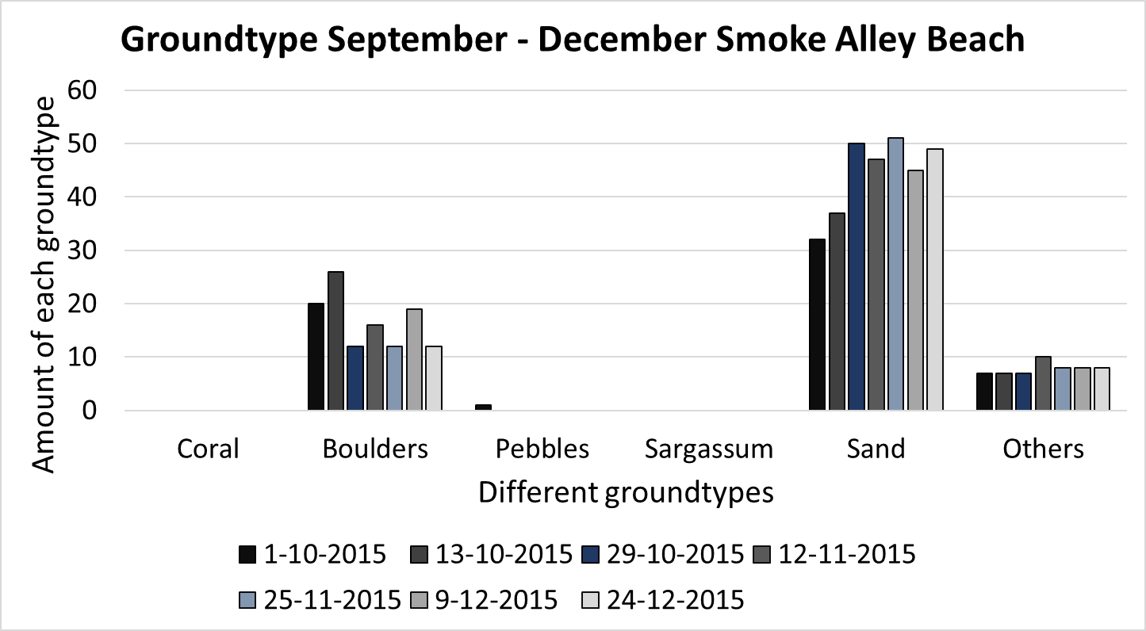

Figure 3.6: Smokey Alley Beach (sandy beach/ west coast)

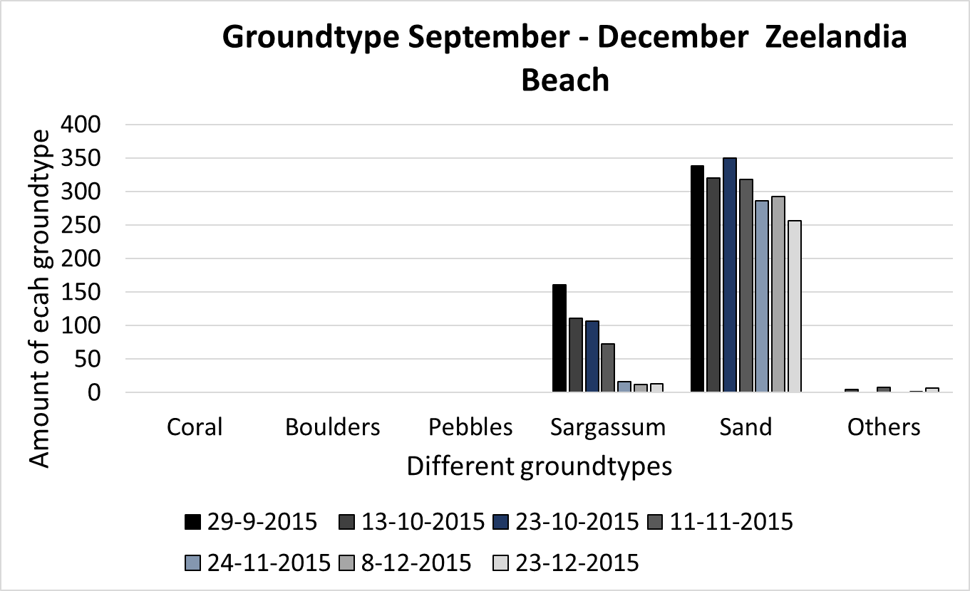

Figure 3.5: Zeelandia Beach (sandy beach/ east coast)

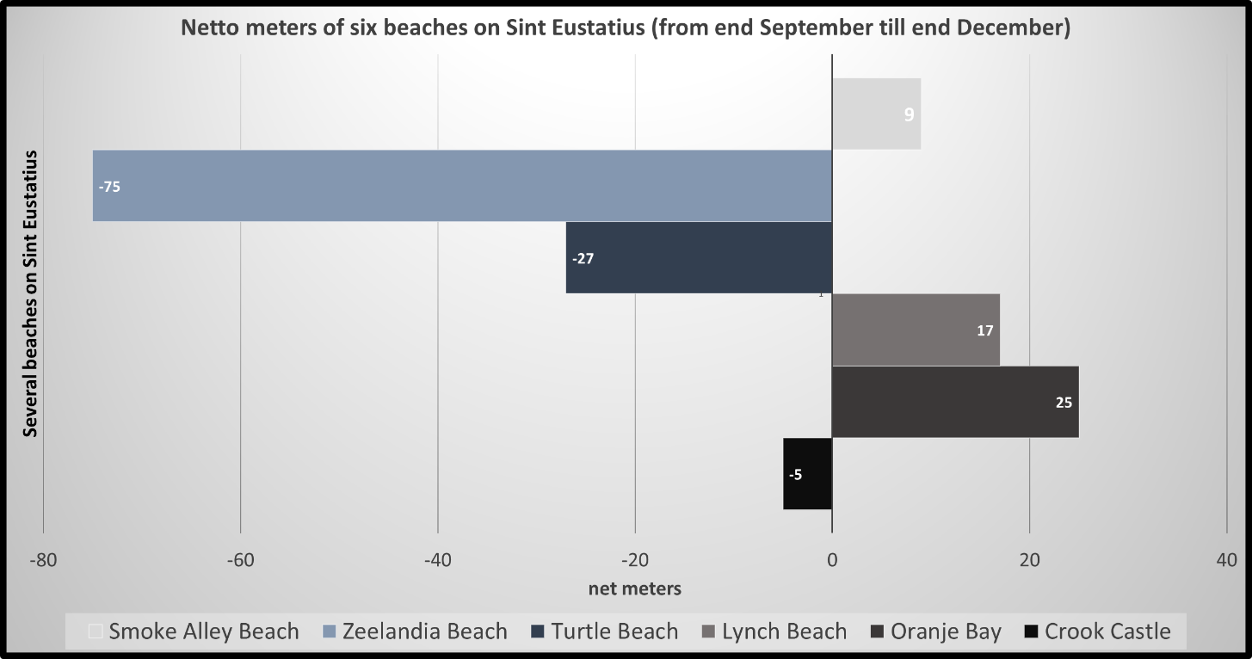

Figure 3.7: Net meters of each beach on Sint Eustatius

These two graphs are showing a difference between a sandy beach and a rocky beach. The beach profile of transect 1 of the beaches Crook’s Castle and Zeelandia are showed in these figures. The beach profile on CC1 demonstrate not a lot of changes instead of ZB1 that demonstrate a lot changes during the time. The angle is much steeper, the length of the transect is shorter and the berm is slowly eroded.

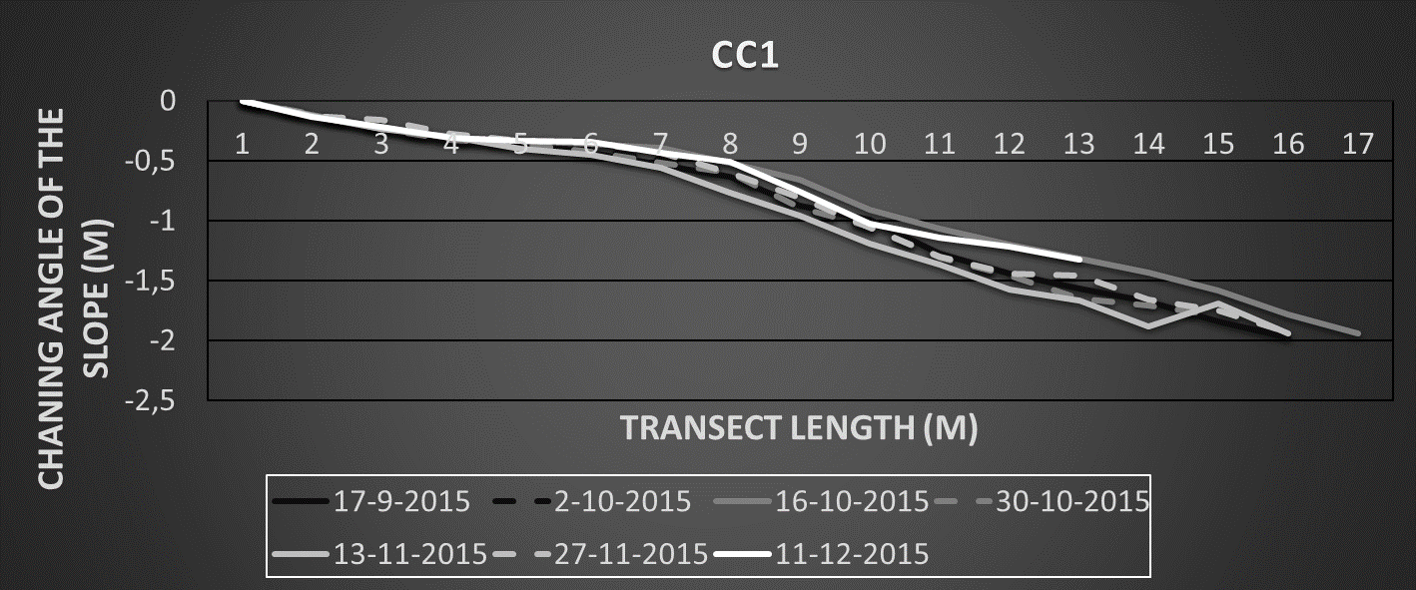

Figure 3.8: Beach profile Crook’s Castle transect 1 (End September – Half December)

# 4. Conclusion

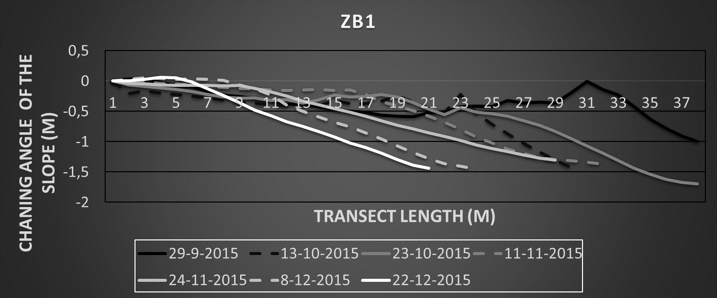

Figure 3.9: Beach profile Zeelandia Beach transect 1 (end September - half December)

On the basis of the results it is possible to make some conclusions. The sandy beaches demonstrate more alternations than the rocky beaches on Sint Eustatius. The beaches Zeelandia and Turtle Beach lay both on the East side of the island, so perhaps it is not only related to the type of sediment, but also on which side of the island a beach is located. The current on the east side could be different than the current on the west side of Sint Eustatius and that could be cause the negative sediment budget, but Lynch beach is not changed so probably there is a link between sandy beaches and more alternation patterns on sandy beaches than on rocky beaches. Furthermore, there is a dominated current from the Southeast (**Joanna Gyory et al., 2013**) and during the rainy season this current is a little bit stronger. This has particularly influence on the sandy beaches on the east side (Zeelandia Beach & Turtle Beach). In the introduction is explained the terms summer profile and storm profile. In the beginning of the survey the beaches Turtle Beach and Zeelandia beach have both a Summer profile, but at the end of the survey both beaches have a beach profile that looks more similar like a storm profile. Earlier is told about the hurricane season between June – November (**Gillian Cambers, 2003**). In this period sand disappeared on the west side of the island, but during the measurements it is visible that the sand comes slowly back during settled weather, this is in case on the beaches Oranje Bay and Smoke Alley B (figure 3.1 & 3.2).

# 5. Discussion

At first the conclusions are based on a research that is examined over a time period of 4 months. Actually more data is needed to make better conclusions about beach profiles on the beaches of Sint Eustatius.

Secondly the tides could be having an influence on the length of the beaches that is measured. It is possible that on some beaches the data always is gathered during low tide and on other beaches the gathering took place when it was high tide.

Furthermore, the A-Frame is one-meter-long, sometimes the A-frame where placed on a berm. The first half of the meter was negative and the other half was negative, because of the one-meter total length of the A-frame this is not visible in the data, but in general the total meters that the profile drops is fairly accurate.

Finally, In the swash zone it was difficult to measure the angle, because of the continuous displacement of sand in this zone of the beach. So the measurement of the angle in the swash zone is the most less accurate measurement. But nevertheless, the faults that have been made probably cancel each other, sometimes is taken a higher angle than it really was and vice versa.

# 6. Acknowledgement

I am very thankful to the people that help me with this research. In the first place I would express my gratitude to my supervisor Martin de Graaf from IMARES. He gives me the possibility to work on the beach profile survey on Sint Eustatius and helped me with arranging all things about the research. As second I will thank Jennifer Rahn who gives me a lot of information and tips how to do the research, arrange the database and how to write the article. Furthermore, I would like to thank Patrick Bron, I appreciate the coordinating of my internship. Also, I appreciate the help of Steve Piontek and Erik Boman for the guidance on the beaches on Sint Eustatius and helping me with material problems. I would like to thank Johan Stapel for providing an excellent accommodation and a pleasant work environment at CNSI. I also very appreciate the help of Amerik Schuitemaker during my stay. He helped me almost every day with gathering data or the processing of data or other things related to the research. At last I would like to thank the students who have gathered data together with Amerik Schuitemaker during the time that I was unable to gather data, because of physical problems.

# 7. References

**Articles and Websites**

Bernabeu, a. M., Medina, R., & Vidal, C. (2003). Wave reflection on natural beaches: An equilibrium beach profile model. *Estuarine, Coastal and Shelf Science*, Volume *57*(4), pg. 577–585. <http://doi.org/10.1016/S0272-7714(02)00393-1>.

Gillian Cambers, (2003). Wise Practices for coping with beach erosion St. Vincent and the Grenadines etc. Unesco publishing. <http://www.unesco.org/csi/act/cosalc/vinb.pdf>.

Jennifer L. Rahn, Heidi J.L. Lannon & Joann Mossa, (March 2015). Diver Depth-Gauge Profiling beyond Wading Depths, A New Simple Method for Underwater Surveying. Journal of Coastal Research, Volume 31 pg. 505-511. <http://www.bioone.org.ezproxy.library.wur.nl/doi/abs/10.2112/JCOASTRES-D-12-00242.1>

Joanna Gyory, Arthur J. Mariano, Edward H. Ryan, 2013. Surface currents in the Caribbean Sea. Ocean Surface Currents. <http://oceancurrents.rsmas.miami.edu/caribbean/caribbean.html>

Kjerfve, B. (1981). Tides of the Caribbean Sea. Journal of Geophysical Research: Oceans (1978–2012). <http://doi.org/10.1029/JC086iC05p04243>.

Paul R. Pinet. 2013. Invitation to Oceanography. *Jones & Bartlett Learning; Burlington* pg. 369-375.

Reguero, B. G., Menndez, F. J., & Losada, I. J. (2013). Variability of multivariate wave climate in Latin America and the Caribbean. Global and Planetary Change, Volume 100, pg. 70–84. <http://doi.org/10.1016/j.gloplacha.2012.09.005>.

Stephen P. Leatherman, Keqi Zhang, Bruce C. Douglas, (2000). Sea level rise shown to drive coastal erosion. EOS, Volume 81, pg. 55-57. <http://onlinelibrary.wiley.com/doi/10.1029/00EO00034/epdf>.

**Pictures**

<http://lighthouse.tamucc.edu/Waves/NearshoreDefinition>

<http://www.pilebuck.com/highways-coastal-environment-second-edition/chapter-5-coastal-sediment-processes/>

# Appendix I field datasheet

