2019

Brent Kaboord

Research report
25-8-2019

A population assessment and habitat description of the Alsophis rufiventris on the Quill and Boven National Park, St. Eustatius
Caribbean Netherlands Science Institute | L.E. Saddlerweg, St Eustatius Caribbean Netherlands

A population assessment and habitat description of the Alsophis rufiventris on the Quill and Boven National Park, St. Eustatius
Author
Brent Kaboord
Education
Applied Biology
Third year
HAS University of Applied Sciences
‘s-Hertogenbosch, The Netherlands

Supervisors
Tim van Wagensveld (RAVON) & Hannah Madden (CNSI)

Supervising professor
Dorith van Gestel (HAS University of Applied Sciences)
Sort report
Research report

Date:
25-08-2019
Source image front page:
Adam Mitchell
Reviews:
Reviewed by: | Date:
Tim van Wagensveld, Msc | 19-08-2019

List of acronyms

Bimodal pattern – A continuous pattern with two distinct peaks every period. A. rufiventris has two activity periods daily with a lag at midday.

Bottleneck effect – A Bottleneck effect happens when a large part of a population dies and only a small part remains. This causes inbreeding within the remaining population. Inbreeding causes loss of genetic diversity, which in turn makes it harder for a population to survive and to prevent extinction.

Diurnal – Active during the day. It is the opposite of nocturnal.

Herpetofauna – The reptiles and amphibians of a particular region, habitat, or geological period.

International Union for Conservation of Nature (IUCN) – The global authority on the status of the natural world. The union keeps track of a ‘red list’. Threatened species will be listed for awareness and conservation efforts among other reasons.

Oviparous – Egg-laying animal.

PIT-tag – Passive integrated transponder tag. An implanted ‘chip’ that can be read using a reader. Each PIT-tag has it’s own unique number. With PIT-tags animals can easily be identified.

Sampling effort – The effort which is needed to gather samples.

Snout – The outer tip of the head of an A. rufiventris individual.

Tail – The outer tip of the tail of an A. rufiventris individual.

Vent – The location of the cloaca of an A. rufiventris individual.

Table of contents

List of acronyms 2
Abstract 4
1. Introduction 5
2. Materials and Methods 7
2.1. Study site 7
2.2. Species description 8
2.3. Sampling method 8
2.4. Population density 11
3. Results 13
4. Discussion 16
5. Conclusion and recommendations 17
6.Literature 18
7. Appendices 21
Appendix I: Permit to conduct research in the National parks of St. Eustatius 21

Abstract
The genus Alsophis used to be very abundant in the Lesser Antilles. Numbers have declined ascribed to anthropogenic causes and the introduction of invasive species to their habitat. Most Alsophis species are classified as endangered or critically endangered by the IUCN. Alsophis rufiventris, a species native to the islands Saba and St. Eustatius, is facing a constant threat of the Javan mongoose being introduced in its habitat. Also dogs, cats, rats and humans actively influence the abundance of A. rufiventris. Though all these threats, the population of A. rufiventris seemed stable and was classified as vulnerable by the IUCN in 2016. In 2017 hurricane Irma and Maria impacted on Saba and St. Eustatius. It was expected that the A. rufiventris population was altered. Therefore a new population assessment was done in the Quill and Boven National Park on St. Eustatius in 2018 and was repeated in this study. In 2018 the population size in the study area was 165.
Distance sampling with line transects was used to estimate the population size of A. rufiventris. In this study 1068 line transect surveys resulted in 60 snakes recordings. As the snake count was sparse, N-mixture models were used as well.
Distance sampling resulted in a population size of 464 and the N-mixture models resulted in a population size of 178. These results are preliminary, as covariates had no influence on the model in the program DISTANCE. While, according to earlier research by Savit et al. in 2015 the covariates should influence the results. Multipliers have to be added in the program DISTANCE to get more accurate results. From this study the habitat preference of A. rufiventris cannot be described, as the findings on habitat categories were not significantly different from each other.
A. rufiventris is becoming more rare in its native habitat and that is a cause for concern. As many threats to the species are present, but also actively influence their abundance, the species might become, or effectively already can be categorized as (critically) endangered. It is advised to continue monitoring of this species not only on St. Eustatius but on Saba as well. Also conservation actions like establishing biosecurity and conducting rodent control might be beneficial. As these conservation actions might not happen in the near future, a breeding program in a zoo might be beneficial to preserve the genetic variance in the population.

1. Introduction
Dipsadidae is a prominent and large family of snake species within Central and South America. One of its genera, Alsophis, used to be very abundant in the Lesser Antilles. Nowadays numbers within the Alsophis genus, down to species level have dramatically decreased (Sajdak et al., 1991). An example is the Antiguan racer (Alsophis antigue), this species had a population size of approximately 50 in the year 1995 and was considered the “world’s rarest snake” (Daltry et al., 2001). The decline in Alsophis species is mostly ascribed to anthropogenic causes and the introduction of invasive species to their habitat (Sajdak et al., 1991).
Most Caribbean species of the Alsophis genus are now classified as endangered or even critically endangered by the International Union for Conservation of Nature (IUCN) (IUCN, 2019). One of the Alsophis species, the red-bellied racer (Alsophis rufiventris), also used to be classified as endangered. Since 2016 however their IUCN status was changed. While threats like mongooses, rats, cats and people were still present, the A. rufiventris population seemed stable. For that reason A. rufiventris was classified as vulnerable (IUCN, 2019; Daltry et al., 2016).

The A. rufiventris is endemic to two islands in the Lesser Antilles, Saba and St. Eustatius. These two islands form a combined range of less than 33km², which is just 10.9% of the species’ historic range. The historic range of A. rufiventris also included St. Kitts and Nevis. Despite surveys on both of the latter islands, there haven’t been any sightings of the snake since before the year 1900. Therefore the species is presumed to have been extirpated on St. Kitts and Nevis (Daltry et al., 2016; Sajdak et al., 1991).

The introduction of the Javan mongoose (Herpestes javanicus) to the Lesser Antilles has caused herpetofauna numbers to decline. The genus Alsophis tends to be more susceptible to invasive mongoose than other reptiles, because they are diurnal, mostly ground-dwelling, oviparous, active foragers and relatively small (Henderson, 1992).
The extirpation of A. rufiventris on St. Kitts and Nevis pre-dates the introduction of mongoose on these islands and is likely caused by other human related causes and the introduction of other invasive species. Mongoose are still a threat to the remaining population of A. rufiventris. Mongoose have not yet been able to sustain a population on Saba or St. Eustatius. For now A. rufiventris is safe from the mongoose, but mongoose are not the only species posing a threat (Henderson et al., 1992; Powell et al., 2015).
Dogs (Canis lupus familiaris), domestic and feral cats (Felis catus), chickens (Gallus gallus domesticus), rats (Rattus rattus), free ranging livestock and humans are a threat towards A. rufiventris as well. Dogs, cats, chickens and rats may injure or kill A. rufiventris individuals (Powell et al., 2015; Daltry, 1997; Hannah Madden, Tim van Wagensveld & Adam Mitchell pers. comm.).
It is commonly seen in A. rufiventris individuals that part of their tail is missing, due to an unfortunate encounter with an invasive predator. Presumably this is mostly caused by rats. Male Alsophis specimen with partial missing tails may have implications for reproductive success, as the hemipenises and retractor muscles are located in the tail (Daltry et al., 1997; Daltry, 2006).
Free ranging livestock, mostly goats (Capra aegagrus hircus), cause changes to habitat through soil degradation, loss of organic matter, reduced water retention and erosion. It is likely that the change in habitat influences the abundance of A. rufiventris (Debrot et al., 2015; Hannah Madden, pers. comm.).
A. rufiventris are harmless to humans, but humans still remain a big threat. Snakes often end up as roadkill or are deliberately killed by humans out of fear(Henderson et al., 1992; Powell et al., 2015).

All these threats indicate that maintaining a stable population by A. rufiventris is pressured. Though in 2016 it was suggested by Daltry, et al. that as long as mongooses do not establish a population on Saba or St. Eustatius, that the A. rufiventris population likely will remain stable. Mongooses have been on St. Eustatius before but were not able to sustain a population (Daltry, et al., 1997; Daltry et al., 2016).
Everyday there is a chance of a mongoose introduction on Saba or St. Eustatius. A lot of traffic destined for Saba or St. Eustatius passes through St. Maarten, where mongooses have a sustained population. On both Saba and St. Eustatius there is no biosecurity and few controls on import. Invasive species have a relatively easy access to these islands (Daltry et al., 1997; Daltry et al., 2016; Adam Mitchell, Hannah Madden and Tim van Wagensveld pers. comm.).

The estimation of a stable A. rufiventris population by Daltry, et al., (2016), was made before two hurricanes impacted on Saba and St. Eustatius. On the 6th and 19th of September 2017 hurricane Irma and Maria did substantial damage to the islands’ forest ecosystems (Eppinga et al., 2018). Alsophis species can be vulnerable to the effects of hurricanes. For example prey abundance reduces (Daltry et al., 2001). A current study done by Jesse and Zilber supports the claim of prey abundance reduction whereas lizard populations might have declined on St. Maarten after hurricanes Irma and Maria (Nature Foundation St Maarten, 2018). Also rat populations decline but quickly recover due to food resources following a hurricane (Tapia-Palacios et al., 2017; Hannah Madden pers. comm.) Habitat alteration and mortality by storms also play a part in the vulnerability of Alsophis species to hurricanes (Daltry et al., 2001; Eppina et al., 2018)
The size and dispersion of the population of A. rufiventris could have been altered by the 2017 hurricanes. After the hurricanes a new population assessment of the A. rufiventris took place on St. Eustatius and indicated that the population there was small in numbers. In 2018 the population estimate was 165, with a minimum of 120 and a maximum of 228 specimen in the national parks on St. Eustatius (Verdel, 2018; Hannah Madden pers. comm.).
If the A. rufiventris population becomes too small it might undergo a bottleneck effect and experience inbreeding depression. Genetic variance will be lost and it might not be possible to achieve a stable population again. Inbreeding depression and loss of genetic variance already happened to another reptile species native to St. Eustatius, the Lesser Antillean iguana (Iguana delicatissima). Less genetic variance makes it harder to conserve the species (Nei et al., 1975; van den Burg, 2018; Adam Mitchell and Tim van Wagensveld pers. comm.). Continuous monitoring of A. rufiventris causes for more knowledge about the size and dispersion of the population over time. This may be useful data if this species is in need of conservation.

The last population assessment was conducted within the Quill National Park and Boven National Park on St. Eustatius (Verdel, 2018). These areas are protected and have lower human activity. The A. rufiventris are also most abundant in the national parks, it is estimated that due to the different microhabitats A. rufiventris tends to stay at a higher elevation (Savit et al., 2005). To get a better estimate of the populations size, growth and dispersion and how this compares to the findings in the last study, this research had to be repeated. The main goal for this research was to get a better insight in the population of A. rufiventris. This research will take place in the same area as the last assessment. This will allow for a repeated assessment.

2. Materials and Methods

2.1. Study site
This research was conducted within the Quill National Park and Boven National Park on the island St. Eustatius. St. Eustatius(21 km²) consists of two volcanic areas, which are separated by lowlands (Andel et al., 2016). The Quill National Park mainly covers the dormant volcano ‘the Quill’ from 250 meters elevation and up. Boven National Park covers the northern hills on St. Eustatius (figure 1)(STENAPA, 2019).
The national parks are protected, managed and maintained by STENAPA. To conduct research in these national parks a permit has been granted by Clarisse Buma, director of STENAPA (Appendix I).

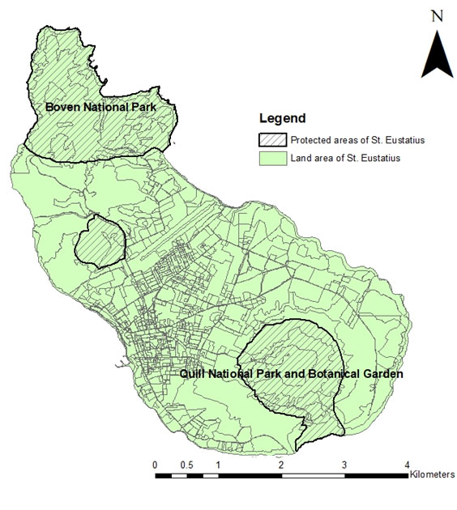
Figure 2.1.1: Map of St. Eustatius with both Quill National Park and Boven National Park indicated (Layer source: Dutch Caribbean Biodiversity Database).

2.2. Species description
This research is on the A. rufiventris, also known as the Red-bellied racer, Orange-bellied racer and Saba racer, (Daltry et al., 2016). The name rufiventris derived from Latin rufus, meaning ‘red’, and venter, meaning ‘belly’ (Powell et al., 2015).
A. rufiventris is a snake of moderate size. The Snout-Vent length is commonly less than a meter, but exceptionally large specimens may approach a total body length of 1.5 meters. Its colours range from pale to dark brown and to grey and grey-brown. The colours and patterns also tend to differ between the sexes, which may be a sign that this species is sexual dimorphic. Males tend to have a pattern of black-bordered brown blotches on the middle of the back that deteriorates towards the tail into a broad dark stripe. Females tend to have a series of streaks and smudges down the back, becoming less obvious towards the tail. Also females have longer and broader heads than males (figure 2.2.1 & figure 2.2.2)(Daltry et al., 1997; Powell et al., 2015; Zobel, 2017).
The diet of A. rufiventris mostly consists of small reptiles and amphibians. It forages and actively hunts for prey on the ground, although it can and will sometimes forage high in trees. The snake is strictly diurnal, but it tends to avoid the hottest times of the day. Not much is known about the reproduction of the snake, but other species of its genus are oviparous (Savit et al., 2005; Powell, 2006; Powell et al., 2015; van Wagensveld et al., 2017; Zobel et al., 2018).

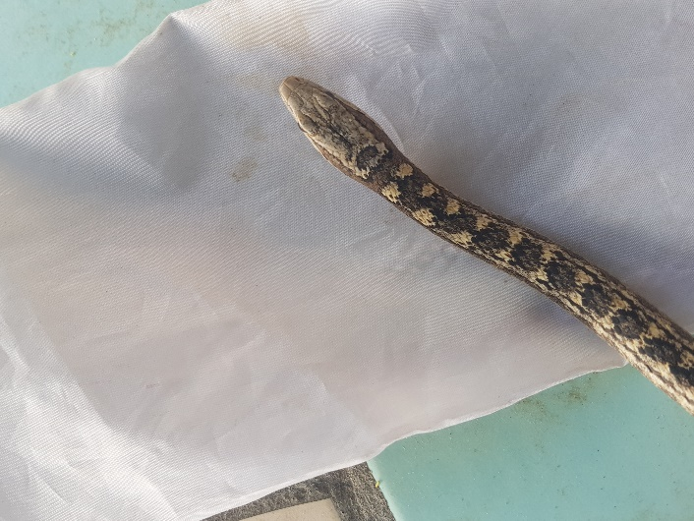  Figure 2.2.1: Picture of a male A. rufiventris by Brent Kaboord. | 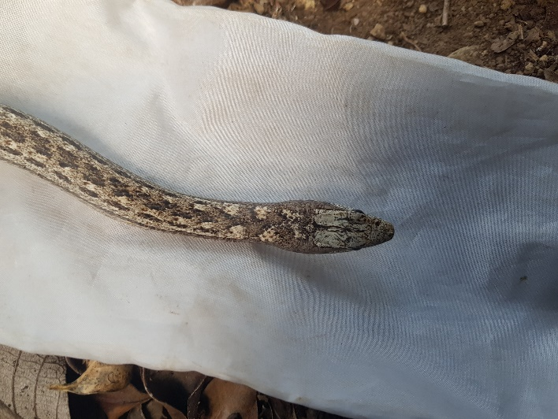  Figure 2.2.2: Picture of a female A. rufiventris by Brent Kaboord.

2.3. Sampling method
The Caribbean Netherlands Science Institute set out evenly distributed GPS locations over St. Eustatius in the past. These GPS locations could be used for research of all sorts. 98 of these GPS locations were used in the previous population assessment on A. rufiventris. All 98 GPS locations were set in the Quill and Boven National Parks (Figure 2.3.1). These GPS locations were picked because only the trails containing these GPS locations were accessible after the hurricanes Irma and Maria (Verdel, 2018; Hannah Madden, Kevin Verdel pers. comm.). By having repeated the previous study, an estimate of the size and density of the population of A. rufiventris could be made over time.
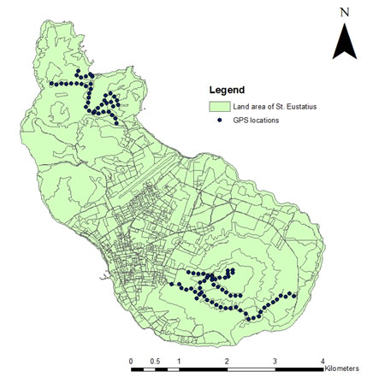
Figure 2.3.1: Map of St. Eustatius with 98 set GPS locations indicated. Based on Verdel’s study in 2018 (Layer source: Dutch Caribbean Biodiversity Database).
With the 98 GPS locations, 92 line transects were set (Figure 2.3.2). The line transects were only surveyed in between dawn and dusk, roughly in between 0500-1900 h. This was done as in 2005 it was suggested by Savit et al. that A. rufiventris are strictly diurnal. A. rufiventris’s activity has a bimodal pattern with a lag at midday (Savit et al. 2005). Bimodality in daily activity is not rare in snakes and seems to be influenced by temperature (Gibbons et al., 1987; Peterson et al. 1993). Temperature differs daily and temperature and time of day were covariates, so the surveys did not stop midday. Savit et al. also stated that encounter rates of A. rufiventris are influenced by air temperature, surface temperature, elevation and time of day. All factors that could be measured with the available equipment were used as covariates.
The line transects were all surveyed at least 10 times (Hannah Madden pers. comm.). Each survey was done at a slow pace (Savit et al., 2005). During these surveys A. rufiventris were observed and caught. When a specimen was caught the transect time stopped so it could be measured.
This study took place from February 2019 till the end of June 2019.
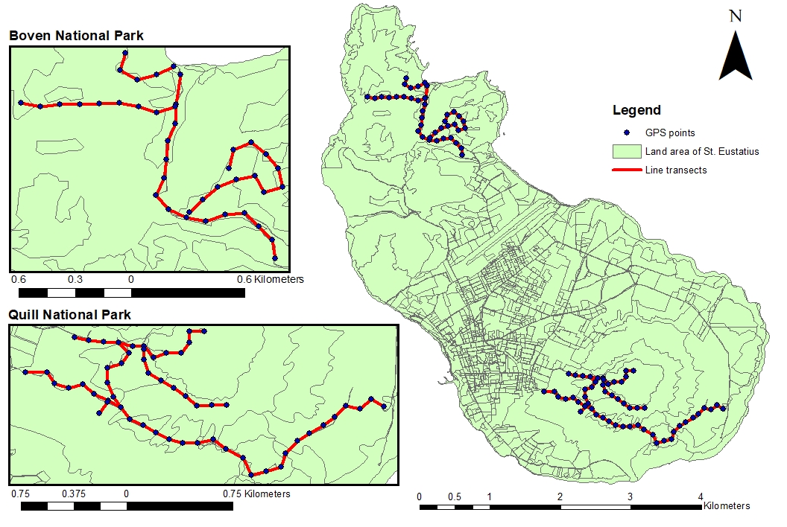
Figure 2.3.2: Map of St. Eustatius with 92 line transects set out in Boven National Park and Quill National Park (Layer source: Dutch Caribbean Biodiversity Database).

At the start of each transect multiple variables were measured(table 1). Elevation was measured with a GPS, model “eTrex 10, GARMIN”. Temperature and wind speed were measured using an “ADC wind, BRUNTON”.
Every line transect was situated in a certain habitat category, this habitat category was also used as covariate. The different habitat categories that were used in this study were described by Eupen and Puijk in 2015. The habitat categories that are in the study area and are relevant to this study are: ‘capparis Pisonia’, ‘crater rim north side’, ‘dry river bed’, ‘inner quill’, ‘pissionia bothro (plant, grass)’, ‘pisonia Eugenia and capparis anthirea vegetation’, ‘pisonia justician hill (plant, plant)’ and ‘upper part quill - chionanthus Nectandra’ (Eupen et al., 2015).

Table 2.3.1: List of variables, which were noted per surveyed line transect.
Variable | Value
TransectID | Number
Repetition number | Number
Date | dd-mm-yy
Start time | hh:mm
End time | hh:mm
Elevation | m
Temperature | °C
Wind speed | Km/h
Cloudiness | Yes/no
Rain | Yes/no
Habitat category | String
Disturbance | Yes/no

When an A. rufiventris individual was encountered and caught data was collected (table 2). A PIT-tag number was collected using a “Halo Scanner”. If no PIT-tag was present in the specimen a new PIT-tag was implanted (only when PIT-tags were available for use). GPS locations were fixed with a GPS, model “eTrex 10, GARMIN”.
The length of the snake was measured using a piece of thin rope. The rope follows a coiled snakes spine more easily. After measuring the length with the rope, the rope was measured using a tape measure (Tim van Wagensveld & Naomi Lambrikx, pers. comm.).
Weight was measured using a “1000g Pesola spring scale”.
Every captured snakes head was photographed from the top, bottom and lateral sides. These photographs are additional data and might be used for a photograph database in the future. Individual snakes might be identifiable by taking pictures of them (Tim van Wagensveld, pers. comm.).
When the capture failed only time of day, perpendicular distance, side of line transect, behaviour, sunlight, substrate and the GPS location were noted.
Perpendicular distance was measured with a measuring tape.

Table 1.3.2: List of variables, which were collected after encountering (and catching) an A. rufiventris.
Variable | Value
Time of day | hh:mm
Perpendicular distance | cm
Side of line transect | Left / centre / right
Sex | Male / female
Maturity | Juvenile / subadult / adult / large adult
PIT-tag number | Text
Behaviour | Sprawled / moving / coiled
Sunlight | Full sun / partial sun / shade
Substrate | Leaves / rock / leaves and rock / sand
GPS location | Coordinates
Length snout to vent | cm
Length vent to tail | cm
Total length | cm
Weight | kg

2.4. Population density
To estimate the density of the A. rufiventris population the data was modelled with the program DISTANCE version 7.3. All possible different key functions were used in combination with all different adjustments to get a successful model to estimate density (Buckland et al., 2001; Boal, 2018; Thomas et al., 2010; Hannah Madden pers. comm.). DISTANCE calculated a detection probability, the further away a specimen was from the line transect, the less likely it was to be detected. Based on detection probability and study area size DISTANCE calculated a population estimate (Buckland et al., 2001).
The population density of A. rufiventris was suggested to be relatively low in the study area in 2018, based on a sparse count of snakes. In this study the number of snakes counted was sparse as well. When surveys generate sparse count data it may be more difficult to estimate population size. In cases like this, N-Mixture models can be used to estimate population size (Royle, 2004; Hannah Madden pers. comm.). The N-mixture models were conducted in Rstudio. To get a better and more complete insight in the population density of A. rufiventris in the study area, both DISTANCE and N-Mixture models were used.
Additionally, due to the low frequency of sightings, population density was also calculated by including distances linking surveyed transects and time spent in the field. This sampling effort is expressed in specimen per unit time spent searching, unit time spent searching per specimen and distance per specimen. The sampling effort will be classified by trails (Figure 2.3.1), as this is an easy way to distinguish areas from one another (Debrot et al., 2013; Kevin Verdel & Tim van Wagensveld pers. comm.).

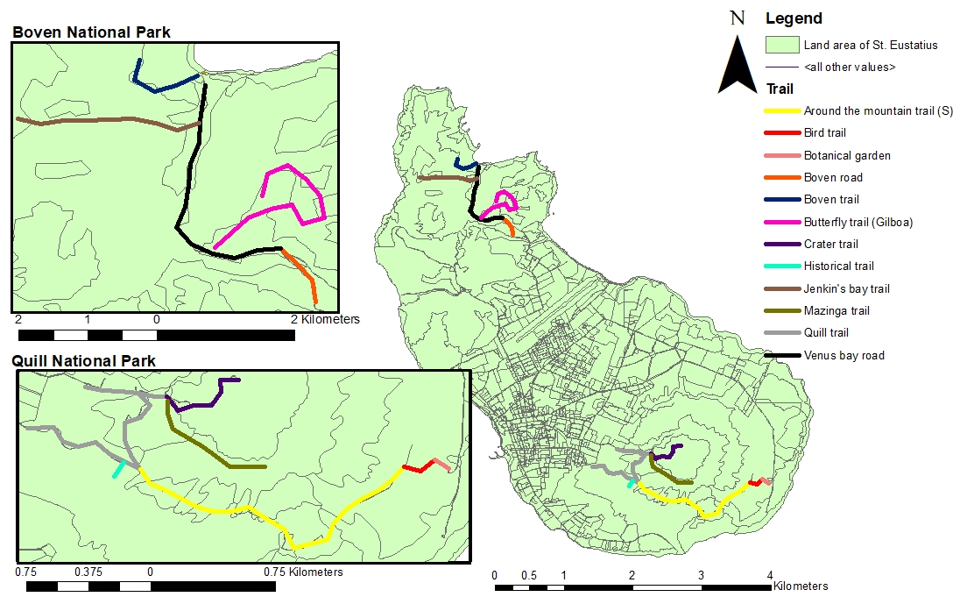
Figure 2.3.1: Map of St. Eustatius with trails displayed (Layer source: Dutch Caribbean Biodiversity Database).

3. Results
In the previous study from 2018, 1467 line transect surveys were conducted and 54 A. rufiventris specimen were recorded in these surveys. In this study 1068 line transect surveys were conducted with 60 snake specimen recordings, in which there were significantly more observations (P = 0.007).

A half-normal function with the simple polynomial adjustment provided the best fit for the data from this study within DISTANCE 7.3. This model resulted in a population size of 464 individuals within the study area. The detection probability calculated in this model can be seen in Figure 3.1.
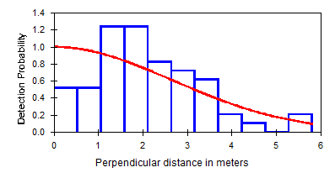
Figure 3.1: Detection probability of Alsophis rufiventris over perpendicular distance (m) from line transect. The figure was modeled using the half-normal key function and the simple polynomial adjustment, with no co-variates. Detection probability in red color based on the findings displayed in blue color.
The N-Mixture model resulted in a population size of 178 with a minimum of 173 and a maximum of 182.

Table 3.1 shows the locations of snakes sighted during this study and the effort put in to find them. The sampling effort of Verdel in 2018 is also included for comparison.

Table 2.1: Alsophis rufiventris sampling effort on different trails in the Quill and Boven National Park and the number of A. rufiventris detected, expressed as specimen per hour searched, hour searched per specimen and distance per specimen. Results by Verdel (2018) are included for comparison.
Trail name | Total search effort (min) | Surveyed distance (m) | Total snakes | m/snake | Snakes/h | h/snake | 2018 h/snake
Around the mountain trail (S) | 1288 | 21819 | 5 | 4363.8 | 0.2 | 4.3 | 3.1
Bird trail | 144 | 2233 | 0 | - | 0.0 | - | -
Botanical garden | 45 | 1089 | 0 | - | 0.0 | - | -
Boven road | 154 | 2990 | 1 | 2990.0 | 0.4 | 2.6 | -
Boven trail | 222 | 3940 | 2 | 1970.0 | 0.5 | 1.9 | -
Butterfly trail (Gilboa) | 819 | 11099 | 10 | 1109.9 | 0.7 | 1.4 | 2.0
Crater trail | 894 | 7992 | 1 | 7992.0 | 0.1 | 14.9 | 3.4
Historical trail | 143 | 1528 | 3 | 509.3 | 1.3 | 0.8 | -
Jenkin's Bay trail | 973 | 10138 | 14 | 724.1 | 0.9 | 1.2 | 11.6
Mazinga trail | 965 | 8536 | 6 | 1422.7 | 0.4 | 2.7 | 1.3
Quill trail | 2491 | 25793 | 15 | 1719.5 | 0.4 | 2.8 | 4.0
Venus bay road | 641 | 13019 | 3 | 4339.7 | 0.3 | 3.6 | -
Total | 8779 | 110176 | 60 | 1836.3 | 0.4 | 2.4 | 2.8

Snake recordings per habitat category have been summed up and shown in Figure 3.2. There was no significant difference in the number of snakes per habitat category (P = 0.060).

Figure 3.2: Number of snakes recorded per habitat category.

Temperature seemed to have no significant correlation with the abundance of snakes in this study (P = 0.823). The number of snake recordings at different temperatures is shown in Figure 3.3.

Figure 3.3: Number of snakes recorded at different temperatures.
Also elevation had no significant correlation with snake recordings in this study (P = 0.558). All snake recordings are shown in Figure 3.4 at the elevation of the transect they were on.

Figure 3.4: Snake recordings at each transect elevation.

To give an indication on the dispersion of A. rufiventris in the surveyed area a density map was made (Figure 3.5). This does not show the whole study area, as only a part of the study area was surveyed for this study. Spatial analyst was not used because of irregular findings on the Butterfly trail (Gilboa) during the study, instead a normal density map was made. A 200 meter range was used. It is not known whether this snake species is territorial and how big their territory might be. In this study a repeated capture of a snake individual occurred, which were 200 meter apart.
As the findings on the Butterfly trail (Gilboa) were irregular, it cannot be considered a snake hotspot. Around Jenkin’s Bay trail and the Historical trail it seems that more snakes were found than in other places, though the difference is not significant (P = 0.607).

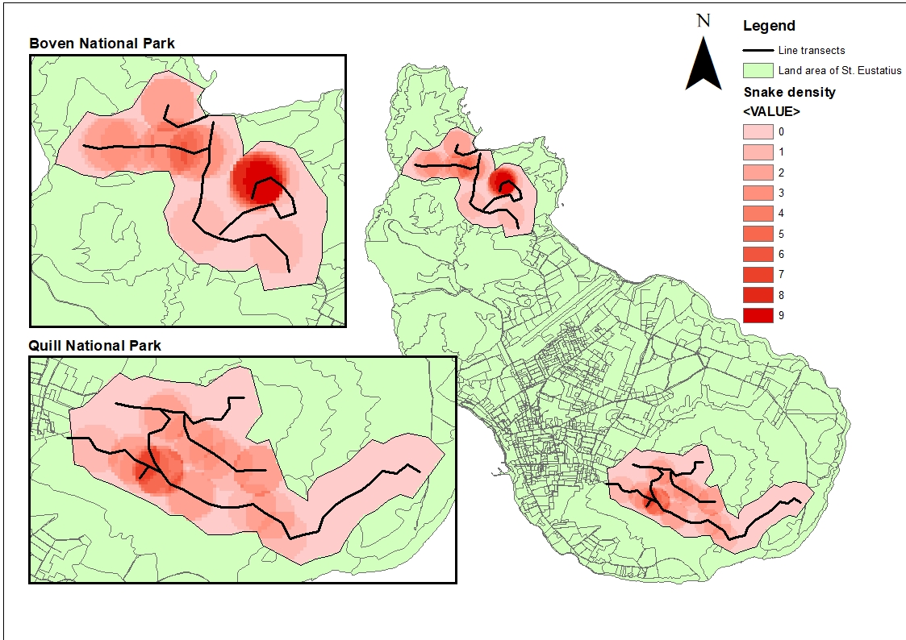
Figure 3.5: Density map of A. rufiventris based on findings in 2019.

4. Discussion
As in this survey significantly more recordings of A. rufiventris have been done it could indicate that A. rufiventris became more abundant. It could also be that Kaboord was better at finding snakes in this study than Verdel was in 2018. Both, this assessment and the assessment of 2018, used distance sampling. The program DISTANCE takes detection probability in account. If a researcher in one assessment is better at detecting than the other one in another assessment, it doesn’t influence the results from distance sampling (Buckland et al., 2001).

According to the model in DISTANCE the A. rufiventris population has grown in the study area compared to the results from the previous study. The given population size is 464, which is more than twice the population size last recorded. It is possible that the population A. rufiventris is recovering from 2017’s hurricanes. This would be conflicting with the other results acquired from this study. The N-Mixture model analysis states that the population size would be 178. While conducting the analysis in DISTANCE it showed all covariates involved had no significant influence on the outcome of the analysis. Covariates, such as temperature, elevation and time of day, should have influence on the outcome of the analysis. In 2005 Savit et al. claimed that these covariates significantly correlated with the encounter rate of A. rufiventris (Savit et al. 2005). As the population A. rufiventris presumably declined due to the hurricanes in 2017 it might have become so small that covariates don’t seem to have any influence on the outcome.
While it is ideal to estimate a population size using distance sampling with a minimum of 60-80 observations it might be different in this case. If a population is too small and it takes too many transect surveys to get to 60-80 observations covariates might not seem to have any effect on the outcome (Buckland et al. 2001; Hannah Madden & Frank Rivera Pers. Comm.). To still get an accurate population size estimate from DISTANCE covariates have to translated to multipliers that have to be used into the calculations. Presumably the results will be closer to the N-Mixture model results when multipliers have been added (Hannah Madden, Frank Rivera pers. comm.).
On average a sampling effort of 2.4 hours is needed to find one A. rufiventris specimen in the study area. In the previous study the average sampling effort was 2.8 hours. This means there might be a small increase in the population size of the A. rufiventris. There is no significant difference yet, so the variation in sampling effort might be a coincidence.

A goal in this study was to find out what habitat A. rufiventris prefers and where it is most likely found. While, in the end there were noticeable differences in the numbers of specimen per habitat category, there were no significant differences between the habitat categories. Most likely because there were so few observations over time. Habitat likely has influence on the abundance of A. rufiventris but it can’t be proven with the data gathered in this study.
Another reasoning for the absence of significant differences between habitat categories might be that habitats have been altered after the hurricanes from 2017 (Eppinga et al., 2018). The habitat categories used in this study, while being the most recent data on habitat categories on St. Eustatius, were pre-hurricanes (Eupen et al., 2015).

The density map shows one very bright red spot on the Butterfly trail (Gilboa). It is indicated that A. rufiventris specimen can be found more often there than other places. During most of the surveys very few A. rufiventris could be found in that spot. During this study a rather big storm occurred on the 3rd of June. That day after the storm, the 4th of June, 8 snakes were found within 200 meters of each other in the described spot. This was very unusual and might have a relation to the rainfall. Seven out of the eight snakes found were male. This could also indicate that there was an opportunity to mate, since males typically become more active during breeding season, as they roam in search of females. There is not much known about the reproductive biology of A. rufiventris, but in 1997 Daltry et al. estimated that the breeding season might be around March till May based on only two observations (Daltry et al., 1997). As the observations in this study were in early June, it is possible it was because of ideal conditions during breeding season.

5. Conclusion and recommendations
While the results on the population size in study area are still preliminary, it is safe to say that A. rufiventris are rare on St. Eustatius at this moment. If the population size truly still is approximately 200 individuals it is a cause for concern. Future hurricanes could cause a massive impact on this already small population. While the threat of invasive mongoose, cats, dogs and rats is still present it seems almost impossible that the native snake species can remain extant.

A. rufiventris is suggested to be more abundant on Saba than on St. Eustatius (Daltry et al. 1997). No present numbers are known about the A. rufiventris population on Saba. Before the hurricanes in 2017 there used to be a sampling effort of 20 minutes per snake (Daltry et al., 2016). That is a relatively small sampling effort compared to 2 hours and 26 minutes per snake on St. Eustatius nowadays.

Currently A. rufiventris is classified by the IUCN as vulnerable. Now that the population on St. Eustatius is known to be very small and not much is known about the population on Saba it might be in the interest of the species to reconsider its IUCN status. As many threats to the species are present, but also actively influence their abundance, the species might become, or effectively already can be categorized as (critically) endangered.

To be able to prevent A. rufiventris from becoming extinct continuous monitoring is necessary. Furthermore there needs to be continuous monitoring on not only St. Eustatius but also on Saba.
Besides monitoring multiple actions can be taken to conserve the A. rufiventris population on St. Eustatius and Saba. Biosecurity and rodent control are probably the most important actions that can be conducted at the moment. Setting up biosecurity in the harbor and airports of St. Eustatius and Saba, may stop invasive species from entering the islands (Adam Mitchell & Tim van Wagensveld pers. comm.). Rodent control will presumably greatly benefit A. rufiventris, as great population growth was recorded with a closely related species Alsophis antigue following rat eradication. Rodent control will not only benefit A. rufiventris but other native species as well (Bell et al., 2014; Daltry, 2006). Unfortunately rodent control will only be 100% effective when there is active biosecurity. Otherwise new rats will continuously enter the islands.
Rodent control initiatives face other problems as well on St. Eustatius at the moment. Terrestrial crabs eat poison meant for rodents. Inhabitants of St. Eustatius often hunt terrestrial crabs to eat them. As of this reason rodent control stopped in the National parks, for the safety of the inhabitants of St. Eustatius (Hannah Madden pers. comm.).
Beside biosecurity and rodent control there could be a focus on feral cats. It is presumed cats have a substantial impact on the A. rufiventris population and other herpetofauna abundance (Tolson, 1996; Daltry et al., 1997). Though no specific data has been gathered on this matter. Feral cat monitoring is advised to acquire new knowledge about the impact of cats on A. rufiventris or other herpetofauna.
Also free ranging livestock is actively changing native habitats on St. Eustatius and Saba. Livestock could be controlled by eradicating the free roaming individuals. Legislation on the keeping of livestock could be changed as well so livestock has to be kept on private property only.

Most stated conservation actions cost a lot of effort, money and attention from the Dutch government. Unfortunately the Dutch government either take a long time to process the ecological problems or even refuse to fund conservation projects in the Dutch Caribbean (Adam Mitchell, Hannah Madden & Tim van Wagensveld pers. comm.). As the listed most important conservation actions might not happen in the near future, it may be in the best interest of the species A. rufiventris to consider alternatives.
To prevent loss of genetic variance of A. rufiventris in the future, a breeding program could be set up. Preferably in a zoo, as St. Eustatius and Saba contain invasive predators and might not be a perfectly safe environment.
Also species in zoos are ambassadors of their wild relatives and could cause for funding of local projects, as information about ecological problems gets to the public (EAZA, 2019).

6.Literature
Andel, T. van, Hoorn, B. van der, Stech, M., Arostegui, S. B., Miller, J. (2016). A quantitative assessment of the vegetation types on the island of St. Eustatius, Dutch Caribbean. Global Ecology and Conservation, 7, 59-69. https://doi.org/10.1016/j.gecco.2016.05.003
Bell, E.A. & Daltry, J.C. (2014). Dog Island Restoration Project: Two-year Assessment Following the Eradication of Black Rats (Rattus rattus) From Dog Island, Anguilla. Report from Wildlife Management International Ltd and Fauna & Flora International, New Zealand and UK
Boal, C.W. (2018). Estimates of abundance and longevity of Bridled Quail-Doves (Geotrygon mystacea) on Guana Island, British Virgin Islands. The Wilson Journal of Ornithology, 130(4), 981-987
Buckland S.T., Anderson D.R., Burnham K.P., Laake J.L., Borchers D.L., Thomas L. (2001). Introduction to distance sampling: estimating abundance of biological populations. New York (NY): Oxford University Press.
Burg, M.P. van den, Meimans, P.G., Wagensveld, T. van, Kluskens, B., Madden, H., Welch, M.E., Breeuwer, J.A.J. (2018). The Lesser Antillean Iguana (Iguana delicatissima) on St. Eustatius: genetically depauperate and threatened by ongoing hybridisation. Journal of Heredity, 109, 426-437. doi:10.1093/jhered/esy008
Daltry, J.C., Day, M.L., Ford, N.B. (1997). Red-bellied racer conservation project. Fauna & Flora International.
Daltry, J.C., Bloxam, Q., Cooper, G., Day, M.L., Hartley, J., Henry, M., Smith, B.E. (2001). Five years of conserving the “world’s rarest snake”, the Antiguan racer Alsophis antigue. Oryx, 35(2), 119-127. https://doi.org/10.1046/j.1365-3008.2001.00169.x
Daltry, J. C. (2006). Control of the black rat Rattus rattus for the conservation of the Antiguan racer Alsophis antiguae on Great Bird Island, Antigua. Conservation Evidence, 3, 28-29.
Daltry, J.C. (2006). The effect of black rat Rattus rattus control on the population of the Antiguan racer snake Alsophis antigue on Great Bird Island, Antigua. Conservation evidence, 3, 30-32.
Daltry, J.C., Powell, R. (2016). Alsophis rufiventris. The IUCN Red List of Threatened Species.
Debrot, A.O., Boman, E.B., Madden, H. (2013). The Lesser Antillean Iguana on St. Eustatius: A 2012 Population Status Update and Causes for Concern. IRCF Reptiles & Amphibians, 20, 44-52.
Debrot, A.O., Hazenbosch, J.C.J., Piontek, S., Kraft, C., Belle, J. van, Strijkstra, A. (2015). Roaming livestock distribution, densities and population estimates for St. Eustatius, 2013. Report number C088/15. IMARES Wageningen UR.
EAZA. (2019). About us. https://www.eaza.net/about-us/. Retrieved on: 22th of August 2019
Eppinga, M.B., Pucko, C.A. (2018). The impact of hurricanes Irma and Maria on the forest ecosystems of Saba and St. Eustatius, northern Caribbean. Biotropica, 50, 723-728.
Eupen, M. van, Puijk, A. (2015). The analysis of ecological networks: habitat connectivity and population viability on St.Eustatius. Unpublished. https://www.dcbd.nl/document/habitat-map-steustatius. Retrieved on: 9th of August 2019

Gibbons, J.W., Semlitsch, R.D. (1987). Activity patterns. In: Snakes: Ecology and Evolutionary Biology. 396-421.
Henderson, R. W. (1992). Consequences of predator introductions and habitat destruction on amphibians and reptiles in the post-Columbus West Indies. Caribbean Journal of Science, 28, 1–10. https://doi.org/10.1016/0006-3207(94)90040-X
IUCN 2019. The IUCN Red List of Threatened Species. Version 2019-1. http://www.iucnredlist.org. Retrieved on: 20th of March 2019.
Madden, H., Andel, T., Miller, J., Stech, M., Verdel, K., Eggermont, E. (2019). Vegetation associations and relative abundance of rodents on St. Eustatius, Caribbean Netherlands. Global Ecology and Conservation.
Nei, M., Maruyama, T., Chakraborty, R. (1975). The Bottleneck effect and genetic variability in populations. International journal of organic evolution, 29. https://doi.org/10.1111/j.1558-5646.1975.tb00807.x
Peterson, C.R., Gibson, A.R., Dorcas, M.E. (1993). Snake thermal biology: The causes and consequences of bodytemperature variation. In: Snakes: Ecology and Behavior, 241-314.
Powell, R., Henderson, R.W., Parmerlee, J.S. (2015). The Reptiles and Amphibians of the Dutch Caribbean: St. Eustatius, Saba and St. Maarten. Second edition, revised and expanded. Nature Guide Series No. 004. Dutch Caribbean Nature Alliance, Bonaire, Dutch Caribbean, 238-241.
Royle, J.A. (2004). N-Mixture Models for Estimating Population Size from Spatially Replicated Counts. Biometrics, 60, 108-115.
Sajdak, R. A., Henderson, R. (1991). Status of West Indian racers in the Lesser Antilles. Oryx, 25(1), 33–38. https://doi.org/10.1017/S0030605300034049
Savit, A., Maley, A., Heinz, H., Henderson, R., Powell, R. (2005). Distribution and activity periods of Alsophis rufiventris (Colubridae) on The Quill, St. Eustatius, Netherlands Antilles. AmphibiaReptilia, 26, 418–421. https://doi.org/10.1163/156853805774408621
STENAPA. (2019). Our Parks. http://www.statiapark.org/our-park/. Retrieved on: 14th of March 2019.
Tapia-Palacios, M.A., García-Suárez, O., Sotomayor-Bonilla, J., Silva-Magaña, M.A., Pérez-Ortíz, G., Espinosa-García, A.C., Ortega-Huerta, M.A., Díaz-Ávalos, C., Suzán, G., Mazari-Hiriart, M., (2017). Abiotic and Biotic Changes at the Basin Scale in a Tropical Dry Forest Landscape after Hurricanes Jova and Patricia in Jalisco, Mexico. Forest Ecology and Management, no. October. Elsevier: 1–9, 621. https://doi.org/10.1016/j.foreco.2017.10.015.
Thomas, L., Buckland, S.T., Rexstad, E.A., Laake, J.L., Strindberg, S., Hedley, S.L., Bishop, J.R.B., Marques, T.A., Burnham, K.P. (2010). Distance software: design and analysis of distance sampling surveys for estimating population size. Journal of Applied Ecology, 47, 5-14. doi: 10.1111/j.1365-2664.2009.01737.x
Tolson, P.J. (1996). Conservation of Epicrates monensis on the satellite island of Puerto Rico. In (R. Powell and R.W. Henderson, eds.) Contributions to West Indian Herpetology: a Tribute to Albert Schwartz. 407-415. Society for Study of Amphibians and Reptiles.
Verdel, K. (2018). Post hurricane population assessment of the Red-bellied racer snake (Alsophis rufiventris) on St. Eustatius. Unpublished.
Wagensveld, T. van, Kluskens, B. (2017). Guide to the monitoring of reptiles and amphibians of St. Eustatius. Stichting RAVON.
Zobel, M., Wagensveld, T.P. van, Madden, H., Burg, M.P. van den, (2018). Orange-bellied racer (Alsophis rufiventris); diet and arboreality. The Herpetological Bulletin, 144, 26-28.
Zobel, M. (2017). The Distribution and Dispersion of the Alsophis rufiventris on the Quill, Sint Eustatius. Unpublished.
Nature Foundation St Maarten. (2018). Researchers Record Significant Damage to St. Maarten’s Terrestrial Flora and Fauna Due to the Impacts of Hurricanes Irma and Maria. https://naturefoundationsxm.org/2018/08/30/researchers-record-significant-damage-to-st-maartens-terrestrial-flora-and-fauna-due-to-the-impacts-of-hurricanes-irma-and-maria/. Retrieved on: 9th of August 2019

7. Appendices

Appendix I: Permit to conduct research in the National parks of St. Eustatius
