A Social-Ecological perspective on the invasive creeper Coralita (Antigonon leptopus) on St. Eustatius, Dutch Caribbean: a review

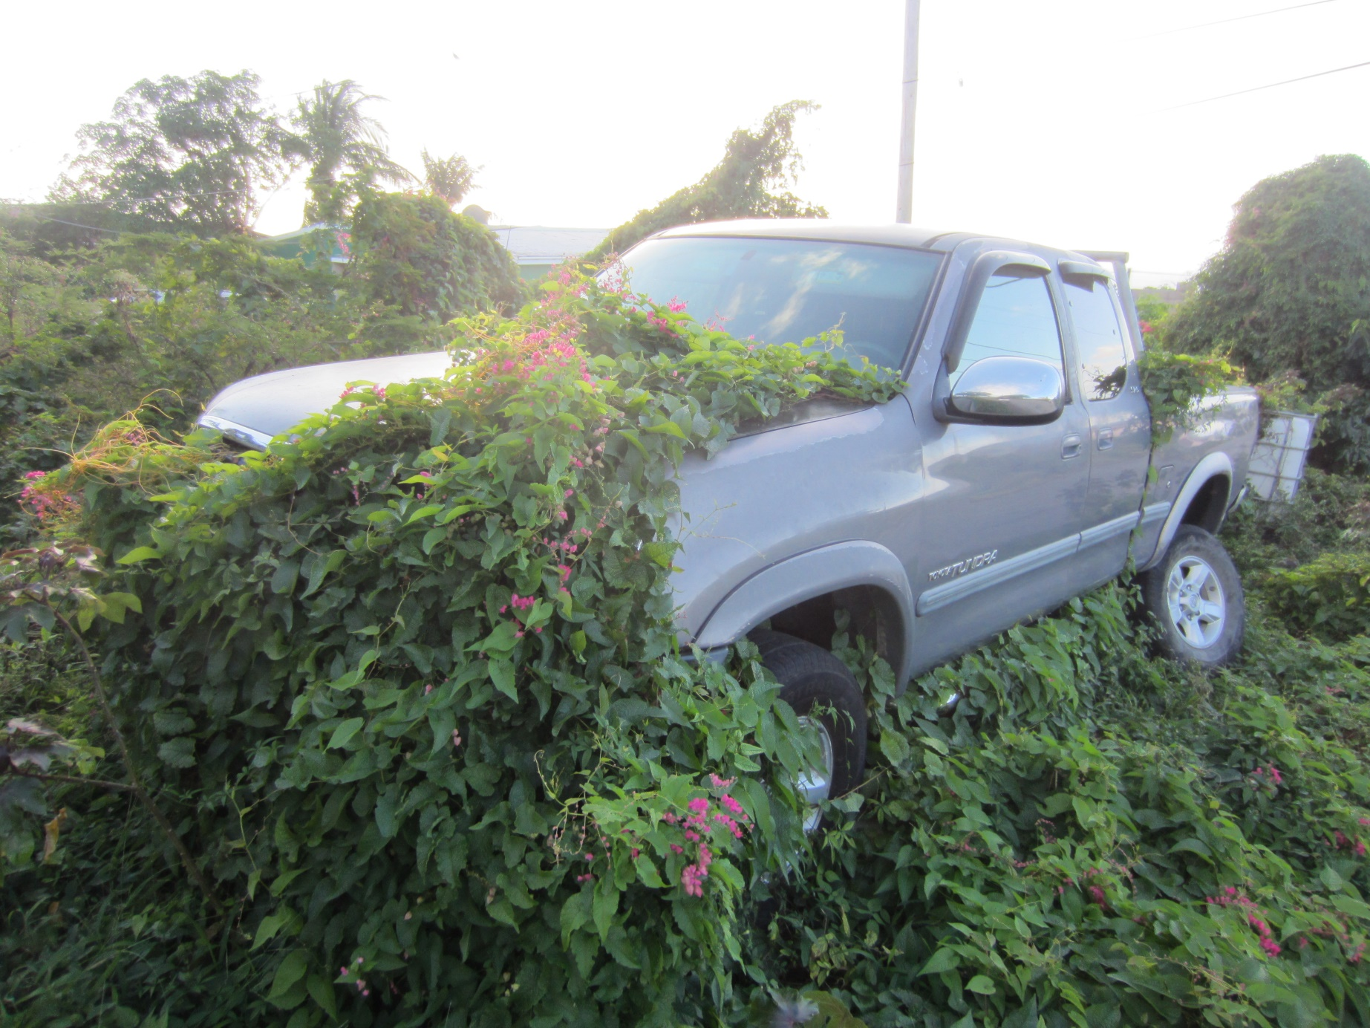

  - Author Thomas Heger
Supervisor Prof. Dr. Tinde van Andel
Examiner Dr. Anja Kuipers
Course code YPS-82318

Preface
This thesis report is submitted for the fulfilment of the degree of Bachelor of Science in Plant Sciences. It was written under the supportive auspices of Prof. Dr. Tinde van Andel, whose encouragement and wisdom have pushed me further than I could have imagined. Furthermore, I would like to thank Dr. Anja Kuipers for the opportunity to shape this BSc thesis the way I did. Lastly, I would like to express my gratitude to all the family and friends that have supported me through proof reading, thoughtful conversations or motivational words.
Unless stated otherwise, all images contained in this report are intellectual property of Thomas Heger. This report may be distributed freely for informative purposes, granted it remains unchanged and attributed to the author(s). Thomas Heger, 2018
Table of contents
Preface 2
0. Abstract 3
2. Introduction 4
3. Methods 6
4. Results 7
4.1 Non-native herbivores 7
4.2 Humans influence on the plant community 9
4.3 Exogenous factors 10
4.4 Social-ecological model on A. leptopus dominated ecosystems of St. Eustatius 10
5. Discussion 11
6. Conclusion 13
7. Acknowledgements 13
8. References 14
9. appendix 1: supplementary tables 17

0. Abstract
Relevance: Invasive species and habitat destruction are seen as the biggest threats to biodiversity worldwide, especially on small islands. The Caribbean islands are a hotspot for biodiversity, harboring 2.3% of the world’s endemic plant species on a tiny area. Due to habitat degradation invasive species are considered a major environmental problem in the Caribbean. The invasive vine Antigonon leptopus Hook. & Arn., colloquially known as coralita, is the most abundant invasive species on the Dutch Caribbean island of St. Eustatius. Forming thick, monospecific carpets, the species is seen by many as a threat to biodiversity. Insight is needed in the ecological and social factors that cause A. leptopus-dominated ecological regimes to be so abundant on the island.
Materials and methods: We used the Social-Ecological Systems framework to search for literature that provides information on factors affecting the invasion status of A. leptopus on St. Eustatius. We reviewed 40 documents, ranging from technical reports and theses to peer-reviewed scientific articles. Based on the information contained in these documents, we built a conceptual model to assess the social and ecological factors that influence the invasibility of the island’s ecosystem. We assessed the level of empirical support for the relationships, and determined research priorities for those factors whose influence has not yet been proven experimentally.
Results: We found three major factors responsible for the A. leptopus-dominated regimes on St. Eustatius: overgrazing by feral animals, anthropogenic disturbance and climate change. These relationships where supported by 16, 13 and six publications, respectively. None of the authors identifying climate change as a factor provided empirical evidence, while the influence of anthropogenic disturbance and overgrazing were supported by three papers that provided quantitative data to back up their claim. Less than half of the papers that reported factors influencing A. leptopus invasion were published in peer-reviewed scientific journals
Conclusions: Our results indicate that the abundance of A. leptopus on St. Eustatius is more of a symptom than a cause in itself. We therefore conclude that efforts to manage A. leptopus infestations by chemically or manually removing the plant are futile if not combined with active reforestation and grazer exclusion. Empirical evidence for the relation between invasibility and social and ecological factors is scarce, as most authors quote the same sources and do not provide empirical evidence for their claims. More experimental research is needed to inform policy and management decisions. We recommend new research to focus on the effects of feral grazer exclusion on the recovery of the vegetation.

2. Introduction
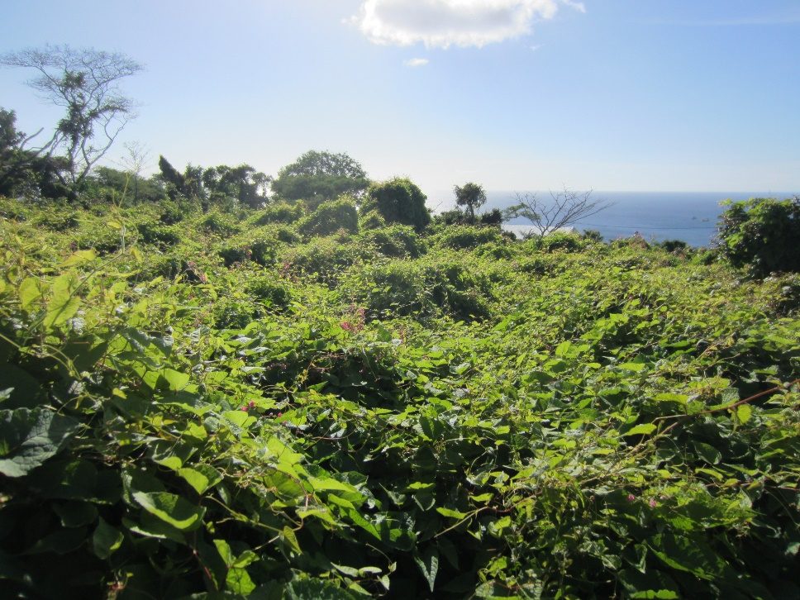
With human population at an all-time high, anthropogenic impact on the environment has never been as severe as it is today. Increasing globalization poses a variety of challenges, such as the increasing impact of invasive species. Invasive species are widely recognized as the second biggest global threat to biodiversity, second only to habitat destruction (Kairo et al., 2003).
Islands are generally vulnerable to invasions (Rojas-Sandoval & Acevedo-Rodríguez, 2014), making them a priority for biodiversity conservation. The Caribbean islands are a hotspot for biodiversity, harboring 2,3% of the worlds’ endemic plant species on just a tiny area (Myers et al., 2000). Thus, the threat by invasive species to the Caribbean is especially relevant for nature conservation.
A striking example of the vulnerability of island ecosystems is situation on the Dutch Caribbean island of St. Eustatius, also known as ‘Statia’. A variety of exotic plant species, often introduced deliberately for horticultural or ornamental purposes, have naturalized on the island. Some of these, like the perennial vine Antigonon leptopus Hook. & Arn., colloquially known as Coralita, have become invasive (figure 1).
A. leptopus is regarded as the most problematic invasive species on the island of St. Eustatius (Burg et al., 2012). Covering large areas with a thick, monospecific carpet, its overwhelming presence on the island is said to have significant negative consequences for biodiversity; both directly as plant species diversity in these invaded communities is low (Van Andel et al., 2016) and indirectly, as A. leptopus negatively affects populations of the endangered Lesser Antillean Iguana (Iguana delicatissima) by decreasing nesting site availability (Debrot et al., 2012; Wagensveld, 2015).
The land use history of St. Eustatius provides some indication for the causes of this exceptional vulnerability. Once a colonial outpost for the Dutch West-India Company, the small island supported plantation agriculture for centuries. Acres of forest were cleared to plant sugar cane, tobacco and indigo. In 1790 there were more than 8.124 people living on the 21 km² island (World atlas, 2017). High population density, combined with intensive agriculture, did not contribute to a balanced ecological situation. In fact, at the end of the 18th century almost the entire islands landscape was anthropogenic. With the exception of a few inaccessible places, none of the original landscape types remained unchanged (Ottens, 1775).
The 20th century was characterized by a decrease in agriculture. Deserted fields provided opportunities for opportunistic plant species (Burg et al., 2012). In addition, no effort was undertaken to manage the large population of herbivores, especially goats, which were not confined to enclosed pastures but freely roamed the island. Overgrazing by roaming goats is said to have a devastating effect on the regeneration of trees and shrubs, shifting the competitive advantage towards invasive, toxic and spiny plant species (Van Andel et al., 2016; Francis et al., 1994).
Figure 1: A. leptopus carpet in a semi-urban environment on the slopes of The Quill, St. Eustatius.
Approaching biological invasions and the ecosystems they affect from the perspective of ecological resilience may lead to a nuanced description of the situation on St. Eustatius. Ecological resilience describes the capacity of an ecosystem to remain in its current regime despite disturbance events (Holling, 1973). Holling’s proposition that ecosystems could exist in more than one stable state was a clear divergence from the previously accepted equilibrium-centered ecological paradigm (Folke, 2006). Once disturbances reach a certain critical threshold, a regime shift takes place. This shift results in a reorganized regime, characterized by a different set of processes, structures, functions and feedbacks (Chaffin et al., 2016).
The A. leptopus-dominated vegetation on St. Eustatius can be regarded as such an alternative regime, brought about by a set of abiotic and biotic factors. This deterministic perspective may help explain why some parts of St. Eustatius are covered with pristine climax communities, whereas others are severely degraded, invaded by exotic plants and prone to soil erosion. Insight is needed in the factors that undermine resilience of the preferred ecosystems and keep degraded communities in their suboptimal state. Analysis of these factors may provide vital information for designing conservation and restoration strategies, and indicate possible knowledge gaps.
Over the past 30 years, a variety of contributions have been made by the scientific community towards a better understanding of the natural environment of the Dutch Caribbean. Vegetation assessments have provided insights into the problem areas for invasive plant species (Van Andel et al., 2016; De Freitas et al., 2012) . Ketner & Ernst (2007) made several attempts at controlling A. leptopus, and comprehensive policy advice on how to manage invasive species has been given by Debrot et al. (2011) and Smith et al. (2014). However, these scientific contributions have not yet been translated into an actionable strategy for environmental management on St. Eustatius (Vaas et al., 2017). One of the reasons for this is the fragmented nature of the available scientific knowledge, which often seems to be confined to a specific discipline. All actors have their own view of the problems that face St. Eustatius.
This literature review aims to provide a broad, holistic perspective on the environmental issues on St. Eustatius that are related to invasive species. With Antigonon leptopus’ invasion status as a focal point, we organized the available published information to create an overview of the social and ecological factors that affect the plant community on the island. We identified gaps in the current knowledge, assessed the level of empirical support for the different relationships and provide a synthesis of available literature.
During our review, we sought to answer the following questions: 1) What is currently known about the social and ecological factors that create and maintain the A. leptopus-dominated ecological regime on St. Eustatius? 2) How much empirical evidence is provided to back up the claims made in the reviewed literature? and 3) Which research priorities can be identified based on this analysis?
Based on our initial exploration of the literature, we expected that currently available literature would confirm that herbivores cause a shift in the competitive advantage within the vegetation toward toxic, spiny and unpalatable species by selectively eating plants, resulting in a A. leptopus dominated regime and a loss of biodiversity (figure 2).
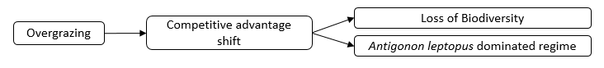
Figure 2: Graphical representation of our hypothesis

We used the Social-Ecological Systems framework to describe the factors affecting the regime. The SES framework conceptualizes the environment as an open system consisting of ecological and social components and processes, including biomes, humans, and wildlife (Virapongse et al., 2016). It provides a common language for researchers working on complex issues that involve both social and ecological aspects; an attempt to draw knowledge out of isolation so it can cumulate (Ostrom, 2009). The SES framework will therefore be useful in bridging the gap between the different disciplines relevant to the invasive species problems on St. Eustatius (Haber et al., 2016).

3. Methods
Search terms for our literature review were defined based on the Social-Ecological Systems framework, which we adapted from Virapongse et al. (2016), and the literature on invasivity of A. leptopus. Our first focus was on the ecological elements of this framework, namely “Overgrazing”, “Resilience”, “Soil erosion”, “Biodiversity” and “Competition”. Each search term was composed of these five aspects (in English) and the scientific and vernacular name of A. leptopus (table 1). We used the vernacular name “coralita” because it is the most recurrent common name in the literature of the west indies (Vanderbroek, in press.).
In November 2017, the search terms were entered into Google Scholar. The resulting hits were scanned for relevance based on title and abstract, and only included for our analysis if they provided information about the relationships proposed in the hypothesized model (figure 1), or where expected to add new relationships to this model. The selected articles were therefore not limited to the Caribbean region or Antigonon leptopus specifically. To capture the breath of information available, accessions included English and Dutch peer-reviewed articles, PhD- and MSc theses and technical reports. Some additional relevant articles encountered in the references of the included articles were included in the review as well (snowball method).
Selected documents were downloaded and their meta-data were recorded as accessions in an excel spreadsheet. During the review process, the information presented in the literature was assessed for its (dis-)agreement with the hypothesized model (figure 1) by condensing the information to components and processes. Furthermore, the origin of the information was assessed to identify whether support for a certain relationship was backed up by empirical evidence or merely quoted from another source. Lastly, we assessed whether the literature sources were peer-reviewed scientific articles or not.
The hypothesized model was then expanded to a conceptual model to show the (dis-)agreement of literature sources and to indicate gaps in knowledge and the need for more scientific research.

4. Results
Our search queries returned a total of 921 hits, of which 30 articles were included in the review (3.5%). An additional ten documents were included via the snowball method. Only 17 out of 40 documents (41.5%) were peer-reviewed articles (Table 1).
Table 1: General summary of search statistics.
Search terms entered in Google Scholar | # articles retrieved | # articles included | % articles included | % articles  peer-reviewed
"Overgrazing" + "Antigonon leptopus" OR "coralita" | 42 | 7 | 16.7 | 14.3
“Resilience” + “Antigonon leptopus” OR "coralita" | 51 | 9 | 17.6 | 33.3
“Soil erosion” + “Antigonon leptopus” OR "coralita" | 61 | 2 | 3.3 | 0
“Biodiversity” + “Antigonon leptopus” OR "coralita" | 522 | 11 | 2.1 | 54.5
“Competition” + “Antigonon leptopus” OR "coralita" | 245 | 1 | 0.4 | 0
Subtotal | 921 | 30 | 3.3 | 33.3
Snowball method |  | 10 |  | 60
Total |  | 40 |  | 40
Based on the literature analyzed, the Social-Ecological system of St. Eustatius can be generalized to five components, interlinked by a multitude of relationships. These components are the plant community, the soil, non-native herbivores, native fauna and humans. These five components are affected by environmental conditions that are exogenous, but do impact its components (figure 3).
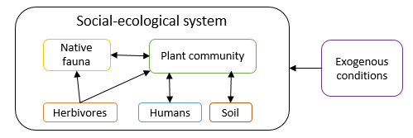
Figure 3: The St. Eustatius Social-ecological system, its components and interactions
Below, we describe the components and their relationships. Our focus is on the invasivity of Antigonon leptopus, which is a feature of the plant community component. Therefore, the description of relationships between the plant community and other components will be at the core of this section. An overview of the relationships and their supporting literature is provided in the supplementary tables (Section 9.1).

4.1 Non-native herbivores
Less than half of the articles (16 out of 40) identified an effect of non-native herbivores on the plant community. Most focused on feral goats, regarded as the largest problem on St. Eustatius (De Freitas et al. 2012). However, the same issues seem to exist in different study areas, often with their own problem species, such as donkeys on Bonaire (Debrot & Bugter, 2010), rabbits on Robinson Crusoe Island(Smith-ramirez et al., 2017) and cattle on the Seychelles (Vos, 2004).
Four related but distinct effects of herbivores on the plant community were identified: a shift in competitive dynamics within the plant community (e.g. Coblentz, 1978; Debrot & Freitas, 1993; Kairo et al., 2003), decreased regeneration of the vegetation (e.g. Van Andel et al., 2016; Smith-Ramirez et al., 2017) , loss of biodiversity (e.g. De Freitas et al., 2012; Francis et al., 1994) and arrested succession (Burg et al., 2012; Helmer et al., 2008).
The most direct effect of herbivores on a vegetation is a decrease in the regeneration of the vegetation (de Freitas et al., 2012). Herbivores eat plant biomass, and since young saplings and seedlings are located close to the ground, these are often the first to be consumed. Removal of these individuals from a population hampers the regeneration processes of the plant community. However, of the eight studies that identify this relationship (Van Andel et al., 2016; Burg et al., 2012; Debrot et al., 2010; Coblentz, 1980; de Freitas et al., 2012; Francis et al., 1994; Smith-ramirez et al., 2017; Smith et al., 2014), none provide direct empirical evidence of this process.
A related effect of herbivores is a shift of competitive dynamics within the plant community (Debrot & Freitas, 1993). In an ecosystem that is under grazing pressure, plant species adapted to an environment with herbivores are more likely to proliferate than species not adapted to these conditions (Francis et al., 1994). Species with spines or unpalatable leaves thus become more dominant within the plant community(de Freitas et al., 2012). On St. Eustatius, this process is visible by the abundance of poisonous plants (e.g. Jatropha gossypiifolia) and spiny shrubs (e.g. Randia aculeata) in overgrazed areas (van Andel et al., 2016). A. leptopus, which is rarely eaten by herbivores (Ketner & Ernst, 2007), experiences the same competitive advantage.
In 1993, Debrot and De Freitas quantified the effects of herbivores on species composition on Curaçao. In a comparison of plant species composition on goat accessible and –inaccessible rocks, they found a sharp decline in grazing sensitive species such as Tillandsia flexuosa and Brassavola nodosa on rocks experiencing grazing pressure. Furthermore, they reported an increase in grazing tolerant species such as the notoriously spiney plants Opuntia wentiana and Acacia tortuosa, as well as Aristida adscensionis, an annual grass inedible for goats because it causes intestinal obstruction. Similar observations were made in rangelands of the Midwestern United States, where an increase in grazing pressure was identified as a cause for a change in vegetation in which herbaceous understory species decreased and less palatable species thrived (Brown et al., 2008).
The shift in species composition is accompanied by a decrease in biodiversity. Francis et al. (1994) found that since the 1800s, 13% of the native canopy tree species had disappeared from Antigua, which they partially attribute to high grazing pressure. This relationship is supported by empirical research from the Mediterranean region, where an increase in grazing pressure led to a reduction in plant diversity (Alados et al., 2003). While both Rojer (1997) and Jongman (2010) identified grazing by free-roaming herbivores as a threat to the biodiversity of St. Eustatius, none of the studies retrieved by our review experimentally quantified the effect of grazing pressure on floristic diversity for St. Eustatius.
Lastly, grazing pressure is said to hamper the successional processes of the plant community (Burg et al., 2012; Helmer et al., 2008). This effect is related to the decreased regenerative abilities discussed earlier. Since young trees are prevented from reaching maturity, the natural development of the vegetation towards its climax community is impeded. The vegetation remains in a state of arrested succession, where only early successional species and disturbance specialists such as A. leptopus can thrive.
The effects of herbivores on the plant community, such as loss of biodiversity and reduced vegetation cover, in turn result in soil erosion (Brown et al., 2008; de Freitas et al., 2012; Rojer, 1997). On St. Eustatius silt deposition caused by soil erosion is causing serious coral deterioration (Burg et al., 2012; Jongman et al., 2010; Smith et al., 2014). These reefs are of vital importance to the local tourism sector, as the related income from these reefs is estimated at USD 9 million (Van de Kerkhof et al., 2012)
Herbivores also affect the populations of native fauna. On St. Eustatius herbivores trample the nesting burrows of seabirds such as the endangered White-tailed tropicbird (Phaeton lepturus)(De Freitas et al., 2012) as well as nests of the endangered Lesser Antillean iguana (Iguana delicatissima)(Debrot et al., 2012). Additionally, the dense, monospecific carpets formed by A. leptopus further decrease the availability of nesting sites for the Lesser Antillean iguana (Wagensveld, 2015). These relationships between herbivores and native fauna, however, were not supported by direct experimental data.

4.2 Humans influence on the plant community
Our literature review on the social and ecological context of the invasion status of Antigonon leptopus on St. Eustatius yielded 13 papers that identified an anthropogenic effect on the plant community. These effects are the result of a variety of human activities such as construction, agriculture and deforestation. Some relationships were well-supported, while others are mentioned only occasionally.
The changes humans make to the landscape have large impacts on the plant community. In the Caribbean, the arrival of European colonists in the 16th and 17th century initiated a period of grave environmental changes (de Freitas et al., 2012). Many forests were logged to make space for plantation agriculture, while human population numbers soared (Francis et al., 1994). In the 20th century, the region saw a gradual decrease of land used for agricultural practices (Helmer et al., 2008; Rojer, 1997). Management intensity of the land decreased, with more and more land left fallow (Delgado et al., 2016). This provided opportunities for colonization by invasive species (BEST, 2003; de Freitas et al., 2012; Ketner & Ernst, 2007). The succession processes taking place on these patches of abandoned agricultural land could not follow their natural pathways due to limited recruitment possibilities among native plant species (Brooks, 2013) and grazing disturbance (Helmer et al., 2008), resulting in plant communities with low biodiversity and a high percentage of invasive plant species.
Similarly, construction and cutting trees for timber and firewood disturbed the balance of the ecosystem. The removal of (parts of) the vegetation during these activities left niches unoccupied, creating room for exotic species to colonize the land (Joseph & Abati, 2016).
The relationship between the presence of invasive plant species and human land use was supported empirically by Wahyuni (2016), who tested the presence and coverage of invasive species in different land use systems on the Indonesian island of Sumatra. Clear differences where observed between oil palm plantations (28 different invasive plant species, 21% total coverage) and pristine forest(no invasive plants at all). In the Midwestern United States, invasive plant presence and coverage was shown to be significantly related to metrics of disturbance and fragmentation such as distance to road and forest intactness index (Moser et al., 2009).
The alterations that humans make to the plant community more selection pressures that influences the competitive advantage of species. Anthropogenic processes such as agriculture create circumstances that are conducive to the establishment and proliferation of certain ‘anthropophilic’ species, that are often exotic (Joseph & Abati, 2016). On land that has been heavily impacted by humans, harsh environmental conditions such as high temperatures, low humidity and highly compacted soils may prevent colonization by native pioneers (Rojas-Sandoval & Acevedo-Rodríguez, 2014). Better adapted to these harsh environmental pressures, exotics replace the native species. In a variety of ecosystems, anthropogenic disturbances also increase the abundance of certain functional groups, especially vines (Delgado Riviera, 2015).
On St. Eustatius, these processes result in clear dominance of A. leptopus on pieces of land that have had the most intense exposure to humans (de Freitas et al., 2012). From the distribution maps of Ketner & Ernst (2007) and Berkowitz (2014) a relationship between anthropogenic disturbance and A. leptopus can be inferred, but clear empirical evidence is lacking.

4.3 Exogenous factors
Aside from processes taking place within the social-ecological system, the plant community is also affected by outside conditions. The main exogenous factor affecting the ecosystem’s regime is climate change, which was identified by six authors as having an effect on the plant community(BEST, 2003; Bullard, 2013; Debrot & Bugter, 2010; Jongman et al., 2010; Ketner & Ernst, 2007; Senterre, 2009).
The predicted rising temperatures are expected to create suitable conditions for invasion by exotic plant species (Bullard, 2013; Ketner & Ernst, 2007). As temperatures rise, the resilience of the native plant community will weaken, while conditions for invasive species improve (Debrot & Bugter, 2010).
Increases in both hurricane frequency and intensity are also expected (Senterre, 2009). Worldwide, hurricane intensity expected to rise by a daunting 66% as a result of climate change (Debrot & Bugter, 2010). Hurricane disturbances, especially combined with grazing pressure, increase the ecosystem’s vulnerability to invasions by invasive plant species (Debrot & Bugter, 2010; Senterre, 2009), although this has not yet been supported by empirical evidence.

4.4 Social-ecological model on A. leptopus dominated ecosystems of St. Eustatius
Through our literature analysis, we identified three major factors responsible for the dominance of Antigonon leptopus on St. Eustatius: overgrazing, anthropogenic disturbance and climate change, supported by 16, 13 and six papers respectively. All relevant papers describing a relation between three factors and A. leptopus domination are depicted in our model (figure 4).
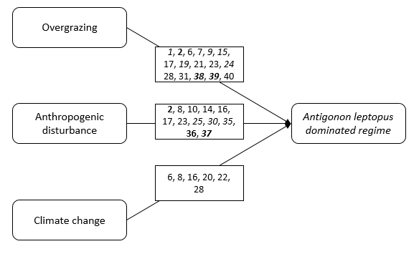
Figure 4: Conceptual model representing the factors responsible for the A. leptopus-dominated regime on St. Eustatius. The numbers in bold indicate studies backed up by empirical evidence, while numbers in italics indicate studies that were published in a peer-reviewed scientific journals. The numbers correspond to the following studies:
1. Van Andel 2016; 2. Francis 1994; 6. Debrot 2010; 7. Burg 2012; 8. Ketner 2007; 9. Helmer 2008; 12. Berkowitz 2014; 14. Delgado 2015; 15. Smith-Ramirez 2017; 16. BEST 2003; 17. Freitas 2012; 19. Brown 2008; 20. Bullard 2013; 21. Kairo 2003; 22. Senterre 2009; 23. Rojer 1997; 24. Coblentz 1978; 25. Rojas-Sandoval 2014; 28. Jongman 2010; 30. Joseph 2016; 31. Smith 2014; 32. Delgado 2015; 35. Brooks 2013; 36. Wahyuni 2016; 37. Moser 2009; 38. Alados 2002; 39. Debrot 1993; 40. Coblentz 1980.
Studies that identified overgrazing, anthropogenic disturbance and climate change as a factor included seven, five and zero peer-reviewed publications, respectively. Over all, of the 28 studies included in our model, 12 were published in a peer-reviewed scientific journal(42.8%).
None of the studies that identified climate change as a factor provided empirical evidence, while both anthropogenic disturbance and overgrazing were supported by three papers that provided quantitative data to back up their claim. Thus, of the 40 papers we analyzed, only five proved the effects of overgrazing and/or anthropogenic disturbance through field observations. Evidence of these relationships was provided by assessing species composition (Alados et al., 2003; Debrot & Freitas, 1993; Francis et al., 1994) and quantifying invasive plant presence and coverage (Moser et al., 2009; Wahyuni, 2016).

5. Discussion
Our literature review on the social and ecological context of the invasion status of Antigonon leptopus on St. Eustatius revealed three major factors that push the vegetation on St. Eustatius towards an alternative stable state in which A. leptopus is the dominant species: overgrazing, anthropogenic disturbance and climate change. The identification of these factors hints towards a new perspective on the issue at hand; one that is not species- but circumstance focused.
As Brooks (2013) points out, biological invasions may be more likely to be the “passengers” of ecological change than the “drivers”. Invasive species are likely to establish themselves in unoccupied niches that were created by disturbance events or changing climatic conditions. When looking for a solution, avoiding the presence of unoccupied niches (i.e. decreasing the invasibility of the vegetation) may thus be considered a more important aspect to focus on than the invasive species itself.
This is not to say the biological aspects of the invasive species itself are irrelevant. A. leptopus possesses a variety of qualities that make it an exceptional fit for the disturbed vegetation of St. Eustatius, such as its tolerance for drought and poor, disturbed soils(Burke & DiTommaso, 2011). Due to its climbing habit, it is able to use structures like abandoned cars and buildings to utilize space that is not available for non-climbing plants.
The cause of the problem, however, lies more in the environmental problems at large. Several ecosystems on St. Eustatius experience such heavy environmental pressures that hardly anything but certain exotic species can thrive. The resulting thick, monospecific carpets that are perceived so negatively may actually perform a vital ecological function. Within invasion literature, the dominant narrative that invasions are ecologically, economically and culturally undesirable has been challenged by the idea that invasive species can, in some instances, actually take over lost ecosystem functions (Chaffin et al., 2016). A. leptopus provides an example of this. The disturbance caused by overgrazing creates bare, exposed soils, which are prone to erosion. The establishment of A. leptopus in these circumstances has a positive effect on erosion control, since a slope with vegetation is more resistant to run-off than a bare slope (figure 5). In this case, A. leptopus takes over an ecosystem function that cannot be performed anymore by the original vegetation. A more holistic perspective on the invasive species problem is necessary; one that takes into account the bigger picture and does not regard invasions as inherently bad.
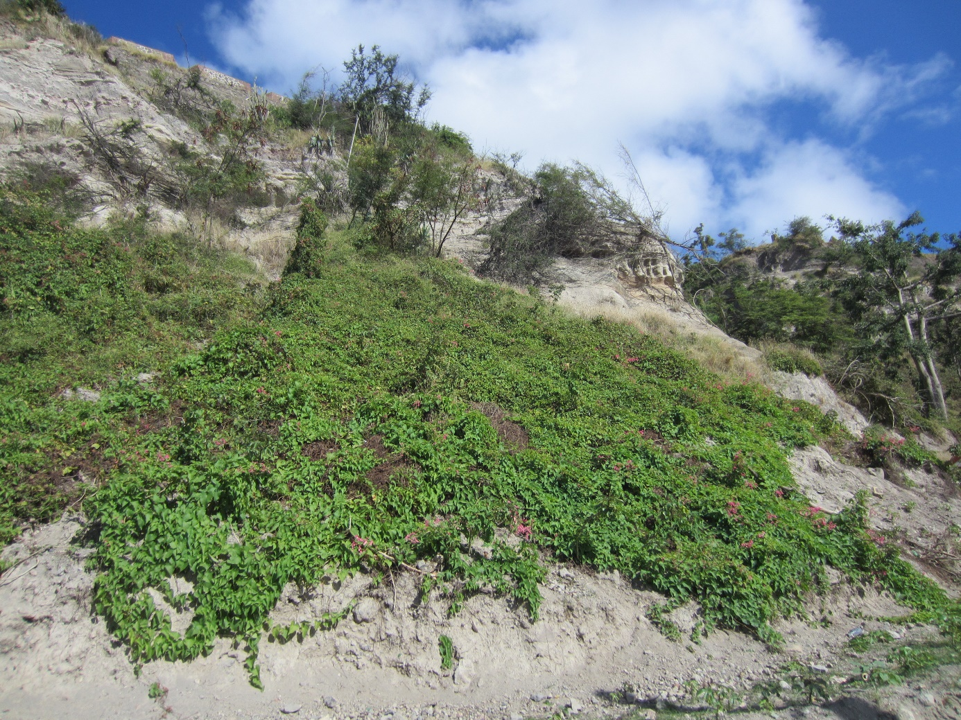
Figure 5: A. leptopus covering an erosion-prone slope. Harbor road, St. Eustatius
These findings have implications for management of A. leptopus infestations. Attempts at managing infestations by solely removing or weakening the plant, through chemical or manual efforts, have proven to be futile(Ketner & Ernst, 2007). The control efforts will re-open a niche, only to quickly be filled with either the same or a different invasive species. Furthermore, removing A. leptopus from slopes will exacerbate soil erosion problems unless combined with sufficient erosion control efforts.
Any effort in combatting A. leptopus infestations should focus on negating the factors that push the vegetation towards this regime in the first place. This will allow the ecosystem to develop, with succession processes running their natural course. When goats are removed from an infested area, heliotrophic plants like A. leptopus will be shadowed out by upcoming trees, decreasing their competitiveness. While this in itself may be enough to restore the vegetation to a biodiverse, balanced and resilient plant community, disturbed areas such as fallow agricultural fields and deserted building sites should be monitored and actively managed to assure the development of a biodiverse and functional plant community.
The effects of climate change on the vegetation are of another scale level, and are not within the control of any one individual on St. Eustatius. The best strategy for negating climate change’s effects on the vegetation may therefore be to focus on overgrazing and anthropogenic disturbance first; to “manage for resilience” by taking away local anthropogenic pressures, as Debrot & Bugter (2010) put it.
Drawing on the previous analysis, we suggest the following research and management priorities. The first logical action to undertake would be to carry out scientific experiments on the effects of grazer exclusion on the recovery of vegetation on St. Eustatius. Similar long-term studies have recently started on Bonaire, but it is too early to draw conclusions from the gathered data (J. Foest, pers. comm.). As recruitment limitations among native species are often a limiting factor in the restoration of ecosystems(Brooks, 2013), excluding grazers may be well combined with active reforestation. Depending on stakeholder goals, this may be done with either native species or agriculturally valuable species such as fruit trees. Research on the competitive dynamics between A. leptopus and other plant species is needed to inform restoration strategies.
Our review demonstrated a lack of empirically supported claims about A. leptopus on St. Eustatius, as well as a clear difference in how well certain relationships are supported by empirical data. One of the reasons for this difference may be the difference in complexity between the different factors. Overgrazing, a clearly delineated phenomenon, is easier to test as a cause than a broad phenomenon like climate change, which affects the ecosystem in many different ways. It is essential, however, that more complex processes like the effects of climate change on St. Eustatius’ ecosystems are also well understood. This may be accomplished by testing the different effects of climate change separately, in order to combine the results and draw general conclusions.
Regime shifts taking place in an ecosystem are the result of many factors that have an effect over different time scales and that can be of ecological and social origin. When dealing with the complex, multi-faceted problems that society faces today, a mono-disciplinary approach does not produce the insights required to solve the problem. Complex ecosystem and land use issues like invasive species require an inter-disciplinary approach (Young & Marzano, 2010). We therefore advocate the cooperation between scientists from different disciplines, and the involvement of the local community in developing solutions for the invasive species problems on St. Eustatius.

6. Conclusion
Our review pointed out that overgrazing, anthropogenic disturbance and climate change are three major factors that create and maintain the A. leptopus-dominated ecological regime on St. Eustatius. Although literature supports these relationships, the information is fragmented and there exists a general lack of empirical data to substantiate the claims. Less than half of the papers that discussed factors influencing A. leptopus invasions were published in peer-reviewed journals. We recommend experimental research on the effects of feral grazers on the vegetation and on different reforestation strategies. Any management plan for invasive species on St. Eustatius should focus on negating the effects of feral grazers and humans on the environment. Our literature review provided an insight into the underlying mechanisms of the invasive species problem on St. Eustatius, and may contribute to possible solutions, not only for St. Eustatius, but to the Caribbean region and island ecosystems in general.

7. Acknowledgements
We are grateful for the support and input of Jetske Vaas and Elizabeth Haber throughout the process that led up to this publication. Furthermore, we would like to thank Ruben Dümmer for the numerous thoughtful conversations that helped realize this research.

8. References

Alados, C. L., Pueyo, Y., Giner, M. L., Navarro, T., Escos, J., Barroso, F., … Emlen, J. M. (2003). Quantitative characterization of the regressive ecological succession by fractal analysis of plant spatial patterns. Ecological Modelling, 163(1–2), 1–17.
Berkowitz, B. (2014). The State of Antigonon Leptopus ( Corallita ) on St Eustatius in 2014. STENAPA, St. Eustatius, Dutch Caribbean.
BEST Commission (2003), The National Invasive Species Strategy for The Bahamas. BEST, Nassau, The Bahamas, 34 pp..
Brooks, W. R. (2013). Factors affecting the Community Invasibility of Tropical Dry Forests and the Implications for Ecological Restoration. The State University of New Jersey.
Brown, C. S., Anderson, V. J., Claassen, V. P., Stannard, M. E., Wilson, L. M., Atkinson, S. Y., … Munis, M. D. (2008). Restoration Ecology and Invasive Plants in the Semiarid West. Invasive Plant Science and Management, 1(4), 399–413.
Bullard, J. M. (2013). Critical Situation Analysis (CSA) of Invasive Alien Species (IAS) Status and Management , The Bahamas , 2013.
Burg, W. J. Van Der, Freitas, J. De, & Debrot, A. O. (2012). Naturalised and invasive alien plant species in the Caribbean Netherlands : status , distribution , threats , priorities and recommendations. Report to Dutch Ministry of Economic Affairs.
Burke, J. M., & DiTommaso, A. (2011). Corallita (Antigonon leptopus): Intentional Introduction of a Plant with Documented Invasive Capability. Invasive Plant Science and Management, 4(3), 265–273.
Chaffin, B. C., Garmestani, A. S., Angeler, D. G., Herrmann, D. L., Stow, C. A., Nyström, M., … Allen, C. R. (2016). Biological invasions, ecological resilience and adaptive governance. Journal of Environmental Management, 183, 399–407.
Coblentz, B. E. (1978). The effects of feral goats (Capra hircus) on islands ecosystems. Biological Conservation, 13(13), 279–286.
Coblentz, B. E. (1980). Goat problems in the national parks of the Netherlands Antilles. The Netherlands Antilles National Parks Foundation, Curaçao, Netherlands Antilles
De Freitas, J. A., Rojer, A. C., Nijhof, B. S. J., & Debrot, A. O. (2012). A landscape Ecological vegetation map of Sint Eustatius (Lesser Antilles), 3. IMARES Wageningen UR, Wageningen, The Netherlands
Debrot, A., & Freitas, J. A. De. (1993). A Comparison of Ungrazed and Livestock-Grazed Rock Vegetations in Curacao. Biotropica, 25(3), 270–280.
Debrot, A. O. ., Boman, E. B. ., & Madden, H. (2013). The Lesser Antillean iguana on St. Eustatius: A 2012 Population Status Update and Causes for Concern. ICRF Reptiles & Amphipians, 20(2):44-52
Debrot, A. O., & Bugter, R. (2010). Climate change effects on the biodiversity of the BES islands. Alterra Wageningen UR, Wageningen, 2010
Debrot, A. O., de Graaf, M., Henkens, R., Meesters, H. W. G., & Slijkerman, D. M. E. (2011). A status report of nature policy development and implementation in the Dutch Caribbean over the last 10 years and recommendations towards the Nature Policy Plan 2012-2017. Report / IMARES Wageningen UR;C064/11. Retrieved from http://edepot.wur.nl/183506
Delgado, D. L., Figueroa, J., & Restrepo, C. (2016). Using multiple traits to assess the potential of introduced and native vines to proliferate in a tropical region. Ecology and Evolution, 6(24), 8832–8845.
Delgado Riviera, D. (2015). Disentangling Vine-invaded tropical landscapes: From individual vine patches to vine networks. University of Puerto Rico. Río Piedras, Puerto Rico
Folke, C. (2006). Resilience: The emergence of a perspective for social-ecological systems analyses. Global Environmental Change, 16(3), 253–267.
Francis, J., Rivera, C., & Figureroa, J. (1994). Toward a Woody Plant list for Antigua and Barbuda: Past and Present. United States Department of Agriculture, Forest service. New Orleans, Louisiana, United States of America.
Haber, E., Vaas, J., Eppinga, M.,(2016). The social and ecological contexts of invasive plant management in the Caribbean. Copernicus Institute of Sustainable Development, Utrecht, The Netherlands.
Helmer, E. H., Kennaway, T. A., Pedreros, D., & Clark, M. (2008). Distributions of land cover and forest formations for St . Kitts , Nevis , St . Eustatius , Grenada and Barbados from satellite imagery. Caribbean Journal of Science Vol. 44, No. 2, 175-198
Holling, C. S. (1973). Resilience and Stability of Ecological Systems. Annual Review of Ecology and Systematics, 4(1973), 1–23.
Jongman, R. H. G., Meesters, E. H. W. G., & Debrot, D. A. O. (2010). Biodiversiteit voor de BES eilanden: Bonaire, St. Eustatius en Saba. Alterra Wageningen UR, Wageningen, The Netherlands
Joseph, P., & Abati, Y. (2016). The flower plants introduced in the Lesser Antilles: Martinique’s example (general summary of the key data and ecosystem impacts). IOSR Journal of Environmental Science, Toxicology and Food Technology, 10(8), 88–108. https://doi.org/10.9790/2402-10080288108
Kairo, M., Ali, B., Cheesman, O., Haysom, K., & Murphy, S. (2003). Invasive species threats in the Caribbean region: report to the Nature Conservancy. CAB International, Trinidad & Tobago.
Ketner, P., & Ernst, J. (2007). Corallita Pilot Project St. Eustatius 2007. ABC Advies, St, Eustatius, Netherlands Antilles.
Moser, W. K., Hansen, M. H., Nelson, M. D., & McWilliams, W. H. (2009). Relationship of Invasive Plant Presence to Evidence of Disturbance in the Forests of the Upper Midwest of the United States. Invasive Plants and Forest Ecosystems, 29–58.
Myers, N., Mittermeier, R. A., Mittermeier, C. G., da Fonseca, G. A. B., & Kent, J. (2000). Biodiversity hotspots for conservation priorities. Nature, 403(6772), 853–858. https://doi.org/10.1038/35002501
Ostrom, E. (2009). Social-Ecological Systems, Science 325(5939), 419–422.
Ottens (1775). Nieuwe Kaart van het Eyland St. Eustatius in derzelver Ligging & Plantagien met de Naamen der Bezitteren, uitgegeven By Reinier Ottens Konst, Amsterdam. 1775.
Rojas-Sandoval, J., & Acevedo-Rodríguez, P. (2014). Naturalization and invasion of alien plants in Puerto Rico and the Virgin Islands. Biological Invasions, 17(1), 149–163.
Rojer, A. (1997). Biological Inventory of Sint Eustatius. Carmabi Foundation, Curaçao, Netherlands Antilles.
Senterre, B. (2009). Invasion risk from climbing and creeping plant species in Seychelles. Consultancy report, Ministry of Environment-UNDP-GEF project, 86 pp.
Smith-ramirez, C., Vargas, R., Castillo, J., Mora, J. P., & Arellano-cataldo, G. (2017). Woody plant invasions and restoration in forests of island ecosystems : lessons from Robinson Crusoe Island , Chile. Biodiversity and Conservation, 1507–1524.
Smith, S. R., Van der Burg, W. J., Debrot, A. O., Van Buurt, G., & De Freitas, J. A. (2014). Key Elements Towards a Joint Invasive Alien Species Strategy for the Dutch Caribbean. IMARES Wagenignen UR, Wageningen, The Netherlands
Vaas, J., Driessen, P. P. J., Giezen, M., Laerhoven, F. Van, & Wassen, M. J. (2017). Who’s in charge here anyway ? Polycentric governance configurations and the development of policy on invasive alien species in the semisovereign Caribbean, Ecology and Society 22(4): 1.
Van Andel, T., van der Hoorn, B., Stech, M., Arostegui, S. B., & Miller, J. (2016). A quantitative assessment of the vegetation types on the island of St. Eustatius, Dutch Caribbean. Global Ecology and Conservation, 7, 59–69.
Van de Kerkhof, S., Schep, S., Beukering, van, P., Brander, L., & Wolfs, E. (2012). The tourism value of nature on St. Eustatius. IVM Institute for Environmental Studies, Amsterdam, The Netherlands
Vanderbroek, I. (2018). A review of coralilla (Antigonon leptopus): An invasive and popular urban bush medicine in Jamaica. Economic Botany, In Press.
Virapongse, A., Brooks, S., Metcalf, E. C., Zedalis, M., Gosz, J., Kliskey, A., & Alessa, L. (2016). A social-ecological systems approach for environmental management. Journal of Environmental Management, 178, 83–91.
Vos, P. 2004. Case Studies on the Status of invasive Woody Plant Species in the Western Indian Ocean: 2. The Comoros Archipelago (Union of the Comoros and Mayotte). Forest Health & Biosecurity Working Papers FBS/4-2E. Forestry Department, Food and Agriculture Organization of the United Nations, Rome, Italy
Wagensveld, T. van. (2015). The Biology and Distribution of Iguana delicatissima on St . Eustatius. Wageningen University and Research Centre, Wageningen, The Netherlands.
Wahyuni, I. (2016). Distribution of Invasive Plant Species and Recommendations for management actions at Bukit Deabelas, Jambi, Sumatra. Bogor Agricultural University.
Young, J. C., & Marzano, M. (2010). Embodied interdisciplinarity: what is the role of polymaths in environmental research? Environmental Conservation, 37(4), 373–375.

9. appendix 1: supplementary tables
Table 3: Studies that identify effects of herbivores on the plant community. Studies in bold provide empirical evidence for their claim, studies in italics were published in a peer-reviewed scientific journal.
Effect | Shift in competitive dynamics | Decreased vegetation regeneration | Biodiversity loss | Hampered succession
Authors | 1. Van Andel 2016 | 1. Van Andel 2016 | 2. Francis 1994 | 7. Burg 2012
 | 2. Francis 1994 | 2. Francis 1994 | 7. Burg 2012 | 9. Helmer 2008
 | 17. Freitas 2012 | 6. Debrot 2010 | 17. De Freitas 2012
 | 19. Brown 2008 | 7. Burg 2012 | 23. Rojer 1997
 | 21. Kairo 2003 | 15. Smith-Ramirez 2017 | 28. Jongman 2010
 | 24. Coblentz 1978 | 17. De Freitas 2012 | 38. Alados 2002
 | 31. Smith 2014 | 31. Smith 2014 | 40. Coblentz 1980
 | 39. Debrot 1993 | 40. Coblentz 1980
 | 40. Coblentz 1980

Table 4: Studies that identify effects of humans on the plant community. Studies in bold provide empirical evidence for their claim, studies in italics were published in a peer-reviewed scientific journal.
Effect | Opportunities for invasion | Shift in competitive advantage | Abundance of invasive species | Loss of ecosystem balance
Authors | 8. Ketner 2007 | 14. Delgado 2015 | 3. Vos 2004 | 30. Joseph 2016
 | 10. Berkowitz 2014 | 17. De Freitas 2012 | 25. Rojas-Sandoval 2014
 | 16. BEST 2003 | 25. Rojas-Sandoval 2014 | 37. Moser 2009
 | 17. De Freitas 2012 | 30. Joseph 2016
 | 32. Delgado 2016
 | 35. Brooks 2013
 | 36. Wahyuni 2016
Effect | Biodiversity loss | Reduced vegetation cover | Habitat loss | Recruitment limitations among native species
Authors | 2. Francis 1994 | 17. De Freitas 2012 | 23. Rojer 1997 | 35. Brooks 2013

Table 5: Studies that identify effects of climate change on the plant community. Studies in bold provide empirical evidence for their claim, studies in italics were published in a peer-reviewed scientific journal.
Effect | Spread of invasive species | Possibilities for new species establishment | Higher hurricane frequency | Biodiversity loss
Authors | 6. Debrot 2010 | 8. Ketner 2007 | 22. Senterre 2009 | 6. Debrot 2010
 | 16. BEST 2003 | 16. BEST 2003 | 28. Jongman 2010
 | 20. Bullard 2013
 | 22. Senterre 2009

