Bachelor Project
Determining the health status of coral reefs: a case-study of the Saba Bank in the Dutch Caribbean
By L.M.P Schefold
11196017
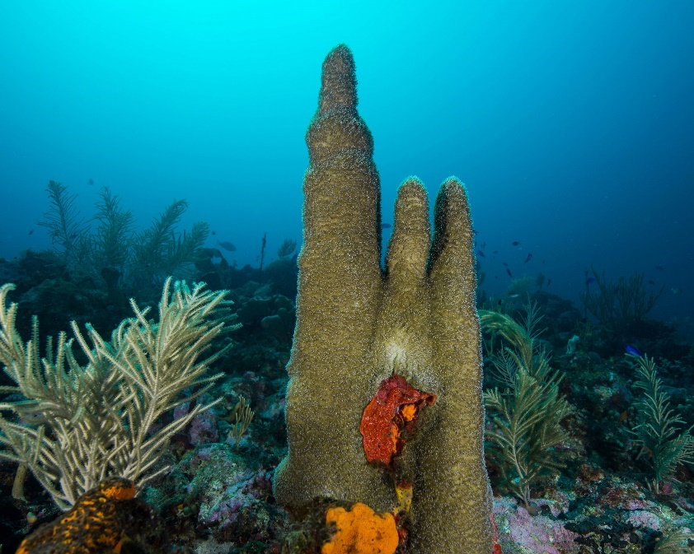
Source: Erik Meesters
BSc Future Planet Studies
Faculty of Science
Supervisor: dr. Erik Meesters
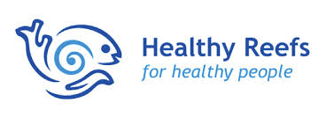
Table of Content

Abstract 3
Introduction 4
Background: trends in coral reef degradation 4
Reef Health Index 5
Saba Bank 5
Research objectives 6
Materials & Methods 8
Expedition 8
Image analysis 9
Data analysis 10
Reef Health Index 11
Results 12
Cover of benthic groups 12
Multivariate analysis of Saba Bank sites 16
Benthic cover 16
Fish groups 19
Environmental variables 20
Linear regression analysis of other environmental variables 22
Reef Health Index scores 25
Comparing the Reef Health Index to multiple environmental variables 26
Discussion 27
Benthic composition 27
Reef Health Index 27
Conclusion 28
Literature references 30
Appendix 34

Abstract
Coral reefs are impacted by temperature rise, ocean acidification and various local anthropogenic stressors, causing global degradation. To apply appropriate conservation strategies, it is necessary to have a clear understanding of the health status of coral reefs. The Reef Health Index (RHI) is an assessment tool for this purpose, using four indicators and set thresholds to determine reef health. However, only shallow reefs have been assessed by the RHI. In this study, the applicability of the RHI for deeper reefs was analyzed. The Saba Bank, a submerged atoll located in the Dutch Caribbean, contains relatively deep reefs (15 m – 30 m) which are less affected by human activity and relatively unstudied. The benthic composition of 12 reef sites of the Saba Bank was assessed by conducting an image analysis. Along with existing data, the health status was then scored using the RHI. This score was compared to an alternative assessment using multiple environmental indicators. As the scores of the two assessment tools differed significantly with a negative bias towards deeper sites, it has been suggested that the RHI adjusts it’s indicators or thresholds to give a realistic representation of reef health for deeper reefs such as on the Saba Bank.

Keywords
Saba Bank, Coral reefs, Fish, Benthic composition, Reef Health Index, Caribbean

Introduction

Trends in coral reef degradation
Coral reefs are of high importance to society due to the ecosystem services they provide to coastal communities and fisheries (Costanza et al., 1997). Additionally, they are one of the most biologically diverse ecosystems in the world (Moberg & Folke, 1999). Over the past decades, coral reefs have been subject to a mixture of direct and indirect anthropogenic stressors, which have caused shifts in their productivity, biodiversity and benthic species composition (Gardner et al, 2003; Hughes, 1994).
Climate change-induced rise in ocean temperature has increased the occurrence of massive coral bleaching events. This causes physiological damage to the coral and in case of prolonged bleaching leads to high mortality rates (van Woesik et al., 2011). Additionally, a reduction in water pH levels is negatively affecting the calcification process of reef-building coral species and weakens their calcium carbonate skeleton (Baker et al., 2008).
More direct mechanisms that drive coral reef degradation are a result of increased human activity in coastal areas, including fisheries (Mora 2008; Oigman-Pszczol & Creed, 2011). Fisheries can heavily affect patterns of diversity over large regions as well as lead to local extinctions of specific species (Hawkins & Roberts, 2004; Sadovy, 1999). Fish diversity is influenced by a multitude of factors in the Caribbean. The ongoing overfishing of herbivorous fish species, in conjunction with the mass mortality of the grazing sea urchin Diadema antillarum around 1983, has caused a significant reduction in the grazing capacity on the Caribbean (Bak et al., 1984). This has led to a rise in macro-algae, which form one of the primary competitors of corals (Jackson et al., 2001; Mumby et al., 2006). In conjunction with other local disturbances such as coastal development and pollution, these factors have caused a large decrease in coral reef productivity and biodiversity in the Caribbean region (de Bakker et al., 2017). It has been estimated that the stony coral cover of shallow reefs (0-20m) has gone from an average of 35% in 1970 to 14-16% in thirty years (Jackson et al., 2014). This trend is predicted to continue, with an estimated 90% of corals being threatened in 2030 by a combination of thermal stress and local threats caused by human activity (Burke et al., 2017).

Reef Health Index
To ensure effective coral reef conservation, it is essential that management authorities and research bodies are well-informed on the changing health status of coral reefs (Downs et a., 2005). Yet, few tools are available to evaluate the possible decline or recovery of coral reef ecosystems and communicate these findings to non-specialist policy makers. Hard coral cover is often used as a single indicator of coral reef health, as the data is easily obtained and communicated to third parties (Wilkinson 2002; Bruno & Selig 2007; Tittensor et al., 2014). However, one indicator alone is insufficient to provide real understanding in the dynamics of the coral reef ecosystem (Díaz-Pérez et al., 2016).
In trying to overcome this limitation, the Healthy Reefs for Healthy People organization has established the Reef Health Index (RHI), which provides a conceptual framework with 58 indicators on what can be termed as a healthy reef (appendix A). These indicators give insight in the impacts humans have on the reef and conversely, how society benefits from its’ ecosystem services (McField et al., 2007). In line with this vision, four key indicators have been highlighted and used (coral cover, fleshy macroalgae biomass, herbivorous fish biomass and commercial fish biomass) to determine the health status of coral reefs in the Caribbean. Herbivorous fish species are of high functional importance for coral reef quality, as they consume macroalgae that dominate reef systems and are primary competitors of corals. Fish biomass has therefore been positively linked to a reduction in macroalgae cover in large-scale analyses of Caribbean coral reefs (Williams & Polunin, 2001; Newman et a., 2006). Parrotfish and surgeonfish density specifically have been highlighted as significant positive drivers of coral reef resilience (Mumby et al., 2006). Besides herbivorous fish, the commercial fish biomass is included as it provides food to coastal communities. In the Mesoamerican reef region, 319 sites have been assessed using these indicators and classified on a 1-5 ordinal scale from critical to very good (McField et al., 2018).
The RHI has stated that it is most suitable for reefs in a 6m-30m depth range. However, the Mesoamerican reefs that were assessed are relatively shallow (6-15m) and no deeper reefs have been assessed using the RHI outside this geographic region (McField et al., 2007). It is therefore uncertain if the applicability of this index is dependent on the depth of the coral reef in question.

Saba Bank
The Saba bank, located in the Dutch Caribbean adjacent to the volcanic island of Saba, is a submerged atoll covering a large area of 2.300 km2 (Macintyre et al., 1975). The bank holds a rich marine biodiversity including high numbers of sponges, corals and reef fish species (Williams et al., 2010; Thacker et al., 2010). Most surface area lies at a depth between 20 m and 50 m average, making it a upper-mesophotic reef system, deeper than most studied reefs in the Caribbean (Thacker et al., 2010; de Bakker et al., 2016). These deep reefs have been theorized to function as important refuges for coral reef organisms, despite being largely neglected in temporal studies (Glynn, 1996; de Bakker et al., 2017). Additionally, anthropogenic stressors on the Saba Bank seems to be low, as the bank is situated away from large landmasses (Wiltink et al., 2017). This makes it an excellent example to study processes that generally occur on Caribbean reefs.
To examine the Saba Bank, the Wageningen Marine Research has undertaken expeditions to the area every few years. In these expeditions, data is collected of the benthic organisms inhabiting the Saba bank. This includes underwater images of different sites on the bank, along a transect line of 50 meters (3 lines per site and 10-12 sites per expedition). The last expedition in 2018 has resulted in a collection of images that have not been analyzed prior to this study.

Research objectives
To examine the health status of the Saba Bank, it is important that the appropriate assessment tool is used. Therefore a consideration has to be made in using indicators that are both cost- and time effective in the assessment process as well as providing a complete and accurate representation of reef health.
Firstly this is attempted with the RHI. To integrate the necessary information into the RHI, data on coral cover and macro algae cover will be collected by conducting an image analysis of the underwater photographs taken on the 2018 expedition by WMR. Further data of the fish biomass which is necessary to apply the RHI will be provided by WMR.
As the Saba Bank reefs are relatively deeper than the ones usually assessed with the RHI, the RHI scores are compared with different indicators that might be more suitable. Diversity and richness of fish and benthic species can be an important indicator of disturbance Jørgensen et al., 2005; Díaz-Pérez et al., 2016) . Moreover, structural complexity of reefs has been widely recognized as highly important for ecosystem functioning (Graham & Nash, 2013). By including these variables into an alternative index and comparing this to the RHI, this study aims to answer the following question:
- Is the Reef Health Index an applicable assessment tool for deeper reefs (15m-30m) such as the sites on the Saba Bank?
Other sub-questions that will be answered are:
- What was the benthic species composition on the Saba Bank sites in 2018?
- What is the health status of the Saba Bank sites when using multiple ecological variables?
- What is the health status of the Saba Bank sites, according to the Healthy Reef Index?
A study by Bak et al. (2005) shows that deep reefs were less influenced by direct anthropogenic pressures and more resilient due to the relatively stable environment of the deeper ocean, resulting in a relatively high health status. However, more recent data has found that deeper reefs are following the same alarming trends as shallow reefs (de Bakker et al., 2016). Accurate data of benthic species composition and abundance in deep reefs is limited by a lack of large-scale mapping studies (Bongaerts et al., 2010). It is however clear that reef accretion rates are lower with increased depth, as the carbonate production is dependent on the amount of available light (McCloskey & Muscatine, 1984; Bosscher 1992). In the neighboring islands of Curacao and Bonaire, a relatively lower coral cover has been observed at deeper reefs (30m and 40m) than shallow reefs (10m) (Bak, 1980; de Bakker et al., 2016). Therefore, lower coral cover might be a general trait of deeper reefs and not solely dependent on its’ health.
Besides coral reef cover, other factors might be dependent on reef depth as well. Several studies have found that reef fish biomass is also negatively correlated with depth (Nemeth & Appeldoorn, 2009; Meekan & Choat, 1997). Because reef fish and coral cover form key indicators for the RHI, it is hypothesized that the thresholds should be adjusted when deeper reefs such as those on the Saba Bank (>15m) are assessed.

Materials & Methods

Expedition
The Saba Bank research program started in 2011 to get insight into the marine ecological processes and state of the Saba Bank. In 2011, 2013, 2015 and 2018 expeditions were undertaken to collect data on the benthic composition and fish species. In these expeditions, transect data was collected on 12 sites on the Saba Bank. Each location had three transects of 50 m, starting from the same point and diverging with a 45° angle. Every meter of the transect, a photographs was taken from above to identify the benthic cover. In this study, the photographs taken in 2018 will be analyzed.
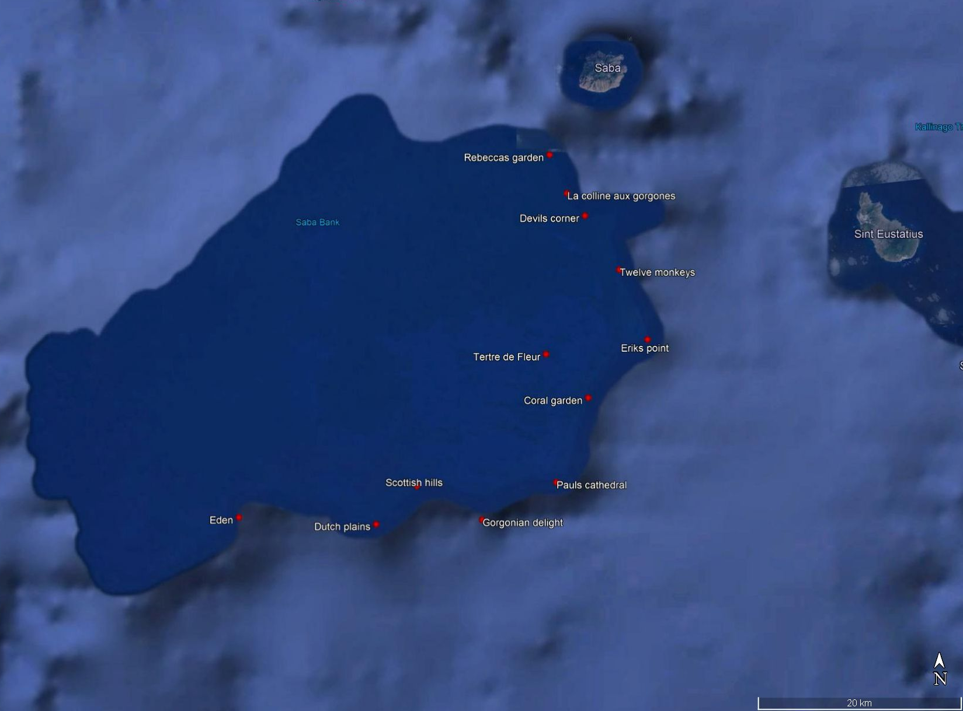
Figure 1. Map of the Saba Bank with the different sites used in this study.

Site | Site Code | Location | Position on bank | Depth (m)
La Colline aux Gorgones | Ca | 20 Q 471312 1937717 | North East | 22,33
Coral Garden | CG | 20 Q 473320 1917831 | East | 22,33
Devils Corner | DC | 20 Q 473049 1935532 | North East | 26,2
Dutch Plains | DP | 20 Q 463403 1908565 | South East | 22,33
Eden | ED | 20 Q 438745 1906842 | South West | 23,67
Erik's Point | EP | 20 Q 479140 1923479 | East | 27,67
Gorgonian Delight | GD | 20 Q 463403 190856 | South East | 15,67
Paul's Cathedral | PC | 20 Q 470180 1909614 | South East | 27,33
Rebecca's Garden | RG | 20 Q 469609 1941467 | North East | 25,57
Scottish Hills | SH | 20 Q 456551 190929 | South East | 15,33
Tetre de Fleur | TF | 20 Q 469207 1922078 | East | 16
Twelve Monkeys | TM | 20 Q 476404 1930273 | East | 21
Table 1. Depth and location of each sampled reef site in 2018. On each site 3 transects of 50m were laid out (A, B, and C) within 90 degrees and 50 pictures of approximately 1 square meter were taken on each transect.

Image analysis
For every transect, a 1 m quadrat was analyzed every 5 m (i.e. on 5 m, 10 m, 15 m, 20 m, 25 m, 30 m, 35 m, 40 m, 45 m, 50 m). If any of the chosen images was unclear it was replaced by the image next to it, ensuring that the spatial diversity in each transect is optimally represented. This resulted in 10 images per transect and 30 per site. In total 360 images were analyzed.
Images were analyzed using the program Coral Point Count (CPCe). This software allows you to distribute a number of stratified random points within an image. A total of 49 points were distributed for each quadrat. This resulted in 490 points per transects and 176400 data points in total, creating a useful overview of the benthic cover whilst considering the available time-window for this study. More points would mean that the increase in the number of identified species would follow a saturation curve. Even though more points would improve the accuracy, it would not necessarily result in more species being found.
Under each point the benthic group will be identified (corals, sponges, macroalgae, turf algae, cyanobacteria, crustose coralline algae, zoanthids, sand and other). In addition, the coral was identified down to species level and a few preselected macroalgae were identified down to genus level. To identify the species, the AGRRA training material was consulted. This catalog explains the characteristics of each species to make identification manageable.

Data analysis
The benthic groups will be analyzed using multivariate analysis based on the Bray-Curtis similarity index, as this is a common index for marine benthic species data (Bray and Curtis 1957; Legendre & Anderson, 1999). For all benthic groups the mean per site is calculated by fourth root transforming the number of appearances per transect and aggregating these to get the average over the three transects per site. This number is then back transformed to calculate the mean percentage and the 95% confidence intervals.
Furthermore, non-metric multidimensional scaling (NMDS) was used to visualize differences in benthic composition between sites and to relate this to environmental variation. NMDS uses a ranking system, placing sites closer when the similarity is highest. Sites were clustered using Bray-Curtis dissimilarity index. Clustering allocates objects to a certain group based on similar traits, which is seen by the adjacency of sites in the NMDS ordination. Hierarchical clustering was used to group members of inferior clusters (i.e. transects that are clustered under one site) in higher ranking clusters, which produces no cluster- overlapping (Borcard et al., 2018). Ward’s minimum variance clustering was used to minimize the sum-of-squares within each cluster (idem.). Environmental variables (depth, rugosity, benthic and fish diversity) were fitted as independent vectors onto the NMDS ordination.
Additionally, a non-linear regression analysis was performed to examine the correlations between benthic composition and various environmental variables. To test the non-linear relationships of the variables, the GAMs package was used in R (Wood, 2003). The used environmental data were rugosity, fish biomass, nutrient loading and coral recruitment which have been collected in the 2018 expedition. Rugosity is a measurement of the surface roughness and therefore gives an indication of the structural complexity of the reef. In this study, rugosity was measured by the height of the most adjacent coral colony every 5 meters. Fish biomass data on group level was fourth root transformed and back transformed to calculate the Shannon-Wiener diversity and richness. This data was also used in the multivariate analysis. For all analyses, the R programming environment was used (R Core Team, 2018). To perform all analyses, vegan, plyr, ggplot2, rgl and plotly packages were utilized (Oksanen et al., 2019; Wickham, 2011; Wickham, 2016; Adler et al., 2020; Sievert, 2020; ).

Reef Health Index
The RHI uses four key indicators (live coral cover, fleshy macroalgae cover, herbivorous fish biomass of the families Scaridae and Acanthuridae (g/100m²) and commercial fish biomass of the families Lutjanidae and Serranidae (g/100m²). As seen in figure 2, these indicators will be scored on a 1-5 ordinal scale by using the threshold values determined by Healthy Reefs (McField et al., 2018). Of these four indicator scores the mean score was taken which determined the overall health status (Critical, Poor, Fair, Good or Very Good) for each of the 12 sites.
Based on the findings of the multivariate and linear regression analysis as well as to existing literature on reef health, multiple environmental variables were selected as indicators to give a more extensive view of reef health. Each site was ranked on a 1-12 ordinal scale, based on their indicator value relative to the other sites. For all sites except macro algae and send, the highest score would mean the highest value. Sand and macro algae were scored in opposite direction as these variables have negative influence on reef health. These scores were summed and compared to the RHI score.
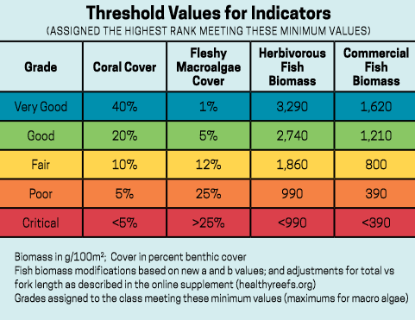
Figure 2. Key indicators and thresholds of the RHI (McField et al., 2018). For every indicator a 1-5 score is given. The average of these 4 scores will determine the health score of the site.

Results

Cover of benthic groups
Cover of the benthic composition was analysed down to species level for coral and down to phyla level for macro algae in the CPCe programme. Other organisms were categorized in different benthic groups (sponges, turf algae, cyanobacteria, crustose coralline algae). The proportion of each benthic group was then calculated by using the average of transect A, B and C for each site (table 2; figure 2). The average coral cover is 5.98% (±2.30) (table 2, figure 3). This means a decrease has been observed with the coral cover average in the Saba Bank of 7.11% (±0.92) in 2013 and 7.82% (±1.26) in 2015 (Wiltink, 2016). Eden (14.37%), Dutch Plains (9.91%) and Twelve Monkeys (8,98%) were the sites with highest coral cover. Tetre de Fleur has the lowest coral cover (1,01%) followed by la Colline aux Gorgones (1.26%), which is similar to 2013 and 2015 observations (Wiltink, 2016).

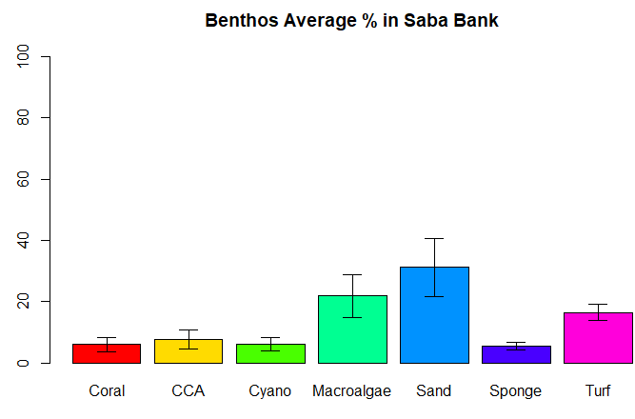
Figure 3. Overall average cover (±95% CI) of most important benthic groups across all sites on the Saba Bank.

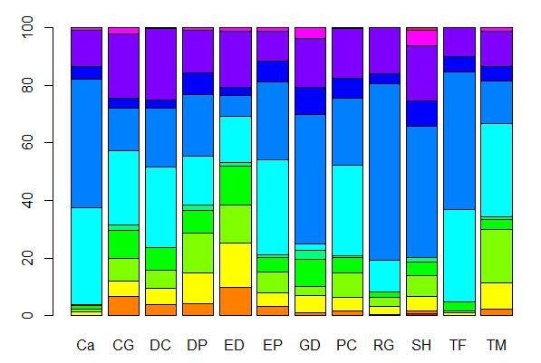
Figure 3. Benthic composition of each site in percentages. X-axis shows 12 Saba Bank sites and y-axis the percentages. All benthic groups are shown in legend. Unknown are points that were either unidentifiable because an object was blocking the view, or the species was unknown. CCA= crustose coralline algae.

Table 2. Percentages of benthic group cover on the Saba Bank sites in 2018. Shade, tape and other species were excluded prior to calculating the percentages. Site means follow a non-normal distribution resulting in asymmetric confidence intervals.
Site | Site Code | Ascididan  (%) | Coral (%) | Crustose coralline algae  (%) | Cyano  bacteria (%) | Gorgonian (%) | Macro  algae (%) | Sponge (%) | Sand (%) | Turf (%) | Zoanthid (%)
La Colline aux Gorgones | Ca | 0 | 1.26 (-1.22 +6.62) | 0.89 (-0.77 +39.18) | 1.08 (-0.95 +48.06) | 0.33 (-0.18 +0.31) | 33.45 (-14.40 +22.43) | 4.07 (-3.17 +18.60) | 40.80 (-15.35 +21.43) | 11.29 (-8.18 +18.60) | 0
Coral Garden | CG | 0 | 5.02 (-2.80 +4.87) | 7.29 (-5.27 +4.78) | 8.95 (-3.15 +4.29) | 1.80 (-0.98 +1.68) | 24.01 (-9.36 +13.26) | 3.31 (-1.94 +17.47) | 13.49 (-11.13 +31.77) | 20.85 (-10.68 +17.47) | 0 (+0.79)
Devils Corner | DC | 0 | 5.17 (-2.34 +3.55) | 6.00 (-3.68 +6.92) | 7.61 (-6.13 +16.62) | 0.19 (-0.15 +9.28) | 26.70 (-11.17 +16.33) | 2.62 (-0.91 +7.74) | 19.79 (-9.42 +14.74) | 23.98 (-6.23 +7.74) | 0,01 (+1.61)
Dutch Plains | DP | 0,14 (-0.10+8.02) | 9.91 (-5.68 +10.08) | 13.14 (-4.82 +6.65) | 7.13 (-6.28 +21.18) | 2.01 (-0.87 +1.30) | 15.87 (-12.85 +35.22) | 6.94 (-1.62 +2.27) | 20.04 (-8.95 +13.50) | 13.85 (-2.02 +2.27) | 0
Eden | ED | 0 | 14.37 (-9.30 +18.46) | 12.19 (-4.61 +6.45) | 12.64 (-9.29 +21.55) | 0.98 (-0.57 +1.02) | 14.92 (-4.37 +5.60) | 2.70 (-0.97 +8.82) | 6.79 (-6.30 +25.94) | 18.01 (-6.44 +8.82) | 0 (+0.77)
Erik's Point | EP | 0 | 4.85 (-2.80 +4.98) | 7.11 (-4.00 +6.98) | 4.77 (-2.45 +4.01) | 1.04 (-0.83 2.24) | 32.72 (-9.04 +11.41) | 6.90 (-1.02 +6.01) | 26.61 (-3.18 +3.50) | 10.37 (-4.18 +6.01) | 0
Gorgonian Delight | GD | 0 | 5.92 (-3.24 +5.53) | 2.87 (-2.55 +5.53) | 9.21 (-5.83 +11.29) | 3.12 (-0.73 +0.89) | 1.87 (-1.20 +2.36) | 8.83 (-1.70 +15.43) | 43.74 (-18.62 +27.44) | 16.47 (-9.01 +15.43) | 0,06 (+2.63)
Paul’s Cathedral | PC | 0 | 4.46 (-2.15 + 3.39) | 8.38 (-1.57 + 1.82) | 5.41 (-3.40 +6.53) | 0.43 (-0.33 +0.86) | 30.99 (-9.43 +12.23) | 6.73 (-1.60 +2.70) | 23.04 (-6.85 +8.82) | 16.91 (-2.41 +2.70) | 0
Rebecca's Garden | RG | 0 | 2.62 (-1.47 +2.58) | 3.11 (-0.76 + 0.92) | 1.74 (-1.53 +77.20 | 0.06 (-0.05 +2.62) | 10.92 (-4.29 +6.27) | 3.20 (-2.28 +12.61) | 57.49 (-16.30 +20.73) | 15.12 (-7.72 +12.61) | 0
Scottish Hills | SH | 0,69 (-0.48 +1.05) | 4.94 (-1.36 +1.71) | 6.87 (-5.05 +11.74) | 4.54 (-3.72 +10.46) | 1.67 (-0.68 +0.98) | 0.08 (-0.07 +3.56 | 8.62 (- 2.93 +7.29) | 44.25 (-17.02 +23.97) | 18.43 (-5.62 +7.29) | 0,98 (-0.56 +1.00)
Tetre de Fleur | TF | 0 | 1.01 (-0.33 + 0.43) | 0.65 (-0.4 +0.75) | 3.10 (-0.99 +1.30) | 0 (+0.77) | 31.52 (-10.77 +14.51) | 5.30 (-0.90 +4.38) | 47.01 (-13.93 +17.92) | 9.77 (-3.28 +4.38) | 0
Twelve Monkeys | TM | 0 | 8.98 (-1.73 +2.03) | 18.22 (-3.84 +4.56) | 3.52 (-1.27 +1.74) | 0.88 (-0.65 +1.51) | 31.83 (-8.02 +0.97) | 4.79 (-2.46 +3.18) | 14.60 (-8.30 +14.63) | 12.19 (-2.66 +3.18) | 0 (+0.78)
Mean ± 95% CI |  | 0,07  (±0.12)) | 5,98  (±2.30) | 7,54 (±3.08) | 6,09 (±2.07) | 1,09 (±0.56) | 21,84 (±6.97) | 5,55 (±1.28) | 31,13 (±9.59) | 16,33 (±2.63) | 0,09 (±0.16)

Multivariate analysis of Saba Bank sites

Benthic cover
Using non-metric multidimensional scaling (NMDS), sites, transects and species were ordinated in a two-dimensional plane based on species composition. In figure 4 an NMDS of the species in and sites on transect level in black is shown. As can be seen, all coral species are distributed on the right side of the graph. Moreover, Ascidiacea and Zoantharia are plotted close together in the top right and Sargassum hystrix and Sargassum spec. in the far left. For closer analysis and to examine general characteristics that are shared among sites, all transects were clustered into 4 groups in the NMDS graph as well as in a dendrogram based on their species composition (figure 5 and 6).

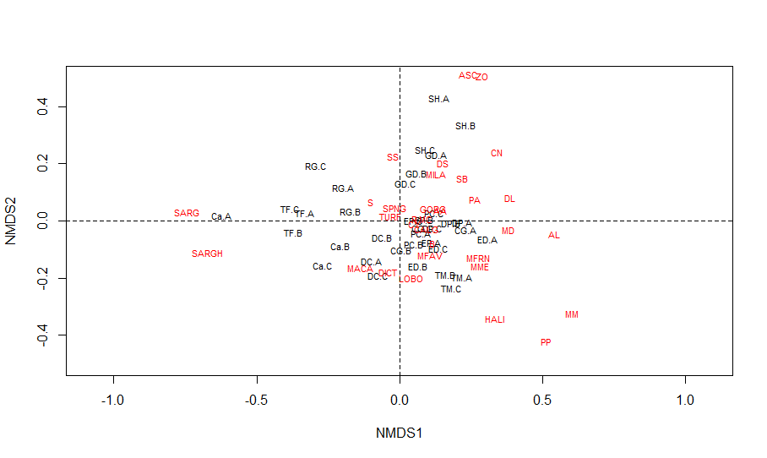
Figure 4. NDMS of transects based on benthic composition down to species level. Based on Bray-Curtis dissimilarity. Data is fourth root transformed. Species seen in red and transect sites in black. See appendix B for species name and abbreviations.

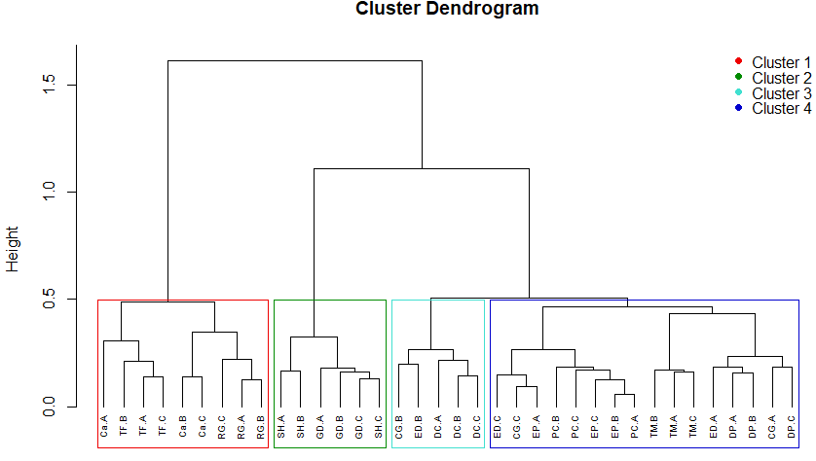
Figure 5. Dendrogram based on benthic composition down to species level. Sites are clustered using Ward’s D linkage into four groups, all transects of sites are clustered together except transect B of Coral Garden and transect B of Eden (cluster 3).
The species were fitted as vectors in figure 6. These vectors indicate how the distribution of transects is arranged based on species presence in the dataset. In this figure and table 3 the particular characteristics in terms of benthic composition of each cluster become apparent. Cluster 1 with la Colline aux Gorgones, Tetre de Fleurs and Rebecca’s Garden is partly based on their high Sargassum and sand cover. Cluster 2, containing Scottish Hills and Gorgonian Delight are characterised by a combination of high sand cover, low macro algae cover and relatively high sponge cover. Moreover, both sites have a relatively high cover of gorgonians, ascidian and zoanthids which are not present on other sites (table 3). Cluster 3 contains Devil’s Corner and transect B of Eden and Coral Garden. These sites have relatively high turf and cyanobacteria (table 3). Also, the macro algae species Lobophora and Dictyota seen in figure 7 ordinate towards the lower left. Despite these characteristics being negative for reef health, cluster 3 does contain average cover of coral and crustose coralline algae, which ordinates them closer to Cluster 4. Cluster 4 shows most sites with a generally higher coral cover than in other clusters, namely Twelve Monkeys, Eden, Dutch Plains, Coral Garden, Paul’s Cathedral and Erik’s Point. The coral species that are vectored in figure 6 are Monastraea Faveolata and Porites Porites, two of the most abundant species that were found. These sites also contain the highest crustose coralline algae cover (CCA).
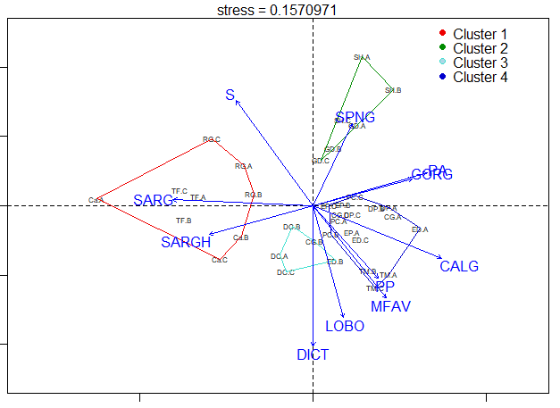
Figure 6. NMDS of transects based on benthic composition down to species level. Transects are clustered in four groups using Ward’s D linkage. Vectors of species are seen in blue. Clusters are outlined. Sites are abbreviated as in table 1, including transect number. Species are abbreviated in clockwise direction: S=sand, SPNG=sponge, PA=Porites Astroides, GORG=gorgonian, CALG= Crustose coralline algae, PP= Porites Porites,, MFAV= Monastraea Faveolata, LOBO= Lobophora,, DICT= Dictyota SARGH= Sargassum hystrix and SARG = Sargassum spec.
Table 3. Average benthic cover of the 4 clusters, including 95% CI. The distribution of means is not normal resulting in a non-symmetric confidence interval.
 | Ascidian (%) | Substrate (%) | Coral (%) | Crustose Coralline Algae (%) | Cyano bacteria (%) | Gorgonian (%) | Macro algae (%) | Sand (%) | Sponge (%) | Turf (%) | Zoanthid (%)
Cluster 1 | 0 | 0.13 (-0.12 + 0.69) | 1.52 (-0.72 +1.13 | 1.29 (-1.03 +2.77) | 1.85 (-1.67 +6.1 | 0.06 (-0.06 +0.3) | 22.16 (-8.17 +11.31) | 48.07 (-7.78 + 8.86) | 4.13 (-1.33 +1.75) | 11.91 (-3.3 + 4.17) | 0
Cluster 2 | 0.04 (-0.04 + 0.81) | 1.00 (-0.22 +0.27) | 5.41 (-1.41 +1.75) | 4.55 (-2.74 +5.06) | 6.57 (-3.42 +5.64) | 2.31 (-0.77 +1.03) | 0.52 (-0.5 +2.46) | 43.99 (-9.56 +11.42) | 8.73 (-1.27 +1.42) | 17.43 (-4.38 +5.39) | 0,3 (-0.29 +1.36)
Cluster 3 | 0 | 8.23 (-6.06 +14.12) | 5.17 (-2.02 +2.86) | 6.69 (-3.06 +4.69) | 9.40 (-4.81 +7.85) | 0.4 (-0.4 +10.85) | 21.64 (-7.88 +10.85) | 15.23 (-6.7 +10.03) | 2.63 (-0.53 +0.62) | 23.11 (-5.11 +6.13) | 0 (+0.11)
Cluster 4 | 0 | 2.97 (-0.86 +1.10) | 7.69 (-2.03 +2.53) | 10.95 (-2.28 +2.70) | 6.05 (-1.77 +2.27) | 1.1 (-0.35 +0.46) | 25.45 (-5.17 +6.09) | 17.32 (-5.0 + 6.38) | 5.36 (-1.02 +1.19) | 14.32 (-1.98 +2.21) | 0

Fish groups
When looked at the fish biomass data in figure 7, there are five fish groups that have significant correlation to the site ordination (p<0.5), namely reef chromis, parrotfish, damselfish, surgeonfish and triggerfish. Parrotfish, a herbivorous fish species that is important for reef health due to its grazing capacity (Bonaldo et al., 2014), has highest biomass levels in cluster 4 (Appendix C) . The other fish species are distributed towards the lower right of the ordination as well, with surgeonfish being the exception. Rebecca’s Garden and Tetre de Fleur show lowest levels of parrotfish biomass (appendix C).

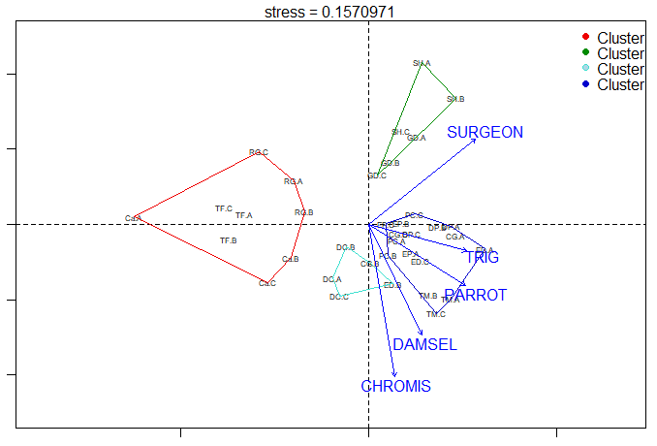
Figure 7. NMDS of transects based on benthic species data including vectors of fish group biomass. Fish and benthos data is fourth root transformed. Only fish species with p-value <0.05 are shown in the graph. Fish groups that are shown here are CHROMIS = reef chromis (Pomacentridaes), DAMSEL= damselfish (Pomacentridae), PARROT = parrotfish (Scaridae), TRIG = triggerfish (Balistidae) and SURGEON = surgeonfish (Acanthuridae).See appendix C for fish biomass per site.

Environmental variables
Multiple environmental variables were added to the NMDS graph. Specific values of every environmental variable per site can be found in table 4. Shannon-Wiener diversity was used to determine the benthic species biodiversity as seen in figure 8 together with benthic species richness. The vectors indicate a higher fish diversity and richness for sites in the lower right corner of the graph. Benthic diversity is highest for sites in cluster 4 and benthic richness for cluster 3 and 4 (table 4). Cluster 1 had overall lowest richness and diversity.
Rugosity shows high variation among the clusters. Cluster 3 and 4 have highest rugosity, with the highest value found in Twelve Monkeys (52.42) and a lowest value in Coral Garden with 28.13. For cluster 1 the highest value was found at 17,70 for la Colline aux Gorgones, and lowest for Tetre de Fleur (8.00). Cluster 2 shows relatively low rugosity with Scottish Hills (16.73) and Gorgonian Delight (13.64).
Lastly, depth is fitted in the graph, with cluster 2 containing the most shallow sites and cluster 4 the deepest (exact numbers in table 1).
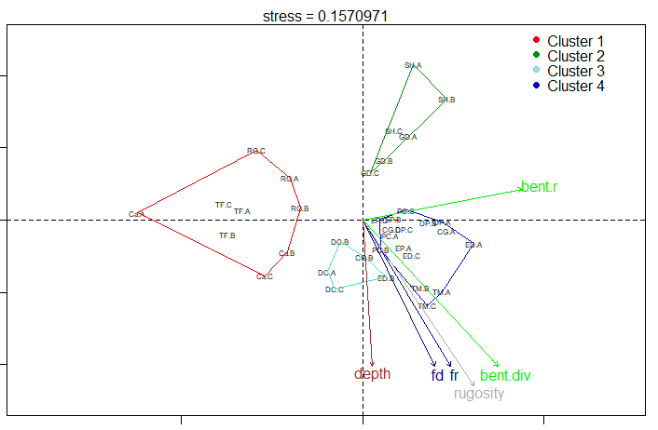
- B)

Figure 9. A) NMDS based on benthic species composition including vectors for benthic species diversity and richness. Data is not transformed (is dat goed?). These vectors indicate that diversity and richness are higher respectively for sites on the lower right and centre/upper right transects. B) Shows the diversity and richness (R) vector of fish, based on fish biomass on group level. Biomass data is fourth root transformed. Vector points to lower right corner as well.
Table 4. Environmental variables used in the NMDS ordination.
Site | Benthic species richness | Benthic species Shannon-Wiener diversity | Fish richness | Fish Shannon-Wiener diversity | Rugosity
Ca | 2,67 | 1,68 | 1,23 | 2,43 | 17,70
CG | 7,67 | 2,13 | 1,33 | 2,50 | 28,13
DC | 5,00 | 2,12 | 1,30 | 2,50 | 30,88
DP | 9,67 | 2,26 | 1,27 | 2,47 | 30,37
ED | 8,67 | 2,28 | 1,37 | 2,57 | 36,69
EP | 5,67 | 2,10 | 1,40 | 2,55 | 32,76
GD | 7,33 | 1,75 | 1,17 | 2,30 | 13,64
PC | 6,67 | 2,09 | 1,33 | 2,50 | 32,83
RG | 5,33 | 1,49 | 1,07 | 2,29 | 12,78
SH | 8,33 | 1,69 | 1,20 | 2,36 | 16,73
TF | 2,67 | 1,58 | 1,30 | 2,47 | 8,00
TM | 6,67 | 2,18 | 1,50 | 2,62 | 52,42

Linear regression analysis of other environmental variables
To examine the correlations between different environmental variables and understand their impact on reef health, a linear regression analysis was performed in R. Different environmental variables (depth, rugosity, recruitment and nutrient loading) and the dataset of the benthic composition on species and group level were used. Most important correlations are shown in figure 11. The non-linear relationships and degrees of smoothness of the model were tested using the GAM package in R.
Rugosity, also known as habitat complexity has been widely associated with high biodiversity and ecosystem functioning, as it increases niche diversity and provides resources and shelter to a wide range of species (Bruno & Bertness, 2001; Hewitt, 2005). When datasets were compared, a significant positive correlation was found between rugosity and coral, and rugosity and crustose coralline algae (fig. 11.A & 11.B). Contrarily, sand and rugosity are negatively correlated (fig. 11.C). In figure 11.D, Shannon-Wiener diversity of the fish assemblages shows a positive correlation with rugosity, which is found widely in the literature as well (Gratwicke, 2005; Jones, 2004).
When looked at different variables along a depth gradient, a rise in Lobophora variegata is found with increasing depth (fig. 11.E). This corresponds with observations in other Caribbean regions (Smith, 2008). Figure 11.F shows a positive correlation between depth and rugosity, suggesting that the deeper sites of the Saba Bank might function as better refuges for a wider range of organisms.
A)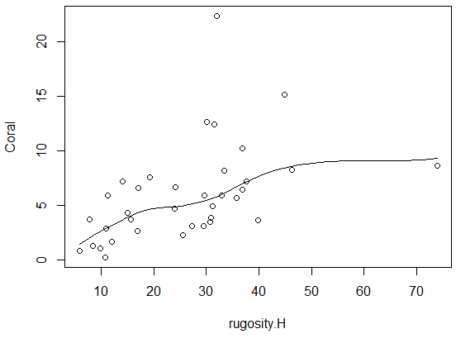 B)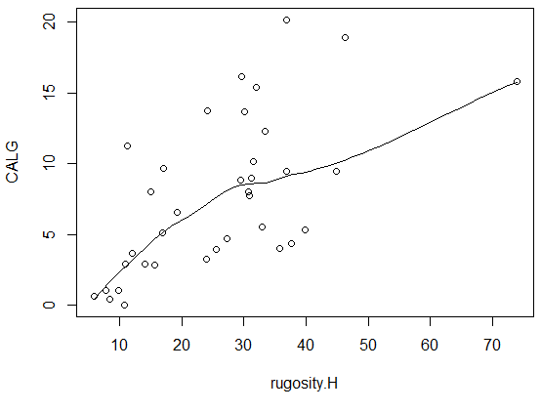
C)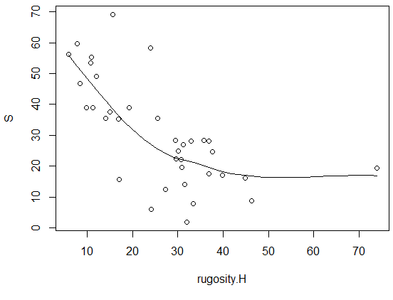 D) 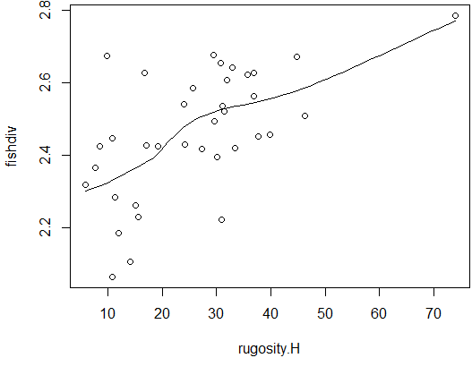
E) 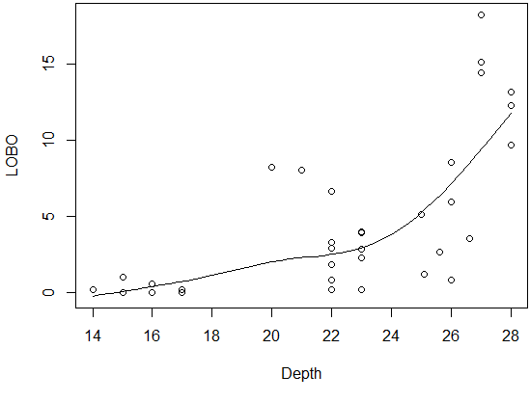 F) 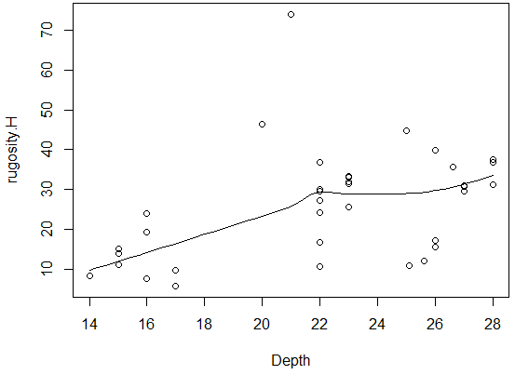
G) 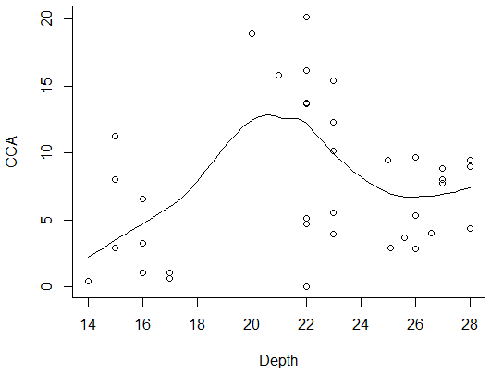 H) 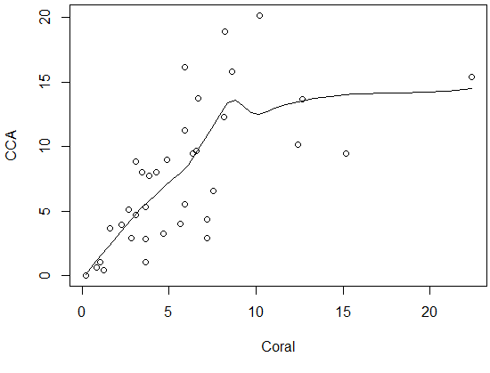
Figure 11. Linear regressions between A) rugosity and coral cover B) rugosity and crustose coralline algae cover C) rugosity and sand cover D) rugosity and fish diversity E) depth and Lobophora cover F) depth and rugosity G) depth and crustose coralline algae cover H) coral cover and crustose coralline algae cover
A positive correlation between depth and crustose coralline algae was found with a peak around 20m depth (CCA and CALG in fig. 11.G). In a 40-year study by de Bakker et al (2017), a decline in CCA cover was observed from 6.4% to 1% in the coastal reef sites of Curacao and Bonaire, with also a higher CCA cover for reefs at 20m to 30m depth than for 10m. In the Saba Bank sites of 2018 however, an average cover of 7,7% was found. Fabricius & De’ath (2001) observed a negative correlation between CCA and coastal adjacency due to increased human activity. Deeper reefs such as the sites on the Saba Bank are less affected by anthropogenic stressors, possibly explaining the correlation in figure 11.G and the overall higher percentage cover. CCA grow on dead coral or coral sand and are beneficial for coral reefs as they enhance coral recruitment by functioning as suitable substrate (Ritson-Williams et al. 2009) and can suppress macroalgal growth (Vermeij et al., 2011). This is reflected in figure 11.H, where a positive correlation with was observed.
Nutrient loading and recruitment didn’t show any significant correlations (appendix D & E). Furthermore, no negative correlation between parrotfish and depth was found (fig. 11.J), despite this being observed in numerous studies (Nemeth & Appeldoorn, 2009; Meekan & Choat, 1997).

Reef Health Index scores
The RHI showed that the health status of Gorgonian Delight was good, Coral Garden and Scottish Hills were fair, Devils Corner, Dutch Plains, Eden and Paul’s Cathedral were poor and Tetre de Fleur, Twelve Monkeys, Erik’s Point, Rebecca’s Garden and la Colline aux Gorgones were critical (figure 12; table 3).
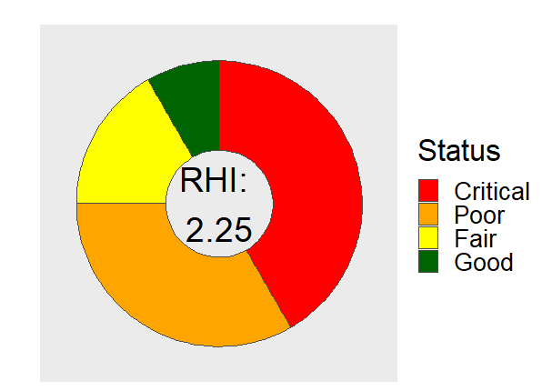
Figure 12. Mean RHI score is 2.25 for the combined 12 Saba Bank sites in 2018. 1 scored good, 2 scored fair, 4 scored poor and 5 scored critical (see table 3). Sites were scored according to the RHI indicators: fleshy macroalgae biomass, coral cover, herbivorous fish biomass and commercial fish biomass. Data on transect level was fourth root transformed to calculate the mean and back transformed for the RHI scores.
Table 3. RHI score and label of each sampled site based on data of the 2018 expedition. The mean of the 3 transects per site is taken and scored. The mean of the 4 scores for the 4 indicators is taken to derive a final score and health status label. See appendix F for score per indicator.
Site | Mean score | Label
CG | 3.00 | Fair
DC | 2.00 | Poor
DP | 2.25 | Poor
ED | 2.50 | Poor
EP | 1.75 | Critical
GD | 3.50 | Good
Ca | 1.25 | Critical
PC | 2.50 | Poor
RG | 1.75 | Critical
SH | 3.25 | Fair
TF | 1.50 | Critical
TM | 1.75 | Critical

Comparing the Reef Health Index to multiple environmental variables
When the sites are scored using the RHI indicators as well as multiple other variables (rugosity, diversity, richness, crustose coralline algae and sand), the results show a different rank of sites from low to high health status than the RHI. Table 4 shows that the cluster 1 sites that were scored lowest in the RHI also scored lowest in this more extensive index. However, the best performing sites according to the RHI which were Scottish Hills and Gorgonian Delight of cluster 2 scored below average. Moreover, the cluster 3 and 4 sites that scored highest in this alternative index, were labeled as Critical or Poor by the RHI, except for Coral Garden which had a Fair status.

Table 4. Second column shows the sum of scores of multiple indicators that were scored on a 1-12 ordinal scale. Score per variable in appendix G. Indicators used: rugosity, benthic species richness, benthic species diversity, herbivorous fish. commercial fish, coral, crustose coralline algae, macro algae, sand, fish richness, fish diversity. Only sand and macro algae are scored higher for lower cover. Table is ranked form lowest to highest site based on the total score. Third column shows the RHI label assigned to that site.
Site | Cluster | Total score | RHI label
RG | 1 | 31 | Critical
Ca | 1 | 35 | Critical
TF | 1 | 35 | Critical
GD | 2 | 63 | Good
SH | 2 | 67 | Fair
EP | 4 | 73 | Critical
DC | 3 | 74 | Poor
PC | 4 | 84 | Poor
CG | 4 | 89 | Fair
DP | 4 | 92 | Poor
TM | 4 | 101 | Critical
ED | 4 | 114 | Poor

Discussion
In this study, the benthic composition of 12 sites on the Saba Bank was assessed using CPCe. Using multivariate analysis and linear regression analysis, the effects of multiple environmental variables on the composition of each site was examined. Lastly, the RHI was used to score the sites on their health and compared to an assessment with more indicators to analyse the applicability of the RHI.

Benthic composition
The benthic composition based on the image analysis shows high variety which could be based on different factors. When looked at cluster 1, a possible determinant for their low coral and high macro algae and sand cover can be their location. Tetre de Fleur is the only site located in the middle of the Bank, whereas other sites are a reef-drop off resulting in more rugosity and therefore possibly a higher biodiversity. La Colline aux Gorgones and Rebecca’s Garden are both situated nearest to the island of Saba, which might account for the high sand and rock cover seen in figure 3. Moreover, Eden and Dutch Plains are located at the south side of the Bank, which might indicate that they have been less influenced by human activity and therefore see a higher coral cover. Part of the composition variety could also be attributed to site depth. Crustose coralline algae have been observed to be less abundant in 10m reefs than 20-30m in the adjacent Caribbean reefs of Curacao and Bonaire (de Bakker et al., 2017). A similar positive correlation of CCA cover and depth was also found in the linear regression analysis. This could explain the low cover in Scottish Hills and Gorgonian Delight and high cover in sites as Eden and Twelve Monkeys.

Reef Health Index
The RHI health status of the sites in the Saba Bank show a different rank than when scored by the more extensive indicator set. Cluster 1 containing La Colline aux Gorgones, Tetre de Fleur and Rebecca’s Garden score low on both indices. Rebecca Garden and La Colline aux Gorgones have low scores for both fish richness and diversity, possibly because they endure higher fishing rates than sites less adjacent to Saba (Mora, 2003). This also resulted in low herbivorous and commercial fish biomass in the RHI and, together with low coral cover, in an overall low health status.
The sites of cluster 4 (Twelve monkey, Coral garden, Eden, Dutch plains, Paul’s cathedral and Erik’s point) were sustaining highest coral cover, highest rugosity, highest benthic and fish diversity including high biomass of the functional parrotfish and highest cover of crustose coralline algae (table 3 and 4). This resulted in the highest total score of the alternative index. Contrastingly, these sites scored poor or critical in the RHI except for Coral Garden. This is mostly due to the fact that most of the named variables are not included in the RHI. Moreover, these sites had a low commercial fish biomass and high macro algae cover, resulting in an overall low score according to the RHI. This is clearly seen in the the deepest site of the Saba Bank, Erik’s Point. It has high rugosity and species diversity (table 4) but a low coral cover and high macro algae cover. In addition, the herbivorous and commercial fish biomass is low, which might be due to its depth (28m). This resulted in a ritical health status with the RHI.
Gorgonian Delight and Scottish hills, the two shallowest reef on the Saba Bank who together form cluster 2, scored good (3.50) and fair (3.25) respectively according to the RHI. As can be seen in appendix F, this was mostly due to high commercial fish biomass for Gorgonian Delight and high herbivorous fish for Scottish Hills. Several studies have found positive correlations between shallow reefs and fish biomass, which might partly explain these observations (Nemeth & Apeldoorn, 2009; Meekan & Choat, 1997). In addition to fish biomass, they both had a low macro algae cover. Nevertheless, the cover of Gorgonian Delight consists of high percentages of cyanobacteria (9,52%), turf (17,02%) and sand (46,31%). Scottish Hills had a similar high composition of turf and sand, which might result in a low percentage cover of macro algae, but is not functionally more beneficial for the reef. This is reflected in the alternative index which included sand as an indicator. Moreover, they both score low on rugosity and Shannon-Wiener benthic diversity which is included in the alternative index as well.

Conclusion
The RHI does provide a method that is straight-forward and widely applicable. However, it does seem to have a positive bias towards more shallow reefs as the threshold values of the indicators are too high for the overall lower averages that are found in deeper reefs for herbivorous fish, commercial fish and coral cover.
The weight of the commercial fish indicator has partly caused a low score for the best performing sites of the alternative index (cluster 4), and a high score for the more shallow sites (cluster 2). It is therefore suggested to further examine the abundance of commercial fish and herbivorous fish in relation to reef depths, and possibly lower the thresholds for deeper reefs.
When looked at coral cover, an overall lower average for deeper reefs (>15m) has been found in literature (Bak, 1980; Bosscher, 1992). The overall average of the Saba Bank is lower compared to studies of more shallow sites in the region (de Bakker, 2016). However the deeper sites on Saba performed relatively well on coral cover compared to the more shallow sites. Despite the observations of this study, lowering the thresholds of coral cover for deeper reefs could be an option when this negative depth-coral correlation is observed in more Mesoamerican reef studies.
Macroalgae are one of the primary competitors of coral, making it a suitable indicator for reef health. However, sand has no beneficial effect on reefs as well and is not included in the RHI. Thus, sites with large sand areas and low coral cover such as cluster 2 will gain a high macro algae score which does not reflect reef quality. Weighing the coral cover indicator more heavily in the final score could ensure that no sand plains with high fish biomass will be labelled as good coral reefs.
Lastly, the multivariate analyses showed interesting correlations between crustose coralline algae and depth. As crustose coralline algae is beneficial for coral recruitment it could potentially be a valuable indicator for coral health on deeper reefs. The same can be concluded for rugosity, which is associated with higher benthic and fish diversity. In order to determine if these indicators should be incorporated into the RHI, the trade-offs between the current index and a more extensive index in terms of efficiency, versatility and accuracy should be further explored.

Literature references
Bak, R. P. M., Carpay, M. J. E., & De Ruyter Van Steveninck, E. D. (1984). Densities of the sea urchin Diadema antillarum before and after mass mortalities on the coral reefs on Curacao. Marine ecology progress series. Oldendorf, 17(1), 105-108.
Bak, R. P., & Luckhurst, B. E. (1980). Constancy and change in coral reef habitats along depth gradients at Curacao. Oecologia, 47(2), 145-155.
Bak, R. P., Nieuwland, G., & Meesters, E. H. (2005). Coral reef crisis in deep and shallow reefs: 30 years of constancy and change in reefs of Curacao and Bonaire. Coral reefs, 24(3), 475-479.
Baker, A. C., Glynn, P. W., & Riegl, B. (2008). Climate change and coral reef bleaching: An ecological assessment of long-term impacts, recovery trends and future outlook. Estuarine, coastal and shelf science, 80(4), 435-471.
Bonaldo, R. M., Hoey, A. S., & Bellwood, D. R. (2014). The ecosystem roles of parrotfishes on tropical reefs. Oceanography and Marine Biology: An Annual Review, 52, 81-132.
Bongaerts, P., Ridgway, T., Sampayo, E. M., & Hoegh-Guldberg, O. (2010). Assessing the ‘deep reef refugia’hypothesis: focus on Caribbean reefs. Coral reefs, 29(2), 309-327.
Bosscher, H., & Schlager, W. (1992). Computer simulation of reef growth. Sedimentology, 39(3), 503-512.
Bray, J. R., & Curtis, J. T. (1957). An ordination of the upland forest communities of southern Wisconsin. Ecological monographs, 27(4), 326-349.
Bruno J. F.& Bertness M. D.. 2001Habitat modification and facilitation in benthic marine communities. Marine community ecology (eds , Bertness M. D., Gaines S. D.& Hay M. E.), pp. 201–218. Sunderland, MA: Sinauer.
Bruno, J. F., & Selig, E. R. (2007). Regional decline of coral cover in the Indo-Pacific: timing, extent, and subregional comparisons. PLoS one, 2(8).
Burke, L. M., Reytar, K., Spalding, M., & Perry, A. (2017). Reefs at risk revisited: World Resources Institute.
C. Sievert. Interactive Web-Based Data Visualization with R, plotly, and shiny. Chapman and Hall/CRC Florida, 2020.
C.R. Wilkinson (Ed.), Status of Coral Reefs of the World: 2002, Australian Institute of Marine Science, Western Australia (2002), p. 378
Costanza, R., d'Arge, R., De Groot, R., Farber, S., Grasso, M., Hannon, B., ... & Raskin, R. G. (1997). The value of the world's ecosystem services and natural capital. nature, 387(6630), 253-260.
Daniel Adler, Duncan Murdoch and others (2020). rgl: 3D Visualization Using OpenGL. R package version 0.100.54.
de Bakker, D. M., Meesters, E. H., Bak, R. P., Nieuwland, G., & Van Duyl, F. C. (2016). Long-term shifts in coral communities on shallow to deep reef slopes of Curaçao and Bonaire: are there any winners?. Frontiers in Marine Science, 3, 247.
de Bakker, D. M., Meesters, E. H., van Bleijswijk, J. D., Luttikhuizen, P. C., Breeuwer, H. J., & Becking, L. E. (2016a). Population genetic structure, abundance, and health status of two dominant benthic species in the Saba Bank National Park, Caribbean Netherlands: Montastraea cavernosa and Xestospongia muta. PLoS One, 11(5).
de Bakker, D. M., Van Duyl, F. C., Bak, R. P., Nugues, M. M., Nieuwland, G., & Meesters, E. H. (2017). 40 Years of benthic community change on the Caribbean reefs of Curaçao and Bonaire: the rise of slimy cyanobacterial mats. Coral Reefs, 36(2), 355-367.
Downs, C. A., Woodley, C. M., Richmond, R. H., Lanning, L. L., & Owen, R. (2005). Shifting the paradigm of coral-reef ‘health’assessment. Marine Pollution Bulletin, 51(5-7), 486-494.
Gardner TA, Côté IM, Gill JA, Grant A, Watkinson AR (2003) Long-term region-wide declines in Caribbean corals. Science 301:958–960
Glynn, P. W. (1996). Coral reef bleaching: facts, hypotheses and implications. Global change biology, 2(6), 495-509.
Gratwicke, B., & Speight, M. R. (2005). Effects of habitat complexity on Caribbean marine fish assemblages. Marine Ecology Progress Series, 292, 301-310.
Jones GP, McCormick MI, Srinivasan M, Eagle JV (2004) Coral decline threatens fish biodiversity in marine reserves. Proc Natl Acad Sci USA 101:8251–8253
Grigg RW (2006) Depth limit for reef building corals in the Au’au Channel. S.E. Hawaii. Coral Reefs 25:77–84
H. Wickham (2016). ggplot2: Elegant Graphics for Data Analysis. Springer-Verlag New York.
Hadley Wickham (2011). The Split-Apply-Combine Strategy for Data Analysis. Journal of Statistical Software, 40(1), 1-29.
Hawkins JP, Roberts CM (2004) Effects of artisanal fishing on Caribbean coral reefs. Conservation Biology 18: 215-226
Hewitt JE, Thrush SE, Halliday J, Duffy C (2005) The importance of small-scale habitat structure for maintaining beta diversity. Ecology 86:1619–1626
Hughes TP (1994) Catastrophes, phase shifts, and large-scale degradation of a Caribbean coral reef. Science 265:1547–1551
Hughes, T. P., Kerry, J. T., Álvarez-Noriega, M., Álvarez-Romero, J. G., Anderson, K. D., Baird, A. H., ... & Bridge, T. C. (2017). Global warming and recurrent mass bleaching of corals. Nature, 543(7645), 373-377.
Jackson JBC, Donovan M, Cramer K, Lam V (2014) Status and trends of Caribbean coral reefs: 1970–2012. Global Coral Reef Monitoring Network, IUCN, Gland, Switzerland
Jørgensen SE, Xu F-L, Salas F, Marques JC. Chapter 2. Application of Indicators for the Assessment of Ecosystem Health. In: Jørgensen SE, Xu F-L, Costanza R (Eds.), Handbook of ecological indicators for assessment of ecosystem health, CRC Press. USA. 2005; 5–66 pp
Díaz-Pérez, L., Rodríguez-Zaragoza, F. A., Ortiz, M., Cupul-Magaña, A. L., Carriquiry, J. D., Rios-Jara, E., ... & del Carmen Garcia-Rivas, M. (2016). Coral reef health indices versus the biological, ecological and functional diversity of fish and coral assemblages in the Caribbean Sea. PloS one, 11(8), e0161812.
Legendre, P., & Anderson, M. J. (1999). Distance‐based redundancy analysis: testing multispecies responses in multifactorial ecological experiments. Ecological monographs, 69(1), 1-24.
Macintyre, I. G., Kinsman, D. J., & German, R. C. (1975). Geological reconnaissance survey of Saba Bank, Caribbean Sea. Carib J Sci, 15, 11-20.
McCloskey, L. R., & Muscatine, L. (1984). Production and respiration in the Red Sea coral Stylophora pistillata as a function of depth. Proceedings of the Royal Society of London. Series B. Biological Sciences, 222(1227), 215-230.
McField, M., & Kramer, P. (2007). Healthy reefs for healthy people: A guide to indicators of reef health and social well-being in the Mesoamerican Reef Region. Smithsonian Institution, Washington, DC, EEUU.
Mcfield, M., Kramer, P., Álvarez-Filip, L., Drysdale, I., Rueda-Flores, M., & Giró-Petersen, A. (2018). Mesoamerican Reef Report Card.
Mcfield, M., Kramer, P., Álvarez-Filip, L., Drysdale, I., Rueda-Flores, M., & Giró-Petersen, A. (2018). Mesoamerican Reef Report Card.
McKenna SA, Etnoyer P. Rapid Assessment of Stony Coral Richness and Condition on Saba Bank, Netherlands Antilles. Plos One. 2010;5(5).
Meekan, M. G., & Choat, J. H. (1997). Latitudinal variation in abundance of herbivorous fishes: a comparison of temperate and tropical reefs. Marine Biology, 128(3), 373-383.
Moberg, F., & Folke, C. (1999). Ecological goods and services of coral reef ecosystems. Ecological economics, 29(2), 215-233.
Mora C, Chittaro PM, Sale PF, Kritzer JP, Ludsin SA et al. (2003) Patterns and processes in reef fish diversity. Nature 421: 933-936. doi:10.1038/nature01393.
Mora, C. (2008). A clear human footprint in the coral reefs of the Caribbean. Proceedings of the Royal Society B: Biological Sciences, 275(1636), 767-773.
Mumby, P. J., Dahlgren, C. P., Harborne, A. R., Kappel, C. V., Micheli, F., Brumbaugh, D. R., ... & Buch, K. (2006). Fishing, trophic cascades, and the process of grazing on coral reefs. science, 311(5757), 98-101.
Nemeth, M., & Appeldoorn, R. (2009). The distribution of herbivorous coral reef fishes within fore-reef habitats: the role of depth, light and rugosity. Caribbean Journal of Science, 45(2–3), 247-253.
Newman, M. J., Paredes, G. A., Sala, E., & Jackson, J. B. (2006). Structure of Caribbean coral reef communities across a large gradient of fish biomass. Ecology letters, 9(11), 1216-1227.
Oigman-Pszczol, S. S., & Creed, J. C. (2011). Can patterns in benthic communities be explained by an environmental pressure index?. Marine pollution bulletin, 62(10), 2181-2189.
Oksanen, F. Guillaume Blanchet, Michael Friendly, Roeland Kindt, Pierre Legendre, Dan McGlinn, Peter R. Minchin, R. B. O'Hara, Gavin L. Simpson, Peter Solymos, M. Henry H. Stevens, Eduard Szoecs and Helene Wagner (2019). vegan: Community Ecology Package. R package version 2.5-6.
R Core Team (2018). R: A language and environment for statistical computing. R Foundation for Statistical Computing, Vienna, Austria. URL https://www.R-project.org/.
Sadovy Y, Eklund A (1999) Synopsis of biological data on the Nassau Grouper Epinephelus striatus (Bloch 1792) and the jewfish Epinephelus itajara (Lichenstein 1822). NOAA-NMFS Technical Paper 146. Maryland: Silver Spring; 65 p.
Smith TB, Nemeth RS, Blondeau J, Calnan JM, Kadison E, Herzlieb S (2008) Assessing coral reef health across onshore to offshore stress gradients in the US Virgin Islands. Mar Pollut Bull 56:1983–1991
Thacker RW, Cristina Diaz M, de Voogd NJ, van Soest RWM, Freeman CJ, Mobley AS, et al. Preliminary Assessment of Sponge Biodiversity on Saba Bank, Netherlands Antilles. Plos One. 2010;5(5).
Thacker, R.W., M.C. Diaz, N.J. de Voogd, R.W.M. van Soest, C.J. Freeman, A. Mobley, J. Lapietra, K. Cope, S. McKenna (2010) Assessment of Sponge Biodiversity on Saba Bank Atoll, Netherlands Antilles. PLoS ONE, in press.
Tittensor, D. P., Walpole, M., Hill, S. L., Boyce, D. G., Britten, G. L., Burgess, N. D., ... & Baumung, R. (2014). A mid-term analysis of progress toward international biodiversity targets. Science, 346(6206), 241-244.
van Woesik, R., Sakai, K., Ganase, A., & Loya, Y. J. M. E. P. S. (2011). Revisiting the winners and the losers a decade after coral bleaching. Marine Ecology Progress Series, 434, 67-76.
Vermeij, M. J. A., Dailer, M. L., & Smith, C. M. (2011). Crustose coralline algae can suppress macroalgal growth and recruitment on Hawaiian coral reefs. Marine Ecology Progress Series, 422, 1-7.
Williams JT, Carpenter KE, Van Tassell JL, Hoetjes P, Toller W, Etnoyer P, et al. Biodiversity Assessment of the Fishes of Saba Bank Atoll, Netherlands Antilles. Plos One. 2010;5(5).
Williams, I., & Polunin, N. (2001). Large-scale associations between macroalgal cover and grazer biomass on mid-depth reefs in the Caribbean. Coral reefs, 19(4), 358-366.
Wiltink, M., Meesters, H. W. G., Bos, O. G., De Voogd, N. J., & Becking, L. E. (2017). Is Saba Bank becoming a sponge reef'?.
Wood, S. N. (2003). Thin plate regression splines. Journal of the Royal Statistical Society: Series B (Statistical Methodology), 65(1), 95-114.

Appendix
- Indicators of a healthy Mesoamerican reef by the Healthy Reef Initiative
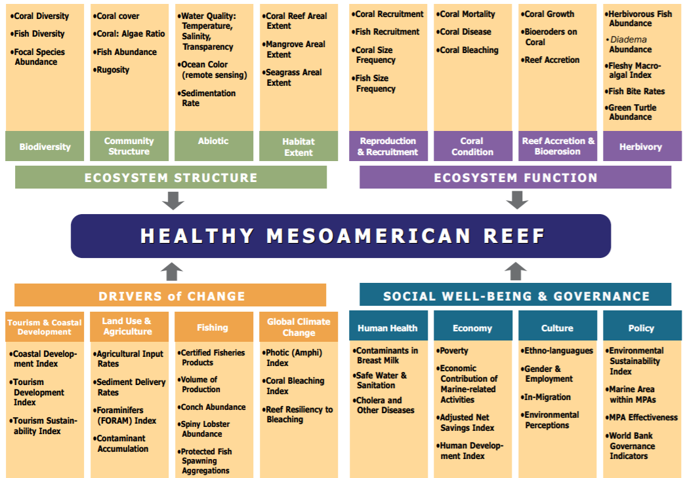
Source: McField, M., & Kramer, P. (2007)
- Abbreviations and names of benthic species in figure 3
Abbreviation | Species name
AA | "Agaricia agaricites"
AG | "Agaricia grahamae"
AL | "Agaricia lamarcki"
CN | "Colpophyllia natans"
DL | "Diploria labyrinthiformis"
DS | "Diploria strigosa"
DSO | "Dichocoenia stokesi"
LC | "Leptoseris cucullata"
MA | "Montastraea annularis"
MC | "Montastraea cavernosa"
MD | "Madracis decactis"
MF | "Mycetophyllia ferox"
MFAV | "Montastrea faveolata"
MFRN | "Montastrea franksi"
MILA | "Millipora alcicornis"
ML | "Mycetophyllia lamarckiana"
MM | "Madracis mirabilis"
MME | "Meandrina meandrites"
PA | "Porites astreoides"
PD | "Porites divaricata"
PF | "Porites furcata"
PP | "Porites porites"
SB | "Solenastrea bournoni"
SC | "Scolymia cubensis"
SM | "Stephanocoenia michelinii"
SR | "Siderastrea radians"
SS | "Siderastrea siderea"
B | "Bare substrate"
P | "Pavement"
R | "Rubble"
S | "Sand"
GORG | "Gorgonian"
ZO | "Zoanthid"
ACT | "Actinaria"
ASC | "Ascidian"
MACA | "Macroalgae"
TURF | "Turf"
DICT | "Dictyota"
LOBO | "Lobophora"
HALI | "Halimeda"
SARGH | "Sargassum Hystrix"
SARG | "Sargassum"
CY | "Cyano"
UNK | "Unknown"

- Fish biomass for most significant groups in figure 7.
Data was fourth root transformed and back transformed to calculate the site mean.
 | Reef Chromis | Damselfish | Parrotfish | Surgeonfish | Triggerfish
CaG | 97.31 | 93.99 | 506.26 | 304.80 | 0.00
CG | 174.35 | 315.59 | 965.84 | 1078.93 | 145.15
DC | 556.60 | 120.27 | 1578.45 | 520.82 | 136.33
DP | 512.81 | 363.45 | 910.59 | 1564.67 | 4842.16
ED | 289.20 | 173.57 | 1178.35 | 1348.60 | 343.30
EP | 1033.27 | 161.95 | 752.28 | 2481.52 | 526.98
GD | 0.00 | 27.37 | 479.35 | 1466.20 | 2758.27
PC | 555.92 | 253.29 | 1000.80 | 1207.99 | 1986.98
RG | 2.43 | 33.12 | 25.96 | 295.30 | 0.00
SH | 0.00 | 3.90 | 796.31 | 2783.20 | 145.33
TF | 55.08 | 94.93 | 70.31 | 1148.19 | 582.03
TM | 395.80 | 354.71 | 762.25 | 604.02 | 2709.52

- Correlation of multiple variables and benthic species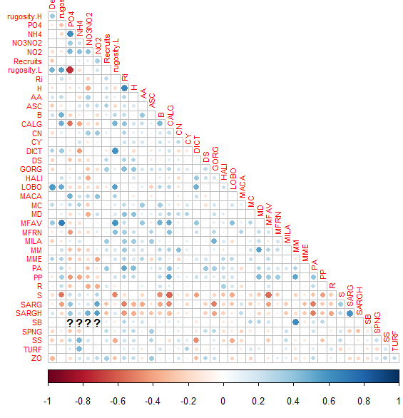
- Correlation of multiple variables and benthic groups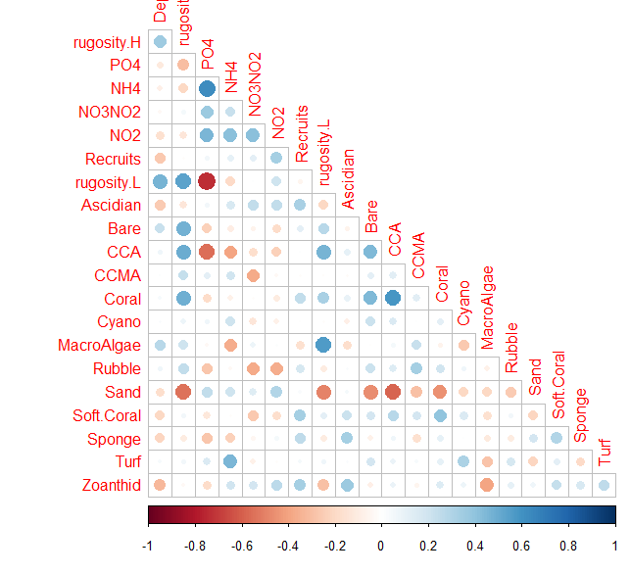

Site | Mean coral  cover | Mean macroalgae  cover | Mean herbivorous  fish | Mean commercial  fish | coral | MA | herb | comm | mean | label
CG | 5.02 (-2.80 +4.87) | 24.01 (-9.36 +13.26) | 2204.55 | 2091.44 | 2 | 2 | 3 | 5 | 3.00 | Fair
DC | 5.17 (-2.34 +3.55) | 26.70 (-11.17 +16.33) | 2191.98 | 606.13 | 2 | 1 | 3 | 2 | 2.00 | Poor
DP | 9.91 (-5.68 +10.08) | 15.87 (-12.85 +35.22) | 2521.82 | 674.13 | 2 | 2 | 3 | 2 | 2.25 | Poor
ED | 14.37 (-9.30 +18.46) | 14.92 (-4.37 +5.60) | 2621.11 | 674.33 | 3 | 2 | 3 | 2 | 2.50 | Poor
EP | 4.85 (-2.80 +4.98) | 32.72 (-9.04 +11.41) | 3295.17 | 8.10 | 1 | 1 | 4 | 1 | 1.75 | Critical
GD | 5.92 (-3.24 +5.53) | 1.87 (-1.20 +2.36) | 2003.30 | 4319.11 | 2 | 4 | 3 | 5 | 3.50 | Good
LG/CaG | 1.26 (-1.22 +6.62) | 0.89 (-0.77 +39.18) | 841.08 | 423.87 | 1 | 1 | 1 | 2 | 1.25 | Critical
PC | 4.46 (-2.15 + 3.39) | 5.41 (-3.40 +6.53) | 2396.22 | 5772.20 | 1 | 1 | 3 | 5 | 2.50 | Poor
RG | 2.62 (-1.47 +2.58) | 1.74 (-1.53 +77.20 | 398.03 | 488.07 | 1 | 3 | 1 | 2 | 1.75 | Critical
SH | 4.94 (-1.36 +1.71) | 4.54 (-3.72 +10.46) | 3582.17 | 498.21 | 1 | 5 | 5 | 2 | 3.25 | Fair
TF | 1.01 (-0.33 + 0.43) | 3.10 (-0.99 +1.30) | 1252.22 | 688.51 | 1 | 1 | 2 | 2 | 1.50 | Critical
TM | 8.98 (-1.73 +2.03) | 3.52 (-1.27 +1.74) | 1366.41 | 785.24 | 2 | 1 | 2 | 2 | 1.75 | Critical
- HRI scores of Saba Bank 2018 sites

- Scoring of Saba Bank sites with RHI indicators and multiple other variables

Site | Rugosity | Benthic species richness | Benthic species diversity | Herbivorous fish | Commercial fish | Coral | CCA | Macro algae | Sand | Fish richness | Fish diversity | Total score
Ca | 5 | 1 | 3 | 2 | 2 | 2 | 2 | 5 | 5 | 4 | 4 | 35
CG | 6 | 9 | 9 | 7 | 10 | 7 | 8 | 7 | 11 | 8 | 7 | 89
DC | 8 | 3 | 8 | 6 | 5 | 8 | 5 | 6 | 9 | 7 | 9 | 74
DP | 7 | 12 | 10 | 9 | 6 | 11 | 11 | 8 | 8 | 5 | 5 | 92
ED | 11 | 11 | 11 | 10 | 7 | 12 | 10 | 9 | 12 | 10 | 11 | 114
EP | 9 | 5 | 7 | 11 | 1 | 5 | 7 | 1 | 6 | 11 | 10 | 73
GD | 3 | 8 | 5 | 5 | 11 | 9 | 3 | 11 | 4 | 2 | 2 | 63
PC | 10 | 7 | 6 | 8 | 12 | 4 | 9 | 4 | 7 | 9 | 8 | 84
RG | 2 | 4 | 1 | 1 | 3 | 3 | 4 | 10 | 1 | 1 | 1 | 31
SH | 4 | 10 | 4 | 12 | 4 | 6 | 6 | 12 | 3 | 3 | 3 | 67
TF | 1 | 2 | 2 | 3 | 8 | 1 | 1 | 3 | 2 | 6 | 6 | 35
TM | 12 | 6 | 12 | 4 | 9 | 10 | 12 | 2 | 10 | 12 | 12 | 101

