**ASSESSING THE VIABILITY OF THE GROASIS WATERBOXX FOR DRY FOREST RESTORATION AND REFORESTATION PROJECTS**

**Daniel James Carlton Fishburn**

**2017**

**being an**

**HONOURS PROJECT**

**submitted to**

**BANGOR UNIVERSITY**

**in partial fulfilment of an**

**HONOURS DEGREE IN ENVIRONMENTAL CONSERVATION**

MAY 2017 University number - 500342298

**Declaration**

I declare that this is the result of my own investigation and that it has not been submitted or accepted in whole or part for any degree, nor is it being submitted for any other degree.

Candidate: Daniel J. C. Fishburn

Signature:

**Acknowledgements**

First and foremost, I would like to express my deepest gratitude to Dr Sophie Williams, her passion for conservation inspired me to pursue it as a career path. She also helped me organise my year in Bonaire, without her this dissertation wouldn’t have been possible.

I would also like to thank Dr Sam Williams, Lauren and Nathan Schmaltz of Echo for providing me with one of the most memorable years of my life and doing all they could to ensure my project ran as smooth as possible. I would like to thank the Walt Disney Company for providing the funding necessary to acquire the Groasis Waterboxxes.

Dr Paul Cross gave me invaluable help, guiding through the process of writing up my dissertation, his advice will help shape my future research and I greatly appreciate him for stepping in as my supervisor when Sophie fell ill.

Michaela Roberts, Nick Verhey and Quirijn Coolen helped me in various ways from teaching me about study design to helping with data collection and being a great set of people to spend my time on Bonaire with.

My final thanks go out to my girlfriend and all of my friends who have prevented me from becoming too stressed, offered general guidance and for proof reading my work.

Without the love and support of my parents, this work, and my degree would not be possible, for that I am eternally grateful.

**Abstract**

Extensive deforestation of dry tropical forests is globally impeding the ecosystem services and functions that the forests provide, which millions of people depend on. On the island of Bonaire, in the Southern leeward section of the Caribbean, 83% of the islands financial value is based on nature tourism. The extensive damage to the dry forest has compromised many forests functions, causing a decline in the health of coral reefs surrounding the island due to increased sediment runoff. This poses a serious threat to the islands main economic sector. Current reforestation efforts have large time and resource requirements. This study experimentally assesses the viability of the novel Groasis Waterboxx as a reforestation technique, by determining the effect it has on seed germination and seedling survival of two native pioneer species, *Prosopis juliflora* (Mesquite) and *Caesaria tremula* (Palu Di Bonairu), and its cost-effectiveness. It was concluded that the Groasis Waterboxx was not a viable technique for seed germination due to the low total germination percentage (14.25%). Many reforestation projects currently propagate seeds in a nursery and transplant the seedlings to field sites where survival rates are low and resource demands are high. If Groasis Waterboxxes were used as the transplant vector, despite the low sample size, this study indicated that survival will be higher (100%). When considering the survival rates, resource and labour requirements, the Groasis Waterboxx is half the price of the only other feasible treatment (regular watering), and requires eleven times less water per plant. Research should be conducted with survival as the only dependant variable to further validate the results of this study. Some modifications to the Waterboxx are also needed to ensure its long-term feasibility.

**Keywords: Dry forest, germination, survival, watering regimes, Groasis Waterboxx**

|  |  |
| --- | --- |
| **Contents: Opening Sections** | |
| Title page | i |
| Declaration | ii |
| Acknowledgments | iii |
| Abstract | iv |
| Contents | v |
| List of tables | vii |
| List of figures | vii |
| List of abbreviations | viii |

|  |  |  |
| --- | --- | --- |
|  | **Contents: Main Body** | |
| 1.0 | Introduction | 1 |
| 1.1 | Research questions | 2 |
| 2.0 | Literature Review | 3 |
| 2.1 | Dry forest background | 3 |
| 2.2 | Deforestation and reforestation in Latin America and the Caribbean | 4 |
| 2.3 | Reforestation with emphasis on dry forest | 4 |
| 2.4 | Limiting factors in a dry forest | 7 |
| 2.5 | Dry forest seed germination and survival with water as the dependant variable | 9 |
| 2.6 | Strengths and limitations of dry forest regeneration studies | 9 |
| 2.7 | Study rational | 10 |
| 3.0 | Methods | 13 |
| 3.1 | Study area | 13 |
| 3.2 | Selection of species | 14 |
| 3.3 | Experimental design | 14 |
| 3.4 | Data analysis | 18 |
| 3.5 | Cost benefit analysis | 19 |
| 4.0 | Results | 20 |
| 4.1 | Seed germination | 20 |
| 4.2 | Seedling survival | 22 |
| 4.3 | Covariates | 24 |
| 4.4 | Seed weight | 24 |
| 4.5 | Study site | 25 |
| 4.6 | Cost benefit analysis | 25 |
| 5.0 | Discussion | 27 |
| 5.1 | Effects of experimental treatments | 27 |
| 5.2 | Cost effectiveness | 30 |
| 5.3 | Considerations for future studies | 31 |
| 5.4 | Conclusion | 32 |
| 6.0 | References | 33 |
| 7.0 | Appendix | 42 |
| 7.1 | Raw data | 42 |

|  |  |  |
| --- | --- | --- |
| **Table Number** | **Description** | **Page** |
| 1 | Initial and running costs per day for all treatments ($ per plant). | 26 |

|  |  |  |
| --- | --- | --- |
| **Figure Number** | **Description** | **Page** |
| 1 | Restoration pathways of dry forests considering various social and biological circumstances assuming pastures which have been abandoned have been grazed by cattle and frequently burned (Griscom & Ashton 2011). | 6 |
| 2 | Total Economic and Financial Value of Bonaire, highlighting the relevant economic sectors (TEEB 2012). | 12 |
| 3 | Climate diagram for Bonaire showing dry season (January – October) and rainy season (October – December) as an average from 1971 – 2000 (De Freitas *et al.* 2005). | 13 |
| 4 | Rainfall during the study period between 2005 – 2015. Data gathered from Cargill Salt, Bonaire. | 14 |
| 5 | Random allocation design of treatment, showing randomised treatment, species and individual seed. | 15 |
| 6 | Components of the Groasis Waterboxx; a) water tank, b) mid-plate, c) cover sheet, d) cap and siphons, e) wick, f) paperboard (Schiavon 2012). | 17 |
| 7 | Statistical procedure for analysis of raw data. | 18 |
| 8 | Cumulative germination percentage for *P. juliflores* and *C. tremula* over time. | 20 |
| 9 | Mean count germination for *P. Juliflores* (a) and *C. Tremula* (b) across all four treatments. Error bars set to 95% confidence interval. | 21 |
| 10 | Cumulative sum of germination for *P. juliflores* and *C tremula* across treatments. | 21 |
| 11 | Distribution and association of mean ranks of germination (days) by treatment. *P. juliflores* – x2(2)=6.143, p=0.041. *C. tremula* - x2(1)=0, p=1 | 22 |
| 12 | Mean survival for *P. juliflores* and *C. tremula* across categories of treatment. Error bars set to one standard deviation. | 23 |
| 13 | a) Mean proportion of the study survived for *P. juliflores* and *C. tremula* across categories of treatment. b) Distribution and association of mean ranks of the proportion of the study survived in days by treatment. *P. juliflores* – x2(2)=0.477, p=0.8. and c) *C. tremula* - x2(1)=1.333, p=0.248. Error bars set to one standard deviation. | 23 |
| 14 | Mean seed weights for *P. juliflores* and *C. tremula* across categories of treatment. Error bars set to one standard error. | 24 |
| 15 | Distribution of germination events throughout the study sight, summarised into percentage germination for 13 approximately even blocks. | 25 |

|  |  |
| --- | --- |
| **Term** | **Abbreviation** |
| Latin America and the Caribbean | LAC |
| Potential evapotranspiration | PET |
| Precipitation | P |
| Year | Yr |
| Hectare | Ha |
| Approximately | ≈ |

**1.0 Introduction**

Dry forests are one of the most threatened ecosystems on the planet (Singh 2001) constituting of 17% of global landmass (Holdridge 1967). The main causes of dry forest loss are: conversion to agricultural land (Murphy & Lugo 1986) and environmental changes (Aide *et al.* 2012). Between 2001 and 2010, there was a net loss of 189,405 km2 of forest across Latin America and the Caribbean (LAC) (Aide *et al.* 2012). This is problematic not only from a biodiversity loss standpoint, but because dry forests play a significant role in the livelihoods of millions of people, including the world’s poorest (Vergles *et al.* 2015; Sunderland *et al.* 2015; Cunningham *et al.* 2008; Campbell *et al.* 1997). Although there are few sources in which local people can gain significant wealth from the dry forest (Vergles *et al.* 2015), the vast range of ecosystem services the forest provides are vital for their livelihoods. Having healthy, functioning forests is of particular importance for coastal and island populations where tourism represents a large proportion of their economic value. This is due to the intrinsic value of the forest and the complex relationship between the terrestrial and marine ecosystems. When considering Bonaire, 83% of the islands total financial value is based on nature tourism; if the current threats to wildlife on the island are left unmanaged, the value of this sector will rapidly depreciate over the next 30 years (TEEB 2012). Given this knowledge, it is imperative that tropical dry forests, especially those on islands such as Bonaire, should be conserved and restored to a condition where the ecosystem functions and services are in a favourable condition (Alexander & Consortium 2010). The techniques which should be employed to achieve this, depend on both biological and social circumstances (Griscom & Ashton 2011). Where possible, passive restoration techniques are used as they have the lowest investment costs (Griscom & Ashton 2011). These techniques include: establishing herbivore exclusion areas and seed casting of early successional species to facilitate natural succession (Gutiérrez *et al.* 2007; Gómez-Aparicio *et al.* 2004). The majority of published literature regarding dry forest restoration focuses on research with limited application for reforestation. Burg *et al.* (2014) describes various seedling establishment techniques in the field; he describes how direct seeding is feasible for certain pioneer species and most weeds. Transplanting nursery grown seedlings is the most successful technique which is feasible for the widest range of species. Planting stumps or cuttings is successful but in a limited range of species, usually those which are difficult to propagate in a nursery. My personal experience has taught me that the main practical issues many reforestation programs face are: propagating seeds in a nursery and transplanting the seedlings into exclusion areas is very resource intensive and requires an in-depth knowledge of plants fruiting cycles and propagation techniques. After transplanting occurs the plants still need to be regularly watered and cared for to ensure the highest survival rates. This is problematic as the areas selected are usually difficult to access and transporting the large quantities of water needed is logistically challenging.

This study intended to address the above issues by investigating a novel reforestation technique, the Groasis Waterboxx, and quantitatively assessed its feasibility as a direct seeding technique. It aimed to determine what effect the Waterboxx had on both germination and survival compared to other, more regimented watering techniques and to assess the costs and benefits associated with each technique. The treatments were: the Groasis Waterboxx, initial deluge and regular watering with a control which received no supplementary water. Environmental variables, such as natural rainfall, along with seed weight were be recorded to determine if they have any effect on germination and survival. The study focused on two pioneer species, *Prosopsis juliflores* and *Caesera tremula*, as they were expected have higher germination rates than later successional species and are adapted to arid environments.

**1.1** *Research questions*

Do seeds from both study species show increased germination in the Groasis Waterboxx over other watering regimes?

Do seedlings from both study species have increased survival to 94 days in the Groasis Waterboxx over other watering regimes?

Is the Groasis Waterboxx more cost-effective than other watering regimes?

**2.0 Literature Review**

**2.1** *Dry Forest Background*

According to the Holdridge (1967) system of life zone classification, dry tropical, subtropical forests and woodlands “occur in frost-free areas where the mean annual biotemperature is higher than 17°C, where mean annual rainfall is 250-2000 mm, and where the annual ratio of potential evapotranspiration (PET) to precipitation (P) exceeds unity.” The climatic limits of the dry forest include: a dry period of about six months, either in one or two seasons and annual rainfall between 400 and 1700mm (Gerhardt & Hytteborn 1992). Although the Holdridge’s (1967) system of life zone classification is robust and covers the majority of life zones globally, Gerhardt & Hytteborn (1992) believe it gives the false impression of a homogenous environent. Janzen (1986) provides evidence to support this by sub-divideing the dry forest into 15 forms throughout the Guanacaste National Park, Costa Rica. The variation in habitat forms was theorised to be due to varying levels of water availability along watercourses and topography (Gerhardt & Hytteborn 1992; Janzen 1986). Bonaire lies within the “Caribbean dry region” (Sarmiento 1976) which is characterized by semi-arid zones where there is less than 800mm/ yr rainfall and arid zones in which less than 500mm/ yr. Bonaire averaged 463mm/ yr between 1971 and 2000 (De Freitas *et al.* 2005) meaning the island falls within the lower limits for annual rainfall in some areas. The above definitions of the dry forest are strongly focused on climatic conditions and not species composition however Sánchez-Azofeifa *et al.* (2005) adds that dry forests must contain at least 50% drought-tolerant deciduous trees. Both the type of forest and its location upon a precipitation gradient determine the percentage of deciduous trees, ranging from 50 - to 100% (Gillespie *et al.* 2000). Trends in tree diversity should be divided into three main categories: mature, relatively old forests, forests used for cultivation and cleared lands (Griscom & Ashton 2011). Their diversities are 77-127 species ha−1 (Gillespie *et al.* 2000; Quigley & Platt 2003), ≈30 species ha−1 (Sabogal 1992) and 21+ species ha−1 (Marín *et al.* 2009) respectivly. Gentry (1995) found, across seven tropical dry forest fragments in Costa Rica and Nicaragua, the most diverse tree/ shrub and linea families were Fabacea and Bignoniaceae.

**2.2** Deforestation *and reforestation in Latin America and the Caribbean*

Globally, 40% of the landmass in both tropical and subtropical regions is covered by forests, the component elements being dry forest (42%), moist forest (33%) and wet/ rain forest (25%) (Holdridge 1967). We will, however, never know to what extent dry forests existed prior to human disturbance as many habitats such as: savannas and scrub/ thorn woodlands are believed to originate from dry forest (Murphy *et al.* 2007; Murphy & Lugo 1986). In E. O. Wilson's Biodiversity (1988), Dr D. Janzen describes how, pre-1500’s, there was 550,000 km2 of dry forest on the Pacific Coast of Mesoamerica. Of this, 0.09% remains today, 2% of which is of sufficient condition to attract conservation interest. This is evidence to support dry forests being one of (Singh 2001) or even the most threatened ecosystem on the planet (Wilson & Janzen 1988). Across Latin America and the Caribbean, between 2001 and 2010, there was a net loss of 189,405 km2of forest with 514,835 km2  lost and 362,430 km2 gained, 80% of which occurs across three biomes: moist forest, dry forest and savannas/ shrublands (Aide *et al.* 2012). Murphy & Lugo (1986) state the main cause of dry forest loss being due to conversion to agricultural land whilst Janzen (1988) states one severe cause of habitat loss is due to the ease in clearing dry forest and suppressing regeneration with fire. In Aide *et al.*’s (2012) paper. However, an analysis of deforestation and reforestation across 16,050 municipalities in 45 countries showed that 76% of the variation in vegetation change was explained by environmental changes such as temperature and precipitation. This highlights how, historically, a significant driver in loss of dry forests was probably due to land use changes, however, due to the importance of temperature in Aide et al’s (2012) model, climate change could have a significant effect on land cover patterns in the future. The reasons for deforestation on Bonaire have changed throughout time. Initially, hardwood trees with self-lubricating wood such as *Guaiacum officinale* (Wayaka) were felled to manufacture boats and, as time progressed, increasing conversion of forest to pastureland for grazing goats and donkeys had an influential role in deforestation (Williams, Pers. Coms.).

**2.3** *Reforestation techniques with emphasis on dry forest*

Few experimental studies have been conducted examining methods of dry forest restoration under various circumstances, partially due to the severe lack of old growth forests which are necessary models to determine what the forest composition should be (Griscom & Ashton 2011). Many factors influence the techniques which should be used in reforestation including biological and social circumstances; Griscom & Ashton (2011) synthesise the various restoration pathways which accommodate this (Fig. 1). Depending on the goals of reforestation, multiple approaches should be considered, with minimal intervention techniques and intensive practices lying at the extremes, each with varying time and maintenance costs (Hooper *et al.* 2012; Griscom & Ashton 2011).

Passive restoration generally has the lowest investment costs (Griscom & Ashton 2011). It includes techniques such as: developing herbivore exclusion areas to facilitate natural regeneration (Gutiérrez *et al.* 2007) and seed casting of early successional species on bare ground, creating necessary micro-climatic conditions for succession to take place (Gómez-Aparicio *et al.* 2004). Passive restoration has low maintenance costs (Marín *et al.* 2009) compared to other methods however it is ineffective if the soil is highly degraded (Aide *et al.* 2000) and increases the likelihood of arresting succession (Lamb *et al.* 2005). In order to be successful, this technique depends on the presence of legacy trees, the amount of forest, species composition and diversity and the nature of site heterogeneity (Griscom & Ashton 2011). Passive restoration programs are prevalent throughout Bonaire. Organisations such as Echo and STINAPA are currently building herbivore exclusion areas where legacy trees are planted to facilitate natural succession and act as a refugia for currently endangered trees throughout the island.

High incidences of disturbance by fire can cause dry forests to be converted to savannah biomes (Fensham *et al.* 2003), although, naturally this form of disturbance is infrequent (Vieira & Scariot 2006). Due to the severity of this disturbance, one method of dry forest restoration is to prevent fires during the dry season. In the absence of grazers, fire breaks can be created but are very costly. Stern *et al.* (2002) suggests that having grazers present is a more economic strategy however this has been shown to lower species diversity due to browsing pressure on tree saplings (Griscom *et al.* 2009). Grazers present a particular problem on Bonaire due to the high numbers of feral goats, donkeys and pigs which, over generations, have led to a regime shift on Bonaire. This has caused arrested succession in post-deforestation scenarios, almost creating a monoculture of trees with defence mechanisms (eg. stipular thorns or species specific poisons). This means that fire prevention methods on Bonaire are not currently necessary but could become relevant if current efforts to remove feral grazers are successful. Following the intermediate disturbance hypothesis (Connell *et al.* 1978) it should be true that, providing stocking levels are correctly adjusted, an intermediate level of grazing could keep levels of grass low enough to prevent fire but promote higher diversity.

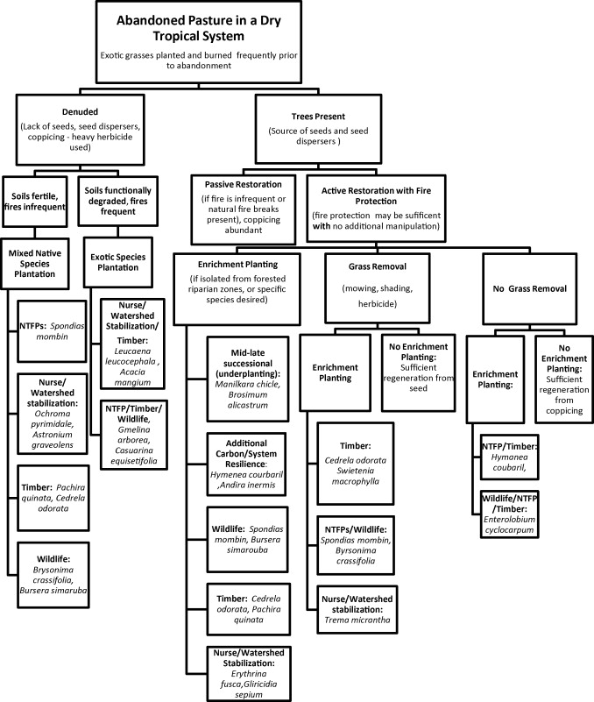

Figure 1: Restoration pathways of dry forests considering various social and biological circumstances assuming pastures which have been abandoned have been grazed by cattle and frequently burned (Griscom & Ashton 2011).

**2.4** *Limiting factors in a dry forest*

Ceccon *et al.* (2006) describe four sets of abiotic features which influence tropical forest regeneration: climatic seasonality, soil fertility and moisture, natural disturbances and resource availability and anthropogenic disturbances. Climatic variation in dry forests can be extreme; Bullock & Solis-Magallanes (1990) describes how there can be years with eight consecutive months of drought in tropical dry forests in Mexico, during my study period which took place in the rainy season, there was a three month drought. This unpredictability of rainfall could be due to the periodic occurrences of El Niño and La Niña cycles (García-oliva *et al.* 2002). Soil moisture availability is one of the most influential factors for seed germination and survival (Lugo *et al.* 1978; McLaren & McDonald 2003; Blain & Kellman 1991). Cell growth models of seed germination having shown that, at reduced water potential, growth rates are inhabited germination rate decreases with an increase in water stress (Bradford 1990; Cavalcante 1995). Bunker & Carson (2005) had two main findings, irrigation increased overall seedling growth in dry forest species but did not affect seedling mortality over wet forest species, which could show that dry forest seedlings are moisture limited. Both Augspurger (1979) and Blain & Kellman (1991), showed germination to be more responsive to water fluctuations than survival, possibly as these large fluctuations are present at the start and end of the rainy season, meaning plants could have evolved strategies to cope with this selection pressure. Bunker & Carson (2005) found that irrigation reduced species’ loss and that density dependence weakened as abiotic stress increased. They also highlighted that reduction in rainfall throughout the 20th century could lead to a loss of diversity in dry forests however, species adapted to this habitat may benefit from increased dry season length. DeBano (1981) reported that soils exposed to high heat which are sandy (as many dry forest soils are) or high in organic matter can become hydrophobic and in some cases impermeable. This suggests that, unless rainfall is accurately simulated, watering treatments may not have the desired effects due to water not penetrating the soil surface.

There is a marked variation in germination, survival and seedling growth responses to light intensity between species (Singh 2001). Teketay (1996) explained that for most Caribbean dry forest species there was little difference in germination success between shaded and unshaded treatments. The findings of McLaren & McDonald (2003) supported this and added that increasing light intensities lead to higher growth rates but lower survival. This has different effects on dry forest seedlings depending on the amount of foliage present in the canopy; loss of leaves in the early rainy season could increase seedling growth and establishment (Gerhardt 1998) as germination is mainly limited by moisture availability (McLaren & McDonald 2003). A loss in canopy foliage towards the end of the rainy season could decrease the survival of seedlings (Gerhardt 1998).

Soil fertility can be considered a limiting factor in many dry forests due to their nutrient poor soils (Singh *et al.* 1989). In a summary of the effects of soil nutrients on seedling growth, Singh (2001) found that nitrogen addition increased growth of tree seedlings however, past a concentration threshold, nitrogen became an inhibitor causing a loss of biomass. He theorised this could be because high concentrations of nitrogen could limit phosphorus and potassium uptake. Singh (2001) also found that phosphorous availability can enhance the mycorrhizal association in the soil, improving water relations.

Predators can be both deleterious and advantageous for seeds and seedlings for a multitude of reasons (Singh 2001). Many dry forest species have evolved defence mechanisms to prevent insects parasitizing seeds such as thick seed coats (Mohamed-Yasseen *et al.* 1994). One example of this defence mechanism is *P. juliflores* (Burg *et al.* 2014) however personal observations in the field show that this defence mechanism is not always effective as some seeds which had fallen to the forest floor had evidence of bruchid damage (exit holes). Benítez-Malvido *et al.* (2003) found that 95% of dispersed *P. juliflores* seeds had evidence of bruchid damage however only 33% of seeds ingested by *Ctenosaura pectinate* (Mexican spiny-tailed iguana) showed this. The study also found seed ingestion showed increased germination and reduced mortality, suggesting *P. juliflores* use the frugivorous vertebrate as a means of dispersal and colonization of new sites. Other studies also show increased germination of seeds after passing through reptile guts (Rust & Roth 1981; Willson *et al.* 1996; Castilla 1999). Barnea *et al.* (1991) investigated the effect ingestion by birds can play on seed germination in the Mediterranean and found that seeds within the same habitat respond differently to ingestion by birds, possibly due to the variation in gut retention time. It is possible that ingestion by *Amazona barbadensis* effects the germination of the study species *C. tremula* as Beach (1956) and myself repeatedly observed *A. barbadensis* feeding on the fleshy fruit, nearly stripping trees of all of their fruits.

**2.5** *Dry forest seed germination and survival with water as the dependent variable*

Only one study focuses on dry forest germination and survival in relation to water only (Blain & Kellman 1991).

By definition, “germination incorporates those events that commence with the uptake of water by the quiescent dry seed and terminate with the elongation of the embryonic axis” (Bewley & Black 1964). Bewley (1997) furthers this definition by stating visible germination is usually complete when the radicle penetrates the structures surrounding the embryos. This varies between seed type; it is true for recalcitrant (non-dormant) seeds however orthodox (dormant) seeds can show all necessary metabolic steps required for complete germination however the radicle fails to elongate (Singh 2001).

In dry tropical forests, seed germination, establishment and survival are regulated by soil moisture and light (Ceccon *et al.* 2006; Ray & Brown 1994; Gerhardt 1996) and water has been shown to be the major influencing factor for seedling survival (McLaren & McDonald 2003; Lugo *et al.* 1978; Singh 2001). Most woody species throughout this biome germinate at the start of the rainy season (Garwood 1983) with seasonal moisture variation showing significantly higher germination than experimental watering regimes (McLaren & McDonald 2003). Gerhardt (1996) and Blain & Kellman (1991) found that there was either little or no difference in germination between experimental plots with supplemented water and natural rainfall. Both Augspurger (1979) and Blain & Kellman (1991) found that water fluctuations influenced germination more significantly than survival. Cabin *et al.* (2002) found that during periods of drought water is the major limiting factor to seedling survival for both native and exotic species. This suggests that, even though germination may be more significantly affected by water, the relationship between most germination events and water only take up a small proportion of the total year (during the rainy season) whereas seedlings can die at any point throughout the year meaning, although the relationship between water and survival is statistically weaker it will have a larger effect on forest regeneration due to timescale.

**2.6** *Strengths and limitations of forest regeneration studies*

"Any study of forest regeneration should ideally separate the effects of individual environmental factors and their interactions.”(McLaren & McDonald 2003)

Experimental forest regeneration studies can be undertaken either in the laboratory or the field, each of which have advantages and disadvantages. Laboratory based studies can control many environmental covariates which is either difficult or impossible to replicate in the field. This allows for the manipulation of specific independent variables to determine their effect on the dependant variable, producing results with less statistical noise than field based studies (McClelland & Judd 1993). Many studies, although robust in many ways, fail to account for the effect of some covariates. For instance, McLaren & McDonald (2003) failed to account for the effect of herbivory on seed germination and survival rates at the beginning of their study, probably due to very large sample size and limited recording resources. Aide *et al.* (2012) assumed that differences between the chemical composition of rainwater and the water used in the study would not have any effect on germination or survival with no supporting evidence from the literature and only spaced the seeds 5-7cm apart (probably due to limited study site), failing to account possible competition between seedlings for resources. These unaccounted covariates inherently reduce accuracy of some statistical analysis, causing unnecessary statistical noise (McClelland & Judd 1993). Blain & Kellman (1991) state that the apparent lack of an experimental rainfall effect on seedling establishment in their study could be due to an inability to reproduce realistic rainfall patterns or achieve the desired alternation of wet and dry soils. Reasons such as these highlight the difficulty of field-based experiments and show how some limitations which cannot be overcome, could have a statistically profound effect on the results (McClelland & Judd 1993). It is, however for these limiting reasons that field based studies could be more useful for studying forest regeneration. Although the statistical power is not as high as in laboratory based studies, the interactions of covariates with the dependant variable are difficult to replicate in the laboratory. This could be because: the complex relationships may be unknown, due to resource limitations or due to a lack of knowledge in the field of question. This suggests that field based studies are needed to account for complex interactions which cannot be replicated in the laboratory.

**2.7** *Study Rational*

Between 2008 and 2016, the Groasis Waterboxx won numerus awards, ranging from the Popular Science award for Green Tech in 2008 to the National Icon Award of the Netherlands in 2016. The Waterboxx, theoretically, enables people to grow food crops in the desert and reforest in arid environments for minimal cost however, there is a lack of published data to support the claims of the inventor. The inventor claims that up to 100% of transplanted trees survive in the Waterboxx with nearly 90% in good condition (Groasis B. V. n.d.).

This study determines the viability and cost-effectiveness of the Waterboxx as a direct seeding technique for reforestation, determining what effect the Waterboxx has on both germination and survival compared to other, more regimented watering regimes.

Even though dry forest take up 17% of global landmass and 42% of global forests, very little is known about their ecosystem services (Maass *et al.* 2005). These services are the benefits people receive or obtain from ecosystems (Daily 1997). A 20 year study in Mexico attempted to evaluate and rank the ecosystem services delivered by a dry forest (Maass *et al.* 2005). Maass *et al.* (2005) classifies the most important services as:

* Freshwater - specifically its availability for agriculture.
* Diverse resource provisioning - roughly 162 tropical dry forest species are currently, or have been used for medicine, timber, wood fuels etc., from local to national scale.
* Biodiversity and future options - focusing on how dry tropical forest species are adapted to a warming climate.
* Climate regulation - dry forests have been shown to sequester larger amounts of carbon than evergreen forests (Kauffman *et al.* 2003).
* Soil fertility maintenance - dry forest soils have a high leaching potential of this service is degraded.

Although this ecosystem provides many services, apart from timber there are few dry forest products which have generated a source of significant wealth for the local people (Vergles *et al.* 2015).

This suggests we have to look in a broader scope when considering the value of dry tropical forests. Focusing on Bonaire specifically, TEEB (2012) valued the nature on the island at $105 million. With current threats left unmanaged, in ten years, this will decrease to $60 million and $40 million over 30 years (TEEB 2012). Nature tourism is valued at $50 million, with marine having a higher value than terrestrial tourism which is 36% of Bonaire’s total economic value (TEEB 2012) and accounts for 83% of the total financial value of the island (see Fig. 2). With 30,000 free-roaming goats present across Bonaire (Zembrano Cortés 2012) the terrestrial ecosystem is unable to regenerate due to the predation on young seedlings. This, however is not the most pressing issue for the economy of Bonaire. Greene *et al.* (1994) found, with zero ground cover, increasing stocking densities cause significantly higher rates of runoff showing that the effects of both grazing of perennial plants and surface trampling can have a major impact on local water balances and erosion rates. Hartanto *et al.* (2003) also found that trail creation by herbivores increases runoff by removing soil and surface roughness, causing soil detachment by raindrops. The high densities of feral herbivores throughout Bonaire will, therefore, negatively impact water as an ecosystem service and cause increased runoff of sediments into the marine reserve surrounding the island. In a review of the state of knowledge of the direct effects of terrestrial runoff on marine ecosystems, Fabricius (2005) found runoff reduced recruitment success in corals and promoted the growth of macroalgae which can reduce reef calcification, change the community structure and greatly reduce species richness which compromises the reefs ecosystem functions. This could prove detrimental to the people of Bonaire as such a large proportion of the economy is based on ecotourism such as dive tourism.

Figure 2: Total Economic and Financial Value of Bonaire, highlighting the relevant economic sectors (TEEB 2012).

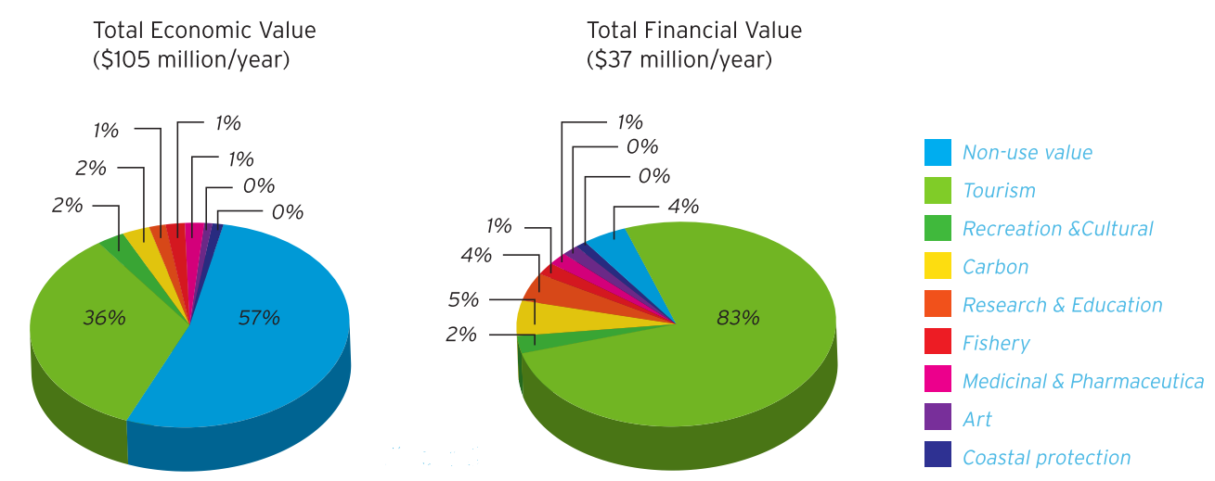

Reforesting Bonaire would help prevent this substantial loss of income it would require the removal or control of a large proportion of feral goats (TEEB 2012). Increased tree cover has also been shown to reduce runoff through: mitigation via the tree canopy (Sanders 1986), trees functioning as water retention structures (Dwyer *et al.* 1992) and by increasing leaf litter preventing soil detachment (Hartanto *et al.* 2003). This means it is essential to find the most cost effective method of doing so which could potentially be the use of the Groasis Waterboxx.

**3.0 Methods**

**3.1** *Study area*

The Dos Pos valley contains patchy dry forest over the volcanic Washikemba Formation, lying East-West between the town of Rincon and Lake Gotomeer. The valley is located in the north-western region of Bonaire (12°14’71” N 68°21’26 W). The elevation of the site is 36m with the northern and southern sides of the valley rising to approximately 120m. The island is 6.7 km wide at this point, the greatest length and width of the island are 35km and 11km respectively with a total land area of 265 km2 (De Freitas *et al.* 2005; Beach 1956). The average annual climatic data is as follows: temperature is 28.0 ° C, daily evaporation rate is 8.4mm, relative humidity is 75.9%, wind speed is 6.6m/s at 10m elevation and direction of the trade wind is east (079 degrees) (De Freitas *et al.* 2005).

Rainfall during the wet season (October – December) varies significantly between the recording stations throughout the island. The average rainfall between the four stations in 1988 was 230mm which is approximately the same as the 1971-2000 average for the whole island (237mm) for October – December. Although the mean wet season rainfall exceeds 200mm annually, during the study period (December – March) only 94mm of rainfall was recorded, possibly due to the presence of the El Nino. Between 2005 and 2015 the mean rainfall during the study period was 188mm (Cargill Salt Bonaire, 2016).

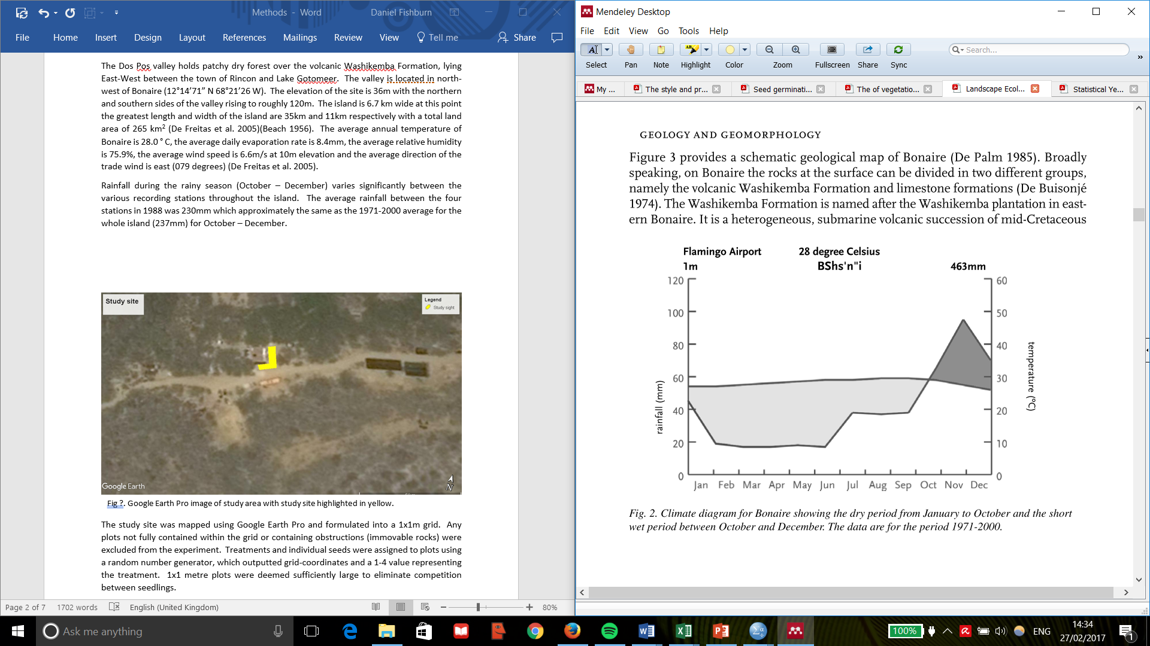

Figure 3: Climate diagram for Bonaire showing dry season (January – October) and rainy season (October – December) as an average from 1971 – 2000 (De Freitas *et al.* 2005).

Figure 4: Rainfall during the study period between 2005 – 2015. Data gathered from Cargill Salt, Bonaire.

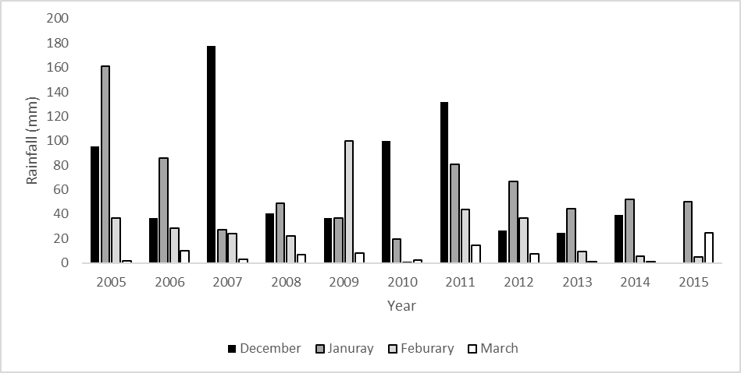

**3.2** *Selection of Species*

The two study species selected were *Prosopis juliflora* and *Caesaria tremula*. The basis for their selection was their ability to germinate in gaps in the forest canopy, open to the sky and in which full sunlight impinges at ground level for at least part of the day (Swaine & Whitmore 1988) and due to their ability to survive in harsh arid environments (as they are pioneer species). *C. tremula – P. juliflora* woodland is one of the three principle woodland types present on Bonaire (Freitas *et al.* 2005). *P. juliflora* is an evergreen, fast growing tree/ shrub native to South and Central America (Ilukor *et al.* 2016) suited to extreme arid conditions and forming part of the canopy, with a mature height between 2 and 15m (Anon. 1825). *C. tremula* is a fast-growing deciduous tree with a dense crown (UICN, n.d.), often seen growing in open areas and is not present in mature forest stands (Williams, pers. com.). Throughout the island, open areas such as disturbed pasture are exposed to direct sunlight for most of the day, creating a harsh and arid environment with little moisture and no shade. Seed weight varied between the species: *P. juliflores* (0.0332g ± 0.00458 (S.E)) and *C. tremula* (0.0127 ± 0.00214).

**3.3** *Experimental design*

In December 2015, an experiment was set up within a herbivore exclusion area in a cleared patch of dry forest located in the Dos Pos valley to determine the effect of watering regime on the germination of seeds and the survival of seedlings. The perimeter of the study site was marked out at 1m intervals and formulated into a 1x1m grid, any plots not fully contained within the grid or containing obstructions (immovable rocks) were excluded from the experiment. Treatments (Groasis, initial deluge, regular watering and control) and individual seeds were assigned to plots using a random number generator, which provided grid-coordinates and a 1-4 value representing the treatment, species was also randomly generated with a value of 1 representing *P. juliflora* and 2 representing *C. tremula*, creating a map of the study site (see Fig. 5). 1x1 metre plots were deemed sufficiently large to eliminate competition between seedlings.



Figure 5: Random allocation design of treatment, showing randomised treatment, species and individual seed.

Seeds were primarily collected from Dos Pos, one month prior to the peak of the rainy season (September) when the fruit matured (Burg *et al.* 2014) from multiple trees to maximise genetic variability within the seeds. Due to the vast abundance of pioneer species throughout Bonaire we were able to collect a large numbers of seeds. Seeds where processed in accordance with Burg *et al.* (2014), removing the outer seed case and any fleshy material that could cause mould; air dried for three days in a paper bag and stored in a freezer. Following this, seeds were pseudo randomly selected by picking individual seeds from an opaque bag (Brenner & Fishman 1992) to account for natural genetic variation between seeds; randomly assigned to treatments and weighed using a Mettler Toledo XPE205 analytical balance scale (accurate to 0.01mg).

The seed casting experiment consisted of four watering regimes: Groasis, initial deluge, regular watering and no watering.

There were six steps involved in setting up the Waterboxx:

* Soil preparation: A 60cm diameter hole was dug to a depth of 10cm and levelled to ensure efficient water collection. All removed soil was set-aside to be used later in the installation process.
* Orientation: The central figure-eight hole should be orientated east-west to ensure the seedlings receive adequate light.
* Laying the paperboard: The supplied paperboard had the central seed slot removed, a small hole, three times the size of the seed was dug, the seed laid within and soil was placed over the top of the paperboard, to provide protection from evaporation (see Fig. 6. f).
* Placing the water tank: Half of the length of the wick is pulled through the pre-drilled hole in the bottom of the Waterboxx (see Fig. 6. e). The water tank was then placed inside the pre-dug hole, orientating with the paperboard and levelled using a spirit level.
* Mounting the Waterboxx: The mid-plate is placed inside the water tank and the coversheet immediately on top (see Fig. 6. a,b,c), clicked into place and secured.
* Final preparations: The removed soil should be placed around the water tank, preventing wind from blowing underneath the box. 16 litres of water were added to the water tank and four litres poured through the centre hole. The blue siphon pieces and cap (Fig. 6. d) are then secured in place and a final three cm of soil added to the opening inside the box for protection against wind and evaporation.

Figure 6: Components of the Groasis Waterboxx; a) water tank, b) mid-plate, c) cover sheet, d) cap and siphons, e) wick, f) paperboard (Schiavon 2012).

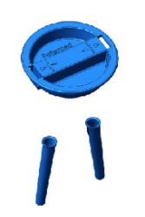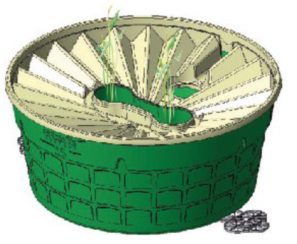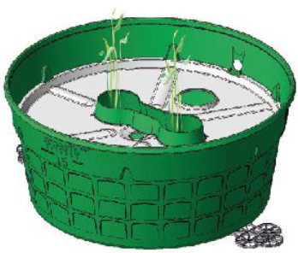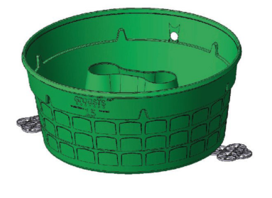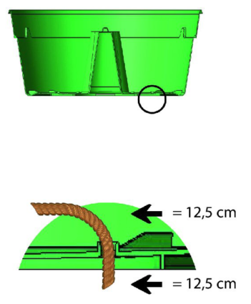

a

b

c

e

d

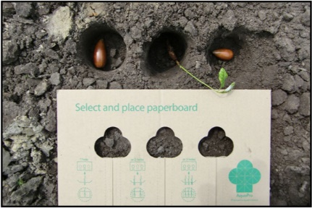

f

Water quantities for both initial deluge and regular watering were calculated using Cargill Salt Bonaire BV (2015) unpublished rainfall data. Initial deluge was assumed to be one week’s rainfall from the start of the rainy season, equalling 6.74l, averaged over the 6 years of available data. Regular watering was set to 4l every three days to supplement watering to average wet season levels. It was correctly predicted that there would be very little rain throughout the study period due to it taking place in an El Nino year meaning the supplementary water was simulating the average rainy season as accurately as possible. Supplementary water was collected as rainfall prior to the study.

Recordings were made daily at mid-day. After installation, the Groasis Waterboxx and seed casting received no extra stimulation to assist growth. The amount of water left in the Waterboxxs was recorded upon termination of the study.

Confounding variables were accounted for where possible in the experimental design, in most instances where this could not occur the variables were recorded. Light, temperature, humidity and erosion should remain constant between plots due to the open nature of the study site along with the random study design. Environmental data was obtained from BestForcast™ (The Weather Company, 2015). Seed weight, rainfall and the amount of water left in the Waterboxx were recorded and analysed.

**3.4** *Data Analysis*

All analysis was completed using IBM SPSS 21 (IBM Corp. 2012)

6. Fishers Exact Test

1. Shapiro-Wilk Test

2. Quantile-Quantile plots

3. Logarithmic data transformation

4. Shapiro-Wilk and Quantile-Quantile plots

5. Bar Chart with standard error

Figure 7: Statistical procedure for analysis of raw data.

7. Kruskal Wallice with post hoc

8. Binary Logistic Regression/ One way ANOVA

1. Germination and survival (days) were tested for normality using a Shapiro-Wilk test with a Lillefors Significance Correction.
2. Data was not normal (p=0.0001) so quantile-quantile plots were formulated to determine how the data was distributed.
3. A logarithmic transformation was undertaken attempting to “normalise” the data.
4. The Shapiro-Wilk Test was reapplied and Quantile-Quantile plots were reformulated to see if the data had been normalised.
5. Not all data could be normalised so the data was graphically represented with standard error to show any significant differences between treatments.
6. A two-tailed Fishers Exact test was performed, 50% of the data had a count value less than five, violating the assumption of a Chi-Squared test.
7. As some data was not normally distributed all data was ran through a Kruskal-Wallis Test with post-hoc analysis to determine whether the mean ranks of groups showed any statistical significant difference.
8. A binary logistic regression was ran to determine whether any covariates had any significant effect on the dependent variables and a One-way ANOVA was conducted to determine whether there was any significant difference between seed weight between categories of treatment.

To determine whether germination events were evenly distributed throughout the sight, Fig. 5. was split into approximately equal blocks and germination percentage was calculated for each block.

**3.5** *Cost benefit analysis*

A cost benefit analysis was conducted to determine the economic value of the Groasis Waterboxx compared to traditional watering techniques considering start-up, labour and water costs. Water cost was $9.42 per m3 (WEB 2012), labour costs were calculated based on the US minimum wage as of 2016 (Bradley 2016) and the cost of the Waterboxx was based on actual costs, it should be noted that the Waterboxxs’ used can be reused five times so costs per plant will be divided by five to represent the longer term investment. The economic value of the benefits were derived from TEEB (2012).

**4.0 Results**

**4.1** *Seed germination*

Total germination percentage for *P. Juliflores* was 19.6% within three weeks of sowing and *C. Tremula* achieved 8.9% within four weeks of sowing (see Fig. 8.)

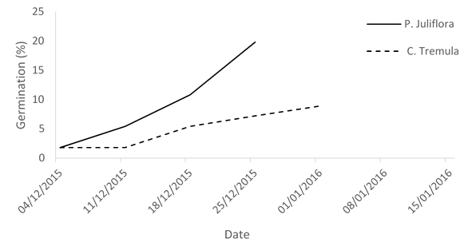

Figure 8: Cumulative germination percentage for *P. juliflores* and *C. tremula* over time*.*

Treatment influenced germination for both species, Groasis and regular watering increased germination of both species compared to the control groups where no germination occurred. Mean germination for *P. juliflora* varied between all four treatments with no germination in the control treatment. Germination was significantly higher in the regular watering treatment compared to all other treatments (Fig. 9. a.) with regular watering achieved 57.1% (8/14) germination, compared to 28.6% (4/14) in the initial deluge treatment (p=0.013) and 7.14% (1/14) in Groasis (p=0.02). *C. Tremula* germinated in two of the four treatments (Fig 9. b), Groasis and Regular Watering. Groasis had a higher mean germination however the relationship was not significant. Groasis achieved 21.4% (3/14) germination, compared to 14.3% (2/14) in regular watering (p=1.0).

Figure 9: Mean count germination for *P. Juliflores* (a) and *C. Tremula* (b) across all four treatments. Error bars set to 95% confidence interval.

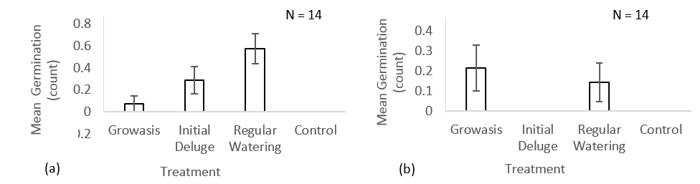

Of all treatments which showed germination had varied responses. Figure 10. emphasises the relationships between treatment and germination over time showing how, in general, the germination response was quicker in treatments where water was added directly to the topsoil (initial deluge and regular watering).

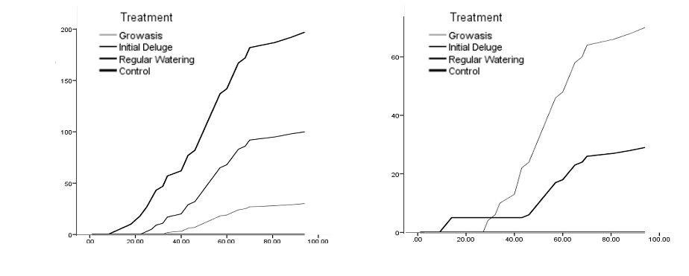

Cumulative sum of germination

Cumulative sum of germination

Time (days)

Time (days)

*P. juliflores*

*C. tremula*

Figure 10.Cumulative sum of germination for *P. juliflores* and *C. tremula* across treatments.

There was a significant difference between scores for germination (days) across treatments for *P. juliflores* however a pairways comparison following Dunn's (1961) procedure with a Bonferroni correction for multiple comparisons revealed no significant difference between basic group combinations. There was no significant difference between germination (days) across treatments for *C. tremula* (Fig. 11.)*.*

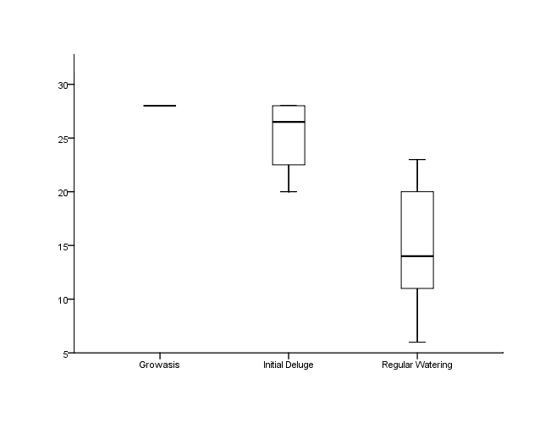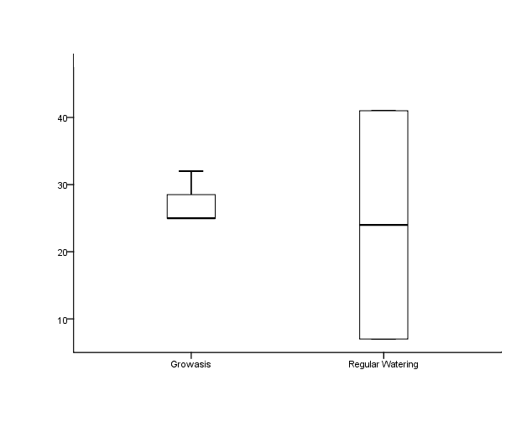

Treatment

Treatment

Germination (days)

Germination (days)

n = 1

n = 4

n = 6

n = 3

n = 2

Figure 11: Distribution and association of mean ranks of germination (days) by treatment. *P. juliflores* – x2(2)=6.143, p=0.041. *C. tremula* - x2(1)=0, p=1

*P. juliflores*

*C. tremula*

**4.2** *Seedling Survival*

Seedling survival varied between species with 12.5% of *P. juliflora* and 3.6% of *C. tremula* seedlings surviving until the end of the study*.* It is assumed that treatment affected the survival of both species due to the differences in mean survival between treatments (Fig. 12.) however, there was no control for survival as none of the control group germinated.

There was no significant difference between the survival of *P. juliflora* seedlings between treatments: Groasis had a survival rate of 100% (1/1), compared to 50% (2/4) in initial deluge (p=1.0) and 50% (4/8) in regular watering (p=1). Only seeds of the Groasis treatment survived for *C. tremula* with a 100% (3/3) survival rate. Due to the extremely low sample size this was not seen to be significantly higher than regular watering with a 0% (0/2) survival rate (p=0.333). It should be noted that this relationship was significant according to a Pearson Chi-Square test (p=0.046) however as the count value was too low this could be false significance.

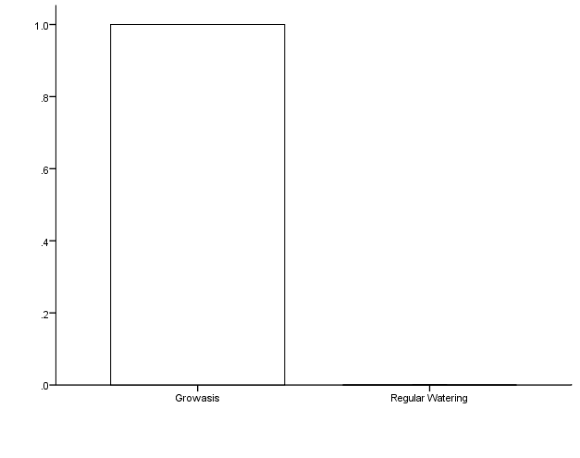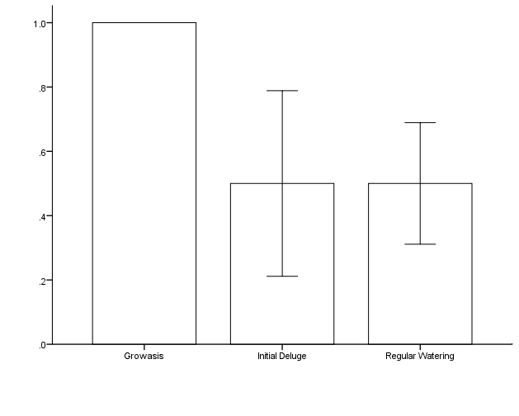

Treatment

Treatment

Mean survival (count)

Mean survival (count)

*P. juliflores*

*C. tremula*

n = 1

n = 3

n = 4

n = 8

Figure 12: Mean survival for *P. juliflores* and *C. tremula* across categories of treatment. Error bars set to one standard deviation.

n = 2

Mean survival for seedlings of *P. juliflores* survived a larger proportion of the study than seeds of *C. tremula* (Fig. 13. a): 61 and 35 days respectively. There was no significant difference between scores for the proportion of the study survived (days) for both species (Fig. 13. b,c)

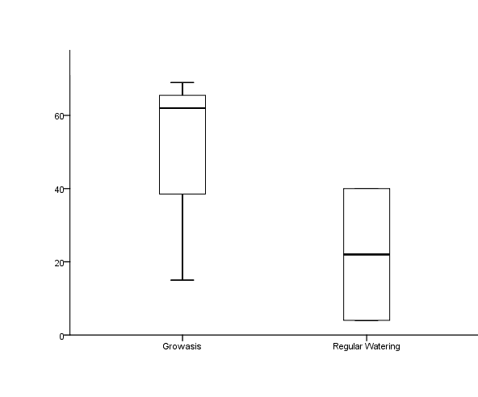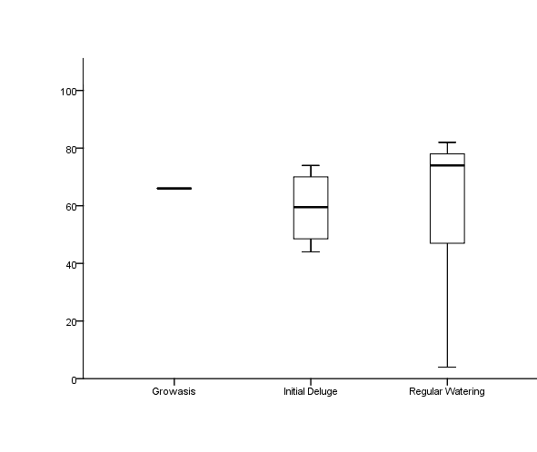

Proportion of study survived (days)

Proportion of study survived (days)

Treatment

Treatment

n = 1

n = 4

n = 8

n = 3

n = 2

Figure 13: a) Mean proportion of the study survived for *P. juliflores* and *C. tremula* across categories of treatment. b) Distribution and association of mean ranks of the proportion of the study survived in days by treatment. *P. juliflores* – x2(2)=0.477, p=0.8. and c) *C. tremula* - x2(1)=1.333, p=0.248. Error bars set to one standard deviation.

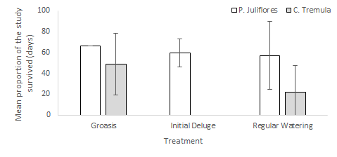

n = 1

n = 4

n = 8

n = 3

n = 2

a)

b)

c)

**4.3** *Covariates*

*Water left in Groasis Waterboxx*

All Waterboxxs’ were filled with 16l of water at the start of the study. Upon termination of the study, the remaining water was measured. The mean residual water was 5.768l (±4.097) with a range of 0 – 12 litres. One box was completely empty. The mean quantity of water for Waterboxxs’ containing *P. Juliflores* seeds was 5.964l (±3.953) and 5.571l (±4.376) for *C. Tremula*.

**4.4** *Seed weight*

A one-way ANOVA was conducted to determine whether seed weight varied between levels of treatment. All data was normally distributed for individual groups, as assessed by a Shapiro-Wilk test (p > 0.05). Seed weights for *P. juliflora* showed homogeneity of variance according to a Levenes test (p = 0.895) however *C. tremula* did not show homogeneity of variance (p = 0.017) so it was subjected to a Scheffes’ post-hoc test which is robust against this violation (Weerahandi 1995). There was no significant difference between seed weights for *P. juliflores F*(3,52) = 0.773, p=0.515. Seed weight varied significantly between groups for *C. tremula F*(3,52) = 8.641, p<0.0005. A post-hoc analysis using Scheffes’ procedure indicated statistically significant differences between Groasis and regular watering (mean difference (MD) = -0.00217, p=0.024), Groasis and control (MD = -0.00331, p<0.0005) and initial deluge and control (MD = -0.00212, p=0.029).

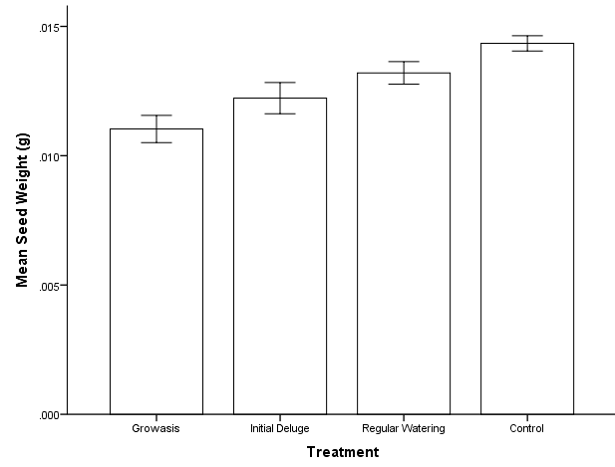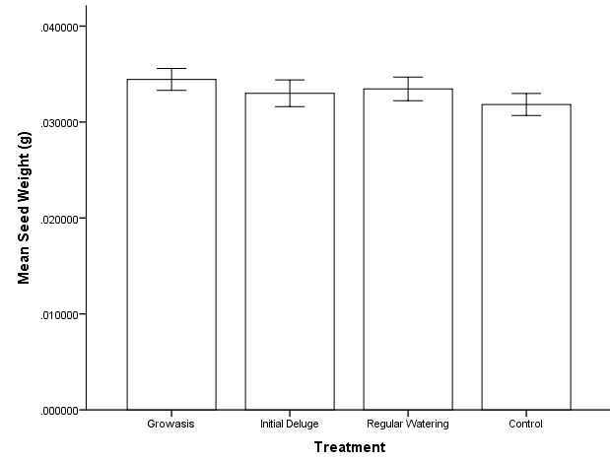

*P. juliflores*

*C. tremula*

Figure 14: Mean seed weights for *P. juliflores* and *C. tremula* across categories of treatment. Error bars set to one standard error.

**4.5** *Study site*

The distribution of germination events across the study sight was not random, 25% of germination events occurred in ≈8% of the study sight (Fig. 15.) and 75% of total germination occurred across 31% of the study area.

Figure 15: Distribution of germination events throughout the study sight, summarised into percentage germination for 13 approximately even blocks.



**4.6** *Cost benefit analysis*

The cost of the Waterboxx was $26.52. The yearly costs of each treatment per plant are as follows: Groasis ($7.35), regular watering if watered every day ($47.87), if watered bi-weekly ($13.52) and if watered weekly ($6.76), initial deluge ($0.45) and control ($0.01).

When considering mean germination, the cost per plant is: Groasis ($48.99), regular watering if watered every day ($132.56), if watered bi-weekly ($37.45) and if watered weekly ($18.72), initial deluge ($1.70) and control (N/A).

When considering mean survival of seedlings: Groasis ($7.350), regular watering if watered every day ($119.68), if watered bi-weekly ($33.8) and if watered weekly ($16.9), initial deluge ($0.896) and control (N/A).

|  |  |  |  |  |
| --- | --- | --- | --- | --- |
| Table 1: Initial and running costs per day for all treatments ($ per plant). | | | | |
|  | Treatment | | | |
|  | Groasis | Regular Watering | Initial Deluge | Control |
| Start-up | 5.304 | 0 | 0 | 0 |
| Water (initial) | 0.188 | 0.00942 | 0.0644 | 0 |
| Water (running) | 0 | 0.00942 | 0 | 0 |
| Labour (initial) | 1.859 | 0.544 | 0.384 | 0.0108 |
| Labour (running) | 0 | 0.121 | 0 | 0 |
| Totals | | | | |
| Initial Cost | 7.350 | 0.553 | 0.448 | 0.0108 |
| Running Cost (per day) | 0 | 0.130 | 0 | 0 |

**5.0 Discussion**

**5.1** Effects *of experimental treatments*

Treatment had an effect on both seed germination and seedling survival with varied responses between species. Seeds of *P. juliflora* had a significantly higher mean germination under the regular watering treatment compared to any other treatment which is reflected in natural settings as woody species in the dry forest germinate at the start of the rainy season (Garwood 1983), suggesting that seeds may require frequent exposure to large quantities of water for germination events to be triggered. Groasis and initial deluge treatments were only exposed to large quantities of water upon installation and the Waterboxx only wicks 50ml of water daily into the soil which may not have been sufficient to trigger germination. Total germination was lower than expected (14.25%) compared to <80% in Blain & Kellman (1991) who also focused on water manipulation in the field and Burg *et al.* (2014) who showed *P. juliflores* achieving 85% germination success under experimental conditions. This could be for a number of reasons:

* Seeds of both species may not have been viable.
* The removal of the hard coat of *P. juliflores* could have caused invasion by microorganisms (Mohamed-Yasseen *et al.* 1994).
* Supplementary rainwater was stored for long periods of time increasing the risk of contamination by pathogens which would have increased the percentage of non-viable seeds.
* The soil being frequently exposed to high temperatures and having a sandy nature could have caused the surface layer to become hydrophobic (DeBano 1981) meaning water would have evaporated from the surface instead of percolating through the upper layers.
* Dormancy periods of up to 12 months are common in seeds from environments with varying rainfall trends (Singh 2001), is attempts to remove seed dormancy were unsuccessful, germination would be hindered.

Germination success in *P. juliflores* could have been increased by mechanical scarification via boiling water or using acid scarification techniques with sulphuric acid (Burg *et al.* 2014; Teketay 1996). *C. tremula* fruited particularly poorly the year of seed collection, possibly due to the low rainfall prior to the study however, *P. juliflores* fruited very well. This could have contributed to *C. tremula* having a lower mean germination than *P. juliflores.* Survival varied markedly between treatments with all Groasis seedlings surviving opposed to half surviving in initial deluge and regular watering treatments for *P. juliflores* and no individuals surviving in regular watering for *C. tremula.*  It is, however, hard to draw conclusions from the survival data as there was no control data available (as no seeds germinated in the control treatment) and due to the low number of germination events. As well as watering amounts being manipulated between treatments, the Groasis Waterboxx alters various other abiotic features such as: light, water percolation and humidity. The design of the Waterboxx is such that, young plants surrounded by the Waterboxx are exposed to lower diurnal temperature and humidity fluctuations (AquaPro 2012; Schiavon 2012) as the water in the tank absorbs heat throughout the day and releases it during the night. Soil temperature is also stabilised due to water constantly being wicked into the soil (Schiavon 2012) and the soils ability to hold water is increased as the constant, slow percolation of water into the soil restores the capillary channels within the soil. These could be the reason that, both germination in the Groasis treatment was low and survival was high. Pearson *et al.* (2002) found that some species of neotropical pioneers require increased magnitudes of temperature fluctuation to trigger germination. Mortality could be decreased in the Waterboxx primarily due to the stabilisation of soil moisture levels (Wellington & Noble 1985) but also due to increased levels of shading and moisture retention, which is supported by McLaren & McDonald (2003), who found that survival rates significantly decreased over time in unshaded plots with low moisture retention. This insight could prove useful for restoration projects in arid environments, especially in areas focused on reforesting open areas such as degraded pastureland where survival rates are expected to be low.

One of the main difficulties faced with field based studies is the inability to control all factors which could affect the dependant variable (McClelland & Judd 1993). It has been determined that three covariates could have had an effect on germination and survival in the study. For *C. tremula*, seed weight was significantly lower in the Groasis treatment than all others with control seeds also having a significantly higher seed weight than initial deluge seeds. Control seeds having a significantly higher seed weight should have enhanced their chances of germination and survival due to the ability of larger seeds to persist in providing the metabolic requirements prior to germination (Khurana & Singh 2001). This suggests the effect of treatment could be more significant than the study suggests, especially considering *C. tremula* seeds had the highest mean germination in the Groasis treatment even though it had a significantly lower seed weight. The land use history of the site could have had a significant effect on germination patterns due to the grouping of germination events across the study site. Throughout Bonaire many old Kunukus (farm houses) such as Dos Pos were intensively used for agricultural practices, it is unknown if these had previously taken place in the study site. Sweeney *et al.* (2008) found that low levels of nitrogen based fertilizers can increase germination of come species, if true for either study species, residual fertilizers from past land use could explain the grouping of germination.

Upon termination of the study, all of the residual water in the Groasis treatment was recorded, the design of the Waterboxx is such that the water tank should never empty however the mean residual water was 5.768 litres, the range was 0-12 litres, one box having completely emptied. The only Waterboxx where the loss of water will have affected germination was the one with no residual water as all other boxes would still leach 50ml of water daily, regardless of how little water was left. This issue was not deemed to have a significant effect on the outcome of the study. However, it has negative implications for the Waterboxxs’ effectiveness for reforestation purposes. One of the most practical features is its ability to be used in passive restoration projects as minimal effort is needed post installation. The issue arises from the methods of water collection in the Waterboxx; for collection to occur, water must pass through the narrow siphons on the cover sheet (Fig. 6. d.). It was observed that soil, detritus, bird faeces and even one naturally dispersed seedling blocked the siphon, preventing the refilling of the water tank. Siphons were not cleared as the study aimed to reflect the practical aspect of using the Waterboxx in the field. If implemented on a large scale, regular clearing of siphons may be needed but would not be feasible as the Waterboxxes would often be used in areas which are difficult to access as the treatment is intended to be low maintenance. Although problematic, this issue could have a simple, yet elegant solution. A wire dome with a central hole which is sufficiently large that it does not impede the growth of the sapling, that attaches to the cover sheet of the Waterboxx would prevent the majority of leaf litter and detritus blocking the siphon whilst adding little additional cost and work effort to the Groasis treatment.

**5.2** *Cost effectiveness*

The ecosystems of Bonaire vary from the terrestrial dry forest through to salinas and coral reefs which surround the island. When attempting to place a monetary value on the islands forests it is of vital importance to consider the complex interactions between the terrestrial and marine ecosystems. The forest provides a diverse provisioning of resources which range from freshwater to timber and important medicinal ingredients, it holds the high levels of biodiversity, sequesters large amounts of carbon and maintains soil fertility (Kauffman *et al.* 2003). The coral reefs surrounding Bonaire also provide a vast range of ecosystem services ranging from the provisioning of food to locals to various forms of ecotourism (Moberg & Folke 1999). With 30,000 free-roaming goats present across Bonaire (Zembrano Cortés 2012) the terrestrial ecosystem is unable to naturally regenerate due to the predation on young seedlings. These herbivores present a particular problem for the terrestrial ecosystems as there are no natural predators present on the island and the most of the indigenous flora lacks the specific adaptations to mammalian herbivores (Coomes *et al.* 2003) meaning the forest currently exists in a state of arrested succession, dominated by the few species with natural defence mechanisms such as *P. juliflores* and *C. tremula.* The degraded nature of the forest along with the presence of large numbers of free-roaming herbivores is not only damaging the ecosystem services of the forest on the island it is inhabiting some of the ecosystems functions. Reductions in tree numbers and densities are reducing leaf litter quantities, lowering canopy cover and removing the ability for trees to act as water retention structures, causing increased run-off of sediments into the marine system (Sanders 1986; Dwyer *et al.* 1992; Hartanto *et al.* 2003). This is exacerbated by the loss of ground cover from overgrazing of perennial plants and the loss of soil roughness by herbivore trail creation (Greene *et al.* 1994; Hartanto *et al.* 2003). Current vegetation loss on Bonaire is already causing increased levels of levels of freshwater runoff and nutrient loading which is increasing the eutrophication on coral reefs and causing mortality the mangrove forests (Zembrano Cortés 2012). TEEB (2012) economically valued the terrestrial and marine ecosystems of Bonaire at $105 million with predictions that, if current threats are left unmanaged, the value will drop to $60 million over ten years and $40 million over thirty years. Nature tourism specifically, has a financial value of $50 million which makes up 83% of Bonaire’s total financial value (TEEB 2012). Intrinsic values set aside, the sheer proportion of the economy which is based on having healthy, functioning ecosystems makes is not a priority but a necessity to conserve and restore both the terrestrial and marine ecosystems. This means that the argument proposed should not be whether we should conserve Bonaire’s nature, but how? This study has highlighted some of the positive and negative aspects of the using the Groasis Waterboxxs’. No methods of seed casting which were examined are deemed suitable for reforestation due to the low germination rates causing a high cost per plant. If seeds are initially propagated in a nursery then transplanted into the field, reforestation via the Groasis treatment would be the most cost-effective procedure, providing the proposed technique for preventing the blocking of siphons is successful. The supporting reasons are as follows: the only feasible techniques in the field are Groasis and regular watering, the regular watering treatment would require watering frequencies to be at least bi-weekly to be successful which poses three problems. The cost is $16.90 per plant per year as opposed to $7.35 in the Groasis treatment. Water is not readily available on Bonaire, the Waterboxx requires a total of 36l of water per plant, over the space of a year, regular watering would require 416l per year to supplement to natural rainfall, 11 times the water requirement of Groasis. The labour requirements of the Groasis treatment are marginal compared to regular watering as it becomes a no maintenance system post set-up.

**5.3** *Considerations for future studies*

This study provided a useful insight into the effects of the Groasis Waterboxx on germination and survival, highlighted some of its strengths and weaknesses and provides useful data and advice for reforestation purposes. However, the low germination values, inherently, give cause for concern due to the lower statistical power associated with low n values. Before the Waterboxx is rolled-out on large scale reforestation projects further research would be useful to establish the effect it has on survival across a range of species. This should come in the form of a larger scale study with a range of species, encompassing the different stages of forest development. The study should focus on survival as the dependant variable with saplings germinated in a nursery before the study, allowing analysis against a robust control group. Data should also be collected on soil moisture, temperature and humidity inside and outside the Waterboxx to determine the reasons as to why the Waterboxx is effective which would be useful to establish which species would be most suited and have the highest survival rates in the Waterboxx treatment. In the data analysis of this study a repeated measures binomial logistic regression was ran to determine the effects of covariates. The results were controversial to the literature however it was deemed that, due to personal inexperience with complex regression analysis, pseudo-replication occurred. Subsequently, the analysis was omitted from the results and discussion.

**5.4** *Conclusion*

Dry tropical forests are one of the most threatened ecosystems on the planet for a multitude of reasons. They are often present in many rapidly developing countries, where many people are reliant on the ecosystem services and functions it provides. Many of these ecosystems are facing new stresses due to a lack of adaptations to an ever-changing climate as the planet continues to warm. Dry forests are already adapted to cope with high temperatures and prolonged periods of drought. For these reasons, it is imperative action is taken to restore these degraded systems. The fundamental issues reforestation projects regarding dry forests face are associated with limited resource availability, chiefly money, water and human resource availability. The Groasis Waterboxx is an innovative solution to both of these issues, offering a minimal effort, maximum reward restoration pathway. With more development, this technique could play a key role in global reforestation of dry forests.

**6.0 References**

Aide, T.M. et al., 2012. Deforestation and Reforestation of Latin America and the Caribbean (2001 – 2010). *Biotropica*, 45(2), pp.262–271.

Aide, T.M. et al., 2000. Forest regeneration in a chronosequence of tropical abandoned pasture: implications for restoration ecology. *Restoration Ecology*, 4(4), pp.328–338.

Alexander, M. & Consortium, C.M.S., 2010. *A Guide to Management Planning*, Available at: www.esdm.co.uk/cms.

Anon., 1825. Prosopis juliflora. *Prodromus Systematis Naturalis Regni Vegetabilis*, 2(442), pp.178–182.

AquaPro, 2012. *The balencing effect on temperature of the Groasis waterboxx*, Available at: https://www.groasis.com/en/projects/scientific-results-of-planting-trees-with-groasis-in-difficult-climates-with-less-water.

Augspurger, C.K., 1979. International Association for Ecology Irregular Rain Cues and the Germination and Seedling Survival of a Panamanian Shrub Published by : Springer in cooperation with International Association for Ecology Stable URL : http://www.jstor.org/stable/4215983. *Oecologia*, 44(1), pp.53–59.

Barnea, A., Yom-Tov, Y. & Friedman, J., 1991. Does ingestion by birds affect seed germination? *Functional Ecology*, 5(3), pp.394–402.

Beach, P., 1956. The of vegetation the Netherlands Antilles. *Botanisch Museum en Herbarium Utrecht*, (October), pp.1–142.

Benítez-Malvido, J. et al., 2003. Germination and seed damage in tropical dry forest plants ingested by iguanas. *Journal of Herpetology*, 37(2), pp.301–308. Available at: http://www.jstor.org/stable/1566145%5Cnhttp://www.jstor.org/stable/10.2307/1566145%5Cnhttp://www.bioone.org/doi/abs/10.1670/0022-1511(2003)037[0301:GASDIT]2.0.CO;2.

Bewley, J., 1997. Seed Germination and Dormancy. *The Plant cell*, 9(7), pp.1055–1066.

Bewley, J.D. & Black, M., 1964. *Physiology and Biochemistry of Seeds in Relation to Germination*,

Blain, D. & Kellman, M., 1991. The effect of water supply on tree seed germination and seedling survival in a tropical seasonal forest in Veracruz , Mexico. *Journal of Tropical Ecology*, 7(1), pp.69–83.

Bradford, K.J., 1990. A Water Relations Analysis of Seed Germination Rates. *Plant Physiology*, 94(2), pp.840–849. Available at: http://www.ncbi.nlm.nih.gov/pmc/articles/PMC1077306/%5Cnhttp://www.plantphysiol.org/content/94/2/840.full.pdf.

Bradley, D.H., 2016. *State Minimum Wages : An Overview*,

Brenner, N. & Fishman, S., 1992. Pseudo-randomness and localization. *Nonlinearity*, 5(1), pp.211–235. Available at: http://stacks.iop.org/0951-7715/5/i=1/a=009?key=crossref.81a02ee5db280125ed9e2899be76000e.

Bullock, S.H. & Solis-Magallanes, J.A., 1990. Phenology of Canopy Trees of a Tropical Deciduous Forest in Mexico. *Biotropica*, 22(1), pp.22–35.

Bunker, D.E. & Carson, W.P., 2005. Drought stress and tropical forest woody seedlings : effect. *Journal of Ecology*, 93, pp.794–806.

Burg, J. Van Der et al., 2014. *Seed germination methods for native Caribbean trees and shrubs*,

Cabin, R.J. et al., 2002. Effects of microsite, water, weeding, and direct seeding on the regeneration of native and alien species within a Hawaiian dry forest preserve. *Biological Conservation*, 104, pp.181–190.

Campbell, B.M., Luckert, M. & Scoones, I., 1997. Local-level valuation of savanna resources: A case study from Zimbabwe [Avaliacao a Nivel Local Dos Recursos da Savana: Um Caso Estuado do Zimbabwe]. *Economic Botany*, 51(1), pp.59–77. Available at: http://www.scopus.com/inward/record.url?eid=2-s2.0-0030929703&partnerID=40&md5=536c258f08975db87a5d43a65b22f222.

Cargill Salt Bonaire BV, 2015. Rainfall Data 2005-2011. , p.1.

Castilla, A.M., 1999. Podarcis lilfordi from the Balearic islands as a potential disperser of the rare Mediterranean plant Withania frutescens. *Acta Oecologica*, 20(2), pp.103–107.

Cavalcante, A.D.M.B.& P.S.C.J.G.D.A., 1995. Effects of water and salt stresses on germination of Leucaena leucocephala (Lam.) de wit seeds. *Pesquisa Agropecuaria Brasileira*, 3., pp.281–9.

Ceccon, E.E., Huante, P. & Rincon, E., 2006. Abiotic factors influencing tropical dry forests regeneration. *Brazilian archives of biology and technology*, 49(2), pp.305–312. Available at: http://sfx.library.wur.nl:9003/sfx_local?sid=Elsevier:Scopus&issn=15168913&volume=49&issue=2&spage=305&epage=312&pages=305-312&artnum=&date=2006&title=Brazilian Archives of Biology and Technology&atitle=Abiotic factors influencing tropical dry forests reg.

Connell, J.H., Series, N. & Mar, N., 1978. Diversity in Tropical Rain Forests and Coral Reefs High diversity of trees and corals is maintained. *Science*, 199(4335), pp.1302–1310.

Coomes, D.A. et al., 2003. Factors preventing the recovery of New Zealand forests following control of invasive deer. *Conservation Biology*, 17(2), pp.450–459.

Cunningham, A.B. et al., 2008. Sustainable trade and management of forest products and services in the COMESA region. *COMESA and CIFOR*, p.104.

Daily, G.C., 1997. Nature’s Services: Societal dependence on naturla ecosystems. *The Centre for Resource Economics: Island Press*, p.412.

DeBano, L.F., 1981. *Water repellent soils: a state-of-the-art*,

Dunn, O.J., 1961. Multiple Comparisons Among Means. *Journal of the American Statistical Association*, 56(293), pp.52–64.

Dwyer, J.F. et al., 1992. Assessing the Benefits and Costs of the urban forest. *Journal of Arborculture*, 18(September), pp.227–234.

Fabricius, K.E., 2005. Effects of terrestrial runoff on the ecology of corals and coral reefs: Review and synthesis. *Marine Pollution Bulletin*, 50(2), pp.125–146.

Fensham, R.J. et al., 2003. Effects of fire and drought in a tropical eucalypt savanna colonized by rain forest. *Journal of Biogeography*, 30(9), pp.1405–1414.

Freitas, J. a De et al., 2005. *Landscape Ecological Vegetation Map of Bonaire*, Royal Netherlands Academy of Arts and Sciences. Available at: http://www.dcbd.nl/sites/www.dcbd.nl/files/documents/Freitas et al 2005 Landscape ecological vegetation map Bonaire.pdf.

De Freitas, J. a et al., 2005. *Landscape ecological vegetation map of the island of Bonaire (southern Caribbean)*,

García-oliva, F., Camou, A. & Maass, J.M., 2002. El clima de la región central de la costa del pacífico mexicano. *Historia Natural de Chamela*, (January), pp.3–10.

Garwood, N.C., 1983. Ecological Society of America Seed Germination in a Seasonal Tropical Forest in Panama : A Community Study. *Ecological Society of America*, 53(2), pp.159–181.

Gerhardt, K., 1996. Effects of root competition and canopy openness on survival and growth of tree seedlings in a tropical seasonal dry forest. *Forest Ecology and Management*, 82(1–3), pp.33–48.

Gerhardt, K., 1998. Leaf defoliation of tropical dry forest tree seedlings – implications for survival and growth. *Trees*, 13(2), pp.88–95.

Gerhardt, K. & Hytteborn, H., 1992. Natural Dynamics and Regeneration Methods in Tropical Dry Forests : An Introduction. *Journal of Vegetation Science*, 3(3), pp.361–364.

Gillespie, T.W., Grijalva, A. & Farris, C.N., 2000. Diversity, composition, and structure of tropical dry forests in Central America. *Plant Ecology*, 147(1995), pp.37–47.

Gómez-Aparicio, L. et al., 2004. Applying plant facilitation to forest restoration: A meta-analysis of the use of shrubs as nurse plants. *Ecological Applications*, 14(4), pp.1128–1138.

Greene, R.S.B., Kinnell, P.I.A. & Wood, J.T., 1994. Role of plant cover and stock trampling on runoff and soil erosion from semi-arid wooded rangelands. *Australian Journal of Soil Research*, 32(5), pp.953–973.

Griscom, H.P. & Ashton, M.S., 2011. Restoration of dry tropical forests in Central America: A review of pattern and process. *Forest Ecology and Management*, 261(10), pp.1564–1579. Available at: http://dx.doi.org/10.1016/j.foreco.2010.08.027.

Griscom, H.P., Griscom, B.W. & Ashton, M.S., 2009. Forest regeneration from pasture in the dry tropics of Panama: Effects of cattle, exotic grass, and forested riparia. *Restoration Ecology*, 17(1), pp.117–126.

Gutiérrez, J.R. et al., 2007. Reduced herbivore pressure under rainy ENSO conditions could facilitate dryland reforestation. *Journal of Arid Environments*, 68(2), pp.322–330.

Hartanto, H. et al., 2003. Factors affecting runoff and soil erosion: Plot-level soil loss monitoring for assessing sustainability of forest management. *Forest Ecology and Management*, 180(1–3), pp.361–374.

Holdridge, L.R., 1967. Life zone ecology. , p.206. Available at: http://www.cabdirect.org/abstracts/19670604180.html;jsessionid=E82760BE633600B0FC2F82BA1E4D71E2.

Hooper, D.U. et al., 2012. A global synthesis reveals biodiversity loss as a major driver of ecosystem change. *Nature*, 486(7401), pp.105–108. Available at: http://dx.doi.org/10.1038/nature11118%5Cnhttp://www.nature.com/nature/journal/v486/n7401/abs/nature11118.html#supplementary-information.

IBM Corp., 2012. IBM SPSS Statistics for Windows, Version 21.0. *IBM Corp.* Available at: http://www.research.swinburne.edu.au/research-students/documents/IBM_amos_Users_guide.pdf.

Ilukor, J. et al., 2016. To eradicate or not to eradicate? Recommendations on Prosopis juliflora management in Afar, Ethiopia, from an interdisciplinary perspective. *Pastoralism*, 6(1), p.14. Available at: http://pastoralismjournal.springeropen.com/articles/10.1186/s13570-016-0061-1.

Janzen, D.H., 1986. *Guanacaste National Park: tropical ecological and cultural restoration*, Servicio de Parques Nacionales (Costa Rica).

Kauffman, J.B. et al., 2003. Biomass dynamics associated with deforestation, fire, and, conversion to cattle pasture in a Mexican tropical dry forest. *Forest Ecology and Management*, 176(1–3), pp.1–12.

Khurana, E. & Singh, J.S., 2001. Ecology of seed and seedling growth for conservation and restoration of tropical dry forest : a review. *Environmental Conservation*, 28(1), pp.39–52. Available at: http://www.journals.cambridge.org/abstract_S0376892901000042.

Lugo, A.E. et al., 1978. Structure, productivity, and transpiration of a subtropical dry forest in Puerto Rico. *Biotropica*, 10(4), pp.278–291.

Maass, J.M. et al., 2005. Ecosystem Services of Tropical Dry Forests: Insights from Long-term Ecological and Social Research on the Pacific Coast of Mexico. *Ecology And Society*, 10(1), p.17. Available at: http://www.ecologyandsociety.org/vol10/iss1/art17/.

Marín, G.C. et al., 2009. A chronosequence analysis of forest recovery on abandoned agricultural fields in nicaragua. *Journal of Forestry Research*, 20(3), pp.213–222.

McClelland, G.H. & Judd, C.M., 1993. Statistical difficulties of detecting interactions and moderator effects. *Psychological Bulletin*, 114(2), pp.376–390. Available at: http://www.ncbi.nlm.nih.gov/pubmed/8416037.

McLaren, K.P. & McDonald, M.A., 2003. The effects of moisture and shade on seed germination and seedling survival in a tropical dry forest in Jamaica. *Forest Ecology and Management*, 183(1–3), pp.61–75.

Moberg, F.F. & Folke, C., 1999. Ecological goods and services of coral reef ecosystems. *Ecological Economics*, 29(2), pp.215–233. Available at: http://www.sciencedirect.com/science/article/pii/S0921800999000099.

Mohamed-Yasseen, Y. et al., 1994. The role of seed coats in seed viability. *The Botanical Review*, 60(4), pp.426–439.

Murphy, P.G., Lugo, A.E. & Murphy, P.G., 2007. Ecology of a Tropical Dry Forest. , 17(1986), pp.67–88.

Murphy, P.G. & Lugo, a E., 1986. Ecology of Tropical Dry Forest. *Annual Review of Ecology and Systematics*, 17(1), pp.67–88.

Pearson, T.R.H. et al., 2002. Germination ecology of neotropical poineers: interacting effects of environmental conditions and seed size. *Ecological Society of America*, 83(10), pp.2798–2807.

Quigley, M.F. & Platt, W.J., 2003. Composition and structure of seasonally deciduous forests in the Americas. *Ecological Monographs*, 73(1), pp.87–106.

Ray, G.J. & Brown, B.J., 1994. Seed Ecology of Woody Species in a Caribbean Dry Forest. *Restoration Ecology*, 2(3), pp.156–163.

Rust, R.W. & Roth, R.R., 1981. Seed production and seedling establishment in the mayapple, Podophyllum peltatum L. *American Midland Naturalist*, 105(1), pp.51–60.

Sabogal, C., 1992. Regeneration of tropical dry forests in Central America, with examples from Nicaragua. *Journal of Vegetation Science*, 3(3), pp.407–416. Available at: http://dx.doi.org/10.2307/3235767.

Sánchez-Azofeifa, G.A. et al., 2005. Research priorities for neotropical dry forests. *Biotropica*, 37(4), pp.477–485.

Sanders, R.A., 1986. Urban vegetation impacts on the hydrology of Dayton, Ohio. *Urban Ecology*, 9(3–4), pp.361–376.

Schiavon, D., 2012. *Report: the Groasis waterboxx ©*,

Singh, E.K.J.S., 2001. Ecology of seed and seedling growth for conservation and restoration of tropical dry forest. *Environmental Conservation*, 28 (1)(JANUARY 2001), pp.39–52.

Singh, J.S. et al., 1989. Microbial biomass acts as a source of plant nutrients in dry tropical forest and savanna. *Nature*, 338(6215), pp.499–500.

Stern, M., Quesada, M. & Stoner, K.E., 2002. Changes in composition and structure of a tropical dry forest following intermittent cattle grazing. *Revista de biología tropical*, 50(3–4), pp.1021–34. Available at: http://www.ncbi.nlm.nih.gov/pubmed/12947586.

Sunderland, T. et al., 2015. Global dry forests: a prologue. *International Forestry Review*, 17((S2)), pp.1–9.

Swaine, M.D. & Whitmore, T.C., 1988. On the definition of ecological species groups in tropical rain forests. *Vegetatio*, 75(1–2), pp.81–86.

Sweeney, A.E. et al., 2008. Effect of Fertilizer Nitrogen on Weed Emergence and Growth. *Weed Science*, 56(5), pp.714–721.

TEEB, 2012. What’s Bonaire Nature worth ? *Minestry of Economic Affairs, Agriculture and Innovation of the Netherlands*, (January), pp.1–48.

Teketay, D., 1996. Germination ecology of twelve indigenous and eight exotic multipurpose leguminous species from Ethiopia. *Forest Ecology and Management*, 80(1–3), pp.209–223.

Vergles, E. et al., 2015. Dry Forests, Livelihoods and Poverty Alleviation: Understanding Current Trends. *International Forestry Review*, 17(S2), pp.54–69. Available at: http://www.bioone.org/doi/full/10.1505/146554815815834868.

Vieira, D.L. & Scariot, A., 2006. Principles of natural regeneration of Tropical Dry Forests for regeneration. *Restoration Ecology*, 14(1), pp.11–20. Available at: http://onlinelibrary.wiley.com/doi/10.1111/j.1526-100X.2006.00100.x/pdf.

WEB, 2012. WEB: New English Tarrifs. , pp.0–3.

Weerahandi, S., 1995. ANOVA under Unequal Error Variances. *International Biometric Society*, 51(2), pp.589–599. Available at: http://www.jstor.org/stable/2532947.

Wellington, A.B. & Noble, I.R., 1985. Seed Dynamics and Factors Limiting Recruitment of the Mallee Eucalyptus Incrassata in Semi-Arid, South-Eastern Australia. *Journal of Ecology*, 73(2), pp.657–666. Available at: http://www.jstor.org/stable/2260502%5Cnhttp://www.jstor.org/page/info/about/policies/terms.jsp.

Willson, M.F. et al., 1996. Seed dispersal by lizards in Chilean rainforest. *Revista Chilena de Historia Natural*, 69(3), pp.339–342.

Wilson, E.O. & Janzen, D.H., 1988. *Biodiversity*,

Zembrano Cortés, D.G., 2012. An ecological-economic model of the tropical dry forest on the island of Bonaire. *Institute of Environmental Studies*, Msc(468017 (research project)), p.53.

**7.0 Appendix**

**7.1** *Raw data*

Raw data submitted on accompanying compact disk.